Proposal for Design and Control of 3-D Printer with Two Different Print Heads

Design Team #11
Sponsor: MSU Technologies
Facilitator: Chuan Wang

Annalin Davis
He Chen
Michael Saybolt
Joshua Folks
Matthew Luzenski

February 21, 2015

Project Summary
MSU Technologies would like a 3-axis gantry developed that can be used as a positioning platform for a multi-head 3D printer. The end goal is to make this device capable of printing a range of materials, from plastics, to metal deposited through plasma. A user friendly software setup is also required to use the 3D printer. Hardware compatibility with open source software or APIs is desired and is taken into account in the part selection process. Multiple design options have been considered and purchasing and modifying a Wanhao Duplicator 4S 3D printer is the most time and cost effective solution to have an operating gantry to build on. At the project end date, the device will be capable of accurately positioning two print heads for a proof of concept demo of 3D printing metal with plasma assisted deposition of metals.

Table of Contents

Introduction 2

Background 2

Objectives 3

Conceptual Designs 5

Design Ranking 6

Proposed Design 8

Risk Analysis 9

Budget Management Plan 10

References 14

- Introduction
In recent years the field of additive manufacturing, or 3D printing as it is often referred, has grown into a publicly available and affordable process. The process has wide applications in manufacturing of parts made from many materials for rapid prototyping and structural complexity. MSU Technologies would like to capitalize on the market boom by incorporating its plasma assisted deposition of metals research project into a 3D printer. This design team is tasked with creating or modifying a desktop scale printer for use in printing both metals using the plasma deposition method and plastics using the standard fused deposition modeling technology.

While it is currently possible to print metals using a different method, it is the combination of the two materials into a single printer that is novel and desirable for more unique part fabrication. The ability to create a part that is made of both metal and plastic is desirable in many manufacturing processes. The end goal is to show that conductive parts can be made cheaply and quickly with this printer in the hope the process can be profitable for sale to an outside entity. The metal deposition process occurs on the atomic scale so it will be very slow and produce thin layers. To ensure the integrity of the metallic components in the produced piece, the plastic layers that it will be printed on must be as smooth as possible. The controller must also allow the rate of printing to be adjustable for both materials to keep completion times low but still allow the metal to be produced properly. Furthermore the printer must be easily modified to accommodate the mounting of the plasma head and maintain a print range of around 150 × 75 × 150mm. The interface must be user friendly and simple so that parts are produced exactly as desired with ease. It is unlikely that the plasma printing head will be available to during the project’s timeframe so the printer must be tested with its dual plastic extruders. Modifications must also be made to the printer so that it will be easy to swap out a plastic extruder head for a plasma head at a later date. At the end of the project, the design will be compatible for mounting of any desired print head. The ability of the printer to create parts with different layers and thicknesses will be thoroughly tested.

2. Background

There are other 3D printing systems out there that have dual extruder heads or multi-material capabilities. Stratasys makes multiple printers that can print a variety of different plastic materials. The Objet Connex 350 is one of them, and according to the manufacturer's website, can print over 140 different types of resins. It has two heads to deposit a mixture of materials to have even more combinations of materials and properties.

Printing metal is an entirely different process and requires the use of a high powered infrared laser guided by a laser galvanometer to quickly and precisely fuse powdered metal particles together. This is referred to as Direct Metal Laser Sintering (DMLS) and there are variants of this process that can work on plastic, however they are generally not combined.

A new idea has recently been proposed that uses plasma to transfer suspended metal particles to a surface, enabling transfer well below the material's melting point. This makes it feasible for use on plastics, thus making a truly multi-material 3D printer possible.

MakerBot (recently acquired by Stratasys) claims to be the industry leader in desktop 3D printing, using a Fused Deposition Modeling (FDM) technique where spools of plastic are fed through an extruder that is guided by a Computer Numerical Control (CNC) gantry to make layers which are built up to make a complete object. While much less accurate than most resin based printers, the FDM process is much cheaper, and an FDM printer provides the perfect hardware configuration for mounting two plasma deposition heads, which is the goal of this project.

This project involves building some sort of 3 axis gantry, and making it suitable for use with the plasma deposition technique. It will be tested by using two FDM heads to extrude two different color plastics to demonstrate the accuracy of the two heads working in conjunction with one another.

Once the 3D printer gantry is assembled and the extruder heads mounted, software is required to turn an object into toolpaths, or G-code. The software must also be able to generate two different toolpaths for the right and left extruder head, or plasma deposition apparatus.

The end result should be a 3 axis gantry sporting a custom mounting carriage that will be able to print two different color plastics. The FDM extruder heads can then be removed and replaced with the plasma deposition setup and should be able to deposit metal or any other printable material with the same accuracy as previously demonstrated with plastic.

The goal for this project is to design a modular 3D printer with capabilities of expanding to different materials using interchangeable heads. Thanks to MSU Technologies the development of metal printing head using plasma deposition method will be the first third-party head designed to work with this printer with metal printing capabilities.

3. Design Objectives:

Careful consideration needs to go into choosing a 3D printer. In order to meet the design requirements, the 3D printer that is chosen should be accurate, have dual extruder heads, and be easily modified and compatible with available open source software. The cost of 3D printers varies greatly due to the number of features available. This will be taken into consideration when comparing potential 3D printers.

Accuracy is needed to produce usable products. Future applications include printing a very thin layer of metal with extremely low tolerances for error. Accuracy can be improved by examining several features. Using extruder heads with smaller nozzle diameters will allow more precision and control over the shape of the final printed part. Also, a 3D printer with a bed that only moves on the z-axis is more accurate than a 3D printer with a bed that moves along the x or y-axis. Reducing the degrees of freedom of the bed and the weight carried on top of it minimizes backlash in the system and the need for frequent recalibration. While this is an issue that can be resolved, it is much more efficient to have the bed only move on the z-axis.

Dual extruder heads allow the 3D printer to print two different plastics, or two different materials at the same time. Buying a printer that already comes with dual extruder heads installed saves time that would be used modifying a single extruder head printer. This time could be used to focus on the future applications of the printer or other aspects of the project. It also makes replacing heads considerably easier as the space and carriage are already designed to fit two extruder heads.

Adaptability of the 3D printer is necessary to make modification possible to comply with design standards. This is especially needed for 3D printers that require the installation of a second extruder head. A 3D printer’s adaptability relies on how large it is and how open the chassis is, as these qualities provide more space for installing an additional extruder head, and reduce how much real estate has to be sacrificed.

The 3D printer should be compatible with software that is easy to use and easily modified. The software may need to be modified to have the ability to generate code for use by dual head extruders, print plastic in a more specific way than the default setup allows, have longer pauses, and/or longer or shorter height adjustments.

3D printers can be found in a very large range of prices. To be efficient in the price category, a printer must offer many of the desirable qualities for a competitive price. A printer will be chosen that matches the most of these qualities while staying within budget. A FAST Diagram detailing the goals of the project can be seen in Figure 1. A summary of the design requirements includes the following:

- Limit project spending to $1500.
- Develop a printer to handle different materials with different feed rate and extrusion diameter.
- Creating standards for different head design for unlimited possibilities.
- Develop user friendly user interface for calibrating developmental printer heads and general use.
- Create standards for inputting modeling files (STL) for slicer programs.
- Modify currently available slicer programs to be compatible with different materials and heads.
- Investigate and improve bonding properties for printing metal and plastic together.

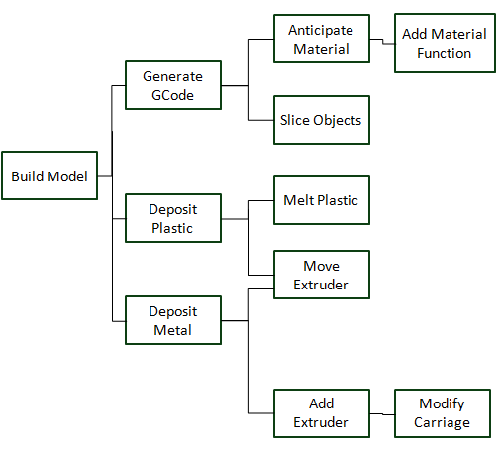
Figure 1 FAST diagram

4. Conceptual Designs

Three conceptual designs were created based on three different 3D printers. Details about each printer will be provided along with a concise explanation of additional tasks that would need to be completed to create a suitable prototype.

Software also needs to be chosen to go along with the printer. Most softwares are already fairly user-friendly. After adding in more functionalities and customizations, the program should still be just as user-friendly as when it started. Some softwares already have built in functionality for operating a 3D printer with two print heads. This is an ideal starting point for the project. It allows more focus to be given to the other features that will be implemented. The software needs to be modified to allow the user to choose what material each print head uses. It should also allow the user to edit the temperature of the print head, speed of the print head and how many layers the print head should lay down per pass.

The first conceptual design is built around the ORD Bot Hadron 3D printer mechanical platform (see Figure 2). This model is just the chassis for a 3D printer; it still needs extruders and a microcontroller. The extruders would need to be mounted and calibrated. The mounting for the extruder heads is large and open, making it easy to attach a different printer head. The mounting may need a little reinforcement. A microcontroller and corresponding software would have to be chosen for this printer. The microcontroller would have to be attached, and software installed and tested. To account for the moving bed of the 3D printer, the software would also have to be calibrated to help deal with the inaccuracy. The base for the second conceptual design is the Asterid 1000HB 3D printer (See Figure 2).

It has dual extruder heads, a microcontroller that comes with its own software and a moving bed. To modify this 3D printer to fit the purposes of the project the following tasks would need to be done: Creation/modification of a carriage to allow interchanging of extruder heads and calibration of software to account for inaccuracies due to the moving bed.

The Wanhao Duplicator 4s is the base for the third conceptual design (See Figure 3). It is a sturdy printer with a bed that only moves in the z-axis. It comes with a microcontroller that is compatible with multiple software options. This printer would need a new carriage modeled and created to allow for a new print head to be installed.
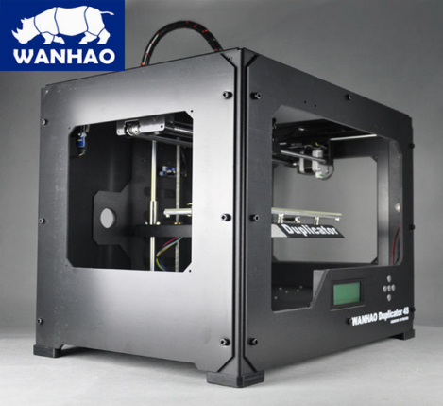
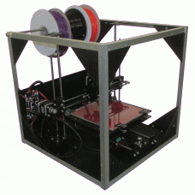
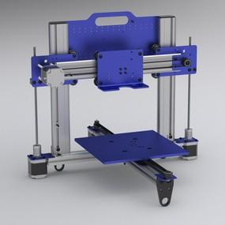

Figure 2 ORDBot Asterid 1000HB Wanhao Duplicator 4S
5. Conceptual Design Rankings

The design with the highest ranking is the Duplicator 4S. This is a 3D printer with high accuracy and potentially of high precision. The build platform is attached to the Z axis which will eliminate the weight of the object as a factor in causing backlash. The dual extruder head is already included with the Duplicator, so an additional one will not need to be purchased. While this printer has the bulkiest chassis, it is still adaptable enough to satisfy the interchangeable print head design objective. The microcontroller for this printer is compatible with multiple open source softwares. This printer meets most of the hardware requirements and software requirements for the design solution.

The second highest ranking of the conceptual designs, the Asterid 1000HB, fell short of ideal. The main issue with this 3D printer is the build platform. This build platform moves on the X axis which causes the weight of the product to affect the accuracy and precision due to backlash. This is not ideal when proving the concept to print metal. However, the adaptability is very high with an open chassis that will be able to print a large size object. This model is also software friendly along with inexpensive.

The lowest ranking design, the ORD Bot Hadron, had drawbacks in many important areas. The cost is very inexpensive and with a tight budget, this 3D printer seemed like a reliable option. The adaptability is the most impressive area of this printer; it has a very open chassis and a mount that should hold most extruders, including a dual extruder set-up. However it does not come with any extruders or a microcontroller. The poor accuracy, and amount of extra time that would need to be spent installing and testing the extruders and microcontroller makes this design unfeasible for the timeframe of the project. The software would need to be chosen based on the microcontroller. Overall, this printer will only dent the customer needs. An overview of the rankings of the printers with weighted importance of the design attributes is displayed in Table 1.

Engineering Criteria | Importance
 |  | ORD Bot Hadron 3D printer | Duplicator 4S | Asterid 1000HB 3D Printer
Accuracy | 5 | 3 | 9 | 3
Dual Extruder Heads | 3 | 1 | 9 | 9
Adaptability | 3 | 9 | 3 | 9
Compatibility with available software | 4 | 9 | 9 | 3
Price | 2 | 9 | 3 | 3
Totals |  | 99 | 123 | 87
Table 1 Solutions Selection Matrix
6. Proposed Design Solution

The goal is to have a 3D printer capable of printing different materials in one given structure using interchangeable extruder heads. The hardware solution will consist of modifying a 3D printer that will include two interchangeable print heads. The Wanhao 4S Duplicator was chosen as the 3D printer, its specifications are listed in Table 2. It will be calibrated to have a high level of accuracy, create a smooth surface, and be precise. These features are necessary due to the plans that MSU Technologies has to integrate a plasma deposition print head, used to print metal. Introducing a plasma print head will require a custom made mount that will be placed inside of the printer. As far as construction, the printer purchased will be fully assembled. There will be an initial test to ensure full functionality of a normal 3D printer. The extra print head and mount would then be designed and fabricated. The custom made mount will be 3D printed or made in the machine shop.

The software solution is more complex and will allow the user to operate the 3D printer with a user friendly interface. The software will have the following settings added to it: multi-pass, extruder temperature, material selection, and layer height. More settings and options will be added if it becomes apparent that they are needed. Multi-pass and layer height are two ways of achieving a similar goal. The goal is to have the metal print head print more layers for every layer of plastic. Using multi-pass the user would say how many times they wanted the printer to print each layer, while adjusting the layer height will change the G-code to make the extruder head move by smaller increments while printing the metal, effectively forcing it to make multiple passes. Extruder temperature is a setting that is already available in the code, but it may be beneficial to have a setting to turn off the heating element for one or more of the print heads. A material selection option could be very user friendly. Installing a drop down menu that allows the user to choose their material for each extruder head and preloads in defaults for that material will save the user a lot of time. These users will still be able to edit these values if something needs to be changed.

Once the software and the hardware designs are completed and working together, then the testing of the solution will commence. The initial testing will include using the 3D printer to construct an object using two different plastic materials. This test will show that the interchangeable extruder heads are working simultaneously. There will also be tests to test metal to plastic bonding. These tests will deliver a simulation that will yield a success or failure similar to the customer requirements. These tests will also show that the custom mount and the software interface design have been modeled correctly. The proposed design solution would then be capable of meeting all requirements and suggestions made by the customer.

Minimum print size | 50 × 50 × 50mm (W × D × H)
Maximum allowed head size (each) | 42 × 75 × 46mm (W × D × H)
Printer Dimension | 320 × 466 × 382 mm (W × D × H)
Frame Material | Steel
Positioning Precision | Z-Axis 2.5 micron, XY Axis 11 micron
Layer Resolution | 0.1mm - 0.5mm (for plastic)
Maximum allowed heads | 2
Slicer | ReplicatorG
Connectivity | USB or SD Card
Stepper Motors | 1.8° step angle with 1/16 micro-stepping
XYZ Bearings | Wear-resistant, oil-infused bronze
Table 2 Design Specifications

7. Risk Analysis

With the project there are certain risks involved with modifying and use of the 3D printing system. Accuracy becomes very important because several risks arise from inaccuracy. The first and simplest risk from inaccurate printing is that a reprint is needed and parts are not created to specifications. This can also occur from printer extruding too fast and is a low risk event. A medium level risk from inaccuracy is that the print will not be smooth enough to support the metal deposition process and conduction, and will reduce freedom of printing metal parts. Software modifications are very low risk because if there are bugs or poor behavior the software can be rolled back to its original state because it is open source. Hardware modifications are medium risk because these will be permanent changes and would be high cost to replace mistake parts. The high risk portions of the project occur during actual printing which involve burns and inhalation of fumes during ABS printing.

8. Business Management

The programming tasks involve user interface development and print speed control. UI development requires an easy to use user interface so that the user can make the gantry do its task without consulting documentation. There is already a form for this function, so it will be relatively straightforward to modify it to support additional parameters. Michael, Annalin and Josh will work on implementation.

Extruder speed must also be modified, such that the head makes multiple passes over the same layer because for metal deposition, the layers are quite thin. This can be done by running negligibly small layer height so that the motor doesn’t actually move until 10 layers are completed, or it could be instructed to repeat a layer. Depending on whether or not the G-code slicer can handle tiny layers or not will dictate how this is implemented. It is desirable to not have to touch the slicer, because it is written in a different language, and is a separate part of the program. Modifying it will introduce more variables. Matt, Michael, Josh, and Annalin will all work on this part.

The temperature requirement for the extruders will also need to be overwritten to use the plasma head. Currently the software will not generate a toolpath unless the extruders have a valid temperature set, but this is not required for printing metal. This will be done by He.

Moving onto hardware, the carriage that holds the plastic extruders as well as the plasma deposition heads will need to be designed and fabricated. He Chen is in charge of modeling the carriage as well as Josh if necessary. It will then need to be redesigned to support a modular mount so that the plastic heads can be removed and plasma heads attached.

The printer will also need to undergo calibration and extensive testing. For calibration, the build plate needs to be properly leveled to ensure a uniform printing surface. The feedrate multipliers also need to be adjusted in the software to make sure the right amount of plastic per unit area is deposited. This is done by printing several 20mm cubes at 100% infill and observing the last layer for bulges, dips, or uneven areas. Calibration and testing will be done by He and Matt. Task allocation can be seen in Table 3 below and time allocation can be seen in Figure 3.

Task: | Michael | Annalin | Matt | He | Josh
UI Development | Yes | Yes | No | No | Yes
Extruder speed and Movement Control (Metal work) | Yes | Yes | Yes | No | Yes
Calibration and Testing | No | No | Yes | Yes | No
Carriage CAD | No | No | No | Yes | Yes
Temperature Control | No | No | No | Yes | No
Table 3 Task Assignment

8.1 Timeline
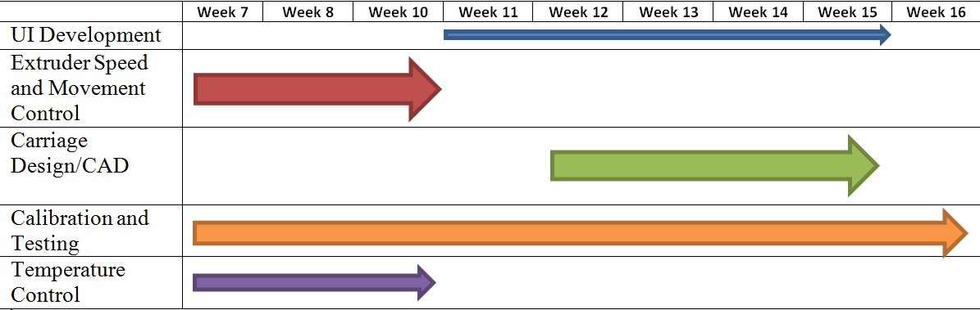
Figure 3 Task Timeline

8.2 Resources and facilities

Below are the list of hardware and software needed for the proposed design and the preferred method.
Hardware:
• Duplicator 4S – Will be ordered from the manufacturer and deducted from the budget.
• Assembly and disassembly – Use ECE 480 lab equipment as well as provided tools from manufacturer.
• Printing supplies – Will be ordered and deducted from the budget.
• Raw material (metals) – Will order from McMaster Carr, obtain through the ME machine shop, or purchase locally through Alro Metals Plus.
• Possible tooling needs for raw material – Obtain through ME machine shop, order through McMaster Carr, or purchase locally through Production Tool Supply.
• Possible machining labor and equipment – Will use ME machine shop. Will request for professional help if needed.
Software:
• 3D model to G-code – ReplicatorG will be used for this project. ReplicatorG is a powerful, free, and open source tool for converting 3D models into a language the 3D printer uses.
• Python and Java environment – Both can be obtained freely through the company’s website.
• Computing equipment – Will unitize MSU’s engineering building computer labs.
• Modeling of carriage and printer extruders/head – Will use UGS NX with license through MSU’s network.

8.3. Budget

The needed materials for this project and their corresponding costs are listed in Table 4. The Duplicator 4S was the best choice for 3D printer, as detailed above it meets the requirements better than any other solution. Printing materials, such as PLA and ABS, will be needed to test the printer. It costs around $20-$50 a roll depending on material. Buying a few more rolls of different materials for testing purposes may be necessary so $100 of the budget was allocated to this purpose. In the case that one of the extruders breaks or another is required for testing purposes we have allocated another $100. If the software for the microcontroller proves to be too difficult to edit or isn’t working for this project’s purposes, a new microcontroller can be purchased. To complete this project a new mount will have to be made for the print heads; this should not be too expensive and could potentially be 3D printed. Another consideration is given towards the software being incompatible with the project’s needs. For this, and for future tests that may need materials that have not been mentioned, there is an extra $200 in the budget.

Material | Cost
Duplicator 4S | $1000
Printing Materials | $100
Extra Compatible Extruder | $100
Different Controller | $70
Mount for Print Heads | $30
Miscellaneous/Software | $200
Total | $1500
Table 4 Budget

References

"3d Printers for Sale: ORD Bot Hadron 3D Printer Mechanical Platform Kit | Automation Technology Inc." Automation Technology Inc RSS. N.p., n.d. Web. 19 Feb. 2015.

"Duplicator 4S - Steel ExoFrame – Wanhao USA." Duplicator 4S - Steel ExoFrame – Wanhao USA. N.p., n.d. Web. 19 Feb. 2015.

"Asterid 1000HB 3D Printer." Asterid 1000HB 3D Printer. N.p., n.d. Web. 19 Feb. 2015.

"Objet Connex 3D Printers." Objet Connex Multi-Material 3D Printers. N.p., n.d. Web. 20 Feb. 2015.
<http://www.stratasys.com/3d-printers/design-series/connex-systems>.

"How Does DMLS - Direct Metal Laser Sintering Work?" How Does DMLS. N.p., n.d. Web. 20 Feb. 2015. <http://gpiprototype.com/blog/how-does-dmls-direct-metal-laser-sintering-work.html>.

