ECE 480
Application Note
Regulating Voltage
Michael Burch
Spring 2014



Abstract:
In many applications, there are times when a system requires different voltages to run properly. One device or part in the system requires 12 volts and another 9 volts. With the complexity of components increasing and being a user friendly device becomes mandatory, having a system that can plug into a wall and regulate all of voltages itself can be beneficial. The purpose of this note is to provide a brief summary of voltage regulators.

Table of Contents

Introduction………………………………………………………...……………………………………..3

Quality Assurance.………………………………………………………………………………………4

Implementation………………………………………………………………………………………….6

Conclusion…………………………………………………………………………………………………..6

References…………………………………………………………………………………………………..7

Introduction:
Voltage regulators are designed to maintain a constant voltage. They can be design to handle either DC or AC voltages. They can be found in many appliances to stabilize the DC voltage such as computer power supplies to power the processor, memory, and other components. AC voltage regulator can be used in alternators in cars to stabilize voltages to the electric parts throughout without damaging them. They are also used in power substations and along power distribution lines to keep voltages stabilized for the consumer.
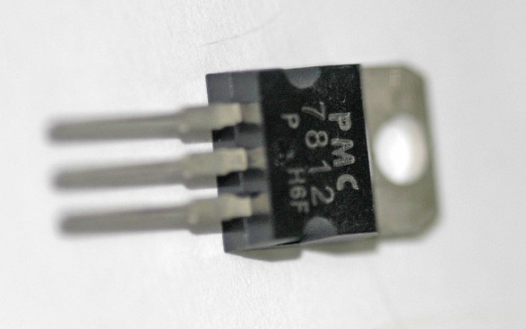
Figure 1: A common three pin 12 V DC regulator

Quality Assurance:
A voltage regulator’s quality can be measured using multiple variables. Load regulation, temperature coefficient, dropout voltage, and maximum ratings to name a few measurements. These parameters determine the usefulness of a voltage regulator and help users choose which regulator to use in their design. Load regulation is a change in output voltage to a given load current change. If a load is changed from a 1 amp to a 3 amp draw, the voltage being outputted may drop and/or become unstable.
The temperature coefficient determines the output voltage based on temperature fluctuation. Under normal temperatures the regulator will function as desired, but if you exceed this temperature, the regulator may drop its output voltage or become damaged. If the regulator is needed in danger of possibly overheating in normal operation, heat sinks can be applied to help heat dissipation.
Dropout voltage is a minimum difference between input and output voltages and still be able to supply the rated current. A low drop-out (LDO) is designed to keep the difference between input and output voltages is kept around one volt.
Maximum ratings are quantities given that cannot be exceeded by that regulator. These are max output current, max input voltage, maximum power dissipation at a defined temperature, dropout voltage and others. These limits are given to ensure proper use and help users determine the proper voltage regulator for their design.
The table below is an example of all the other quality characteristics used to asses a voltage regulator. These are all important to your design as not meeting or exceeding these values can result in product failure and possible damage to whatever it is used to regulate.
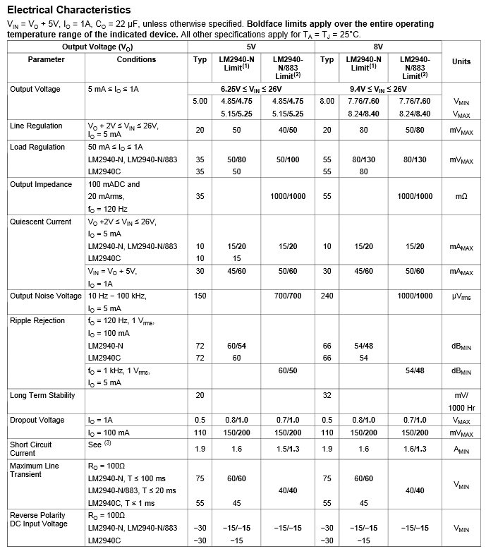
Figure 2: A table of electrical characteristics of the voltage regulator LM2940.

Implementation:
With the use of diodes and capacitors, you can manipulate the use of a voltage regulator. In the figure below (Figure 2), the diodes and capacitors are being used as a full-wave rectifier circuit.
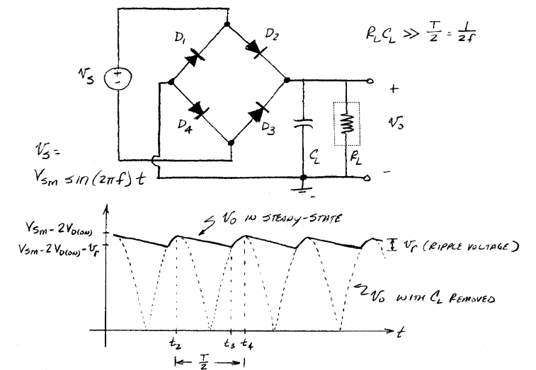
Figure 3: This is an example of rectifying circuit.
The change in peak voltage is known as a ripple voltage. This can be managed by using different capacitors. This is important since some regulators can handle very specific input voltages.
By using many voltage regulators, you can create multiple output voltages from a single source. A circuit that uses power from a regular wall outlet and can output multiple voltages can be very useful.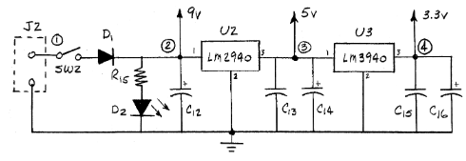
Figure 4: Multiple output voltage and regulator circuit.
In figure 4, is an example of a single input, multiple outputs, voltage regulated power supply. This is using an input from wall wart that is sent to a switch. Toggling this switch enables the circuit and a LED to inform the user the circuit is on. The resistor protects the LED from having too much current applied. There is one unregulated nine volt source and regulated five and three volt sources.
Having multiple sources to choose from allows users to connect various components to a single circuit. This reduces cost and weight of a product if the circuit is created to accommodate all the component power needs.

Conclusion:
This application note gave a broad overview of voltage regulators, and there are more aspects for regulators to take into account when choosing a voltage regulator such as quality measurements. Having a stable voltage is very important to increases a products lifecycle, but it also keeps operation safer since there is little chance to a large fluctuation to damage components. With a huge demand for devices with multiple uses, more unique regulators will be created to fill the gap.

References:
http://en.wikipedia.org/wiki/Voltage_regulator
http://www.egr.msu.edu/~wierzba/480_lab01.pdf
http://www.ti.com/lit/ds/symlink/lm2940-n.pdf
http://www.ti.com/lit/ds/symlink/lm2340-n.pdf
Figures:
1: http://en.wikipedia.org/wiki/Voltage_regulator
2: http://www.ti.com/lit/ds/symlink/lm2940-n.pdf
3 & 4: http://www.egr.msu.edu/~wierzba/480_lab01.pdf

