ECE 480 Application Note
Battery Balancing Methods and Applications
Abstract
Battery balancing systems are used in conjunction with battery management systems to increase the efficiency and life of batteries. As electric vehicles become increasingly popular, such balancing systems are now extremely important. This note will provide a brief overview of different battery balancing systems and how to apply them.
Keywords
Cells, lithium ion, voltage sensor, microcontroller, cell imbalance, State of Charge (SOC), Electric Vehicle,


By: Matt Gilbert-Eyres
3/26/2014

Table of Contents

Introduction 3

Objective 4

Body 4
Passive Balancing 4
Active Balancing 5
Single Capacitor Balancing 5
Converter Balancing 6

Conclusion 7

References 8

Introduction

Battery balancing is becoming a very important method used with battery management systems. Due to new legislation limiting vehicle emission and high gas prices, demand for safe, efficient electric vehicles is only increasing. Battery balancing systems have many benefits such as increased safety, battery run time and battery life. This makes the overall system safer and more efficient.
When temperatures reach critical levels or voltages go over specifications, Lithium Ion cells can go through a process called accelerated cell degradation. During this extreme process, cells can catch fire and explode. The battery management system prevents this from happening by carefully monitoring the overall system. When multiple cells are connected in series, a slower form of degradation can occur due to cell imbalance.
Not every battery is created equal. Battery cells can have small differences in state of charge, discharge rate, capacitance and internal resistance. When connected in series, these differences can cause serious problems during charging and discharge. During charging, batteries with lower capacity or high impedance can be overcharged. This causes the individual battery to degrade much faster. While discharging, these weaker cells have a higher rate of discharge and will lose voltage too fast. This decreases the overall life and performance of the battery system. This is when battery balancing plays an important role.
Battery balancing compensates for the differences among the batteries by equalizing the voltage of each cell during charge and discharge cycles. There are two main categories regarding battery balancing, passive and active.
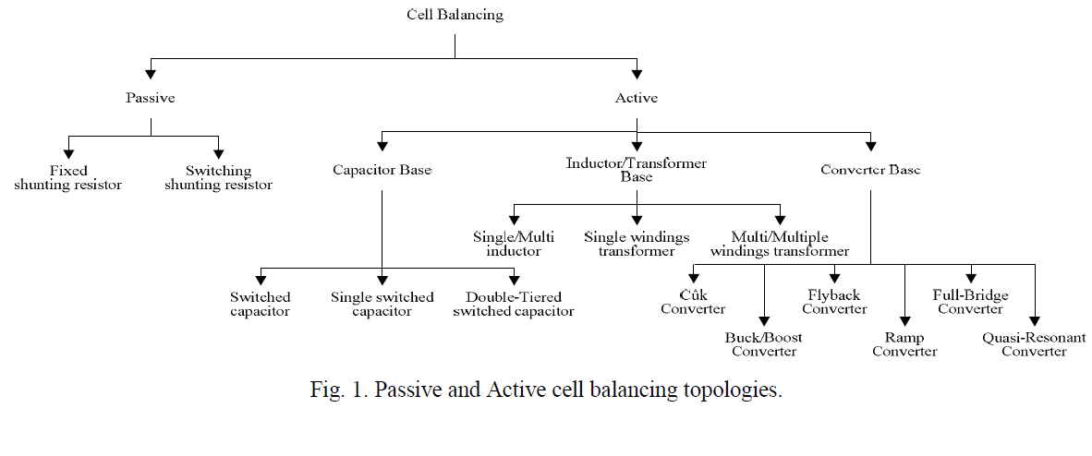
Passive balancing equalizes the cell’s voltages by discharging higher voltages cells using resistors. This method is easy to impellent but all of the excess energy is wasted. Active balancing moves the extra energy around the system to compensate. There are many different types of active balancing.
Objective

This application note outlines the basic fundamentals of battery balancing methods. It describes how to connect and choose components for each balancing method along with appropriate switching logic to control these systems.

Passive balancing

Passive balancing equalizes the cell’s voltages by discharging higher voltages cells using resistors. Figure 2 shows the circuit design of such system. There are four main components to this system; resistors, voltage sensors, switches and microcontroller. Voltage sensors continuously monitor the individual voltages of the cells. When the voltage sensors detect a higher voltage battery compared to the others, it sends a signal to the microcontroller. The microcontroller then closes a switch creating a parallel connection with the high voltage battery to a resistor.
Choosing the right resistor is critical. The wrong resistor could start an electrical fire. In this design, the resistor is used to drain excess voltage from the higher cell. In order to accomplish this in short time, a low ohm high wattage resistor should be used. A low ohm resistor will draw high currents and the high wattage rating will prevent fires. For example: A 3.7v 2200mAH lithium ion battery would require a 2ohm/10w resistor to safely drain the battery. Two equations could be used to calculate the required resistor. Ohm = (Rated Voltage/ Rated mAH) , Wattage = Voltage*Current.
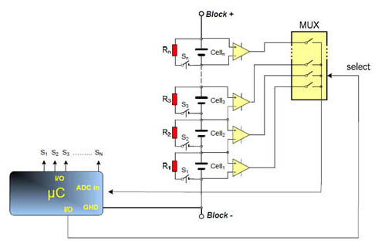
Table 1. Switching logic
Case | Sw1 | Sw2 | Sw3
Cell 1 High | 1 | 0 | 0
Cell 2 High | 0 | 1 | 0
Cell 3 High | 0 | 0 | 1

Figure 2.
Active Balancing

Instead of burning the excess energy as heat through a resistor, active balancing moves the extra energy around the system to compensate for lower voltage battery cells. This method uses a high level of complexity but is very efficient. There are many methods regarding active balancing. Single switched capacitor and buck-boost converter balancing systems will be highlighted in this article.

Single Switch Capacitor

Single switch capacitor balancing uses one capacitor to move the excess energy from battery cell to another. Figure 3 show the circuit design of such system. There are four main components to this system; capacitor, voltage sensors, switches and microcontroller. Voltage sensors continuously monitor the individual voltages of the cells. When the voltage sensors detect a higher voltage battery compared to the others, it sends a signal to the microcontroller. The microcontroller then opens and closes certain switches so that the higher battery cell is connected in parallel with the capacitor. This charges the capacitor. When the capacitor is charged, it is then connected to the lower voltage battery cell. It is crucial to pick the right components for this design. The capacitor should be rated at or above the voltage of the connecting battery and should have low capacitance and minimum internal impedance. http://www.mouser.com/Power/Supercapacitors/_/N-6uivw is a good website to find capacitors.

State | Sw1 | Sw2 | Sw3 | Sw4 | Sw5 | Sw6 | Sw7 | Sw8
B1 High (charge Cap) | 1 | 1 | 0 | 0 | 0 | 0 | 1 | 1
B2 Low  (charge bat) | 0 | 1 | 1 | 0 | 0 | 0 | 1 | 1
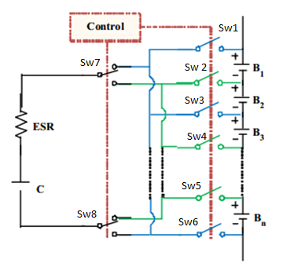
Table 2. Switching logic

Figure 3.

Buck-Boost Converter Balancing

Boost converter balancing is similar to capacitive balancing but instead of a capacitor, it uses a buck-boost converter to move excess energy around the system. A buck-boost converter can either step down voltage or increase it. During charging, the buck converter is used to decrease the voltage of the higher cell to prevent over charging. The boost converter is used during discharge to either boost the lower voltage battery cell or transfer the excess energy from the high cell to a lower one. There are four main components to this system; buck-booster converter, voltage sensors, switches and microcontroller. Voltages sensors are used to monitor each battery cell voltage. This information is sent to the microcontroller which then decides which cell to connect to the converter. Figure 4 show the circuit design of such system.
Pre constructed buck-boost converters can be purchased fromhttp://www.ti.com/lsds/ti/power-management/buck-boost-converter-products.page. Make sure the buck-boost converter is rated for the appropriate voltages. Duty cycle can be determined by using the equation D= (V0/(V0+Vi)). The duty cycle can be manipulated to allow the converter to provide a constant output voltage. The voltage sensors provide the micro-controller with the Vin voltage to the converter. This Vin is then used in the equation to find the correct duty cycle that would provide the requested output voltage. For example: if an output voltage of 3.8v was required and the Vin was 2v, the duty cycle would be .65.
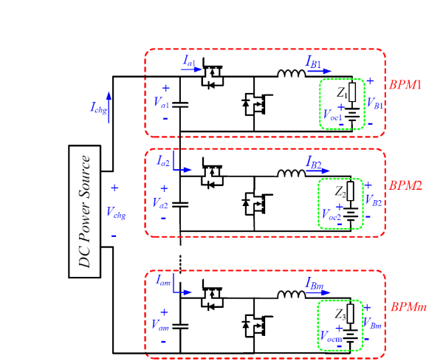

Figure 4.
Conclusion

This application note provides a fundamental overview of three different battery balancing methods and how to apply them. There are many more active balancing methods not covered in this document. Battery balancing plays an important role in battery management systems. This role will only become larger due to the increase demand for such systems. As technology advances, battery balancing safety and efficiency will only increase.

References:

Passive Balancing:
https://www.digikey.com/us/en/techzone/energy-harvesting/resources/articles/battery-cell-balancing.html

Active Balancing (Capacitor)
http://www.mouser.com/Power/Supercapacitors/_/N-6uivw

Active Balancing (Converter)
http://www.ti.com/lsds/ti/power-management/buck-boost-converter-products.page

Additional Information:

Figure 1,3,4
http://www.google.com/url?sa=t&rct=j&q=&esrc=s&source=web&cd=15&ved=0CLABEBYwDg&url=http%3A%2F%2Fwww.researchgate.net%2Fpublication%2F215553090_Passive_and_Active_Battery_Balancing_comparison_based_on_MATLAB_Simulation%2Ffile%2Fd912f507d970ed81f0.pdf&ei=rysyU-iLOsaIyAHu-YDYBQ&usg=AFQjCNHZ5lh7ZuqDIbvsAGJk8FZV8iyHNg&sig2=bNPBRr9AezZouwzpBxWrcg&bvm=bv.63587204,d.aWc

http://www.ti.com/lit/an/slyt322/slyt322.pdf

