Voltage, current, and temperature sensors

Auez Ryskhanov

3/27/2014

Table of Contents
Abstract…………………………………………………………………………………...3
Key Words………………………………………………………………………………..3
Introduction………………………………………………………………………………3
How to choose Sensors for BMS…………………………………………………………4
Sensors Layout……………………………………………………………………………6
Mechanical Setup…………………………………………………………………………8
Conclusion………………………………………………………………………………...8
References………………………………………………………………………………..10

Abstract
Sensor is a hardware component that measures a physical quantity and converts it into a signal which can be read by or observed by an electronic device. Later the output, which is generally a signal can be converted and transmitted to human-readable display. The information that is provided by the sensors allows the user perform his actions accordingly.

Key words
Voltage Sensor, Current Sensor, Temperature Sensor, Battery Management System

Introduction
The team number seven was assigned to develop a customized Battery Management System (BMS) (Figure 1) for the Michigan State University Solar Car Team. BMS monitors key operational parameters during charging and discharging. It checks the voltage, current, and temperature of the battery. The monitoring circuits would normally provide inputs to protection devices which would generate alarms or disconnect the battery from the load or charger in case of the emergency. In order to complete the task the designed Battery Management System was supposed to detect the following events: over voltage, under voltage, over current, and over temperature. As a result, three types of the sensors were involved in the project: voltage sensors, current sensors, and temperature sensors.

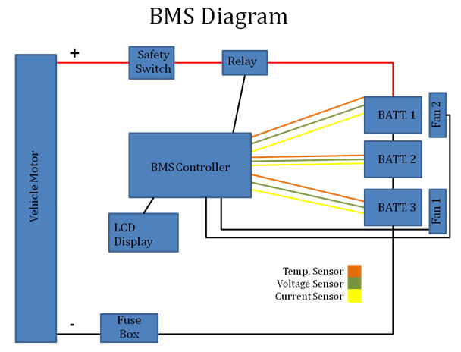
Figure 1: Battery Management System
How to choose Sensors for BMS
First of all, the sensors are supposed to be compatible with a microcontroller. Nowadays, there are a lot of types of the microcontrollers and the sensors. Unfortunately, not all of the microcontrollers and sensors are compatible with each other. Because microcontroller plays as a bridge between the user and the system, it is desired to purchase the microcontroller first and only then start searching for the sensors compatible with it.
Secondary, the range of the operation of the sensors must be taken under consideration. The range of the operation of the sensors must be enough in order to detect the change of the voltage, current, and temperature of the system. Otherwise, the readings of the sensors would be incorrect or the sensors can even be destroyed. This can affect the operation of the whole system.
The last, it is desired to obtain the sensors from the local vendors. Sometimes some suppliers provide the sensors for very cheap price and relatively fast shipping. However, most of these vendors locate oversea. As a result, the time between shipping date and delivery date can be counted in weeks. Therefore, in order to save time it is recommended to pay more, but order the sensors from the local distributer. Also, it is recommended to order some extra parts in order to make sure that in case of damaging the sensors, there are some extra ones.
Team number seven had to order voltage sensors, current sensors, and temperature sensors. First, the team has decided to use Arduino Mega 2560 R3. After the microcontroller has been chosen, the design of the battery pack has been chosen. Overall the battery pack was able to produce 15.2V and 27A max. According to this information the voltage and current sensors were purchased. Voltage sensors had 0.02445-25V input voltage detection range, the current sensors had -50A to 50A current range, and the temperature sensor had approximately -40º C to 125º C range. Unfortunately, because the battery pack was producing small amount of current, while the current sensor had a huge range of performance, the sensor was not able to detect any current. As a result, team had to order a new current sensor with a smaller range. Moreover, team has ordered some sensors from oversea. As a result, some sensors arrived around a 6 week after the placing the order. This delay affected performance of the whole team.

Sensors Layout
Figure 2 shows how the voltage sensor looks. Pin 1 is connected to the positive terminal of the power supply. Pin 2 is connected to the negative terminal of the power supply. Pin 3 is connected to the microcontroller. Pin 4 and Pin 5 are connected to the cell which voltage is needed to measure.
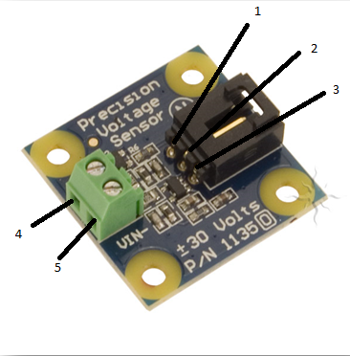
Figure 2: Voltage Sensor

Figure 3 shows how the current sensor looks. Pin 1 is connected to the positive terminal of the power supply. Pin 2 is connected to the negative terminal of the power supply. Pin 3 is connected to the microcontroller. Pin 4 is connected to the ground. In order to measure the current, the cable should pass through port A and B.

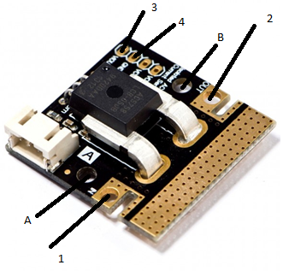
Figure 3: Current Sensor

Figure 4 shows how the temperature sensor looks. Pin 1 is connected to the positive terminal of the power supply. Pin 3 is connected to the negative terminal of the power supply. Pin 2 is connected to the microcontroller.
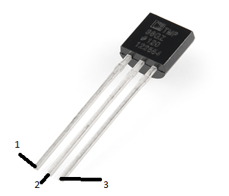
Figure 4: Temperature Sensor

Mechanical Setup
The voltage and current sensors can be installed in any place. Most important part for the voltage sensor is that the positive pin was connected to the positive terminal of the cell, while the negative pin was connected to the negative terminal of the cell. As a result, the number of the voltage sensors depends on the number of the cells in the battery pack. For instance, if the battery pack is consisted of the 3 cell, 3 voltage sensors will be required. For the current sensor it is important that the cable which is coming from the battery pack was passing through the port A and B. Because the cells are connected in series, the overall current will be the same. Therefore, only one current sensor can be used in order to obtain information about the current of the battery pack. The temperature sensor is slight different from the previous sensors. The number of the temperature sensors also depends on the number of the dells, like the voltage sensors. However, this type of sensors should be placed as close as possible to the cell. This type of sensor does not connected to the cell directly. Instead, it just measures the surrounding temperature of the cell. Therefore, the distance from the cell plays important role for the temperature sensor.

Conclusion
There are a lot of sensors out in the market. However, it is important to know which sensors will work with a certain type of the microcontrollers. Moreover, some cheap sensors are shipped from China. This means that the shipping can take longer than usual. Therefore, it is recommended to obtain the sensors from the local supplier. Team seven had to use three types of the sensors: voltage, current, and temperature. The sensors were obtained from the local suppliers as well as from the oversea vendor. The shipping for the local suppliers took around a week, while the shipping for the oversea vendor took around 6 weeks. Voltage and current sensors that are sold from robotshop cost $19.00 and $14.50 each respectively. The temperature sensors that are sold from SparkFun cost $1.50 each.

References
[1] http://whatis.techtarget.com/definition/sensor
[2] http://windows.microsoft.com/en-us/windows7/what-is-a-sensor
[3]http://www.em.avnetasia.com/Products/DesignSolutionShow.aspx?pagesId=27&MasterPageId=17&ID=149
[4] http://dlnmh9ip6v2uc.cloudfront.net/datasheets/Sensors/Temp/TMP35_36_37.pdf
[5] http://www.robotshop.com/en/dfrobot-50a-current-sensor-ac-dc.html
[6] http://www.trossenrobotics.com/p/phidgets-precision-voltage-sensor.aspx

