Albert Ware
Application Note
ECE480
Group 7:Battery Management System
Topic: Relay Controlled Power Disconnect
Due: Week 12

Abstract:
Relays are mechanical switches that can be controlled by an external power source such as an output pin from a microcontroller. The four pin relay is a relatively simple system but requires a power source to activate a coil that will trigger a switch to close. This allows a system to pass power to a desired output. Once the power is shut off to the coil, the switch will open, which will stop the power flow to the desired output. This note will go into detail on how and when a four pin mechanical relay should be used. It also contains a brief overview of how a relay is used in a Battery Management System as a kill switch.

Table Of Contents

Introduction Page 3
How A Four Pin Relay Works Page 3-4
Checking System Requirements Page 4-5
Example Of How Relays Can be implemented Page 6
Conclusion Page 7
Reference Page 8

Introduction:
The Relay was first invented in 1835 for long distance telegraph circuits. Its purpose was to amplify the signal at various junctions so the information could be received at greater distances. Today relays are commonly used in the automotive industry to control vehicle ignitions, windshield wipers, and the motors in the HVAC systems. They can also be found in house hold appliances, such as automatic lights, AC systems, and refrigerators. The reason for their popularity is their low cost, their ability to handle high current and voltage, and their ability to be easily replaced. For the Solar Teams Battery Management System the relay acts as protection switch. The relay is trigger off when the system senses under or over voltage, current, and temperature. In the event that the system fails a manual switch and fuse have been put in place.
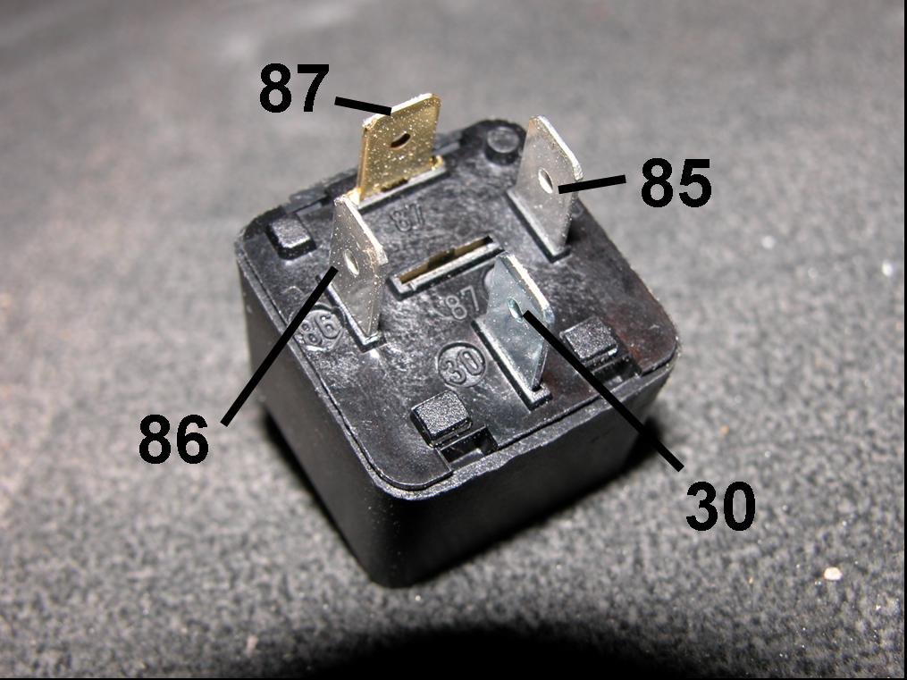
Figure 1: Four Pin Relay
How A Four Pin Relay Works:
Four pin relays have two pins that are meant to control the switch and two pins that act as an input and output pin that are connected by a switch. Below, Figure 2 shows the pin outs and the circuit layout of the relay. In order to activate or to switch on the relay, a positive voltage must be applied to pin 85, and pin 86 must be attached to ground. The magnetic field generated by the coil will pull the switch closed completing the circuit between pins 30 and 87. Pins 85 and 86 are usually connected to a low power source to trigger the switch between pins 30 and 87. Pins 30 and 87 are usually used to turn on or off higher voltage items such as motors.
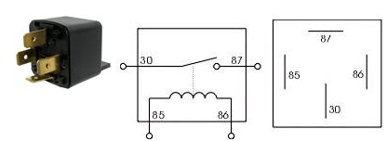
Figure 2: Relay Circuit
Checking System Requirements:
In order to properly get the relay working there are a few things that must be checked, first being the coil current. The coil current is an important part when it comes to matching a relay to the source that will be triggering it. If the source being used has a lower output current than the coil current, the coil will not close the switch. If the current source is a lot higher than the coil rating, the user runs the risk of damaging the relay. A second key item to look for when selecting the correct relay is the max on and min off voltage. This is important because if source does not output over the min off voltage the switch will not be triggered as well. Figure 3 shows the relay when the switch is open, and shows the switch when it has been activated by the coil.
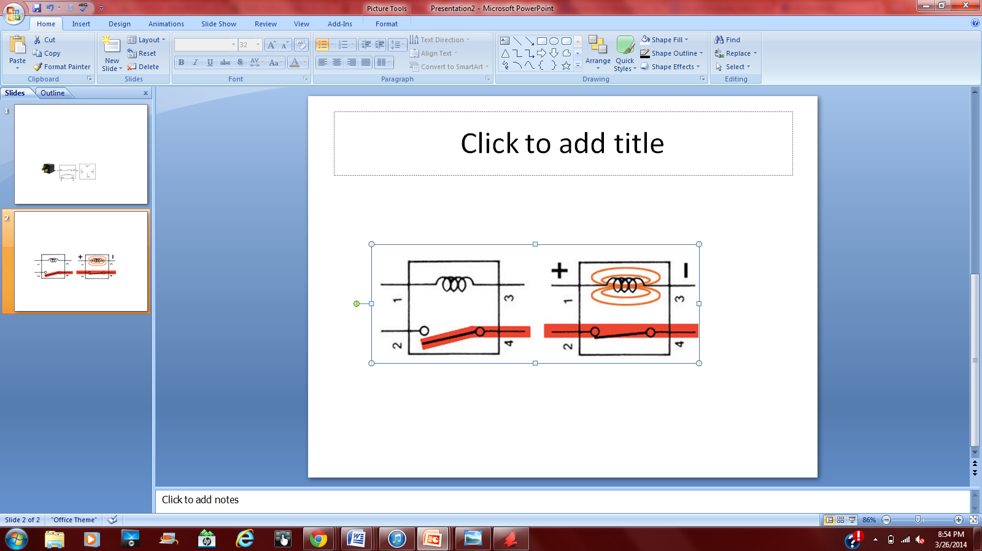
Figure 3: Relay In off position and on position
For the high voltage, high current connection being made using the relay, items such as switching voltage and contact current should be compared to the planned voltage and current the relay will be turning on and off. Over voltage and over current can result in damaging the switching circuit. The worst case situation can result in welding the connection closed, even if power is shut off to pins 85 and 86. The relay should be rated a little above the planned load to ensure all components of the relay operate as intended. Also, if a relay is supplying power to a motor, a diode should be added somewhere in the connection after pin 87. This should be implemented in to the circuit to ensure that the voltage generated by the motor as it spins does not make its way back to the relay once it has been turned off. Figures 4 and 5 show the effects of adding a diode into the system. Forward voltage and current is passed, while reverse voltage and current are blocked by the diode. Some relays will come with a diode already in them, so an extra one is just an added cost. This information can be found in the features section of the data sheet.
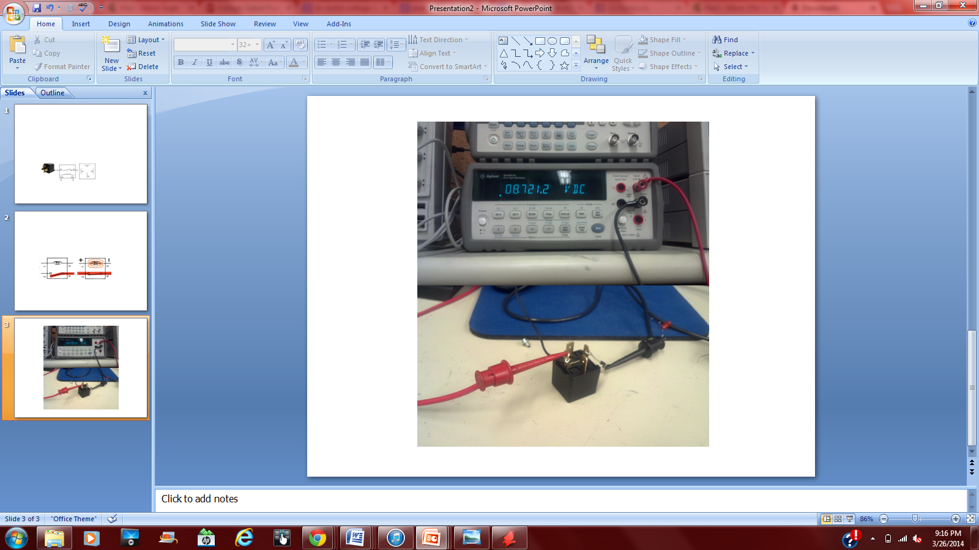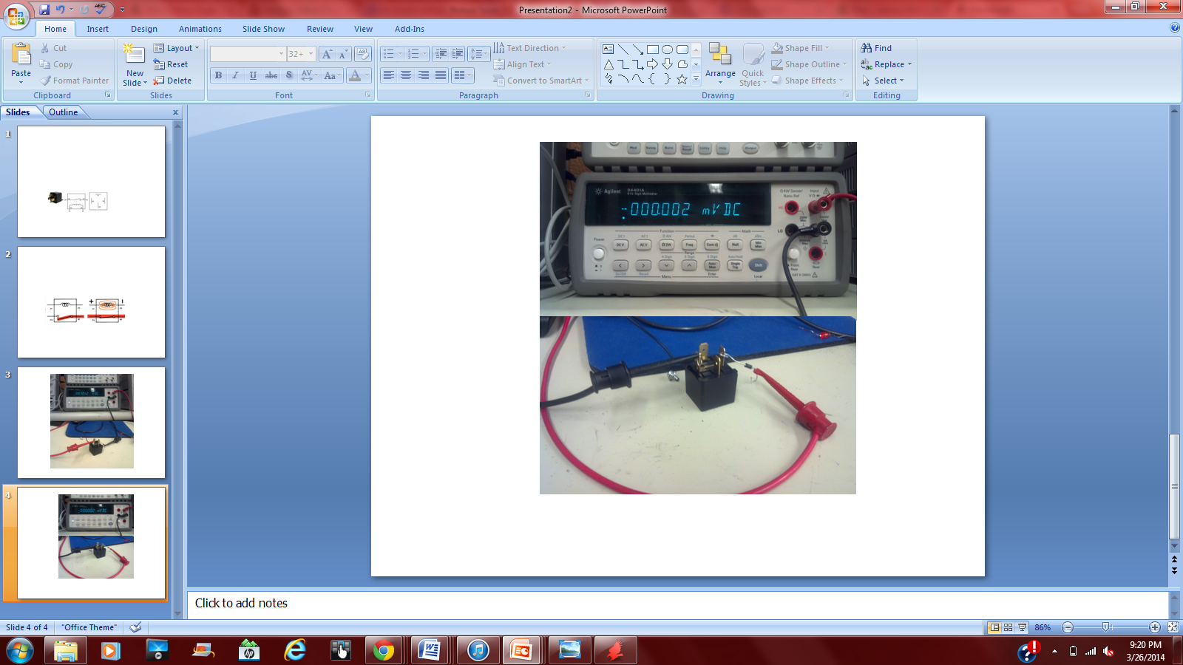
Figure 4: Forward Voltage Across Diode Figure 5: Diode Stopping Reverse Voltage
Another key item to look for on the data sheet when selecting a relay is the operation time and the release time. The operation time is the time it takes for the switch to close, where the release time is how long it takes for the coil to discharge and open the switch. If on off timing is a major factor in the systems functionality then a relay may not be the right triggering method. A transistor or mosfet have ability to do the same function as a relay but almost instantaneously. With those items, cost will increase for larger voltage and current capacities.
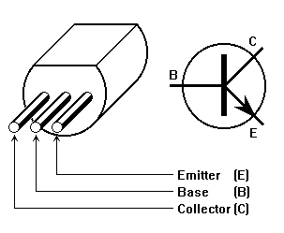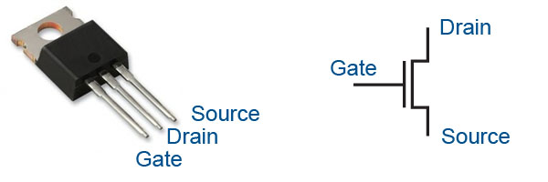
Figure 6: Transistor Figure 7: MOSFET
Example Of How Relays Can be implemented:
One of the key features of a battery management system is having the ability to shut power off if the system goes in to an unstable state. Figure 10 shows the completed relay power disconnect system that uses a two relay method to cut power. An output pin from an Arduino is used as the master input into the first relay which then controls the second relay turning the system on or off. Relay one shown in Figure 8 has a coil current of 20milli-Amps, allowing it to be triggered by the Arduino which supplies 35milli-Amps at 5 Volts. The latch line of the relay can handle 250 Volts and 10 Amps allowing 12 Volts and 300milli-Amps to pass. The second Relay shown in Figure 9 is controlled by the first Relay. The coil current of the second relay is 133.3milli-Amps, and is supplied by the 12 Volt, 300milli-Amps coming from relay 1. The latch line of the relay is rated at 14 Volts 30 Amps, where the max load that can be supplied is 12 Volts 27 Amps. In normal operation, relay one and two are both in the on position, but in the case of system failure or loss of power, relay one and two will disconnect. This will result in the loss of power to the motor shown in Figure 10.
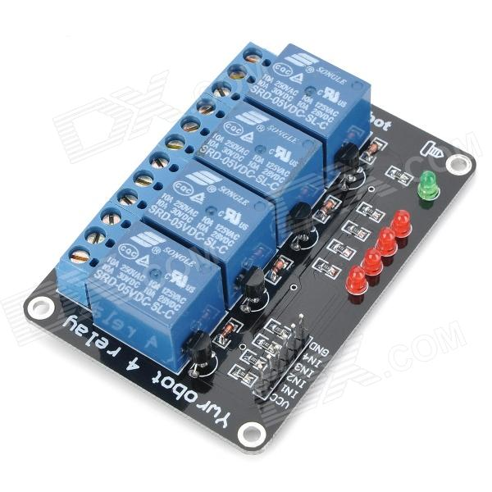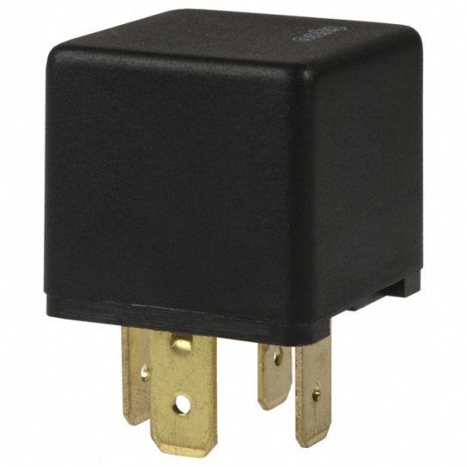
Figure 8: Relay 1 Figure 9: Relay 2
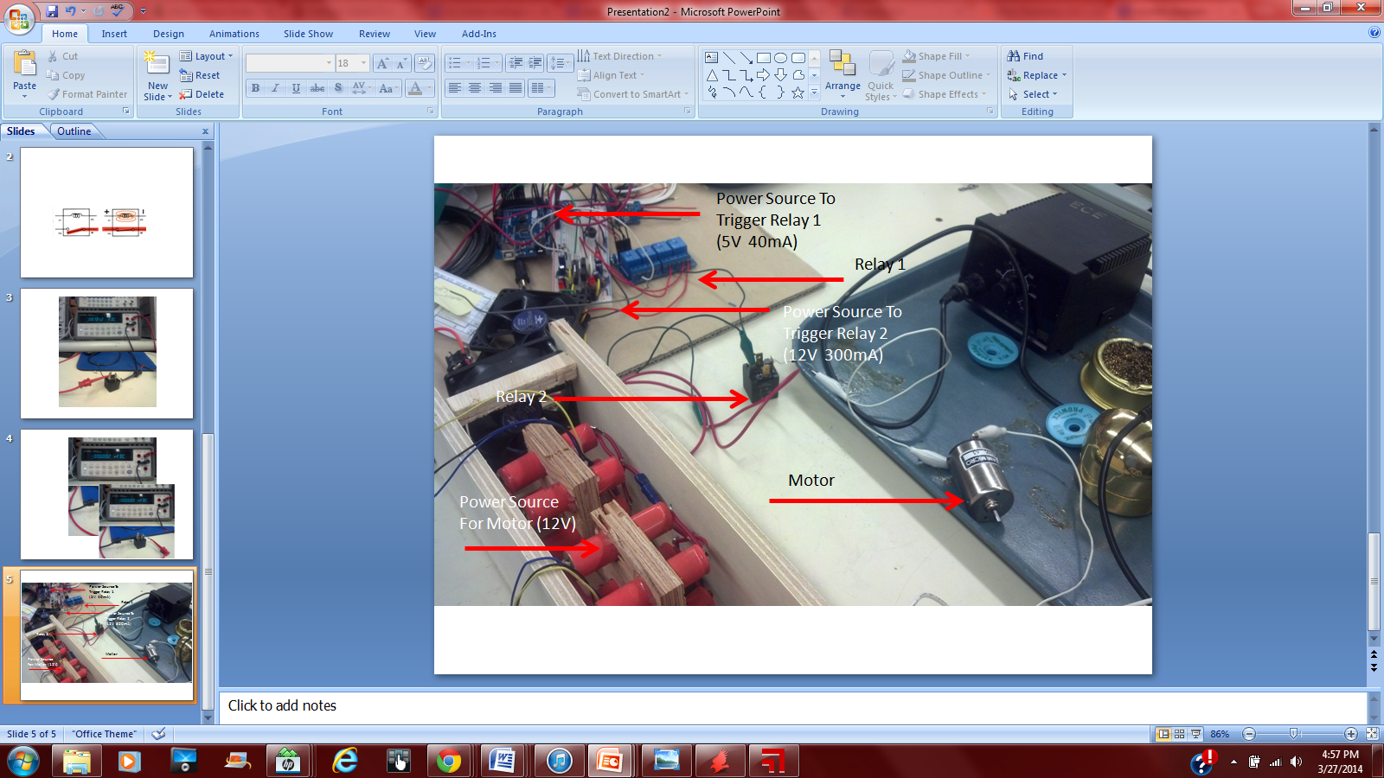
Figure 10: Relay Controlled Power Disconnect Setup
Conclusion:
This application note gave a brief overview of how to select relays based on a system's abilities and requirements. It also showed how multiple relays with different current and voltage capabilities can be paired together to make a functioning switch that controls high voltage sources, but can be triggered by a low voltage input. There are many types of relays that can control more than one output and that have different starting switch positions. For the purpose of a battery management system project, the four pin relay meets the required functions and features. Depending on system requirements, another relay may be a better fit.

References:
- http://www.digikey.com/
- http://en.wikipedia.org/wiki/Relay
- http://www.biopatent.com/
- http://www.roboteq.com/
- http://www.instructables.com/id/How-Electronic-Switches-Work-For-Noobs-Relays-and/step5/How-a-Does-a-Transistor-Work/

