MSU Solar Car Battery Management System

Michigan State University
Senior Design – ECE 480 – Team 7
Spring 2014

Project Sponsor:
MSU Solar Car

Project Facilitator:
Binseng Wang

Team Members:
Michael Burch
Matthew Gilbert-Eyres
Auez Ryskhanov
Gerald Saumier
Albert Ware

Table of Contents

1. Executive Summary…………………………………………………………………………3-5
1.1 Background
1.2 Currently Available Products
2. Technical Summary………………………………………………………………………..6-10
2.1 Function
2.2 Performance
2.3 Delivery Date
2.4 Environmental Conditions
2.5 Safety
2.6 Reliability
2.7 Maintenance
2.8 Size
2.9 Weight
2.10 Encasing
2.11 Communication Board Connections
2.12 Operating Instructions
2.12 Prototype Drawings
2.13 Initial Costs
3. FAST Diagram……………………………………………………………………………….11
4. Design……………………………………………………………………………………...12-15
4.1 Design Stages
4.2 Design Concept Rakings
4.3 Proposed Design Solutions
5. Project Management……………………………………………………………………..16-18
5.1 Non-Technical Roles
5.2 Technical Roles
5.3 Gantt Chart
6. Estimated Total Cost………………………………………………………………………..19
7. References……………………………………………………………………………………20

1. Executive Summary

The Michigan State Solar Car Team is a relatively new racing team at the university. The student run team creates an electric vehicle powered by solar cells. This vehicle then races in many competitions. The last race the Solar Car Team participated in was the American Solar Challenge in 2012. The solar car suffered multiple failures during this race.

Michigan State Solar Car Team currently has a working battery management system. The current BMS is a standard product from a company. The Solar Car Team would like to have a student created BMS that can be customized specifically for the solar car. The BMS has multiple requirements. Most importantly it needs to maintain a high level of safety. The solar car uses high current and voltages that has the potential for injury. The BMS must monitor the battery and cells and report the data to the user. The BMS design should allow for additional cells to be added at a later time.

1.1 Background:

What is the Battery Management System?

A battery management system (BMS) is an electronically controlled system that manages rechargeable battery cells. The system will have five functions. The first function is called Cell Protection. This function is one of the most important features of the BMS. The system protects the battery cells by monitoring the voltage, the current and the temperature of the battery cells. When any of these measurements fall outside the specified design limits, the BMS will take corrective actions to ensure system stability and safety. Such actions could include emergency shutdown or simply turning on a cooling system. The next function is charge control. This system keeps the battery cells charged to ensure operation. A related function is called state of charge (SOC) determination. This function measures the individual battery cell’s voltage. SOC is critical for operation of charge control and cell balancing. Cell balancing is a practice used in multi-cell battery systems. Since individual battery characteristics can vary due to production tolerances not all cells in a system are equal. This difference can decrease the battery life which decreases the life of the system. Cell balancing protects the system from this error by balancing the cells to compensate for the differences. The last feature of the BMS is communication. Communication is critical for the operation of the system. It connects all the sensors to the control programing. Communication is required for the operator to make changes to parameters of the BMS.

1.2 Currently Available Products

1.2.1 Elithion Lithiumate Pro

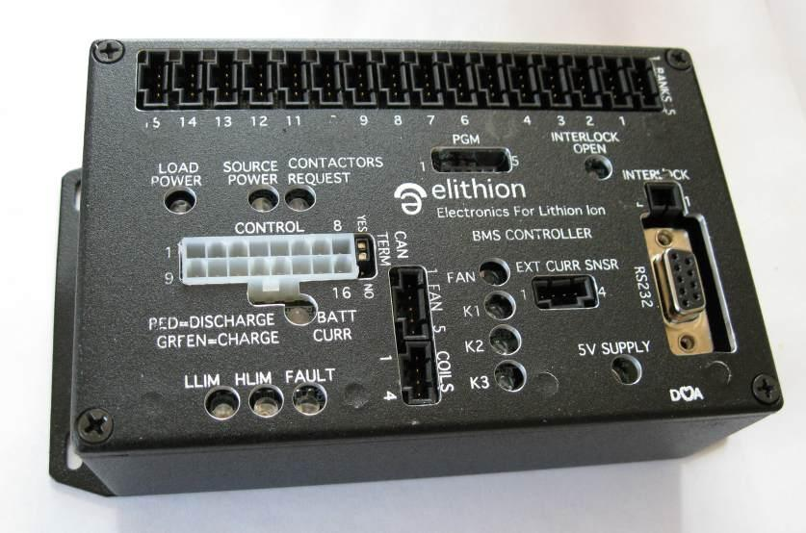
Figure 1.2.1

Elithion is a leading manufacturer of Lithium-ion battery management systems. The Lithiumate Pro is an off the shelf, plug-and-play BMS system designed for professional applications. It uses a cell board which is mounted on each battery cell. It measures the voltage and temperature and balances the cell. The system supports up to 256 cells (~900V). The Lithiumate Pro uses dissipative (passive) balancing. It supports both CAN and RS232 communication systems. It is also compatible with many chargers and motor drivers. Although this system is ideal for the Solar Car team, the price of over $1,250 makes it impossible for the team to purchase.

1.2.2 Linear Technology LTC6804 Microprocessor-Controlled BMS

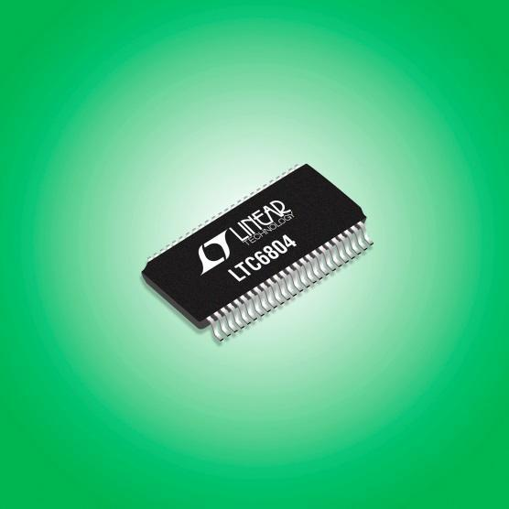
Figure 1.2.2

Linear Technology specializes in microprocessor controlled battery management systems. The LTC6804 is a 3rd generation multi-cell BMS. It supports up to 12 series connected batter cells. It boasts an impressive measurement error less than1.2mV. Multiple LTC6804s can be connected in series to increase the number of cell monitored. The LTC6804 incorporates passive balancing.

1.2.3 Battery Tender BMS

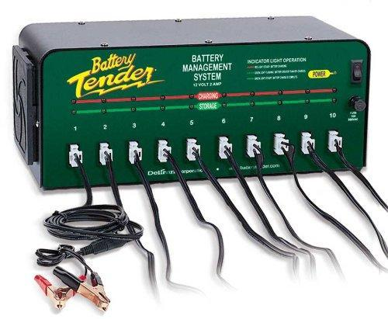
Figure 1.2.3

Battery Tender makes a simplistic battery management system. The system can operate up to ten 12V batteries. It uses a 4-step charging system to maintain voltage and keep a constant current. Since this device can only manage 10 battery cells, it does not meet the need for the Solar Car team.

2. Technical Summary
2.1 Function:
  - Interface with the battery pack to manage and report critical events that take place:
    - Over Voltage
    - Under Voltage
    - Over Current
    - Over Temperature
  - Read the previously mentioned values and report them on a GUI, including:
    - Individual battery cell voltage
    - Battery pack current and temperature
    - Warn user if system needs to be cut off
  - Cut off battery system from the car to prevent damage to the battery pack.
2.2 Performance:
  - System must be able to report dangerous voltage, current, and temperature values to warn the driver to turn off the system.
2.3 Delivery Date:
  - April 25th is the deadline for a functioning management system.
2.4 Environmental Conditions:
  - Must be able to withstand racing conditions:
    - Water
    - High Heat
    - Vibration due to driving car
2.5 Safety:
  - Must be enclosed to ensure no accidental electrocution.
  - Back up switch as a failsafe in case microcontroller fails to shut down system.
  - Will shut down the system in case of any of the previously mentioned events.
  - Fuses will be in place to ensure wires are protected in the event over current.
2.6 Reliability:
  - Must be able to withstand the environmental conditions of racing.
  - Must be able to last 4-5 years due to minimal maintenance required.
2.7 Maintenance:
  - Must provide instructions for maintaining the system so that future solar car members can fix any issues that happen to arise.
  - Must be easy enough to understand that it requires minimal effort to keep up and running.
2.8 Size:
  - Width x Height x Length: 12”x10”x6”
2.9 Weight:
  - Must be minimal weight to ensure the system does not add to the already heavy car.
  - Will aim for around 10 pounds.
2.10 Encasing:
  - Build a dashboard and case for the system

2.11 Communication Board Connections:
  - The communication board being used for this system is the Arduino Mega 2560 R3. It provides enough I/O to successfully interface with all of the sensors, switches, as well as the LCD Screen.

Arduino Mega 2560 R3
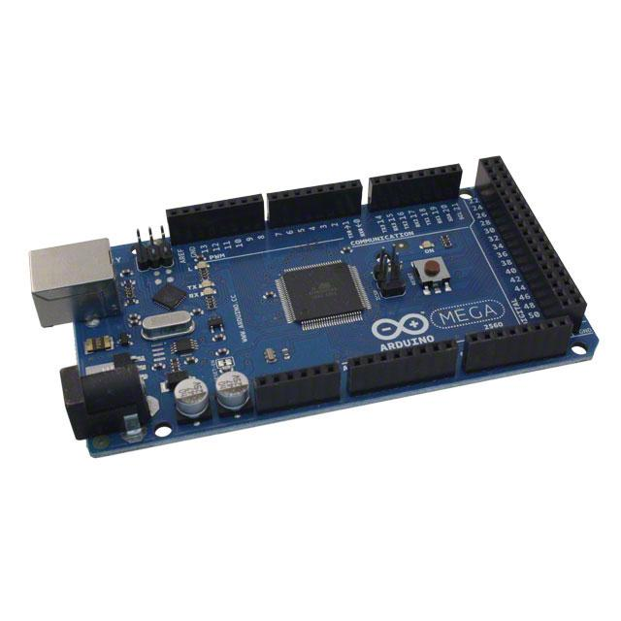
Figure 2.11.1

TFT LCD
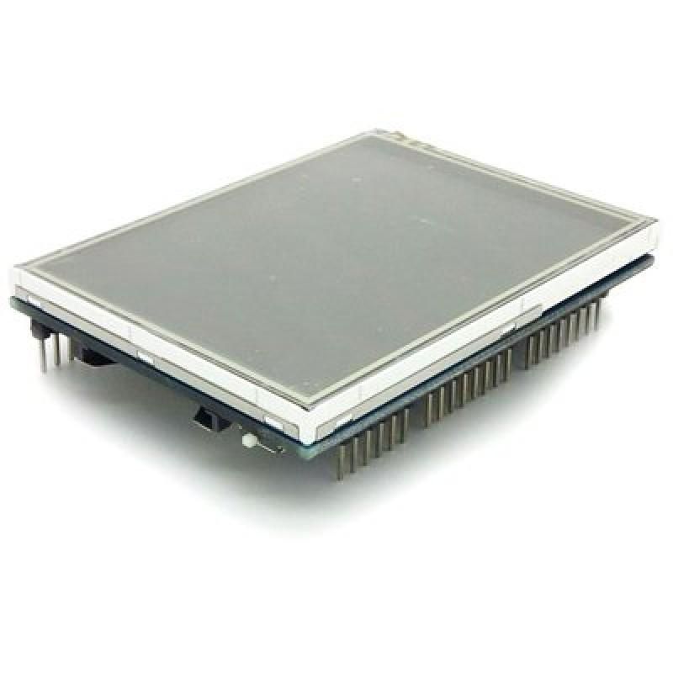
Figure 2.11.2

2.12 Operating Instructions:
  - Will include an easy-to-follow manual for upkeep and maintenance on the system.
2.13 Prototype Drawings:
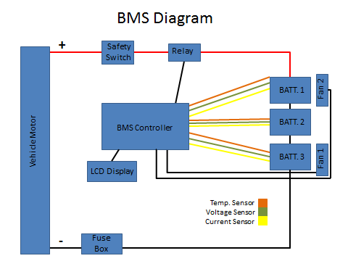
Figure 2.14.1

Figure 2.14.1 is a high level diagram that is going to be implemented for the battery management system (BMS). The load used is to test our system is the prior solar car team’s motor controller. The system will have two protection features that are external to the BMS controller. First being a safety switch which will disconnect the power from the motor. The second feature will be a fuse, which will protect the system in an over current state. Other features our system will have include a touch screen LCD that will allow you to monitor the system voltage, temperature, and current. Also, it will have fans on the battery pack to cool them down when the system notices elevated temperatures. When the system needs to be shut off by the BMS, it will be done by sending a signal to a relay. This will result in the mechanical switch inside the relay being released shutting off the power.

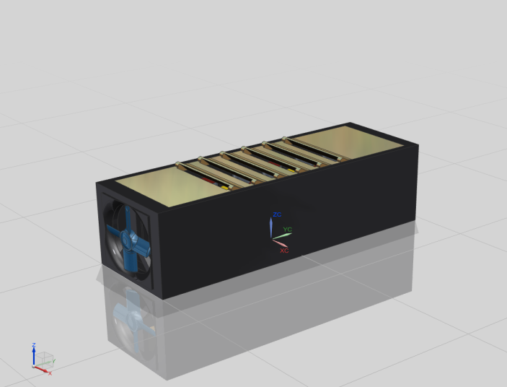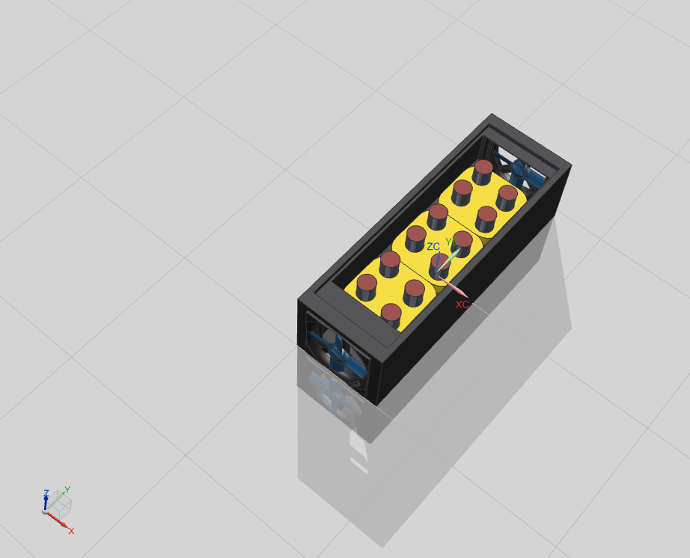
Figure 2.14.2

Figure 2.14.2 shows the design and layout of the battery box. The cooling fans are placed in the front in and the rear of the box to draw cool air in and draw the hot air out.

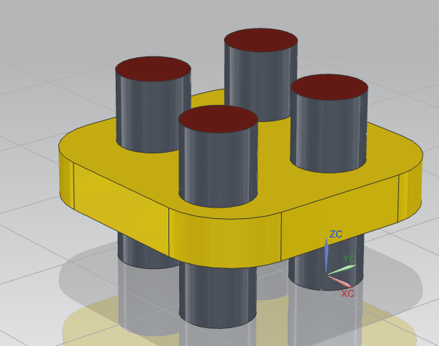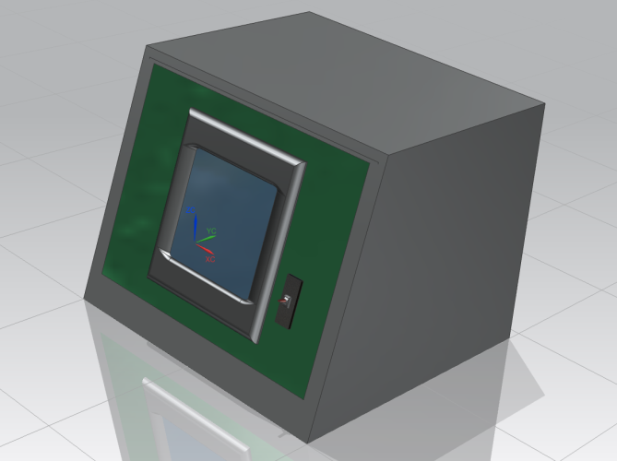
Figure 2.14.3 Figure 2.14.4

Figure 2.14.3 shows the battery holder. Each battery holder will consist of four batteries which will make up one cell.

Figure 2.14.4 is the dashboard that will act as the housing for the BMS controller, LCD touch screen and the emergency safety switch.

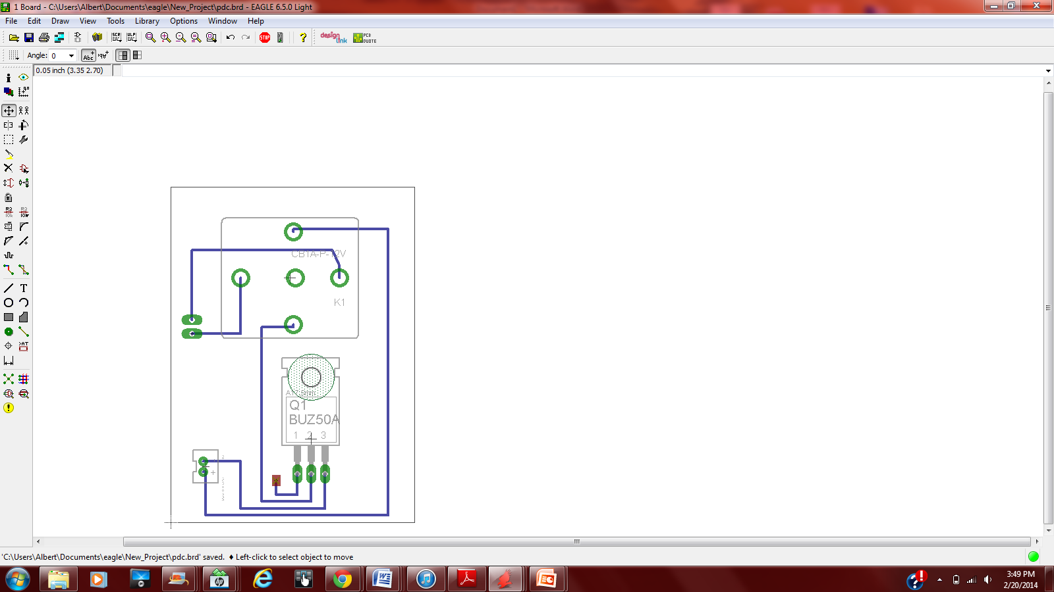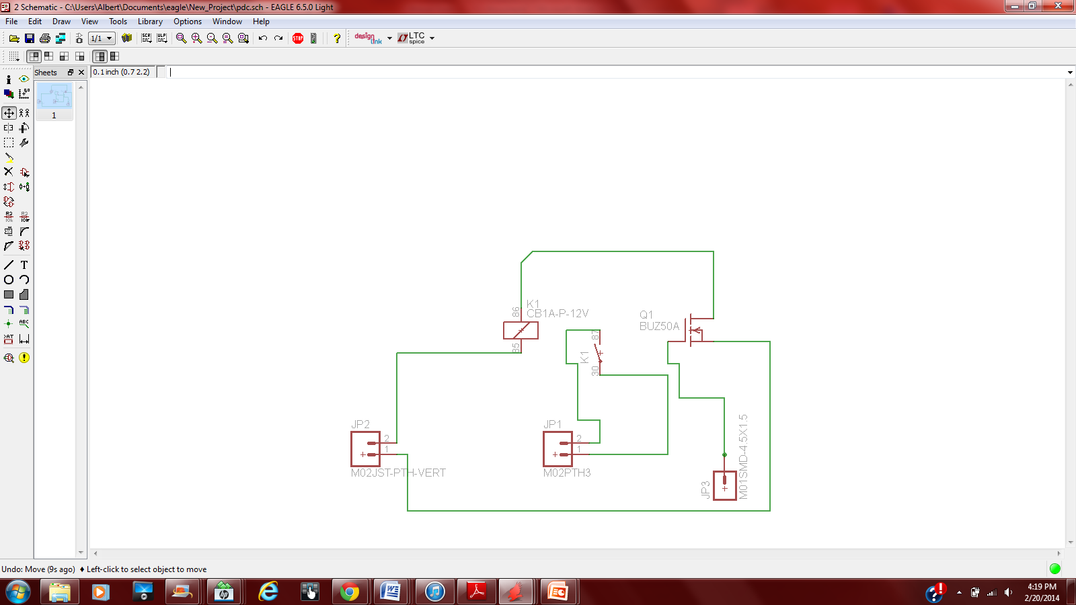
Figure 2.14.5

Figure 2.14.5 is the circuit schematic that will control our relay based on the output of the BMS.

3. Fast Diagram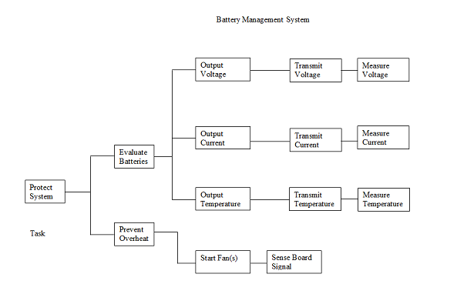

The above fast diagram describes how and why we are going to make our battery management system. On the left is our main goal, which is to protect the system. As the diagram goes to the right, it describes how we are going to accomplish these tasks. In order to protect the system, we need to evaluate the batteries and prevent a system overheat. These values are first read by each of the sensors that we have for different critical points in the system. These sensors are voltage, current, and temperature sensors. These values are then sent to the microcontroller, which are then transmitted to the LCD screen which will then output all of the values, which is how our system will evaluate the batteries. In order to prevent overheating, we must first sense a signal from the board that the temperature is too high, in which case we will start the system’s fans.

4. Design

4.1 Design States
.
The main goal of our project is to build and test a BMS which would be able to measure and display on the monitor the voltage, current, and the temperature of the cells during the operation of the electric (solar) car.

4.1.1 Small Scale Design
To ensure the programing and communication network is fully functional, this design stage will implement only three battery cells and three temperature sensors. The most basic functions of the programing will be tested regarding temperature sense and emergency shutdown protocols.

4.1.2 Medium Scale Design
To ensure safety and project requirements, voltage and current sensors are introduced into the design. These sensors will be fully integrated into the software providing the operator access to up-to-date measurements of the system.

4.1.3 Full Scale Design
To verify the project meets requirements and expectations, extensive testing will be completed regarding voltage, current, and temperature measurements. Control and safety protocols will be fully functional. Operator interface will be easy to use and control.

4.1.4 Full Scale Extra Features Design
To improve the functionality of the product, this design stage introduces additional features to the product. Such features include active cooling system controlled by the temperature of the battery cells, alarm system to notify the operator of issues, and a custom dashboard to house the touch screen display.

4.1.5 Implementation of Battery Balancing (Passive)
To improve the efficiency and life of the battery management system, passive battery balancing is introduced into the design.

4.1.6 Implementation of Battery Balancing (Active)
To vastly improve the performance of the system, active battery balancing is introduced into the design.

4.2 Design Concept Rankings

Figure… shows a design matrix to better understand the complexity and feasibility of each stage. The design matrix rates the six design stages previously discussed. The categories ranked are cost, complexity, and implementation time. A ranking system of 1-5 in which 5 is the beast for each category was implemented
.

Design # | Description | Cost  (5-great 1-poor) | Complexity  (5-simple 1-difficult) | Time  (5-best 1-worst) | Average Feasibility Rank
1 | Small Scale | 5 | 5 | 5 | 5
2 | Medium Scale | 5 | 5 | 4 | 4.67
3 | Full Scale | 4 | 4 | 4 | 4
4 | Full Scale Extra Features | 3 | 4 | 4 | 3.67
5 | Implementation of Battery Balancing (passive) | 3 | 2 | 3 | 2.33
6 | Implementation of Battery Balancing (Active) | 3 | 1 | 2 | 2
Table 4.2.1

4.3 Proposed Design Solutions:

In our design we are going to use three cells with four batteries within. Each battery pack will contain three sensors: voltage sensor, current sensor, and temperature sensor. All these sensors will collect the data and send it to the communication board. The board will collect all this data and display it on the screen, so the driver will be able to see the voltage, current, and the temperature of the batteries while driving the car.
Moreover, our BMS is going to have some features that would keep the driver safe. The BMS will include the system self-shutdown. If the readings of the current sensor and the temperature sensor are outside of the Safe Operating Area, the communication board will shut down the whole system in order to protect the driver. Additionally, the BMS will include a manual kill switch which would shut down the whole system in case of emergency. So if the driver thinks that something is wrong with the power supply they can just turn it off.
The design that we chose is not ideal. There are always some ways to improve things. We could improve our design by adding some other features such as: voltage balancing system, cooling system, and alarm system.

4.3.1 Improved Data Acquisition and User Interface:
The board and screen will allow for user interface through the touch screen. It will input from the driver as to what data to display on the screen, as well as allowing for a cutoff button to shut down the system. The data that is received from the sensors will be stored and displayed on the screen, and the proper action will be taken to avoid damage to the system.

4.3.2 Improved Safety
The system design will include fusing, a cutoff switch, appropriately gauged wiring, and a system shutoff to protect the system from harm. The fuses will make sure that if there is too much current going through the system that the battery packs will be cut off from the motor to make sure there is no damage to it. There is also going to be a cutoff switch that the driver can use to turn off power to the motor. The wiring that we chose to use with the system is the right size for the distance and current that will be passing through it. This will ensure that the wiring of the system will not fail due to the heavy current load. The LCD screen will also be programmed to flash red when there is a major problem with the system, and will allow the driver to press a button on the screen to turn off the power to the motor to make sure nothing is damaged.

4.3.3 Proper Documentation
The system that we build will also include proper documentation to make sure that repairs can be made to the system in a proper fashion, as well as allow for the proper maintenance to be administered to it to make sure that it is less likely to fail when it is being used during the race.

4.3.4 Improve Cooling System
The system contains a custom designed cooling tunnel using two fans providing active cooling. These fans are powered by an emergency battery cell that is not connected to the system. When the temperature is too high in the battery packs, the communication board will send a signal to a relay which then activates the fan system.
4.3.5 Upgradeability
The board that we have chosen has enough analog inputs for the design that we have chosen, however the board has enough analog inputs to allow for expansion to the system, should the need arise for more sensors. This will ensure that if the system ever has the need to grow, that it can be upgraded without too much work or addition to the code of the system.

4.3.6 Battery Balancing
The voltage balancing system will allow for improved performance of the battery management system along with increase life of the individual battery cells. Passive balancing will be implemented as the first step towards this goal. If time and budget allows, the team hopes to implement active balancing which will vastly improve the efficiency of the balancing system. Figure 3.2 shows the basic circuitry of active balancing.

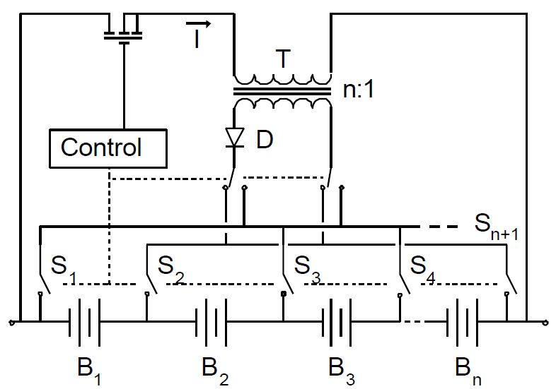
Figure 4.3.1

5. Project Management

5.1 Non-Technical Roles
Name | Non-Technical Role
Michael Burch | Document Preparer
Matthew Gilbert-Eyres | Project Manager
Auez Ryskhanov | Lab Coordinator
Gerald Saumier | Web Design
Albert Ware | Presentation Preparer
Table 5.1.1

5.2 Technical Roles
Name | Technical Role
Michael Burch | Circuit Design / HVAC
Matthew Gilbert-Eyres | Voltage Balancing / System Requirements
Auez Ryskhanov | Sensor Design / Part Acquisitions
Gerald Saumier | Programming / System Control
Albert Ware | Design Layout / Fusing / Wiring
Table 5.2.1

5.3 GANTT Chart
The Gantt chart will give our team a way to keep organized and plan what needs to be done in advance. We can see which task will cause us not to reach our deadline by looking at our critical path. If these tasks are not met, it will push our delivery date past our deadline. This Gantt chart visually shows where the team is along the timeline. Team members can see which task can be delayed and which ones cannot. By giving each task a deadline allows the team to keep organize and us our time wisely. The Gantt chart will start from the day we started research to the day we present it on design day.
Task Name | Duration | Start | Finish
Research | 15 days | Mon 1/13/14 | Fri 1/31/14
start | 0 days | Mon 1/13/14 | Mon 1/13/14
Research Problem | 6 days | Mon 1/13/14 | Mon 1/20/14
Research Designs | 5 days | Tue 1/21/14 | Mon 1/27/14
Research Components | 7 days | Tue 1/21/14 | Wed 1/29/14
Compile Research | 2 days | Thu 1/30/14 | Fri 1/31/14
end | 0 days | Fri 1/31/14 | Fri 1/31/14
Individual Design | 7 days | Fri 1/31/14 | Mon 2/10/14
start | 0 days | Fri 1/31/14 | Fri 1/31/14
Circuit Design | 4 days | Fri 1/31/14 | Wed 2/5/14
Layout Design | 4 days | Fri 1/31/14 | Wed 2/5/14
Programming Map | 4 days | Fri 1/31/14 | Wed 2/5/14
Voltage Balancing Design | 4 days | Fri 1/31/14 | Wed 2/5/14
Prototype(s) Design | 3 days | Thu 2/6/14 | Mon 2/10/14
end | 0 days | Mon 2/10/14 | Mon 2/10/14
Order Parts | 21 days | Mon 1/13/14 | Mon 2/10/14
start | 0 days | Mon 1/13/14 | Mon 1/13/14
end | 0 days | Mon 2/10/14 | Mon 2/10/14
Prototype Construction | 7 days | Mon 2/10/14 | Tue 2/18/14
start | 0 days | Mon 2/10/14 | Mon 2/10/14
Communication Board | 4 days | Mon 2/10/14 | Thu 2/13/14
Voltage Balancing System | 4 days | Mon 2/10/14 | Thu 2/13/14
Mounting Bracket | 3 days | Mon 2/10/14 | Wed 2/12/14
Sensor Layout & Design | 2 days | Mon 2/10/14 | Tue 2/11/14
Wiring | 7 days | Mon 2/10/14 | Tue 2/18/14
Programming | 3 days | Fri 2/14/14 | Tue 2/18/14
end | 0 days | Tue 2/18/14 | Tue 2/18/14
Prototype Testing | 10 days | Tue 2/18/14 | Mon 3/3/14
start | 0 days | Tue 2/18/14 | Tue 2/18/14
Test Over-Current Safety | 5 days | Tue 2/18/14 | Mon 2/24/14
Test Over-Voltage Safety | 5 days | Tue 2/18/14 | Mon 2/24/14
Test Over-Temperature Safety | 5 days | Tue 2/18/14 | Mon 2/24/14
end | 0 days | Mon 3/3/14 | Mon 3/3/14
Improvement Iteration | 25 days | Mon 3/3/14 | Fri 4/4/14
start | 0 days | Mon 3/3/14 | Mon 3/3/14
Cooling System Design | 2 days | Mon 3/3/14 | Tue 3/4/14
Cooling System Construction | 3 days | Wed 3/5/14 | Fri 3/7/14
Cooling System Testing | 2 days | Mon 3/10/14 | Tue 3/11/14
Fix Faults in Prototype | 25 days | Mon 3/3/14 | Fri 4/4/14
end | 0 days | Fri 4/4/14 | Fri 4/4/14
Presentation Preparation | 7 days | Fri 4/4/14 | Tue 4/15/14
start | 0 days | Fri 4/4/14 | Fri 4/4/14
Power Point Presentation | 2 days | Fri 4/4/14 | Tue 4/8/14
Practice | 5 days | Wed 4/9/14 | Tue 4/15/14
end | 0 days | Tue 4/15/14 | Tue 4/15/14
Gantt Chart Due | 0 days | Mon 1/27/14 | Mon 1/27/14
1st Prototype Demonstration | 0 days | Mon 3/17/14 | Mon 3/17/14
Team Technical Lecture | 0 days | Mon 3/31/14 | Mon 3/31/14
Final Report Due | 0 days | Fri 4/11/14 | Fri 4/11/14
Design Day | 0 days | Fri 4/4/14 | Fri 4/4/14

Figure 4.3.1

6. Estimate Total Cost

From the beginning our team has been funded a budget of $500. Therefore, our team had to be very careful choosing the proper parts in order to meet the budget limits. Our final design was under the given budget, and cost us $237.68. The most expensive parts that we had to order were the Arduino Mega 2560 R3 board and the touchscreen 3.2" LCD monitor. Unfortunately, because of the shipping delay of the voltage and temperature sensors, the team had to order some extra sensors in order to start prototyping the design on time. However, some of the parts we have received for free. Therefore, the real cost of our design is $221.04. The fact, that the cost of the design is way below the budget cap, provides an opportunity for the future improvements and expansions.

Component | Quantity | Cost | Tax | Total
Mediabridge 2.0 USB A Male to B Male Cable | 1 | $5.49 | $0.00 | $5.49
3.2\" TFT LCD Touch Shield for Arduino | 1 | $31.34 | $9.93 | $41.27
50A Current Sensor(AC/DC) | 1 | $14.50 | $12.00 | $26.50
TMP36 - Temperature Sensor | 3 | $1.50 | $2.68 | $7.18
Arduino Mega 2560 R3 | 1 | $51.91 | $3.84 | $55.75
Voltage Sensor Module -Arduino Compatible | 3 | $5.58 | $0.00 | $16.74
Temperature Sensor-1 -Arduino Compatible | 3 | $3.58 | $0.00 | $10.74
Phidgets Precision Voltage Sensor | 1 | $18.55 | $3.99 | $22.54
SainSmart 4-Channel Relay Module | 1 | $13.50 | $0.00 | $13.50
Transistors | 2 | $1.00 | $0.00 | $1.00
Switch | 1 | $5.00 | $0.00 | $5.00
Fuse | 1 | $0.65 | $0.00 | $0.65
Fan | 3 | $3.00 | $0.00 | $9.00
MOSFET | 1 | $0.99 | $0.00 | $0.99
Bussmann BP/HHM 30 Amp Mini Fuse Holder | 1 | $3.99 | $0.00 | $3.99
RELAY AUTOMOTIVE SPST 30A 12V | 2 | $15.08 | $0.00 | $15.08
SOCKET RELAY PC MNT FOR VF4 SER | 1 | $2.26 | $0.00 | $2.26
 |  |  | Total: | $237.68
Table 6.1

7. References

http://media.digikey.com/Photos/Arduino/A000047.jpg - Comm. Board Link
http://www.robotshop.com/en/3-2-tft-lcd-touch-shield-arduino.html - Screen Link
http://elithion.com/lithiumate_pro.php

