MSU Solar Car Battery Management System

Michigan State University
Senior Design – ECE 480 – Team 7
Spring 2014

Project Sponsor:
MSU Solar Car

Project Facilitator:
Binseng Wang

Team Members:
Michael Burch
Matthew Gilbert-Eyres
Auez Ryskhanov
Gerald Saumier
Albert Ware

Table of Contents

1. Executive Summary
1.1 Background
1.2 Currently Available Products
1.2.1 Elithion Lithiumate Pro
1.2.2 Linear Technology LTC6804 Microprocessor-Controlled BMS
1.2.3 Battery Tender BMS
2. Technical Summary
A
B
.
.
.
.
.
.
.
.
.

3. Design Stages
4. Project Management
4.1 Non-Technical Roles
4.2 Technical Roles
4.3 Gantt Chart

Executive Summary:

1.1 Background:

What is the Battery Management System?

A battery management system (BMS) is an electronically controlled system that manages rechargeable battery cells. The system may have five functions. The first function is called Cell Protection. This function is one of the most important features of the BMS. The system protects the battery cells by monitoring the voltage, the current and the temperature of the battery cells. When any of these measurements fall outside the specified design limits, the BMS will take corrective actions to ensure system stability and safety. Such actions could include emergency shutdown or simply turning on a cooling system. The next function is charge control. This system keeps the battery cells charged to ensure operation. A related function is called state of charge (SOC) determination. This function measures the individual battery cell’s voltage. SOC is critical for operation of charge control and cell balancing. Cell balancing is a practice used in multi-cell battery systems. Since individual battery characteristics can vary due to production tolerances not all cells in a system are equal. This difference can decrease the battery life which decreases the life of the system. Cell balancing protects the system from this error by balancing the cells to compensate for the differences. The last feature of the BMS is communication. Communication is critical for the operation of the system. It connects all the sensors to the control programing. Communication is required for the operator to make changes to parameters of the BMS.

  - Currently Available Products

1.2.1 Elithion Lithiumate Pro

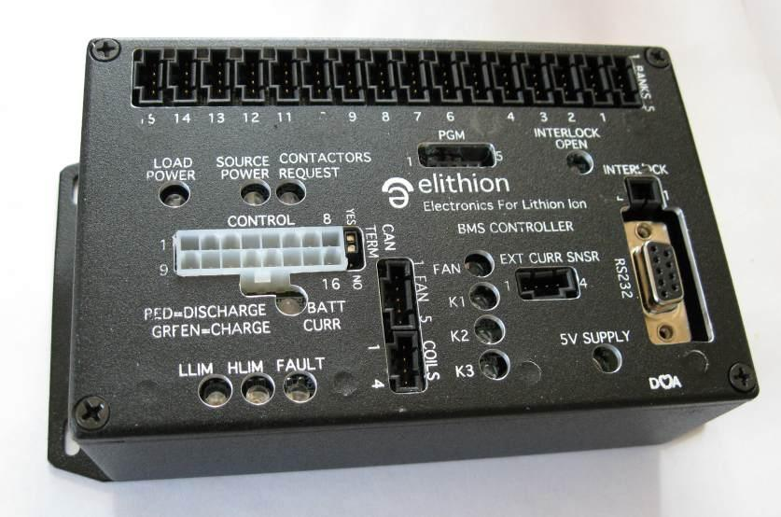
Elithion is a leading manufacturer of Lithium-ion battery management systems. The Lithiumate Pro is an off the shelf, plug-and-play BMS system designed for professional applications. It uses a cell board which is mounted on each battery cell. It measures the voltage and temperature and balances the cell. The system supports up to 256 cells (~900V). The Lithiumate Pro uses dissipative (passive) balancing. It supports both CAN and RS232 communication systems. It is also compatible with many chargers and motor drivers. Although this system is ideal for the Solar Car team, the price of over $1,250 makes it impossible for the team to purchase.

1.2.2 Linear Technology LTC6804 Microprocessor-Controlled BMS

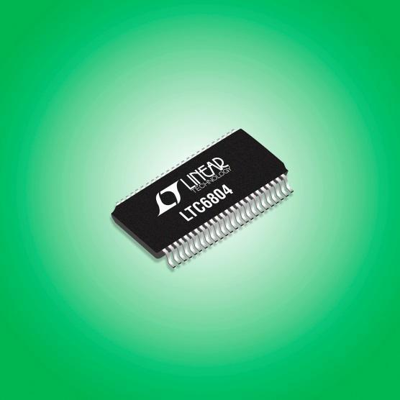

Linear Technology specializes in microprocessor controlled battery management systems. The LTC6804 is a 3rd generation multi-cell BMS. It supports up to 12 series connected batter cells. It boasts an impressive measurement error less than1.2mV. Multiple LTC6804s can be connected in series to increase the number of cell monitored. The LTC6804 incorporates passive balancing.

1.2.3 Battery Tender BMS

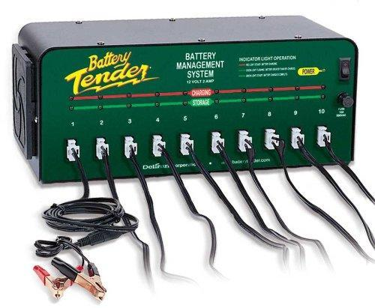

Battery Tender makes a simplistic battery management system. The system can operate up to ten 12V batteries. It uses a 4-step charging system to maintain voltage and keep a constant current. Since this device can only manage 10 battery cells, it does not meet the need for the Solar Car team.

http://elithion.com/lithiumate_pro.php
2. Technical Summary
- Function:
  - Interface with the battery pack to manage and report critical events that take place:
    - Over Voltage
    - Under Voltage
    - Over Current
    - Over Temperature
  - Read the previously mentioned values and report them on a GUI, including:
    - Individual battery cell voltage
    - Battery pack current and temperature
    - Warn user if system needs to be cut off
  - Cut off battery system from the car to prevent damage to the battery pack.
- Performance:
  - System must be able to report dangerous voltage, current, and temperature values to warn the driver to turn off the system.
- Delivery Date:
  - April 25th is the deadline for a functioning management system.
- Environmental Conditions:
  - Must be able to withstand racing conditions:
    - Water
    - High Heat
    - Vibration due to driving car
- Safety:
  - Must be enclosed to ensure no accidental electrocution.
  - Back up switch as a fail safe in case microcontroller fails to shut down system.
  - Will shut down the system in case of any of the previously mentioned events.
  - Fuses will be in place to ensure wires are protected in the event over current.
- Reliability:
  - Must be able to withstand the environmental conditions of racing.
  - Must be able to last 4-5 years due to minimal maintenance required.
- Maintenance:
  - Must provide instructions for maintaining the system so that future solar car members can fix any issues that happen to arise.
  - Must be easy enough to understand that it requires minimal effort to keep up and running.
- Size:
  - Width x Height x Length: 12”x10”x6”
- Weight:
  - Must be minimal weight to ensure the system does not add to the already heavy car.
  - Will aim for around 10 pounds.
- Encasing:
  - 3D print a dashboard and case for the system
- Communication Board Connections:
  - The communication board being used for this system is the Arduino Due. It provides enough I/O to successfully interface with all of the sensors, switches, as well as the LCD Screen.

Arduino Due
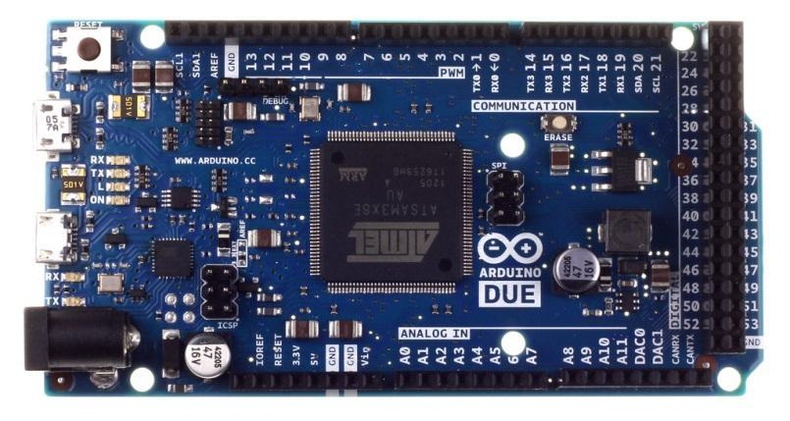
Figure 1.k.1

TFT LCD and Shield
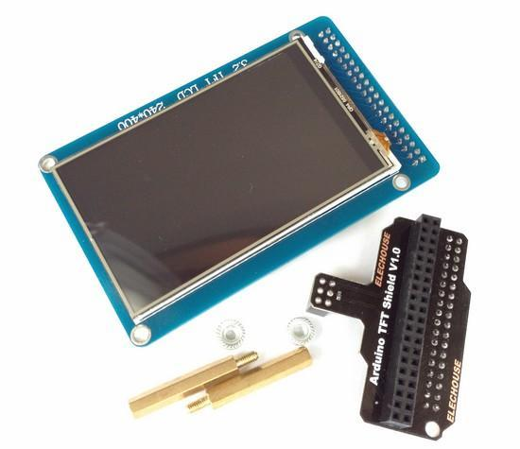
Figure 1.k.2

- Operating Instructions:
  - Will include an easy-to-follow manual for upkeep and maintenance on the system.
- Initial Cost:
  - Communication Board: approx. $50
  - Display LCD: approx. $40
- Prototype Drawings:
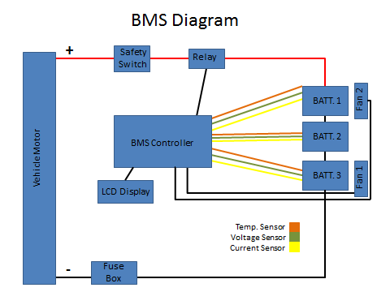
Figure 1.n.1

References I Used:
http://www.elechouse.com/elechouse/index.php?main_page=popup_image&pID=2217 - Screen Link
http://arduino.cc/en/uploads/Main/ArduinoLeonardoFront_2.jpg - Comm. Board Link

3. Design States

A battery management system (BMS) is any electronic system that manages a rechargeable battery cell or battery pack. It protects the battery from operating outside of its Safe Operating Area, reports the data, such as voltage, current, temperature of the batteries at specific time. The BMS is contained of the master and several slaves.
Slaves – each slave has a temperature sensor as well as connections to measure the voltage, all of which are connected to the slave which monitors the conditions of the cell and implements the cell balancing.
The Master – Multiple slaves can be connected to the master which monitors the current and integrates it over time to calculate the net charge flow (coulombs) and this is modified using voltage and temperature data from the slaves to calculate the battery state of charge. The master controls the main battery isolations contactors initiating battery protection in response to data from the main current sensor or voltage and temperature data from the slave.
The main goal of our project is to build and test a BMS which would be able to measure and display on the monitor the voltage, current, and the temperature of the cells during the operation of the electric (solar) car.
In our design we are going to use three cells with four batteries within. As a result we are going to use three slaves and one master. Each slave will contain itself three sensors: voltage sensor, current sensor, and temperature sensor. All these sensors will collect the data and send it to the Master. The master will collect all these data and display it on the screen, so the driver will be able to see the voltage, current, and the temperature of the batteries while driving the car.
Moreover, our BMS is going to have some features that would allow keeping the driver safe. The BMS will include the system self-shutdown. If the readings of the current sensor and the temperature sensor will be outside of the Safe Operating Area, the Master will shut down the whole system in order to protect the driver. Additionally, the BMS will include a manual kill switch which would shut down the whole system in case of emergency. So if the driver assumes that something is wrong with a power supply he can just turn it off.
The design that we chose is not ideal. There are always some ways to improve things. We could improve our design by adding some other features such as: voltage balancing system, cooling system, and alarm system.
The voltage balancing system could allow protecting the single cell from experiencing an overvoltage. There are several ways of balancing the voltage of the battery. Our team will try to use either Flying Capacitor method or Inductive Cell Balancing (Energy Converter) method.
Flying Capacitor method contains a controller that closes proper switches in order to charge a capacitor. Then controller opens the switches and moves the charge to a cell that requires more charge. This method uses charges from the other cells that contain highest amount of charge and transferring it to the cells with the lowest charge. As a result, all cells kept balanced.
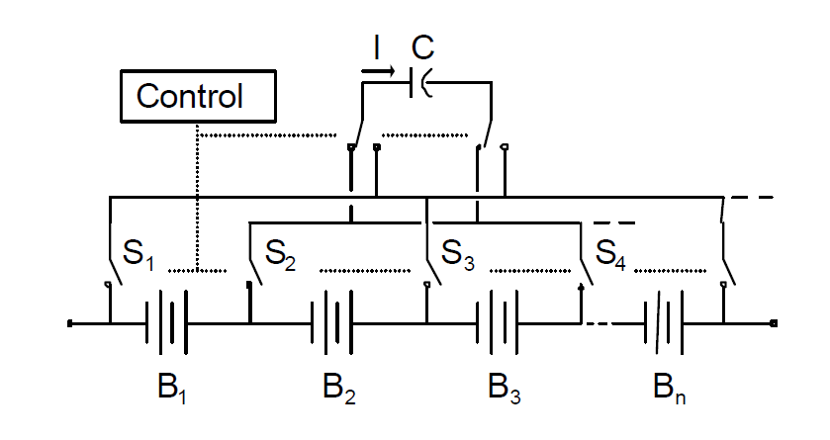
Flying Capacitor Method

Inductive Cell Balancing Method contains cell balancing utilizing energy conversion devices that employ transformers or inductors to move charge from a cell or group of cells the one with the lowest charge. The controller will select the target cell and set the switches.
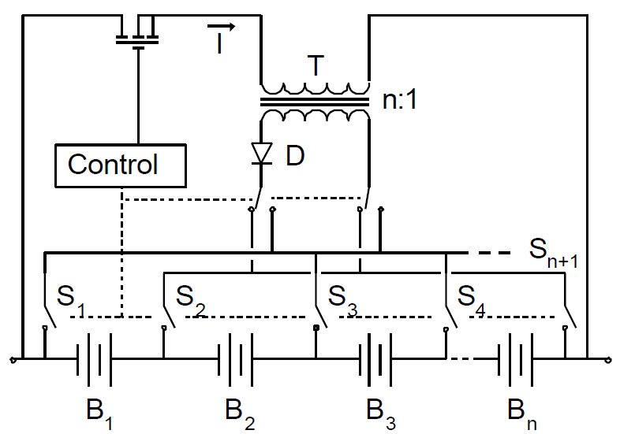
Inductive Cell Balancing Method

Like humans, batteries function best at room temperature and any deviation towards hot and cold changes the performance and longevity. Cooling system could allow keeping all our batteries at desired temperature. In case if any temperature sensors indicates a high temperature, the cooling system will be turned on. The cooling system will be represented as a fan that blows the air toward the cells. In fact, the cooling system will not target specific cell, it will cool all the cells at the same time.
Alarm system could help the driver to make sure that the values of the temperature and current sensors are within the Safe Operating Area. If the temperature or the current will start approaching the critical values, the alarm system will turn on and notify the driver. As a result, the driver will be able to take some actions in order to prevent the failure of the battery system.

4. Project Management

Name | Non-Technical Role
Michael Burch | Document Preparer
Matthew Gilbert-Eyres | Project Manager
Auez Ryskhanov | Lab Coordinator
Gerald Saumier | Web Design
Albert Ware | Presentation Preparer

Table 4.1

Name | Technical Role
Michael Burch | Circuit Design / HVAC
Matthew Gilbert-Eyres | Voltage Balancing / System Requirements
Auez Ryskhanov | Sensor Design / Part Acquisitions
Gerald Saumier | Programming / System Control
Albert Ware | Design Layout / Fusing / Wiring

Table 4.2
4.3 GANTT Chart

