ECE 480 Senior Capstone Design Project
Team 5 – Braille Reading Device
Sponsors: Dr. Satish Udpa, MSU RCPD

Team five will be constructing a tactile display for displaying 3D images. This device will be able to display pictures by raising a series of pins arranged in a grid to different heights, based on grayscale color intensity of the image after it has been processed. The display will be refreshable, allowing multiple graphic figures to be displayed consecutively. It will be implemented using a series of pins arranged in a grid. After a picture has been chosen and processed, a series of actuators beneath the display will push each pin up to the correct height. After each pin is positioned correctly, the device will then lock, allowing users to feel the displayed image without altering pin heights.

Steven Chao
Kodai Ishikawa
Daniel Olbrys
Terry Pharaon
Michael Wang

Table of Contents

1 Executive Summary

3 Introduction

4-5 Design Specification

6 FAST Diagram

7 Conceptual Design Descriptions

8 Ranking of Conceptual Designs

9-10 Proposed Design Solution

11-15 Project Management Plan

16 Budget

17 References

Introduction
In an age of forever increasing digitization, issues arise with equalizing opportunities for the blind. As Universities push for the adoption of new technologies such as braille printers, blind students may be left behind other students. This presents a lack of resources for blind students, especially when it comes to situations which require 3D images (e.g. 3D curves in calculus, maps, etc.). Currently, there are no existing devices that utilize a refreshable display in order to display 3D images.
Team 5 will construct a device that will be able to receive image files, analyze and process the image in terms of color intensity, and then output these results via a 3D pin matrix display, with color intensity determining the height of each pin.
The device will feature a 64x64 pin matrix display that will be adjustable from zero to one inch. This resolution was picked so that users will be able to utilize their entire hands to feel the image, creating a more immersive experience. The pins will be held captive by independent grooved panels, and will be set by a servo which moves along rails for XY axes motion. The servo will have a mechanism to convert rotational motion to Z axis motion, which will set pins to the desired height. Pins will then be “locked” into place by increasing pressure on the pins. This will all be controlled by an Arduino microcontroller.
The refreshable nature of this device means that the device has numerous practical applications, with functionality that is currently unavailable in the marketplace. It will also be far less costly than the use of non-refreshable technology.

Design Specification
Several design specifications have been decided upon based on research sessions conducted with potential users of the 3D Braille display. These design specifications will serve as guidelines to determine what to incorporate or omit in the device, and also to outline the conditions that this device should be used under. The device will be designed for easy, comfortable, and practical use. Based on the needs of the customer and the design being implemented, each design specification will vary in importance.
There are 26 aspects of the design specification, listed in Table 1. Each aspect is ranked in order of importance from critical to trivial. Each design specification is explained with specific parameters and reasons why it is weighted in such a way by the team.

Table 1. Design Specification in Descending Importance
Design Specification | Weight (1-5)  1=Negligible  5=Important
Delivery Date | 5
Reliability | 5
Function/Performance | 5
Health Issues | 5
Maintenance | 5
Operating costs | 5
Operating Instructions | 5
Quality | 5
Service Life | 4
Safety | 4
Cost | 3
Aesthetics | 2
Mechanical Loading | 2
Size | 2
Weight | 2
Environmental Issues | 1
Energy Consumption | 1
Noise Radiation | 1
Quantity | 1
Transportation/Packaging | 1

Aesthetics - Aesthetics are not very important for this project; however, the design should be as streamlined as possible in order to promote intuitive and easy use.

Cost – The device should be priced as cheaply as possible, such that anybody who would benefit from using the device can afford it.

Delivery Date – Design Day is April 25th, 2014. The device should be complete and working by the first week of April, in order to account for potential unforeseen problems that may arise closer to the due date.

Energy Consumption – Power will be supplied by standard wall outlets; therefore, the device will not be constrained by the limitations of battery power.

Environmental Conditions - The device will be used in similar conditions as regular desk mounted devices such as desktop computers, printers, large braille displays, or other similar electronic devices. It should not to be exposed to water, excessive heat/cold (+70/-40 degrees), rapid temperature fluctuations, or other abnormal conditions that may affect its electronic components, enclosure, and external features.

Function/Performance – This device will receive image files, analyze and process the image in terms of color intensity, and then output these results via a 3-dimensional pin matrix display, with color intensity determining the height of each pin.

Health Issues - There are no known health issues associated with this device.

Maintenance - Minimal maintenance will be required for this device. Back-up battery replacement may be necessary after a few years of operation.

Mechanical Loading - The pins of the display should be able to withstand the weight applied by the users’ fingertips (approximately 5 pounds) in order to ensure accurate reading.

Noise Radiation - Noise radiation would be minimal, if not zero.

Operating Costs - The only operating costs involved will be the electricity used to recharge the device, as well as replacement of the back-up rechargeable battery.
Operating Instructions - Instructions are needed to know what type of files is supported by the 3D braille display. Basic operation directions of the device will also be provided.
Quality - Materials of construction need to be of high enough quality to resist normal wear and tear. The housing and other components of the device should last at least 10 years.
Quantity - A single device will be created as a prototype. The goal is to eventually come up with a design that can be mass-produced and distributed at competitive cost.
Reliability - This device must work the first time, every time. In this regard, there needs to be an indicator that the braille display outputs accurate information so users will know that they are reading the proper information. Improperly transmitted information can be very harmful to education, perception and even the surrounding environment.
Safety - The device has minimal safety concerns. The pins will be designed in such way that they will not cause pain for the end user.
Service Life - The braille display will have minimal service required. However, it should be checked every three years to see if output information is accurate and compatibility is still up to date.
Size - The device will be a desk mounted sized device, similar to a desk printer.
Transportation/Packing – Due to its relatively small size, the device should be easy to pack and transport. For future commercial versions, the retail package needs only be slightly larger than the device itself.
Weight - The weight of the device should be less than 10 pounds.
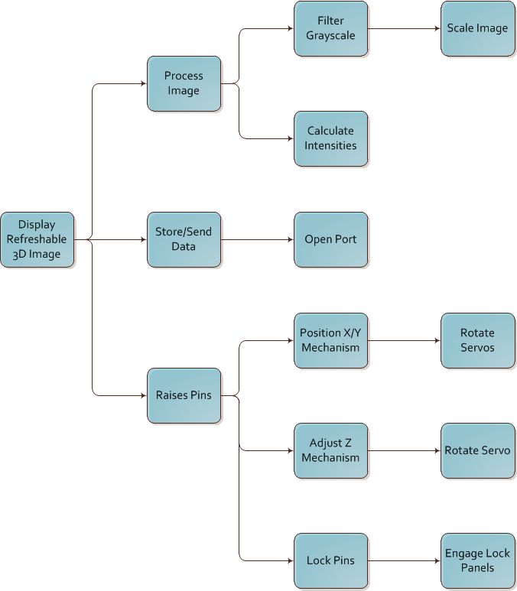Figure 1. FAST Diagram

Conceptual Design Descriptions

Team five will be constructing a tactile display for displaying 3D images. This device will be able to display pictures by raising a series of pins arranged in a grid to different heights, based on grayscale color intensity of the image after it has been processed. The display will be refreshable, allowing multiple graphic figures to be displayed consecutively. It will be implemented using a series of pins arranged in a grid. After a picture has been chosen and processed, a series of actuators beneath the display will push each pin up to the correct height. After each pin is positioned correctly, the device will then lock, allowing users to feel the displayed image without altering pin heights. A description of various methods to accomplish this 3D display is outlined as follows.

Smooth Rod design
The initial design idea was to use a grid composed of many smooth rods. These rods would be held stationary by the friction from a small amount of applied force on the sides of the pin assembly. A series of actuators would move in a manner similar to a printer head to push up the rods to the correct height. After properly positioning all pins, the casing would exert more pressure on the rods, locking them in place. The locking mechanism would be implemented by using a series of grooved panels interspaced between each row of pins. This would serve two purposes: it would maintain the pins in their correct positions, while also allowing each row of pins to be locked individually, by applying the locking force to that panel specifically.

Notched Rod design
Another method for implementing the display uses a similar design, but with notched rods and a slightly different locking method. The locking mechanism would be a thin flat board with holes for all of the pins, set on top of the display, which would still allow free vertical movement of the pins. The actuator assembly would then set all the pins to the correct height and when ready, the locking board would be slid perpendicularly to the pins, fitting into the notches of each pin and locking them into place. One major difference between this design and the previous is that since the locking mechanism is one solid piece, all of the pins will need to be locked simultaneously.

Pull-Down design
Another design being considered is to force the pins to their high states using a spring mechanism. The pins will be set to their correct height by attaching a wire to each pin. Some mechanism (such as a motor and pulley assembly) pulls the pins down to the desired position. While this solves many design issues and would provide a very rapid refresh rate, it also creates new problems, such as the difficulty involved in coordinating individual control of each pin using limited motors with limited space.

Ranking of Designs

Table 2. Decision Matrix Feasibility Criterion
Feasibility Criteria | Smooth Rod | Notched Rod | Pull-up
Locking Mechanism Implementation | Moderately Complex | Least Complicated | Rather Complex
Locking Mechanism Effectiveness | Effective and Modular | Not very effective | Extremely Effective
Pin Setting Implementation | Straightforward | Somewhat Complex | Extremely Complex
Pin Setting Effectiveness | Effective | Effective | Quite Effective
Refresh Rate (speed) | 3 min | 5 min | 2 min
Display Size | 64x64 | 64x64 | 32x32
Cost | $200 | $250 | $450
Robustness | Very Robust | Moderately Robust | Not very Robust

Table 3. Decision Matrix Feasibility Criterion Weighted and Ranked
Feasibility Criteria | Weights | Smooth Rod | Notched Rod | Pull-up
Locking Mechanism Implementation | 2 | 4 | 5 | 2
Locking Mechanism Effectiveness | 4 | 5 | 2 | 5
Pin Setting Implementation | 2 | 4 | 4 | 1
Pin Setting Effectiveness | 4 | 3 | 3 | 5
Refresh Rate (speed) | 3 | 3 | 1 | 5
Display Size | 3 | 5 | 4 | 2
Cost | 1 | 3 | 4 | 1
Robustness | 2 | 4 | 3 | 1
Totals |  | 83 | 63 | 70

The most important criteria for deciding the best method is the effectiveness of the locking method and the pin setting, with the least important being cost. The hardest of these designs to implement is the pull-down method, because of the how difficult it will be control each pin individually, and due to the complexity of the overall system (each pin will need a spring, wire, individual control method, etc.). The other two designs are more similar, and they both have their own pros and cons. The notched rod design’s locking mechanism will be easier to build and control, but at the expense of forcing all of the pins to be locked into position simultaneously. Overall, the best design will be to use the smooth rods with locking panels, which will allow more control over the pin locking process, enabling a larger display, a faster refresh rate, and a more robust system.

Proposed Design Solution
Feedback from the Resource Center for Persons with Disabilities (RCPD) has determined that it is highly desirable to create a refreshable display to display raised “images” to assist with creating maps, graphs, and other pictures that would be difficult for the blind to conceptualize.
Team 5 will construct a device that will be able to receive image files, analyze and process the image in terms of color intensity, and then output these results via a 3D pin matrix display, with color intensity determining the height of each pin.
The device will feature a 64x64 pin matrix display that will be adjustable from zero to one inch. This resolution was picked so that users will be able to utilize their entire hands to feel the image, creating a more immersive experience. The pins will be held captive by independent grooved panels, and will be set by a servo which moves along rails for XY axes motion. The servo will have a mechanism to convert rotational motion to Z axis motion, which will set pins to the desired height. Pins will then be “locked” into place by increasing pressure on the pins. This will all be controlled by an Arduino microcontroller.
The pin setting mechanism will consist of two main components: a small bed in which the mechanism moves along the rails and a servo which controls an arm that converts the rotational movement into a linear motion which raises the pin. After the pins have been raised to their desired heights, a servo will apply pressure to hold the pins in place and lock them from being moved until turned off.
In order to keep within budget constraints, Team 5 has decided to construct a custom apparatus to move our pin setting mechanism along the X-Y plane. The microcontroller will iteratively send commands to the servos to set the pins to the desired height and move the pin setter to the location desired. Team 5 aims to construct at least four pin setters in order to parallelize operations and increase refresh speed.

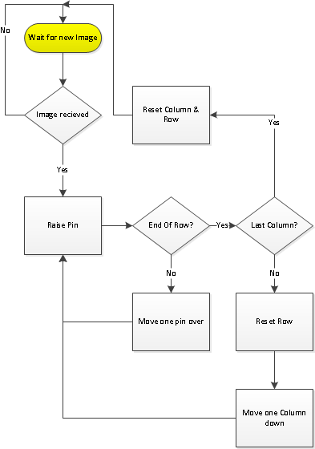
Figure 2. Servo Control Block Diagram

Team 5 has decided to use smooth pins instead of notched pins. The main motive behind this decision was to reduce manufacturing costs as much as possible in order to keep this project within budget specifications since creating notches on each pin would be extremely costly and time consuming. Smooth pins will also allow for better future scaling as there is no predetermined resolution of pin heights as with notched pins. Team 5 is considering modifying finishing nails to create the pins by using epoxy or a hard plastic in order to create the tips of the pins.
For computational resources, Team 5 will use an Arduino Uno in order to control all of the servos and process images. Images will first be loaded onto a computer that will massage the data into a usable format for our device. Then over USB, the image will be loaded onto the display and begin to start setting the pins. For software we will being using C++ and OpenCV. OpenCV will be used as a set of libraries in order to process the image and convert it to a desired format.
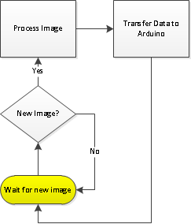
Figure 3. Computer image Processing Block Diagram
The system will built as a series of prototypes. Team 5 will make smaller mock ups, starting with a four by four pin initial test, followed by an eight by eight, and then the final 64 by 64 pin prototype. Team 5 will test accuracy of servos, repeatedly tested to see the difference in runs over time to see if the results are consistent. Tests will include sending pulses to the servo that will correlate to a specific number of turns. Distance traveled will be recorded with load and without load, to get a sense of the stopping force inside the device. Tests will be performed to see if the initial tension on the pin holding device are sufficient and the effects of the device shaking as the other servos are performing actions. Careful measurements will be kept on the pins to see if the pins fall back down at all before locking into place.
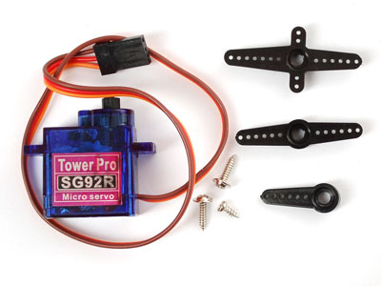
Figure 4. Tower Pro SG92R Servo Motor

Project Management

Team Roles

Steven Chao
Non-technical Role: Lab Coordinator
Technical Role:
Hardware – X-Y Table Assembly and Testing
Research, create, and test the X-Y Table mechanism, which will control the movement between the pins.

Kodai Ishikawa
Non-technical Role: Team Manager
Technical Role: Software – Image Algorithm and Integration
Create the image algorithm and integrate the software with the hardware components.

Daniel Olbrys
Non-technical Role: Web Designer
Technical Role: Hardware – X-Y Table Assembly and Testing
Research, create, and test the X-Y Table mechanism, which will control the movement between the pins.

Terry Pharaon
Non-technical Role: Presentation Preparation
Technical Role:
Hardware – Z-Axis (Raising Pins) Assembly and Testing
Research, create, and test the Z-Axis mechanism, which will raise each pin to a desired height.

Michael Wang
Non-technical Role: Document Preparation
Technical Role:
Hardware – Computer Aided Design (3D Printed Components) and Z-Axis (Raising Pins) Assembly and Testing
Create CAD files for the 3D printed components. Research, create, and test the Z-Axis mechanism, which will raise each pin to a desired height.

Facilities and Resources

Hardware:
Connex 3D Printer – ECE Shop (3D Printed Components)
Agilent E3611A Power Supply – ECE 480 Lab (Testing of Components)
Agilent 34401A Digital Multimeter – ECE 380 Lab (Testing of Components)

Software:
NX CAD – ECE Lab (3D Printed Components)
C++/OpenCV – Team Laptop (Programming)
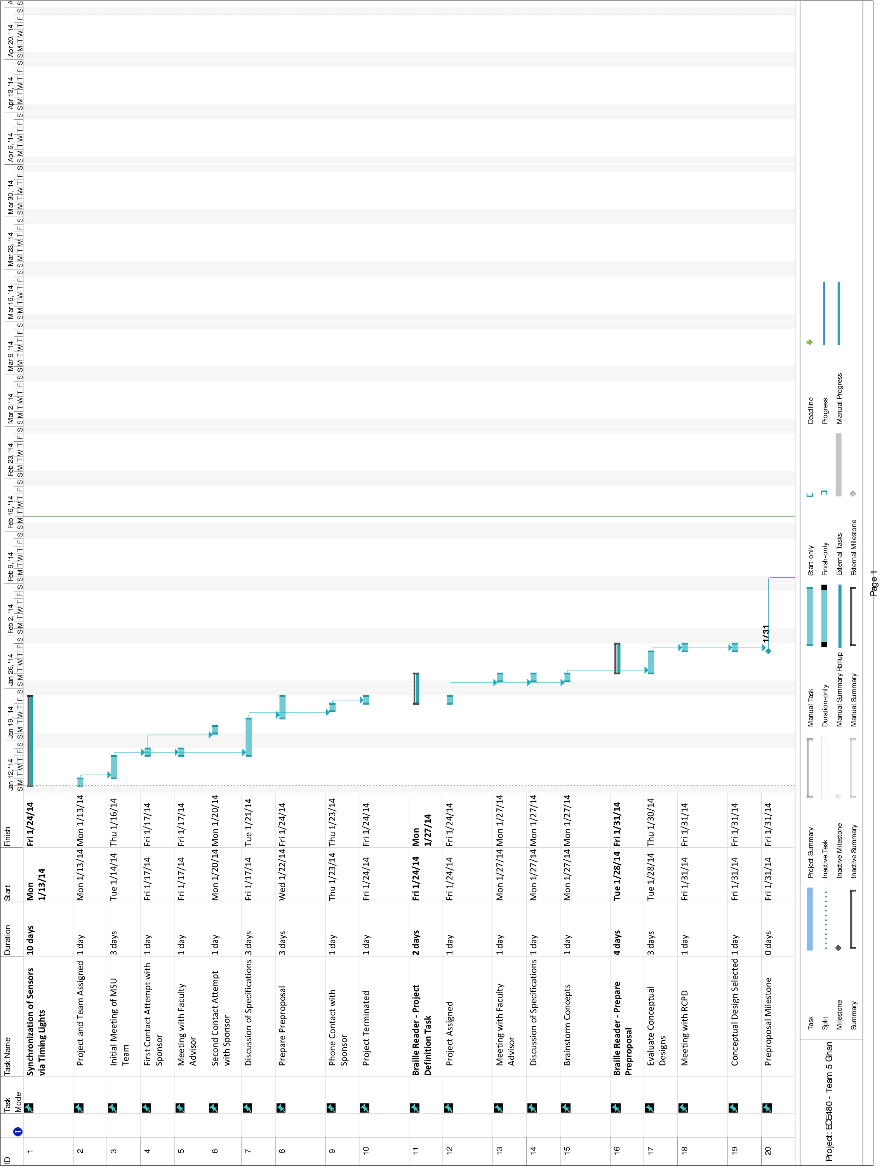Figure 5. Gant Chart
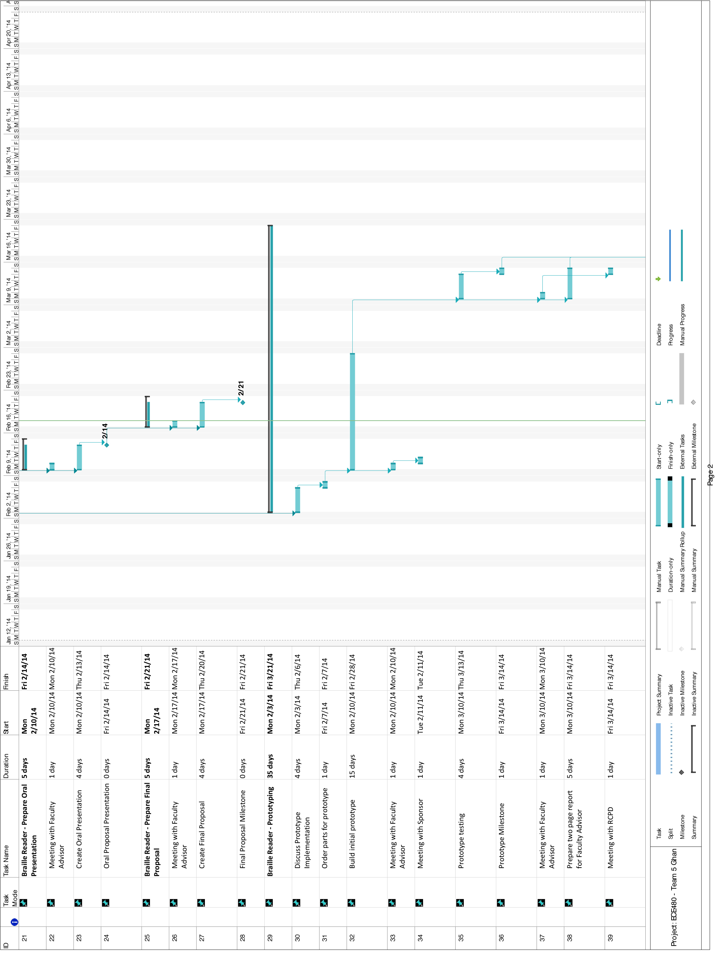Figure 5. Continued
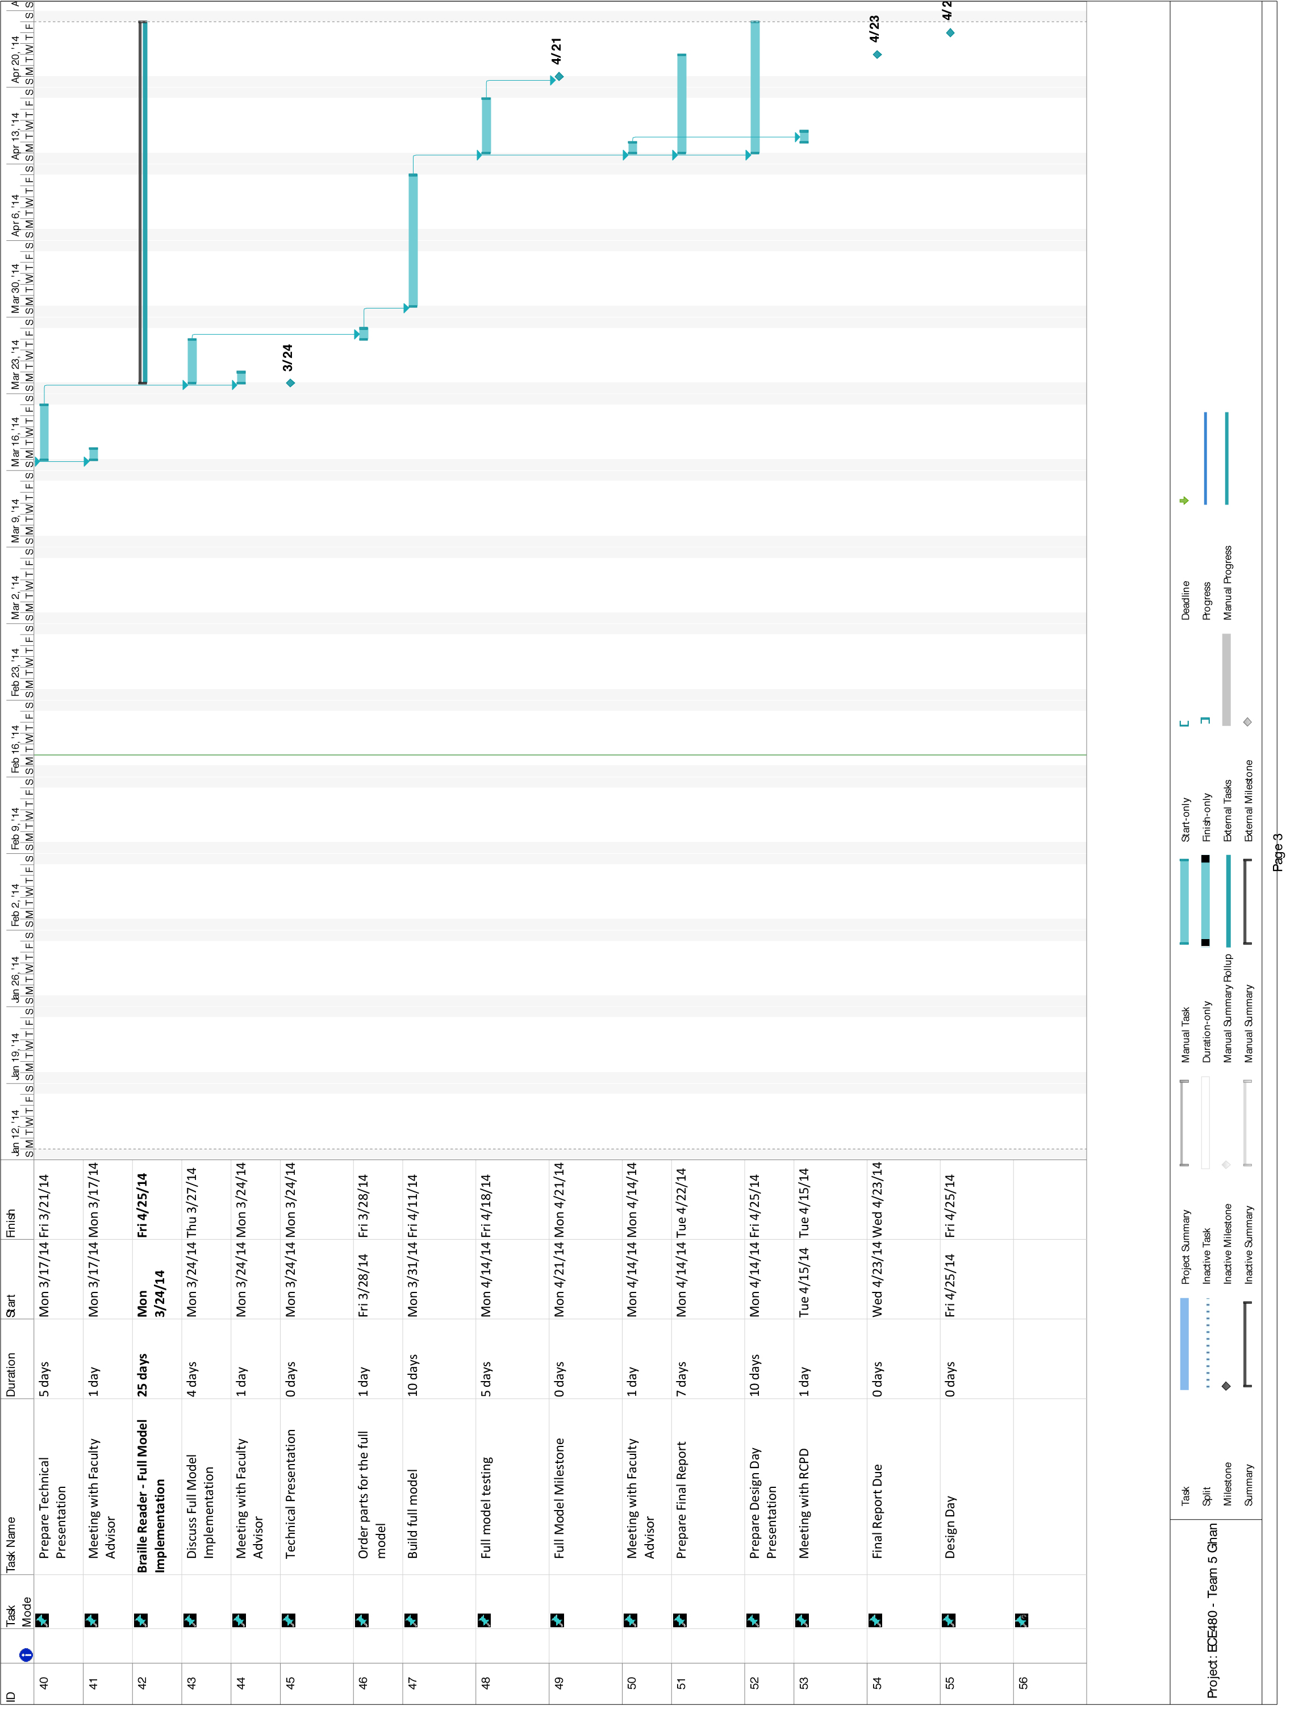Figure 5. Continued

Budget

Table 4. Project Cost
Qty. | Part | Cost
 | 3D Printed Components | $150
2 | Continuous Servos | $40
4 | Micro Servo | $60
1 | Arduino Uno R3 | $30
100 | Metal Pins | $20
4 | X-Y Track | $15
4 | Gears | $5
Total |  | $320

Table 5. Manufacturing Cost (Multiple Prototypes)
Qty. | Part | Cost
 | Molded Components | $50
2 | Continuous Servos | $20
4 | Micro Servo | $40
1 | Arduino Uno R3 | $25
100 | Metal Pins | $5
4 | X-Y Track | $4
4 | Gears | $2
Total |  | $146

REFERENCES

A-Z to Deafblindness. Refreshable Braille Displays. 2014. http://www.deafblind.com/display.html

American Foundation for the Blind. Refreshable Braille Display. 2014. http://www.afb.org/info/living-with-vision-loss/for-job-seekers/careerconnect-virtual-worksites/retail-worksite-for-blind-users/refreshable-braille-display-3652/12345

Deane Blazie. Refreshable Braille Now and in the Years Ahead. 2014. https://nfb.org/Images/nfb/Publications/bm/bm00/bm0001/bm000110.htm

HumanWare. Braille Displays. 2014. http://www.humanware.com/en-usa/products/blindness/braille_displays

Itseez. Open Source Computer Vision. 2014. http://opencv.org/

Microsoft. Basic Tasks in Project. 2013. http://office.microsoft.com/en-us/project-help/basic-tasks-in-project-2013-HA102891709.aspx

Rob Ives. Reciprocating Motion. 2010. http://www.robives.com/mechanisms/recip#.UwenyU2A1Hh

