Low Cost X-Y Table Solution

Steven Chao
3/28/2014

Abstract
An X-Y table provides horizontal motion for automated machinery, while the base remains stationary. This is frequently accomplished through the use of bearings and a drive mechanism. Most commercial X-Y tables are fast, precise, robust, and relatively high cost. For our application, one of our biggest concerns is creating a low cost product, which therefore necessitates the creation of a low cost table. The solution we found utilizes a screwing technique, coupled with a high speed continuous servo and low cost parts found at any local hardware store. The low speed of this solution is, in our application, vastly outweighed by the extremely low cost.

Background
The precision-controlled automated movement provided by X-Y tables are used in many industries, especially within manufacturing. Common uses include coupling their functionality with robotic arms or milling machines in order to increase the degrees of freedom provided by these systems. As a result of these expensive and high precision applications, most all commercially produced tables are fast, robust, extremely precise, have high quality components, and as a result are quite expensive.

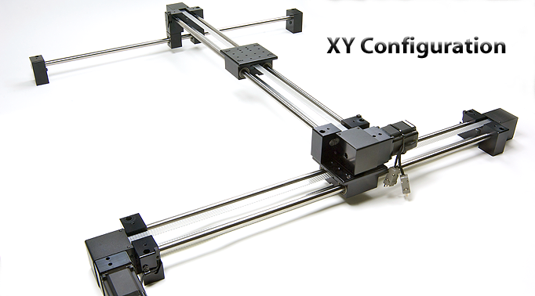
Figure 1: A commercially produced X-Y table

For our application we need an X-Y table to provide an additional two degrees of motion to another feature that only operates on the Z-axis. While this table needs to be somewhat precise, the level of precision offered by commercial products is significantly more than we require. Also, the speed of travel offered by commercial products is significantly faster than we need. Therefore, by reducing the both of those specifications in our design, the overall price should be able to be brought down significantly.

Design
For our application, the biggest design constraint was to create a robust, operational, and low cost X-Y table. Other, less important criteria include the speed of the table’s linear motion, the precision of the position control, and the size of the feature. Due to budget constraints, no commercially produced tables fit these criteria, most being anywhere from $400 to several thousand dollars, which necessitated the design of our own X-Y Table solution.
There are two major components to an X-Y table: the drive mechanism, and the sliding technology. Firstly, when choosing a drive mechanism, we were very limited by the budget constraints. While many commercial tables use linear motors to power the tables, the cost of such motors made them an unfeasible choice. Some of the ideas considered to power the table included the use of stepper motors, actuators, and servos. Ultimately, we chose to design our solution around low cost, high speed, continuous-rotation servomotors, due mainly to their extremely low cost and good functionality. As the name implies, these motors provide high speed, continuous, rotational motion, while fitting nicely within our budget constraints at the price of about $10 apiece.
The second component of the table was to design a sliding mechanism to translate the continuous rotary motion into linear horizontal movement. Some of the designs considered included using a rack and pinion gear system and using a chain belt design similar to that of a bicycle. Eventually however, we decided to use a threaded rod technique. This functions by using a platform on a low-friction rail that has a threaded rod going through it. The continuous rotation servomotor is used to spin the threaded rod, which then has the effect of moving the platform forwards or backwards. The biggest drawback to this technique is the very limited speed at which the platform moves, but since our application doesn’t need to travel far or very quickly, the robustness, cheapness, and precision of this technique clearly make it the best choice.
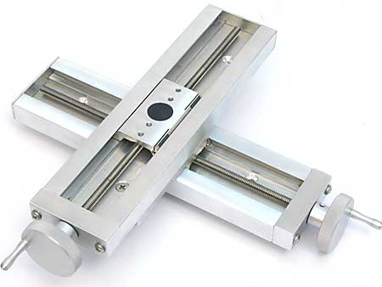

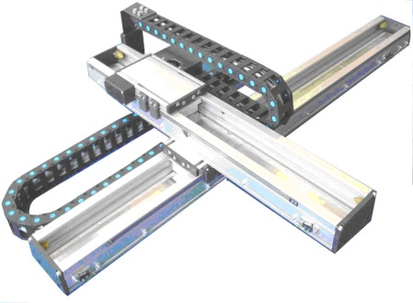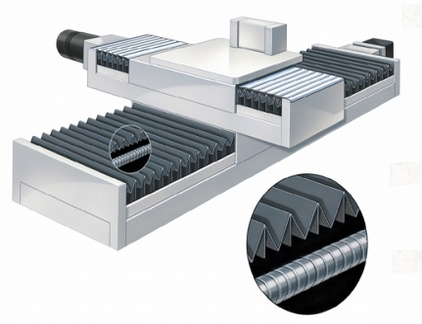
Gear-Belt Method Rack-Pinion Method Threaded-Rod Method

Figure 2: Examples of different X-Y table technology
Implementation
In order to implement this design as cheaply as possible, most materials were acquired from a local hardware store, with the exception of the servomotor. The materials needed include wood, two smooth rods, a threaded rod, some nails, and washers and bolts. Overall, the total cost for a functional, one directional table came to about $20. This meets the biggest design criteria, cost, quite well.
As far as assembly of the feature goes, the table was relatively simple to construct. The wood had to be cut to meet the desired specifications for table size. Next holes had to be drilled in the base and in the moving platform for the rods. Finally, everything was assembled using nails and the bolts, to create a functional table, as can be seen below in Figure 3.

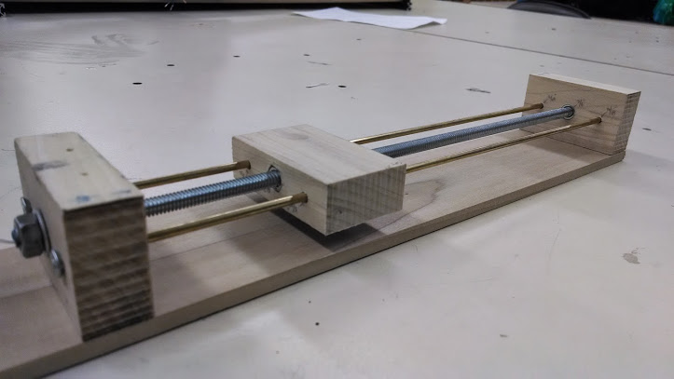
Figure 3: An example of our one-dimensional table

The servomotor was attached firmly by using gorilla glue. With this cheap, one dimensional table designed, building an entire X-Y table was quite simple. Two more identical tables were then built, which serve to move the upper table in a perpendicular direction, resulting in a two-dimensional X-Y table using a total of three individual tables.

Results
Functionality-wise, when testing this X-Y table, we found it to work satisfactorily. After modifying the table slightly to reduce some unintended friction, our overall table ended up working reasonably well, though quite slowly, as we expected. The biggest issue we ran into was precise position control. Because of the use of the continuous rotation servomotor, there wasn’t a way to know precisely where the table’s platform is at any given time; while this could be estimated by keeping track of the rotations of each servo, a more robust and precise method was needed.
To solve this issue, we purchased two SoftPot Membrane Potentiometer strips. These are thin variable potentiometer strips that linearly vary in their resistance when being pressed down on various parts of the strip. This allows us to very accurately calculate the relative position of each table’s platform, increasing the precision of our table to a satisfactory level. Our final XY table design met all of our desired criteria to a satisfactory level, while having a final price tag of less than $100.

Conclusion
In summary, due to our very niche requirements and quite limited budget, the only option to meet our feature’s criteria was to create a custom X-Y table. The solution we created was extremely cost effective, and relatively robust and precise. The major drawback to it was the quite slow travel speed, which limits what applications this low-cost table can be used for. However, since our application has very little need for quick travel speed, this solution worked extremely well in this situation.

