ECE 480
Proposal
Real Time G-Meter with Peak/Hold
Group 4: Karl Anderson, Timothy Carroll, Shuhan Chen, Corey Fox, Eric-John Kohler & Daniel Svoboda
2/22/2013

The team was assigned a project from Instrumented Sensor Technology (IST) to design and build a working prototype of a G-Meter that has a peak/hold function. The purpose of this project is to create a portable G-Meter the size of a watch or cell phone. The team will use a microcontroller from Texas Instruments (TI MSP430G2553), an LCD screen and an accelerometer to design the product. The microcontroller will be programmed to display both the measured G-force and the date that the force was measured. The final product will be able to measure the force applied to the device from the direction perpendicular to the G-Meter for a long period of time and it will be able to display the max force felt over the entire measurement and the current force. The final product will be used in package delivery applications. The device will be placed on a container that is being shipped and will record all of the forces that the package faced throughout the entire shipment.

Table of contents
Introduction Page 2
Background Page 2
Design Specifications Page 3-4
Conceptual Design Description Page 4-5
Ranking of Conceptual Designs Page 5-6
Proposed Design Solution Page 6
Risk Analysis Page 7
Project Management Plan Page 7-9
Budget Page 9
References Page 10
Introduction
The team will be developing the G-Meter to monitor the g-forces experienced by the device. The device will work in a single axis and will monitor the linear acceleration with an accelerometer. In addition, the G-Meter will operate in two different modes, a real time mode and a peak/hold mode. In the real time mode, the G-Meter will display the maximum g-force reading over a 15 second interval. This interval was specified by IST and will be used to calculate and display the root mean square (RMS) value. In the peak/hold mode the G-Meter will store and display the maximum peak and RMS g-force measurements, as well as the time and date that they occurred. Other components of our device will include a DIP switch which will be used to set the bandwidth of the signal, as well as “freeze” and “reset” buttons, which will allow the user to freeze and reset the current g-force value that the G-Meter is reading. The overall size of the device will be comparable to that of a cell phone and should cost approximately $10 for IST to assemble the device. Possible uses for the G-Meter are simple laboratory measurements, in-plant machinery monitoring, and process control applications. Ideally the G-Meter would be attached to large and fragile pieces of equipment that are being shipped all over the world.
Background
The G-Meter (accelerometer) is widely used in flight monitoring, vehicle performance, and many other applications. There are a lot of accelerometers on the market today. Most of these products are a simple real-time G-force indicator that display the current G-force value and are fairly expensive. With the recent development of smart phone technology more accelerometers are being used in smart phone applications, lowering the cost of accelerometers. However, the refreshing frequency of the phone operating system and the system design makes the accelerometer impractical for monitoring purposes. Last semester, Instrumented Sensor Technology sponsored a design team to design a G-switch with cut-off from a relay. They used a microcontroller as, a DIP switch as the user input, an accelerometer as the input, and LEDs and a relay as the output. MEMS accelerometers are used in smart phones and are very compact and practical. A MEMS device is a Micro Electro Mechanical System, which can measure a mechanical variable with the size of a tiny integrated circuit. The theory behind the MEMS accelerometer is a charged finger moves between two parallel plates. The charge changes the capacitance between the finger and one of the plates. By measuring the capacitance, the movement of the finger can be identified, as well as the acceleration.

Design Specifications
The specifications that must be met for the G-Meter design to be successful are as follows:

- Measurement range
- Measurement resolution
- Measurement accuracy
- Measurement rate
- Measurement time window
- Mode selection
- Battery life

The G-Meter must have a range of -17g to 17g, meaning that it can measure at least 17g in either direction on its axis of measurement. It should have a resolution of at least 0.04g, meaning that the minimum change in acceleration that can be detected is 0.04g. The meter should have an accuracy of three percent, so that the displayed acceleration is within three percent of the applied acceleration. It must be capable of taking acceleration measurements at a rate of up to 1 kHz, with the user being able to vary the actual rate among several values up to 1 kHz. During each successive 15 second window of time, the meter will need to capture the peak acceleration and calculate the root mean square (RMS) acceleration. The user must be able to select between "real time" and "peak/hold" operating modes. In "real time" mode, the device must update the peak and RMS acceleration measurements to the display after each 15 second window of time. In "peak/hold" mode, it must save and continually display the largest peak acceleration value and the largest RMS acceleration value along with the times and dates that they occurred. Finally, the meter must have a battery life of at least 30 days when operating on two AA batteries. These design parameters are essential to the desired functionality of the g-meter. The successful implementation of the measurement specifications are not mutually exclusive, and should not involve compromising one to achieve another.

Besides the above capabilities, the G-Meter has several other design parameters that will determine the desirability of one design over another, including:

- User interface
- Display
- Size

The user must be able to select the operating mode, be able to "freeze" the display in the real time mode, select the measurement rate, and be able to reset the device. The interface that provides this functionality should be compact and intuitive. The reset function should be reasonably hidden so that it cannot be easily done while the device is in use. The meter should include a liquid crystal display (LCD) to provide acceleration measurements and other feedback to the user. This includes the time and date of measurements, indication of the current operating mode, and the type of measurement being displayed, either peak or RMS. The layout of the display and the way this information is displayed should be intuitive and easy to understand. The meter should be of a relatively portable size comparable to a cell phone or a wristwatch. Of these design parameters, the size is the least important and will be sacrificed for improvements in the display or user interface. The extent to which design solutions have a logical intuitive interface or display scheme will determine the desirability of one over another.

Conceptual Design Descriptions
Our team began the design process by constructing several high-level hardware diagrams. Due to the specific nature of the design parameters, most of the potential designs for the Real Time G-Meter had highly similar hardware topology. The designs were merged after a discussion of their differences. The layout that was ultimately decided upon is depicted in the diagram below.
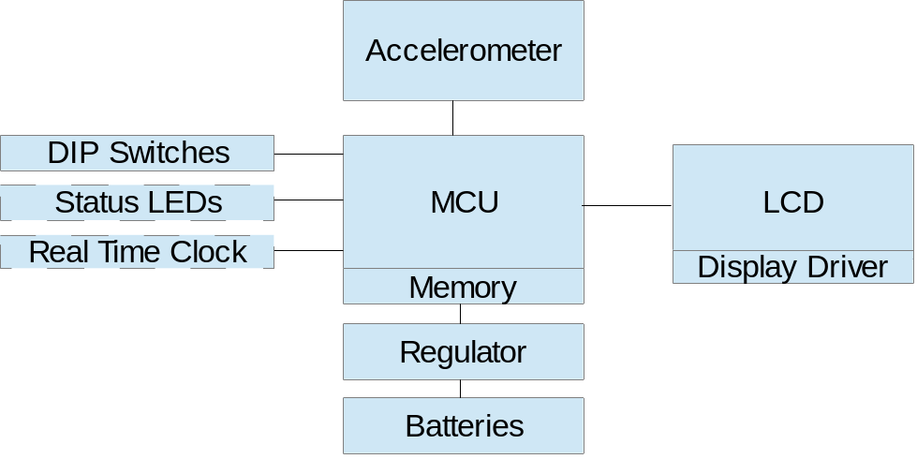
Diagram 1
From this point, the majority of the design decisions that were made involved selecting the best candidate for each of the individual components shown above. Many of these selections were synergistic (ex. use of an analog accelerometer requires a microcontroller with an ADC). Several non-vital components (ex. external real time clock) were ruled out for the final design, because their functionality could be mirrored elsewhere in the design (ex. running a clock on the MCU). These differences are discussed below.
Accelerometer
Digital vs. Analog output
Analog communication between the accelerometer and MCU requires use of an ADC, either within the MCU or on an external IC. The resolution of the acceleration readings will be limited by the number of digits the ADC can produce.
Digital communication does not require an ADC equipped MCU. It may, however, require additional code running on the MCU to interpret the signals coming from the accelerometer (ex. I²C).
Single axis vs. Triple axis
While the specifications only call for one axis of measurement, it may be advantageous to use a triple axis model and disregard the two unneeded axes. Although single axis models are hypothetically cheaper, they tend to only be available in restrictively large quantities. Using a triple axis model will allow more choices on other important specifications like sensitivity, voltage level, and sampling frequency.
LCD
Size: 16x2, 8x2, etc.
Multi-character LCD displays are available in a variety of sizes. A larger model will allow display of all necessary information at the same time. A smaller model may require scrolling to do so, but will also allow the end product to be more compact.
Display Voltage: 3.3V vs. 5V
While 3.3V models are available, they are more expensive. This will weigh into our final selection.
MCU
Several microcontrollers will be considered for the final design. Important specifications include voltage (preferably 3V), amount of memory available for Peak Hold mode, and cost.
Status LEDs
The potential design may either include or omit the status LED’s. According to the sponsor, instead of indicating power and mode with LED’s, this information can instead by indicated on the LCD. This will consume valuable screen real estate, especially if a smaller LCD is selected.
Real Time Clock (RTC)
A real time clock IC running on a small watch battery would keep time for the device, even when the main batteries are turned off. The design requirements do not specify whether time needs to be maintained when the device is off, so this feature may be omitted to reduce cost in the final design. Additionally, all potential MCUs have timekeeping functionality when turned on.
Voltage Regulator
3.3V vs. 5V – Depends on voltage requirements of other components. It may not be necessary at all if MCU has appropriate on board voltage regulation.

Ranking of Conceptual Designs
There are four main designs that are being considered for this G-Meter. Because Instrumented Sensor Technology has such detailed requests for specifications, there is not a lot of room to change the design. The ways that the design can be varied are to benefit the efficiency of the meter. The LED’s were originally intended to show which mode the meter was running in, but there are other ways to display this. They can be taken out. Adding and removing the LED effects power consumption. Varying the size of the LCD display also effects the power consumption, and a specific size of LCD screen was never specified, so we can vary its size. Table 1 below shows the selection matrix. The design with the highest score is the design that will be used for the g-meter. Below is the equation of how the designs are scored.
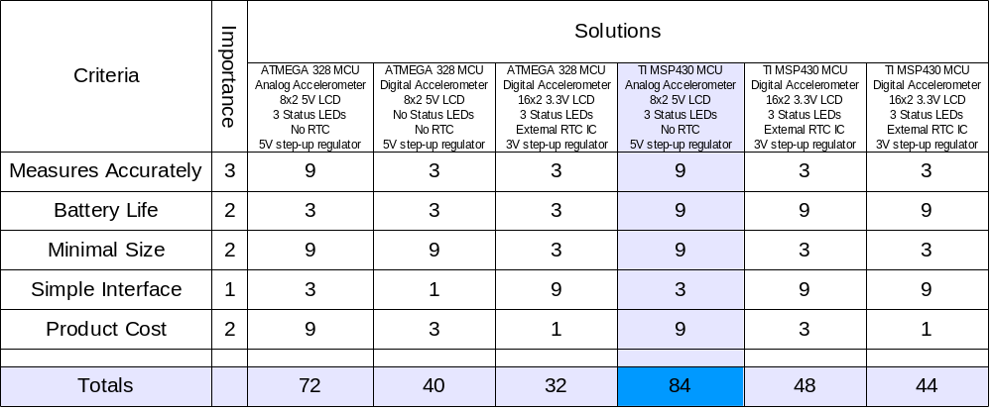
$$Total Points = Importance * Design Ranking$$
Table 1: Selection Matrix

Proposed Design Solution
The proposed design will consist of the most feasible solution for each of the above components. The microcontroller will be a TI MSP430G2553. This MCU's 10 bit ADC will provide more than enough resolution when used with the selected accelerometer, a Freescale MMA Analog. While an LCD has not yet been selected, it is likely that it will be a 3.3V 16x2 character model, in order to best meet voltage and I/O needs.
The design will first be implemented using a TI MSP430 Launch pad and solder less protoboard. Power may come from a power supply during early stages, in order to save on battery cost. Once a functional prototype is developed, it will be taken to Instrument Sensor Technology for testing and calibration on acceleration producing instruments owned by the sponsor. A final prototype will then be produced, likely with a PCB and final enclosure.

Risk Analysis
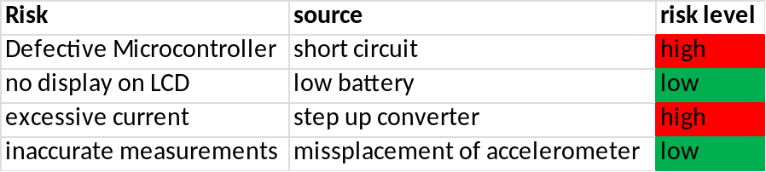
Table 2: Risk Analysis

Project Management Plan
Personnel
Table 3 below contains the details of the team’s non-technical positions. Dr. Grotjohn chose these positions for the team.

Name | Position
Karl Anderson | Presentation Preparation
Timothy Carroll | Document Preparation
Shuhan Chen | Webmaster
Corey Fox | Manager
Eric-John Kohler | Lab Coordinator
Daniel Svoboda | Presentation Preparation
Table 3: Non-Technical Positions

Table 4 below contains the technical positions of Team 4. These positions may change as more information and research is done into the design project.

Name | Position
Karl Anderson | Data Acquisitions
Timothy Carroll | Power Systems Specialist
Shuhan Chen | Product Assessment and Validation
Corey Fox | Testing Technician
Eric-John Kohler | Assembly Associate
Daniel Svoboda | Display Management
Table 4: Technical Positions

Facilities/Resources
The development of this g-meter will require the use of a few facilities. The first facility is the ECE 480 lab. This will be utilized for its electrical and testing equipment such as the voltmeters and power supplies. The sponsor of this project will also be utilized for their g-force testing equipment. Instrumented Sensor Technology has a calibrated vibrating g-force device. This will be used to calibrate the g-meter. It will also be used in the testing and validation portion of the g-meter. The software that will be utilized in the development of this g-meter is TI Code Composer Studio. This is a TI program that will be used for programming the microcontroller. Eagle will also be used to design the g-meter’s PCB.

Schedule
Table 5 below is a list of Team 4’s scheduled deliverables. Figure 2 below is a Gantt chart of the team’s technical schedule. If this schedule works for the duration of the semester, Team 4 should have plenty of time to perfect the design of the G-Meter. The team is well ahead of schedule, so if a situation should set the process back, there will be plenty of time to recover.

Item | Description | Due Date
1 | Pre-Proposal Due to Dr. Radha. With this completed, design and fabrication may begin. | January 31
2 | Proposal presentation is to be completed. | February 20
3 | Final proposal is to be submitted | February 22
4 | Two page progress report is to be submitted. | March 11
5 | Team design issues paper and progress report #2 are to be submitted. | April 12
6 | Professional self assessments are to be submitted | April 17
7 | Final design is to be finished and ready for design day | April 19
8 | Final reports are to be submitted | April 24
Table 5: List of Team Deliverables

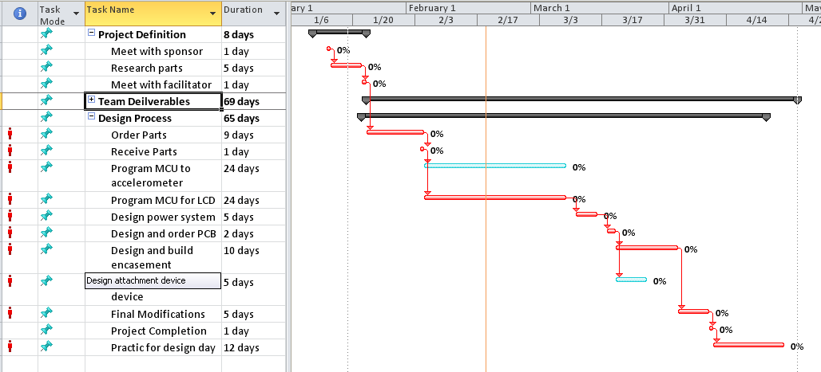

Figure 2: Gantt Chart

Budget
The group is given a total budget of 500 dollars for the project. The goal is to create a product that can be made for around ten dollars apiece if made in bulk (500 or more). The group decided that if the final design can be made for fewer than fifteen dollars then it would be satisfactory. The following table is a list of the current parts that will be used on the device and their prices.

Part | Price per unit (500+)
accelerometer | $ 3.22
microcontroller | $ 1.16
LCD screen | $ 5.72
step-up converter | $3.15
Total | $ 13.25
Table 6: unit prices

References
Goodman, Erik. “Intro to Project Management and MS Project.” Michigan State University, East Lansing. 16 Jan. 2013. Lecture.
"LT1073 Datasheet Pdf." LT1073 Datasheet Pdf - Micropower DC-DC Converter Adjustable and Fixed 5V, 12V - Linear Technology. N.p., n.d. Web. 22 Feb. 2013. <http://www.datasheetcatalog.com/datasheets_pdf/L/T/1/0/LT1073.shtml>.
"MMA6853KW." Mouser Electronics. N.p., n.d. Web. 22 Feb. 2013. <http://www.mouser.com/ProductDetail/Freescale-Semiconductor/MMA6853KW/?qs=sGAEpiMZZMvwE4h8i4g3cutFLaCto2ugxcpm4vp8SJM>.
Motter, Gregg. “Six Sigma.” Michigan State University, East Lansing. 28 Jan. – 8 Feb. 2013. Lecture.
"MSP430G2553 (ACTIVE) MSP430G2x53, MSP430G2x13 Mixed Signal Microcontroller." 16-bit Ultra-Low Power MCUs. Texas Instruments, n.d. Web. 22 Feb. 2013. <http://www.ti.com/product/msp430g2553>.
"NMTC-S0802XRGHS." Mouser Electronics. N.p., n.d. Web. 22 Feb. 2013. <http://www.mouser.com/ProductDetail/Microtips-Technology/NMTC-S0802XRGHS/?qs=/ha2pyFaduhDmAMt2DZ0j4+Jp9NQ1f+oizQtpt0VG73NlcUhdpcZ6g==>.

