Electrocardiogram (ECG) Demonstration Board

Michigan State University
Senior Design – ECE 480 – Team 3
Spring 2013

Project Sponsor:
Texas Instruments

Project Facilitator:
Ramakrishna Mukkamala

Team Members:
Michael Mock
Justin Bohr
Yuan Mei
Nathan Kesto
Chaoli Ang
Xie He



Introduction:

Electrocardiograms (ECGs) are used extensively in hospitals and other health care facilities around the world to monitor the health of their patients. An ECG is a device that measures and records the electrical activity associated with the heart. This recorded activity is then analyzed by doctors and can be used to diagnose patients with various diseases as well as help monitor their patients’ progress. Due to the heart being such a vital component of humans, ECG devices are widely in use and many designs are currently available on the market. Texas Instruments (TI) currently has their own ECG demonstration board to drive customer interest in their products and design solutions.

Texas Instruments has recently been receiving increased interest amongst their customers interested in developing medical devices. ECG technology is constantly evolving and the elevated interest in the use of new designs is creating an additional market for many integrated circuits in TI’s precision analog division. The current ECG demonstration board that TI uses to drive customer interest is outdated. The board is large and uses some TI components that are not fully representative of today’s IC technologies. The precision analog group at TI needs accurate and robust demonstration boards to help their customers realize the capabilities of their parts. A new board populated with current TI products gives TI engineers that opportunity.

In order to meet customer needs while concurrently selling TI products, a new ECG demonstration board needs to be designed and fabricated. Some features needed for the board are low power, low noise, and high reliability during operation. Several precision analog IC’s will be utilized in the design to showcase their functionality. The size of the board must also be optimized by utilizing design solutions that are on the same scale as TI engineering standards. Finally, the board must be as cost effective as possible to further stimulate customer interest. Overall, the board must provide excellent accuracy and precision in a cost-effective package capable of showing customers the advantages of using TI products as an ECG design solution.

Background:

An understanding of what ECG systems measure and how they work is vital to designing a successful ECG demonstration board. ECG devices directly measure the change in small voltages at the surface of the skin. These variations in voltage are generated by the bio-potential differences in the heart. Bio-potentials are electrical potentials between living cells. These potentials are generated by the different ion concentrations, most commonly calcium and sodium, in and outside of cell membranes. When there is a disturbance in these concentrations, action potentials are then generated. An action potential is the depolarization and repolarization of a cell. Action potentials generate action currents which are essentially what ECG signals are. In the heart, action potentials are generated by its rhythmic contractions and start at the right side of the heart. A stimulus from the sinoatrial node (natural pacemaker) causes the heart to contract and depolarize the cells. When the heart relaxes, the cells begin to repolarize to their resting potential which is typically a low negative bio-potential. ECG systems capture the depolarization and repolarization of cells through many methods and locations on the body. One that will be implemented in this design, in collaboration with many other components, is through fingers.

TI has presented the team with the task of replacing an old, outdated ECG demonstration board (See Figure 01 below) and implementing a new design solution to showcase to customers. The new design will be paired with a portable Stellaris oscilloscope module to display the ECG signals on a compact LCD screen. This eliminates the older board’s reliance on a bench-top oscilloscope. The new board will be more accurate, low powered and compact all while implementing products in TI’s current business portfolio. It will take live signal measurements from a user through dry sensors and will process the signal through the Stellaris microcontroller. The proposed solution makes for a very effective tool for TI to use in terms gaining more customers and revenue.

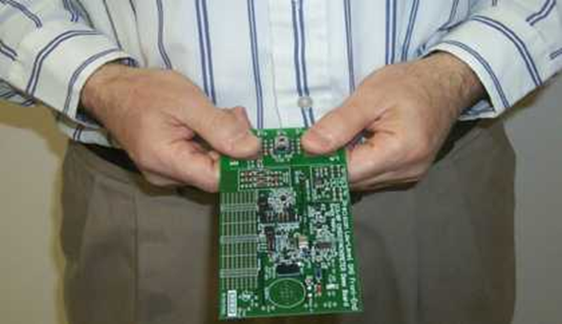

Figure 01: Current ECG demonstration board at Texas Instruments

Design Objectives / Deliverables

The final functional requirements for the ECG demonstration board have been clearly explained by the precision analog group at Texas Instruments. The design team has been given the challenge to design and fabricate a reliable portable analog front end system to interface an ECG Simulator (CardioSim II) with a Stellaris microcontroller evaluation module (oscilloscope). The schematics and much of the circuit topologies for the analog front-end (AFE) have been provided by application engineers in TI’s precisions analog group in Dallas, Texas. The challenge for the team lies in the design, fabrication, and testing of the printed circuit board.

The integrated circuits that TI desires for demonstration in the design are the INA333 instrumentation amplifier, OPA333, OPA320, OPA378 operational amplifiers. The op-amps have the same footprint and pin layout which allows for interchangeability of certain components in the system. Beyond the scope of the components listed above, the team has chosen the TPS62120 integrated power converter to manage the power usage of the board.

The ECG signals used in the demonstration board will initially originate from the CardioSim II which is a portable integrated device used to test ECG systems. It has a variety of signals it can produce and simulate. The team initially proto-typed a test circuit to measure the range of the signal amplitude and noise levels produced by the CardioSim II (See Figure 02 below). The differential amplitude of the signal was found to be in the 1.2-1.5mV peak-to-peak range.
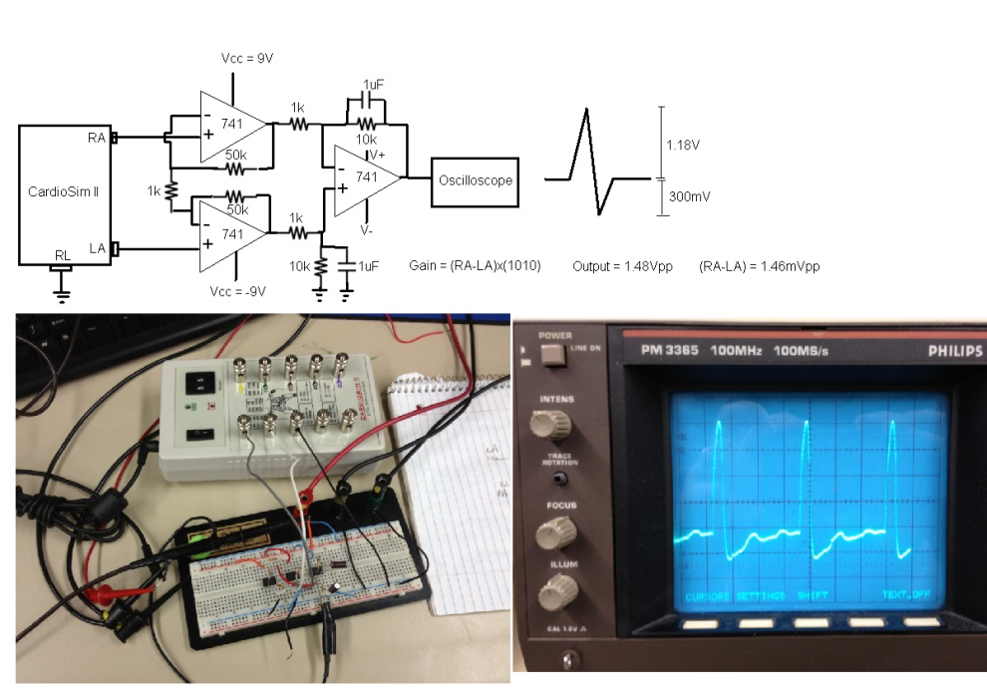

Figure 02: Testing setup used to measure signals from the CardioSim II device
The final circuit board will need to be powered from a battery and highly portable. To exceed this functionality, the design team will use low-power devices to extend the battery life of the product. A 9V will be used to provide the 5V and 2.5V reference voltages for the amplifiers and filters. The team will develop several PCB layouts using PCB Artist. The purpose of simulating multiple circuits, building several boards, and writing up the test results will lead to the most efficient and highest performing design and final product.

Design Solution:

Texas Instrument’s functional specifications will be fulfilled by developing the analog front-end interface to condition the ECG input signals. Initially the team will spend effort and time exploring different integrated circuits and schematics to solve block-level system requirements. Some of the blocks required for example are input and output filtering, the instrumentation amplifier block, the right-leg-drive circuit, and the dc servo loop which will be used to regulate the dc offset of the output signals from the amplifier. Shown below in Figure 03 is a system level block diagram showing the sub-systems required for proper operation of the demonstration board.

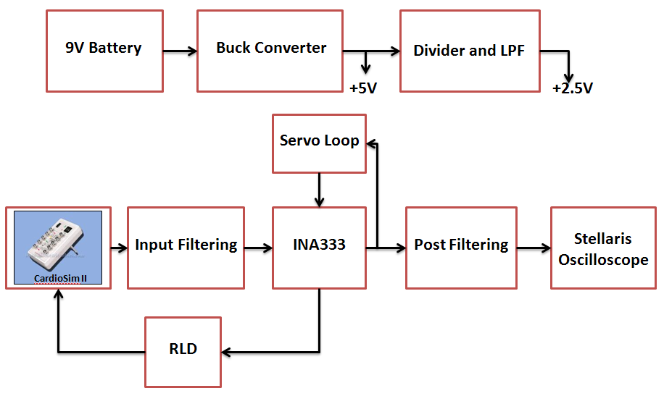

Figure 03: System level block diagram showing circuit components

The system block diagram is actualized in a final schematic (See Figure 04) through the process of designing and simulating each sub-circuit in the system. TINA-TI is an excellent SPICE software package developed by TI. The team will use this software to test and simulate each circuit used in the demonstration board.
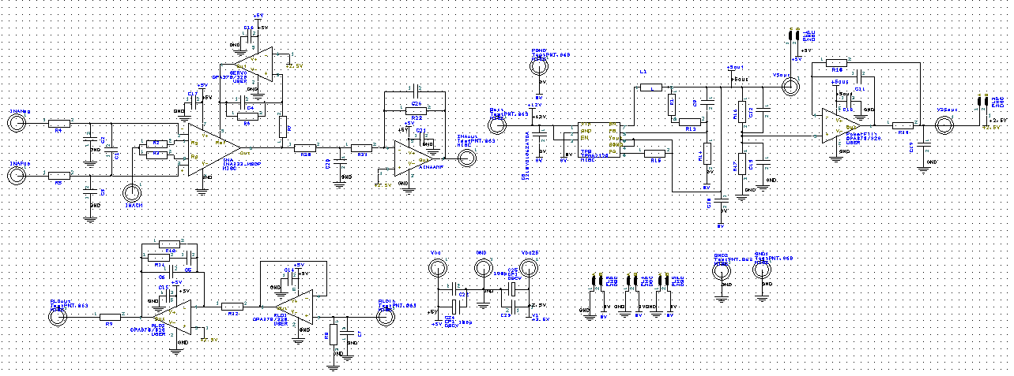

Figure 04: Full schematic of AFE used for the first testing PCB layout

After analysis of each sub-unit in the block diagram shown in Figure 03, the entire system can be realized in a final transfer function broken down into each symbolic component. The transfer function in Formula 05 below details the estimated system’s frequency response.

$$Vout/Vinput=(-16.15*C3*R3*R4s)/((C1*C2*C3*R1*R2*R3*R4) s^3+(C1*C3*R1*R2*R4+C2*C3*R2*R3*R4-C1*C2*R1*R2*R3) s^2+(C3*R2*R4-C1*R1*R2-C2*R2*R3)s+R2)$$

Analyzing this transfer function using MATLAB, the team is able to characterize the frequency response of the ECG system (See Figure 05 below).
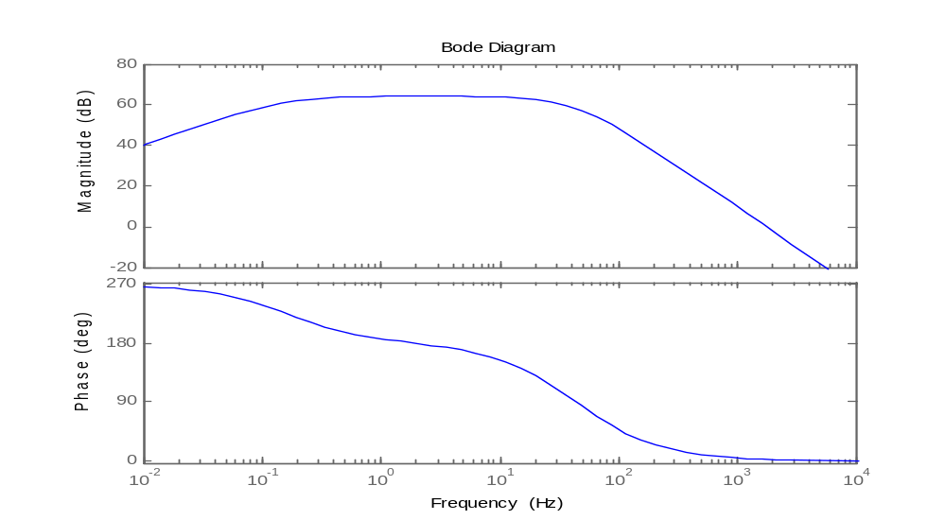
Figure 05: Theoretical frequency and amplitude response of the analog front-end

The bandwidth of the analog front-end system needs between 50-100 Hz to display some of the higher frequency spectra in an ECG signal. After initial prototyping to confirm circuit functionality, the team designed and populated a PCB to test the functionality of the analog front-end (See Figure 06 below).

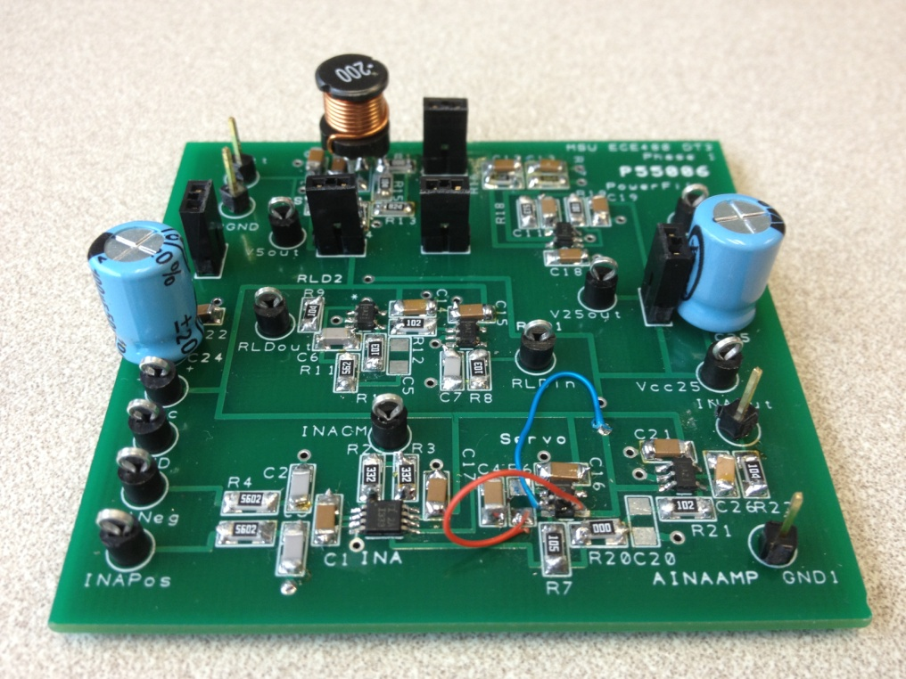

Figure 06: First PCB layout to test the design solution

After testing the first board in lab, measurements of the bandwidth were done to confirm the matching of the desired design specifications. The circuit’s bandwidth measurements are shown below in Figure 07. The bandwidth of the first demonstration board is approximately 25 Hz. The design will be adjusted to match the desired 50-100 Hz bandwidth in the future board designs.

Figure 07: Plot of system bandwidth for first PCB layout
For the designing of the first PCB layout, most design choices were made to meet the design objectives of the project. The grounding of the first PCB layout was chosen to minimize noise in the circuit. The grounding scheme in the buck converter was separated from the rest of the circuit (See Figure 08). This ground could be connected to the AFE’s ground plane through jumpers for when testing the entire circuit together, running on a battery (See Figure 09).

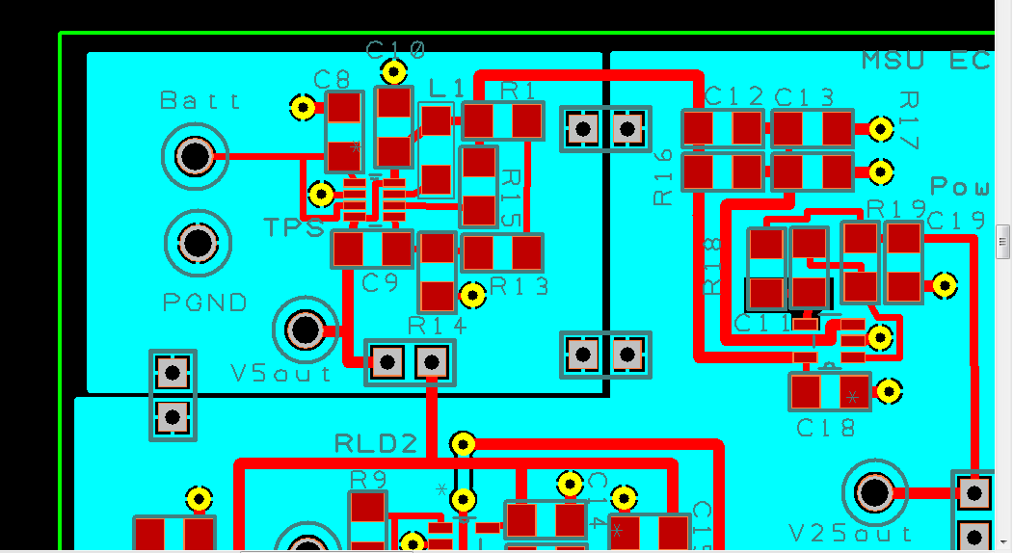
Figure 08. Top left portion of ground plane is separated to isolate switch noise.

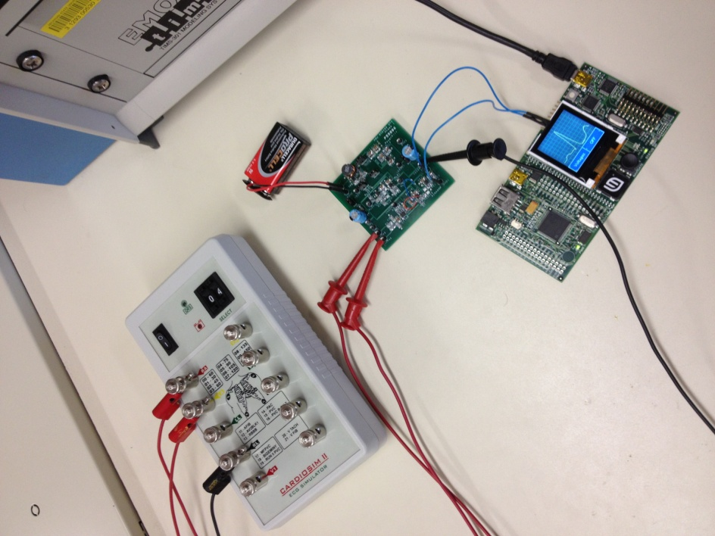

Figure 09: Using jumpers allows the board to be powered from a 9V battery
Since noise travels through the ground plane, special layout precautions were taken for sensitive nodes in the circuit. For sensitive input pins on the INA333 and the negative input terminals for the op-amps, holes were cut through the ground plane below these nodes. This was done to reduce the noise introduced through capacitive coupling in the ground plane near these inputs. Figure 10 shows two examples of the removal of the ground plane to protect the sensitive circuit nodes (dark cutouts below the red pads).

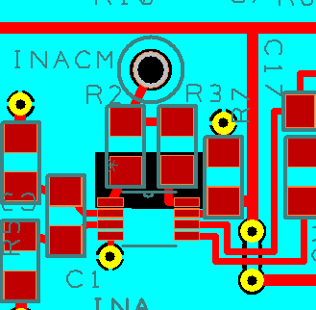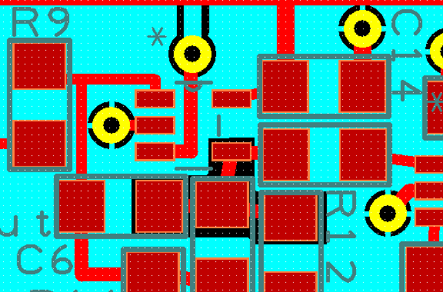

Figure 10: Left: INA333 gain setting resistors. Right: op-amp (-) input terminal.

To minimize the noise introduced in the integrated circuits on the board, decoupling capacitors were also placed near the power pins of each IC. The reason for this is because noise can easily be induced in a long capacitive/inductive trace. Adding decoupling capacitors allows the noise a path to ground to filter and remove the higher frequency noise in the power signal chain. Another portion of the PCB design lies in keeping the length of the board traces shorter when appropriate. This is also to minimize the noise introduced in the amplifiers and filters of the analog front-end.

One of the main design goals is to minimize the noise introduced in the ECG signal throughout the analog front-end. Shown below in Figure 11 is the current output signal the team is able to achieve with the first PCB layout.

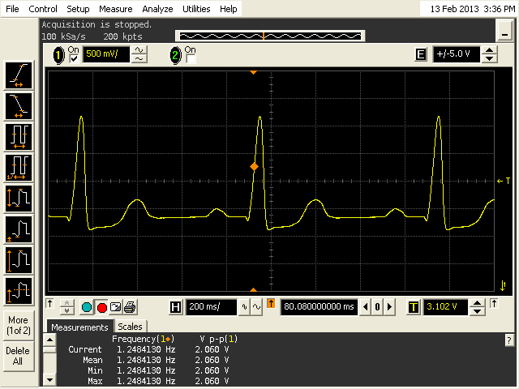

Figure 11: Screen-shot from Agilent Oscilloscope showing current filtered signal
Risk Analysis:

Since patients will be directly connected to the ECG demonstration board to measure their heart rate, protection circuitry is needed to prevent injuries. Power supply isolation and current-limiting resistors will be implemented thus preventing shock to the patient. The demonstration board itself is also prone to Electrostatic discharge (ESD). To protect the board from ESD, it will be transported in ESD packages (See Figure 12). Users will also be required to discharge on a metal object before experimenting with the board to prevent damage.
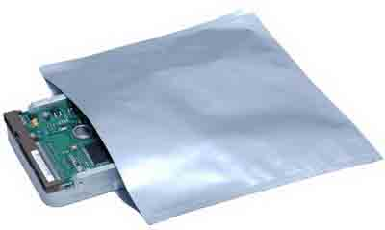
Figure 12: ESD protection bags will be used to transport the board

Project Management:

The team has developed a Gannt Chart for use to track the progress and direction of the project. Each of the six individuals on the team has a non-technical role to help the various aspects of the project be developed efficiently. These non-technical tasks range from developing and maintaining the website all the way to ordering parts and working with coordinating lab space and time. All team members will contribute to the project technically and each member will be assigned tasks and challenges to line up with their individual skills or areas in which they would like development. This will be mutually decided by the team manager and the other team members equally.

Non-Technical Roles:

Justin Bohr – Team Manager

Mike Mock – Document Preparation

Yuan Mei – Lab Coordinator

Xie He – Webmaster

Chaoli Ang – Document Preparation

Nate Kesto – Presentation Preparation

Customers Deadlines:

Texas Instruments and the team have divided the design process into three phases. The phases are as follows:

- Phase 1: Design Analog Front End (AFE)
  - Power Supply, Amplification, and Analog Filters
  - Simulate designs in TINA-TI
  - Lay out design on printed circuit board (PCB)
- Phase 2: Test PCB and Interface with Stellaris µC
    - Test and compare with TINA simulations
  - Integrate AFE PCB with Stellaris µC
  - Design proto-type for finger measurements
- Phase 3: Design Final Product
  - Allow real time ECG measurement from fingers
  - Develop algorithm for µC to detect diseases or beats/min

Shown below in Figure 13 is the current Gannt chart which the team is following to stay on track and manage the projects progress in order to meet the teams goals and direction.
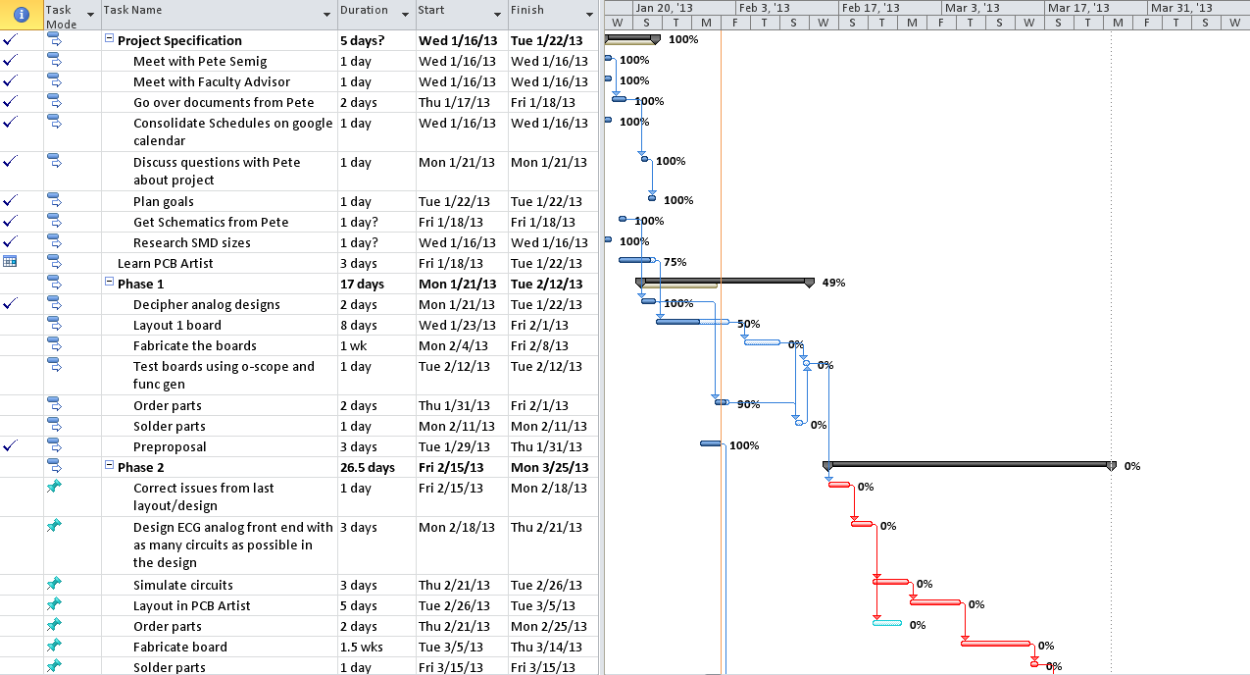

Figure 13: Gannt chart used to track project progress

Major Deadlines:

Oral Presentations: Febrary 15, 2013
Final Proposals Due: February 22, 2013
Final Papers Due: April 24, 2013
Design Day: April 26, 2013
Project Cost:

The design team has been given a budget of $500. This will cover the costs of the project. Many resources used for the project have been financially provided to the team. These include TINA-TI simulation software, free samples of integrated circuits, and PCB artist layout software. Much of the budget will be used for ordering the PCB layouts which cost $33 for a 2-layer and $66 for a 4-layer board. The remaining portions of the costs will originate from ordering parts from online suppliers of electronic devices. At this stage in the design process, the total cost for the project will fall between $200-$300. This includes the design revisions needed to research and develop the final board. The cost to fabricate and produce the final demonstration board will be $75-100 dollars. Using the total budget from ECE480 of $500, the team will be able to design, fabricate, and test the demonstration boards throughout the semester to ultimately produce the final product to TI without going over-budget.

