An Interactive Radar Demonstration for Children



Michigan State University
ECE 480
Spring Semester 2012
Design Team 5

Steve Hughey
Andrew Myrick
Andrew Renton
Nur Syuhada Zakaria

Project Sponsor:
Brad Perry
Massachusetts Institute of Technology Lincoln Laboratory

Executive Summary
Our goal was to develop an interactive radar demonstration to appeal to children aged 5-12. Using the Massachusetts Lincoln Labs radar kit as a starting point, we developed both a hardware-based Pong emulation and a PC-based colorful spectrograph display. The user interacts with the displays by moving back and forth in the radar’s beam path, controlling either the Pong paddle position or the height of the spectrograph. The user can select between range detection and velocity detection; however, velocity detection is unambiguous only for fast-moving objects and is incompatible with the Pong emulation.
We first decided on using an Arduino board for signal processing, as this platform is relatively inexpensive and versatile, and it has an extensive user community to draw upon for ideas and code examples. For graphics processing we chose the 4D Labs PICASO µVGA card. Like the Arduino platform, the PICASO has an active internet community and a wide range of potential applications. With this combination of processing platforms, we decided an emulation of the famous Pong game would be a simple, achievable vehicle for our demonstration of the radar.
We were successful in developing the Pong emulation on the PICASO and in facilitating communication of data from the Arduino to the PICASO; however, the input signal contained limited range information and was quite noisy, so extraction of useful information is rather difficult. After testing and tweaking of the radar kit’s input circuit, we constructed a filtering and biasing circuit to optimize the signal for input into the Arduino. This helped clean up the signal and made it more useful, though the range limitation still existed. Although we were unsuccessful in improving the limited range of the radar, we succeeded in fulfilling our goal of an interactive Pong emulation for demonstrating the radar. We also incorporated into our design the ability to easily upgrade, change, or otherwise improve the functionality of our demonstration by using reprogrammable microchips and including extra switches for future features or additional game modes.

Acknowledgements
We would like to extend our thanks to our generous sponsors at MIT Lincoln Laboratories, our gracious facilitator, Dr. Radha, the College of Engineering at MSU, and the members of the Arduino and PICASO internet communities for their guidance, advice, and technical expertise.

Contents
1 | Introduction 4
1.1 | Background 4
1.2 | Project Overview 4
2 | Solution Analysis and Approach 6
2.1 | Possible Solutions 6
2.2 | Chosen Solution 7
2.3 | Proposed Budget and Schedule 9
3 | Technical Details 11
3.1 | Hardware 11
3.1.1 | Overview of the System 11
3.1.2 | RF Components 12
3.1.3 | Function Generator and Active Low Pass Filter Circuit 14
3.1.4 |Filter and Biasing Circuit 15
3.1.5 | Arduino Mega 2560 R3 16
3.1.6 | PICASO GFX2 16
3.1.7 | Artesyn NFN40 Power Supply 17
3.2 | Software (interface and design implementation) 17
3.2.1 | Arduino Programming 17
3.2.2 |Processing 18
3.2.3 | PICASO Programming 18
4 | Testing 19
4.1 | Initial Tests 19
4.2 | Re-Testing 20
5 | Cost, Schedule, and Summary 24
5.1 | Cost 24
5.2 | Schedule 24
5.3 | Summary 25
5.4 | Conclusion 26
Appendix I: Technical Roles and Responsibilities………………………………………………..….27
Appendix II: Reference Materials and Datasheets…………………………………………………...29
Appendix III: Technical Documentation and Attachments…………………………………………31

1 | Introduction

“Because of radar, astronomers can map the contours of far-off planets, physicians can see images of internal organs, meteorologists can measure rain falling in distant places, air travel is hundreds of times safer than travel by road, long-distance telephone calls are cheaper than postage, computers have become ubiquitous and ordinary people can cook their daily dinners in the time between sitcoms, with what used to be called a radar range.” – Robert Buderi, The Invention that Changed the World

1.1 | Background
In the latter half of the 19th century, the experiments of J.C. Maxwell and Heinrich Hertz laid the foundations for radar and, more generally, all modern wireless technology. Following much experimentation of his own, Maxwell corrected, verified, and consolidated mankind’s knowledge of electricity and magnetism into an elegant set of equations known today as Maxwell’s laws. Using Maxwell’s theory, the German physicist Heinrich Hertz demonstrated that electromagnetic waves travel at the speed of light, and that they can be reflected off objects. In the early 20th century, experimenters like Marconi and Tesla postulated a radar-like device, building on the work of Maxwell and Hertz.
In an age that saw the introduction of aircraft, submarines, and other advanced vehicles into military fleets, the ability to detect these new, deadly vessels from a long distance appealed very strongly to high commands around the world. In 1935 the Scot Sir Robert Watson-Watt successfully detected an aircraft’s position using radar. Since the Second World War radar technology has been improved upon significantly, and it is now an integral and familiar component of military technology.
Despite its military heritage, radar has found many applications in the civilian world. Meteorologists use Doppler radar to detect the motion of precipitation in the atmosphere; automotive manufacturers include radar units on their vehicles to detect objects in the path of a vehicle in reverse; members of law enforcement use radar guns to catch speeding motorists, and baseball scouts use similar radar guns to measure the velocity of pitches; air traffic controllers use radar to track activity in the airspace of their jurisdiction… the list goes on. Because of its versatility, radar technology is extremely useful in many modern applications; unfortunately, student interest in radar and its related fields has waned. It is imperative for the US to produce scientists and engineers with expertise in these fields so that it can maintain its technological advantage, both militarily and industrially.

1.2 | Project Overview
Our goal was to develop an interactive radar demonstration that will engage children and hopefully spark an interest in radar technology and its related fields. We believe that an interactive, game-like display with colorful, stimulating graphics will attract their attention and prompt them to wonder how the box across the room knows where they are. If our design is successful, our product will expose children to the fascinating idea of action at a distance and, hopefully, encourage them to pursue an education in science or engineering.

2 | Solution Analysis and Approach

2.1 | Possible Solutions
In order to develop the best possible solution to this problem, it was first necessary to identify the qualities and the desired features of an ideal solution. To this end, we constructed a FAST (Function Analysis System Technique) diagram (Fig. 1) to illustrate the hierarchy of functionality of the ideal solution. This diagram was very helpful in identifying basic requirements of a successful solution to our problem. The rightmost boxes in Fig. 1 contain fundamental needs of our project, which later helped us direct our search for a processing unit.

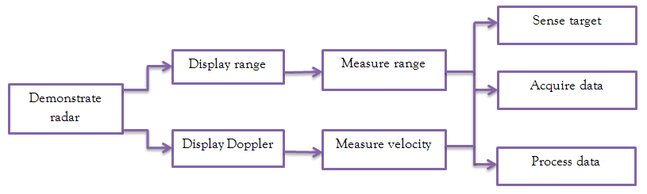
Fig. 1 – FAST diagram for ideal solution.

From the FAST diagram, we determined that the primary method of solution would involve some kind of signal processing chip or platform to extract range and velocity data from the radar signal, and to generate the graphics. We proposed three distinct methods of solution to this task: using Arduino and PICASO boards in communication with one another, using a laptop to perform both tasks, or programming a digital signal processing (DSP) chip to perform both tasks. To evaluate the relative utility of each of these solutions, we constructed both a solution matrix and a feasibility matrix and compared the results of each possible solution with the others. For the solution matrix, which can be seen in Table 2.1, we identified critical customer requirements (CCRs) for our product and rated each solution in terms of how agreeable they are with each CCR. As we can see from the solution matrix, we discovered Arduino-PICASO communication held a slim advantage over using a laptop. The DSP chip idea was more or less vanquished by this analysis, as it would be difficult to use and program, and graphics generation would be extraordinarily difficult on a platform designed specifically for signal processing.

Engineering Criteria | Importance | Possible Method of Solutions
Engineering Criteria | Importance | Arduino and PICASO Based Processing | Laptop | Digital Signal Processing Chip
Portable | 8 | 9 | 9 | 9
Graphical Data Communication | 9 | 3 | 9 | 1
Low Power Consumption | 3 | 9 | 3 | 9
Real Time Processing | 10 | 9 | 9 | 9
Ease of use | 10 | 9 | 9 | 3
Maintenance | 7 | 9 | 3 | 9
Total |  | 369 | 363 | 291
Table 2.1 – Solution matrix.

2.2 | Chosen Solution

In order to settle the debate between the Arduino-PICASO method and the laptop method, we created a feasibility matrix, as seen in Table 2.2. The Arduino-PICASO method won the debate in a landslide, as the cost and time investments would be significantly less than those of a dedicated laptop. At this point it was clear the most desirable solution was to do our signal processing on the Arduino and the graphics processing on the PICASO.
Feasibility | Importance | Possible Method of Solutions
Feasibility | Importance | Arduino and PICASO Based Processing | Laptop | Digital Signal Processing Chip
Cost | 8 | 9 | 1 | 3
Time | 10 | 9 | 3 | 1
Safety | 7 | 9 | 3 | 9
Visual Output | 5 | 3 | 9 | 3
Total |  | 240 | 104 | 112
Table 2.2 – Feasibility matrix.

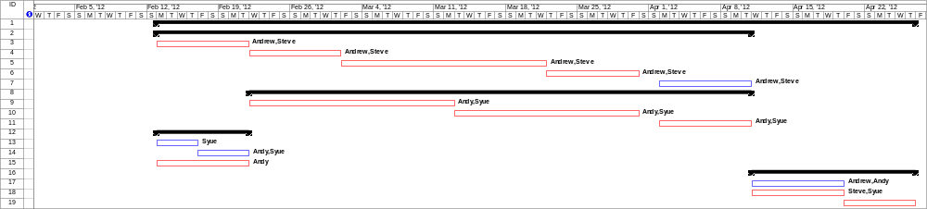Fig. 2.1a – Gantt chart, first half.
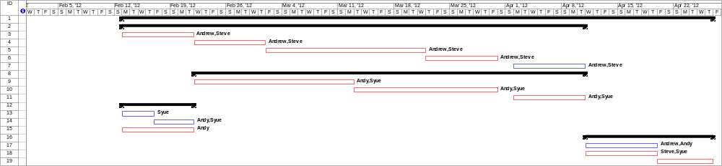Fig. 2.1b – Gantt chart, second half.

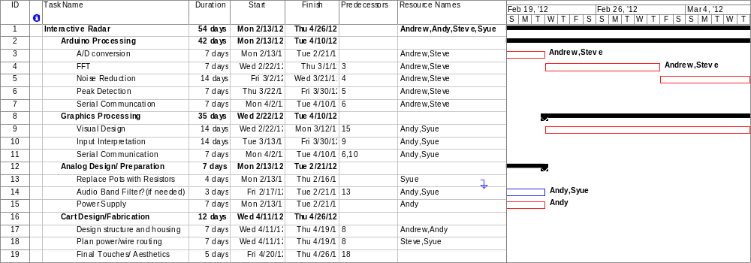
Fig. 2.1c – Gantt chart task detail.

Our choice of Arduino-PICASO processing allows the separate stages of data processing and graphics generation to be performed by different units, so that the capabilities of one stage can be upgraded easily without affecting the other. The separate platforms also allow development to take place in parallel, so a roadblock in one stage does not hold up progress on the other stage.
We were convinced our proposed design would work because the Arduino’s 16 MHz clock and its 10-bit ADC port with a variable sampling rate allow a wide band of frequencies to be represented with little quantization error, and the signal processing would not significantly delay the real-time display. Additionally, the PICASO is capable of producing quality graphics, and it is simple to program, making the design process easier, and increasing the likelihood of producing a visually stimulating demonstration.
In order to display the radar, we also require a monitor and a stand to hold the entire system. We decided to use an LCD screen to display the graphics, and a rolling audio/visual cart as the stand. The rolling cart makes transportation of the product easy, and it also has a shelf which sits a few feet off the ground – perfect height for children to interact with the radar. The LCD screen provides a crisp display, and it uses significantly less energy than a similarly-sized CRT monitor.

2.3 | Proposed Budget and Schedule

Upon deciding to proceed with the proposed design, we drafted a preliminary budget of $500 total for completion of the project. We set aside $250 for microcontrollers and associated costs, including $55 for the PICASO, and $55 for the Arduino. We determined we would need less than $100 for cart construction, since the movable A/V cart cost only $31.50. In order to protect ourselves in the event of any kind of failure of the aforementioned components, we set aside $150 for additional unforeseen costs.
In order to organize our design effort efficiently, we created a Gantt chart (Figs. 2.1a-c) showing the tentative schedule we decided upon as a group. By allocating a known time for each step of the design process, we anticipated we would be able to coordinate our efforts and work in parallel on various components of the design. By the end of the design process, we had deviated from our proposed schedule by only a small amount. Snags in the Arduino programming and in the operation of the RF stage held back our progress slightly. Overall, we followed the Gantt chart as closely as one could realistically expect us to.

3 | Technical Details

3.1 | Hardware

3.1.1 | Overview of the System
The radar system consists of three major components which are the antennas, microcontroller box and an output screen. The antennas are mounted on top of the microcontroller box. The box sits at approximately 1 meter height on the cart, which is roughly the average height of an 8 to 10 year old child. The LCD display screen is placed on a shelf at an appropriate height to ensure visibility from 4 meters away. Each of the three units is modular, allowing various placements to aid in the maintenance of the radar system in the MIT Museum.
. 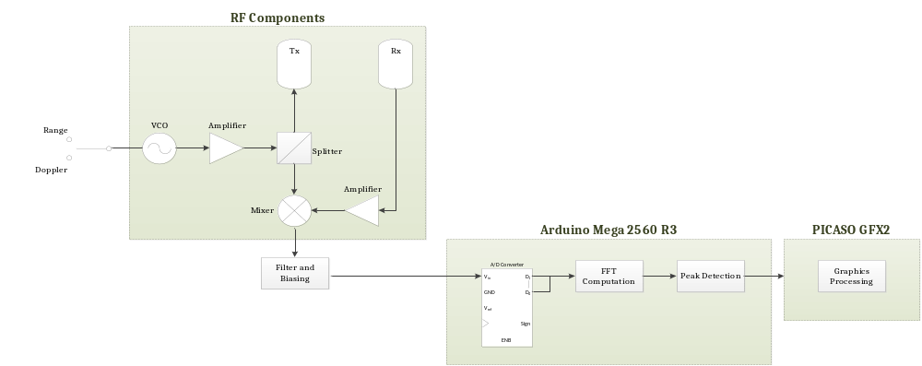

Fig. 3.1 - Block diagram of our design
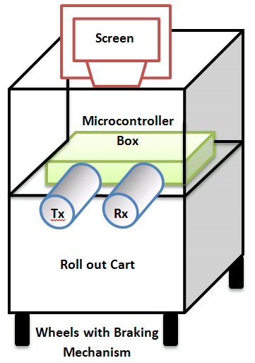
Fig. 3.2 – Diagram of the physical final product.

To demonstrate the radar system, the user needs to have a reflective device, e.g. a metal box or cookie sheet, in hand, and must direct the device to the radar. The user also needs to be in the line of sight of the antennas for detection. The position of the player’s paddle on the screen depends on the user’s distance from the radar system.

3.1.2 | RF Components
The RF circuitry of the radar system consists of a VCO, two amplifiers, a splitter and a frequency mixer. Their layout is shown in Fig. 3.3 below. All components are manufactured by Mini-Circuits, having approximately 2.4 GHz operating frequency, and 50Ω impedance.
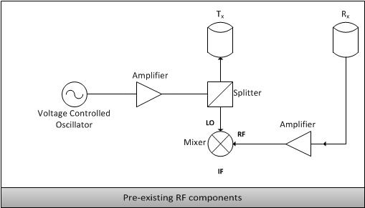
Fig. 3.3 – RF stage layout.

The voltage controlled oscillator (VCO) is set to produce a constant 2.4 GHz signal by supplying its input with roughly 2 V. An IC function generator (XR-2206cp) is used to produce a triangle wave which, when combined with the dc offset, modulates the VCO output, producing a frequency-modulated continuous wave (FMCW) signal. The signal is then channeled through the splitter to divide between the transmitting antenna and the mixer’s local oscillator (LO) port for downconversion with the radio frequency (RF) signal received from the receiving antenna. This signal contains target range or velocity information in its frequency content. The output from the mixer is fed into the Arduino’s ADC port for sampling and signal processing.

3.1.3 | Function Generator and Active Low Pass Filter Circuit
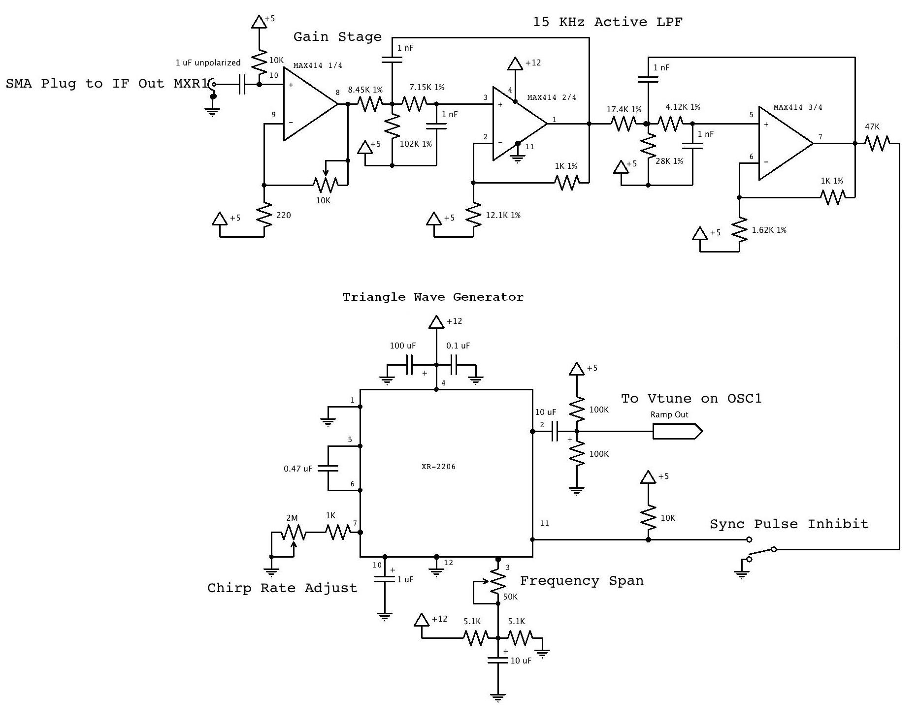
Figure 3.4 - Schematic of Function Generator Circuit and Active Low Pass Filter

The XR-22006cp is a monolithic function generator IC that is used to produce triangle wave signal that modulates the Vtune input pin of the VCO. The voltage at the Vtune pin controls the signal’s frequency. Linear ramping of Vtune causes the VCO to produce a linear FM chirp which is essential to the transmit and receive signals. The ramp waveform sweeps the output frequency from 2.2The average Vtune is 2.5 V which results in a center frequency of 2.408 GHz.
The quad op-amp MAX414 is used in a single-supply configuration to create an active low pass filter. The output of MXR1 is amplified in the gain stage. The signal is then adjusted to max before the op-amp clips during frequency modulation continuous wave mode. This is followed by a 15 kHz 4th order low pass filter to eliminate the higher frequencies, which are artifacts from the mixing process.

3.1.4 |Filter and Biasing Circuit
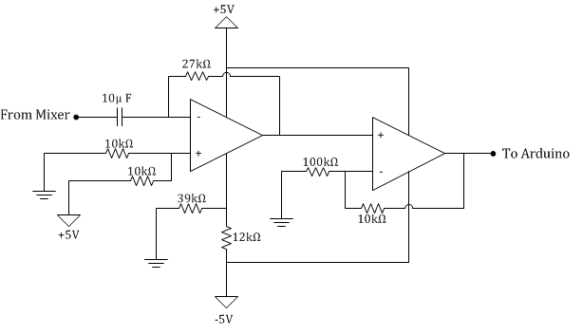
Figure 3.5 – Schematics of Filter and Biasing Circuit
The filtering and biasing circuit depicted in Fig. 3.5 consists of two stages. The first stage blocks the dc component of the input signal, amplifies the ac signal, adds a 2.5 Vdc offset to make the signal compatible with the Arduino processing program’s expected analog input. The second stage acts as a buffer, matching the output impedance of the entire circuit to the input impedance of the Arduino for maximum signal transfer.

3.1.5 | Arduino Mega 2560 R3
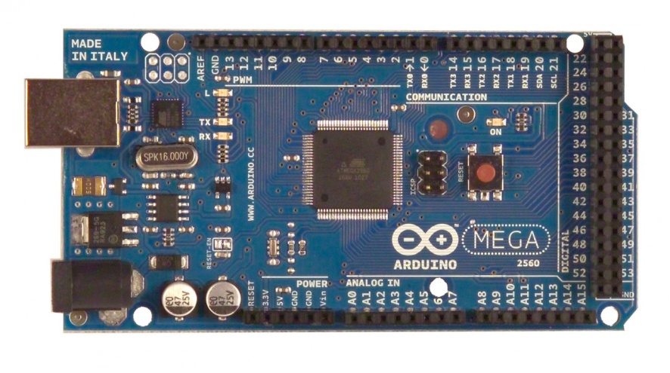
Figure 3.6 – Arduino Mega 2560 R3.
The Arduino MEGA 2560 R3 is the specific model our project employs. It processes the radar output signal and communicates to the PICASO the ranging or speed information gained from the RF stage. It processes information by first utilizing an FIR filter followed by computing the FFT of the signal. The peak detection algorithm then iterates over this output vector and extracts the meaningful peak data with a simple threshold and an averaging algorithm. Target data is then sent via parallel communication to the PICASO for graphical output.

3.1.6 | PICASO GFX2
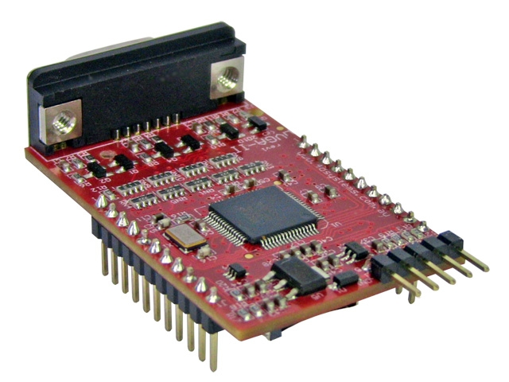
Figure 3.7 – PICASO GFX2.
The PICASO GFX2 board is used for real-time image processing for the Pong emulation. Upper-level graphics functions make the GFX2 easy to use, and its VGA output is compatible with most modern displays. The GFX2 outputs 256 colors which, when compared to similar GPUs, is a wide range. The range and speed information is extracted via parallel communication with Arduino in real time.

3.1.7 | Artesyn NFN40 Power Supply
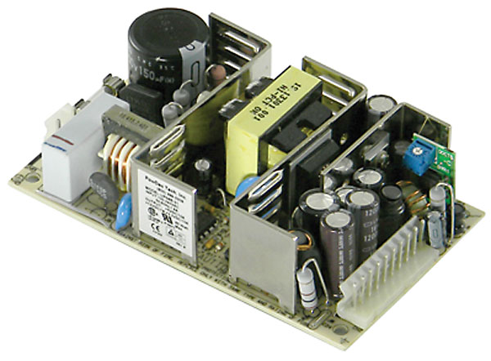
Figure 3.8 – Artesyn NFN40 power supply.
The Artesyn NFN40 power supply is an AC/DC universal switch mode power supply that provides 12 Vdc and 5.1 Vdc to the radar kit. The 45 kHz switching frequency introduces negligible noise into both the digital stages and the RF stages.

3.2 | Software (interface and design implementation)

3.2.1 | Arduino Programming
Arduino’s standard language offers a wide range of typical data processing steps wrapped in easy to use functions. Libraries for specific hardware and more advanced computation are widespread, making functional projects easy to implement. Basic program templates for the Arduino provide services for sequential looping and polling. Testing of the Arduino will be discussed further in Chapter 4.

3.2.2 |Processing
Testing programs for the Arduino were developed using Processing, a free Java-based scripting language with built-in graphics functionality. This requires that a serial communication be established between the Arduino and the PC that Processing is running on. Processing was used purely as a test bed for Arduino input for this project. The graphical outputs and their interpretation will be discussed further in Chapter 4.

3.2.3 | PICASO Programming
Programming the PICASO is made easier by the device having a myriad of internal functions at the coder’s disposal. We first tested the PICASO to see what quality, resolution and frame rate of graphics was produced as output to a 640X480 resolution VGA monitor. The demo program supplied by 4D Systems at their website provided a good platform to test the capabilities of the device.
We decided on a very simple game of Pong in order to display range information in a manner that would most likely be appealing to younger crowds. The demo had some rudimentary elements of the necessary code required to implement Pong on the PICASO. Major improvements to the code were developed to detect collisions on the paddles, randomize ball position and style, include logos for MSU and MITLL between games, make most parameters easily adjustable and access to various counters for debug purposes was implemented.
At first we tried to do serial communication between the Arduino and the PICASO, using only two wires, but we were unsuccessful implementing that communication method. We then choose to use 8 wires to communicate in parallel. The serial issue most likely arose from a timing misconfiguration between the two platforms. Rather than spending time getting it to work, we just used another communication option which could easily be coded and verified.

4 | Testing

4.1 | Initial Tests
Testing the radar output was an iterative process with ever improving test programs and output. Initially the FFT data was used to produce a real time bar graph of the last processed spectrum. An example is shown in Fig. 4.1 below. Later iterations expanded on this and produce a spectrogram with relative brightness as shown in the images later in this chapter.

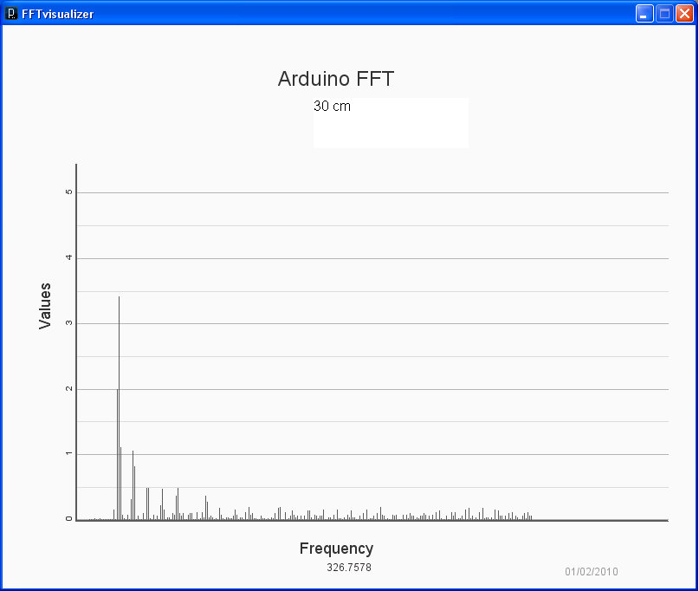
Figure 4.1 – Processing display of radar signal’s frequency components.

To verify the function of the Arduino ADC and FFT functions a waveform generator was used to produce dc offset sine waves in the hopes of a pure clean signal. Figure 2 below shows the Arduino output with the standard sampling rate and ADC settings. Major frequencies are labeled and intermediate steps can be seen when the generator was being adjusted. The number displayed is the programs best guess at the frequency input. At the time of the picture a 3kHz signal was being used leading to a accuracy of about 99%. Lower frequencies tend to be more ambiguous and have a lower typical accuracy.

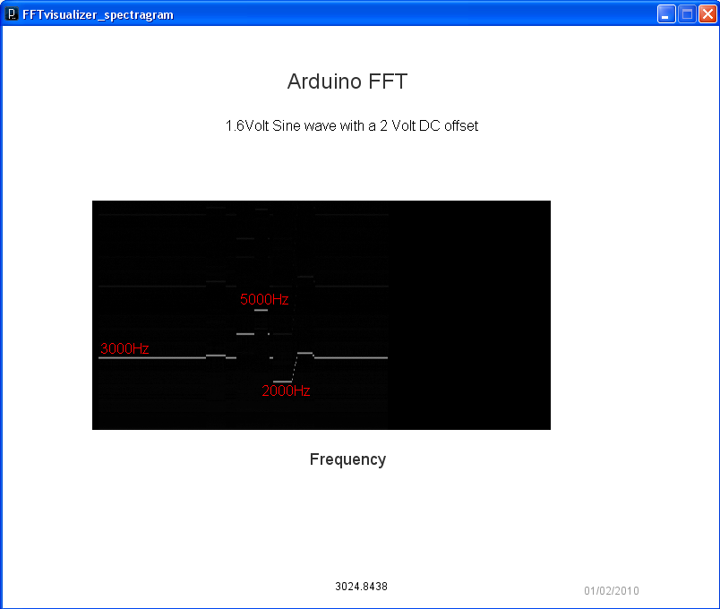
Figure 4.2 – Processing display of function generator input in spectrogram form before increasing sampling rate.

4.2 | Re-Testing
Tweaking the Arduino internal settings in addition to speeding the sampling rate expands the visible window into nearly the entire audio range while adding a minimum of harmonic noise. Figure 2 shows the maximum detectable frequency is expanded by a factor of two while adding harmonic content, visible as faint bars which are aliased to a lower frequency. Similar to the first, the frequency extraction is attempted at the bottom of the picture. The factor of two was not accounted for during the test so it displays roughly half of the input 9 kHz signal. This is roughly where 4.5 kHz would have been with the lower sampling rate, proving its relative consistency.
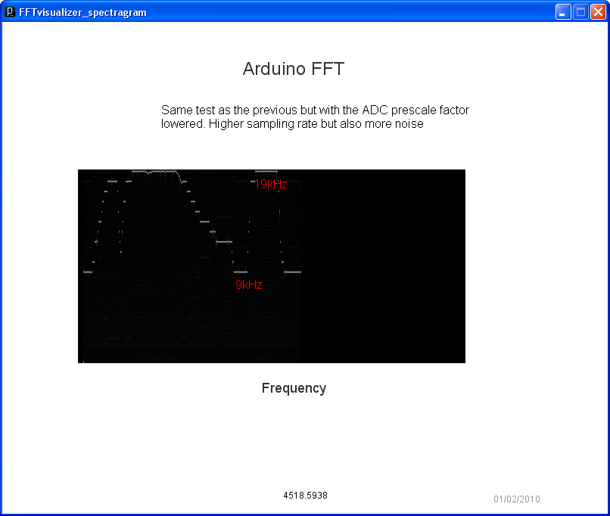
Figure 4.3 – Processing display of function generator input in spectrogram form after increasing sampling rate.

After insuring proper signals were produced with manageable noise, the radar output was processed after basic analog filtering and DC biasing. Ranging signals produce a signal with frequency dependence relative to the target distance. A farther target produces a higher frequency signal as shown in Fig. 4.3. During the course of testing we found that the signal produced by the radar would not deliver a reliable range signal farther than about 2m. The range profile of a cookie sheet being moved back and forth in the radar’s path can be seen in Fig. 4.5. Figs. 4.4 and 4.6 show the radar system being tested for range response.
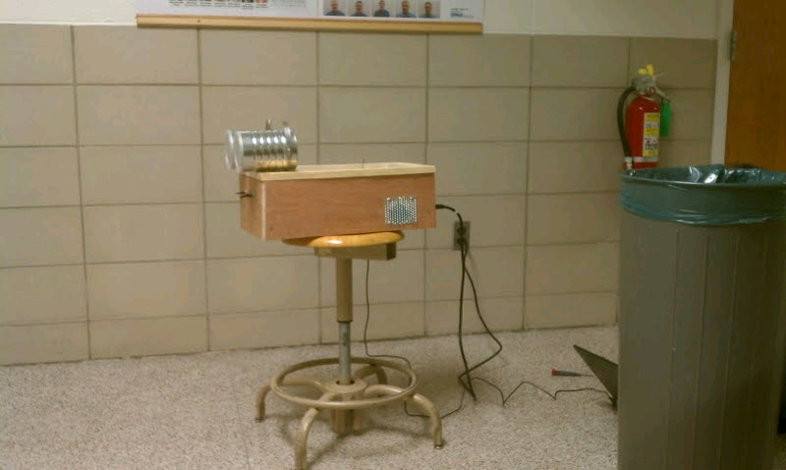
Fig. 4.4 – Radar system being tested in the hallway.

This fact spurred a more directed testing of the RF system utilizing a power meter. Results showed that the VCO was producing a signal with half the expected power, greatly reducing the overall system SNR. We believe this is the primary factor involved in the low maximum range, as the weak signal is washed out in external noise.
The design’s ranging system works semi-reliably within the small range of .5m to 2m. The signal at any given frequency will occasionally pulse giving the peak detection algorithm little to detect. This causes the detected range to fluctuate at its extremes. Doppler functionally is limited for purposes of an indoor test. Velocities necessary for non-ambiguous speed detection are too large to reliably produce without creating dangerous or large scale testing platforms.

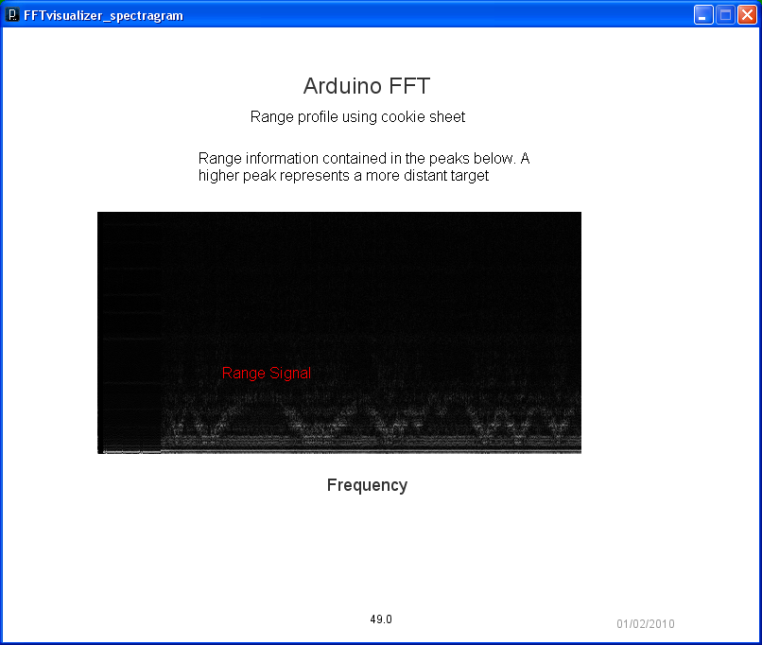
Fig. 4.5 – Processing display of range profile of cookie sheet target in spectrogram form.

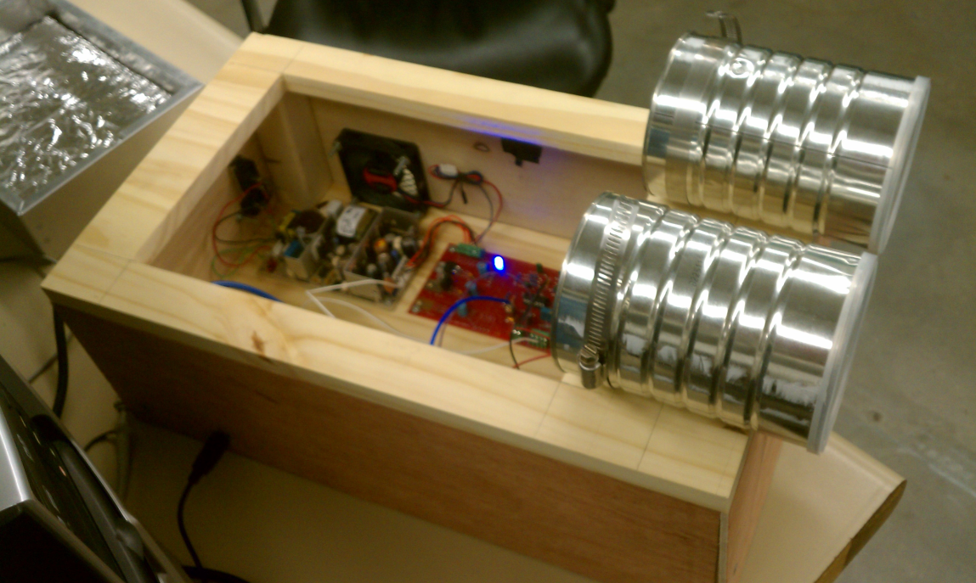
Fig. 4.6 – Radar system being tested for range detection in the lab.

5 | Cost, Schedule, and Summary

5.1 | Cost
The budget allocated for each design team is $500.00. Our team received the most expensive components that are needed for this project – the RF components – from our sponsor. With a final expense total of $198, seen in Table 5.1, we stayed within budget.

Item | Cost
Arduino Mega 2560 R3 | $55.00
PICASO GFX2 | $55.00
Cart | $32.00
Monitor | free
Power Supplies | $18.00
Wood | $15.00
Paint | $14.00
Plexiglass | $8.00
Total | $198.00
Table 5.1 – Design team 5 expenditures.

5.2 | Schedule
The five main tasks were Arduino processing, graphics processing, analog design preparation, testing the radar system and prototype construction. The first three tasks were done in parallel with each other. The testing of the radar was done throughout the whole semester, each time after modifying or adding a component. The construction of final product was done after achieving a decent result.

Task | Start | Finish | Resource Names
Arduino Processing
A/D Conversion | Mon 2/12/12 | Tue 2/21/12 | Andrew, Steve
FFT | Wed 2/22/12 | Thu 3/1/12 | Andrew, Steve
Noise Reduction | Fri 3/2/12 | Wed 3/21/12 | Andrew, Steve
Peak Detection | Thu 3/22/12 | Fri 3/30/12 | Andrew, Steve
Parallel Communication | Mon 4/2/12 | Tue 4/10/12 | Andrew
Graphics Processing
Visual Design | Wed 2/22/12 | Mon 3/12/12 | Andy, Syue
Input Interpretation | Tue 3/13/12 | Fri 3/13/12 | Andy, Syue
Parallel Communication | Mon 4/2/12 | Tue 4/10/12 | Andrew
Analog Design Preparation
Replace Pots with Resistors | Mon 2/13/12 | Thu 2/16/12 | Syue
Power Supply | Fri 2/17/12 | Tue 2/21/12 | Andy
Power Testing | Mon/13/12 | Tue 2/21/12 | Steve, Syue
Radar System Testing | Mon 2/13/12 | Thu 4/26/12 | Andrew, Steve, Syue, Andy
Prototype Construction | Wed 4/11/12 | Thu 4/26/12
Design Structure | Wed 4/11/12 | Thu 4/19/12 | Andrew, Steve, Syue
Components/Circuits housing | Wed 4/11/12 | Thu 4/19/12 | Andrew, Steve
Wire Routing and Switches | Wed 4/11/12 | Thu 4/19/12 | Andrew, Steve
Final Touches/Aesthetics | Fri 4/20/12 | Thu 4/26/12 | Andrew, Steve, Syue
Table 5.2 – Design team 5’s schedule.

5.3 | Summary
The purpose of this project is to demonstrate the radar to children of age 5 to 12 through interaction with a real-time display. This project aims to spark children’s interest in science and engineering. The radar kit, which consists of one transmitting antenna, one receiving antenna, 2.4 GHz RF components such as VCO, amplifier, mixer, and splitter, waveform generator circuit, and active low pass filter circuit, was provided to us by Massachusetts Institute of Technology Lincoln Laboratory. MITLL had previously sponsored two design teams to carry out a similar project that processes range and speed in real time. However, those teams were unable to achieve the sponsor’s requirements, mainly in real time processing.
The interactive radar system was built with two main processing components – the Arduino Mega 2560 R3, for signal processing, and the PICASO GFX2, for image processing. The Arduino is used to compute the FFT of the receiving signal, perform peak detection, and to relay the detected peak to the graphics processing stage. The PICASO is used to display the processed information through VGA output. Both of these microcontrollers are linked via parallel communication. The final outcome is an emulation of Pong on the monitor. The left paddle is controlled by the user and the right paddle is controlled by an artificial intelligence program written into the PICASO code. Basically, the left paddle moves up on y-axis as the user gets closer to the radar and down on y-axis as the user goes further from the radar. The whole system is powered by an Artesyn1 NFN40 switch mode power supply that provides 12 Vdc and 5 Vdc. The microcontrollers, circuits, power supply and RF components are enclosed in a wooden box, and the antennas are mounted on top. This box provides protection to the components for the safety of the equipment and the user. It is placed on a roll out cart with the monitor to create a portable system suitable for museum exhibition.
Our team achieved range detection in real time even though the range is only approximately 2 meters. Our initial expectation was about 6 to 8 meters. The possible cause of this small range could be insufficient power production by the VCO or imperfect noise reduction. Nevertheless, the radar system is able to detect a short range that is sufficient for the children to observe the effect in the Pong emulation. Initially, the Arduino and PICASO were linked through serial communication. This attempt was unsuccessful probably due to lack of language knowledge or a clock synchronization error. Thus, we shifted to parallel communication which uses multiple wire channels and provides faster data transfer.
Our major failures are not being able to display velocity, and the poor range. We were able to process the speed information because it is essentially the same processing as range. Due to time constraints, we were not able to do further signal processing to obtain decent speed information. Velocity detection does not work at low speeds, as the frequencies containing low velocity information cannot be sampled by the Arduino because they are too low. Additionally, our sponsor initially requested a dual power resource, from the power supply or battery to increase the accessibility of the product. Having two supplies and a switch would make our design more complicated and due to time shortage, we were unable to achieve this goal. Regardless of the issue, our product is still convenient to use with only a single cord that should be plugged to the wall and having all components on a movable cart.
For future reference, it would be a good idea to test the functionality of all components before implementing it in the design. Some circuits and components that were handed down might not work as expected, which could cause the team to take a step back and run necessary testing or replace faulty components. It would also be beneficial to get as much assistance as possible from professionals, either in person or online.

5.4 | Conclusion
In brief, our design project has been partially successful in that it is able to detect approximately 2 meter range in real time and produce a Pong emulation to create an interactive platform. The radar system also fits the stand-alone criteria given by MITLL. On the other hand, the unachieved goals are displaying velocity data in real time, and providing a dual power source of power supply and battery that can be used simultaneously. We have provided ample room for expansion of functionality by choosing user-friendly processing platforms and including unused switches on the box, and we hope a future team can improve on our design in order to better interest children in science and engineering careers.

Appendix I: Technical Roles and Responsibilities


Andrew Renton


Steve Hughey


Nur Syuhada Zakaria


Andrew Myrick

Andrew Renton is a senior in both electrical and computer engineering. He is the project manager of team 5. His main technical role is programming the Arduino to extract range and speed information from the radar circuit. He programmed the Arduino to perform FFT, peak detection, FIR filtering, and noise cancellation. He also wrote a spectrograph program to observe the range versus time for testing. He and Hughey designed and constructed a filtering and biasing circuit to optimize the signal for the Arduino. He successfully connected the Arduino and PICASO via parallel communication. He played a central role in testing of the radar system and the construction of the end product.

Steve Hughey is a senior in electrical engineering and the webmaster of this team. He is interested principally in electromagnetics, and he will be continuing his education in this field. He is mainly in charge of programming the Arduino and designing/building the filtering and biasing circuit alongside Renton. He focuses on understanding the theoretical radar concepts, making it easier to troubleshoot the issues that arose regarding the radar kit. He also tested the functionality of the RF components by measuring the power and measured the size of the antenna. He helped test the radar system, and he helped construct the end product.

Nur Syuhada Zakaria is a senior in electrical engineering and the presentation coordinator of this team. She is also an electromagnetics enthusiast. She is mainly in charge of programming the PICASO alongside Myrick. She focuses on researching theoretical concepts of the “Pong” emulation and how to implement it. She measured the power going through the RF components with Hughey using the power meter. She replaced the pot with a fixed-value resistor in the ramp generator circuit to fix the dc offset. She also helped with testing the radar system and with end product construction.

Andrew Myrick is a senior in electrical engineering. He is the document coordinator of this team. His main technical role is programming the PICASO to produce a visually stimulating output for children, in cooperation with Zakaria. He attempted serial communication between the Arduino and PICASO units. He was in charge of selecting the most suitable power supply to be used in this project.

Appendix II: Reference Materials and Datasheets

Textbook

[1]M. Skolnik, Introduction to Radar Systems, Edition of book, USA: McGraw-Hill Book Company Inc, 1962, p. 648.

Websites
[2]Arduino. Arduino, n.d. Web. Feb. 2012. <http://www.arduino.cc/>.
[3]Fry, Ben, and Casey Reas, eds. Processing. Media Temple, n.d. Web. Feb. 2012. <http://processing.org/>.
[4]MIT Open Courseware. Massachusetts Institute of Technology Lincoln Laboratoty, 2002. Web. Feb. 2012. <http://ocw.mit.edu/index.htm>.
[5]U.S. Centennial of Flight Commission. N.p., n.d. Web. Mar. 2012. <http://www.centennialofflight.gov/essay/Evolution_of_Technology/radar/Tech39.htm>.
Datasheets and Manuals
[6]" Coaxial Voltage Controlled Oscillator ZX95-2536C+." Datasheet (2011): 2. Mini-Circuits. Web. Mar. 2012. <http://www.minicircuits.com/pdfs/ZX95-2536C+.pdf>.
[7]"LM471 Operational Amplifier." Datasheet (2000): 9. National Semiconductor. Web. Mar. 2012. <http://www.ti.com/lit/ds/symlink/lm741.pdf>.
[8]"NFS40 and NFN40 Series." Datasheet (2000): 26. Artesyn Technologies. Web. Feb. 2012. <http://www.datasheetcatalog.org/datasheets2/50/50695_1.pdf>.
[9]"PICASO GFX2 Datasheet." Embedded 4DGL Graphics Controller 4 (2012): 29. 4D Labs. Web. Feb. 2012. <http://www.4dsystems.com.au/downloads/Semiconductors/PICASO-GFX2/Docs/PICASO-GFX2-DS-rev4.pdf>.
[10]"PICASO GFX2 Manual." Internal 4DGL Functions 4 (2012): 315. 4D Labs. Web. Feb. 2012. <http://www.4dsystems.com.au/downloads/Semiconductors/PICASO-GFX2/Docs/PICASO-GFX2-4DGL-Internal-Functions-rev4.pdf>.
[11]"XR-2206 Monolithic Function Generator." Datasheet (1997): 16. XP EXAR. Web. Feb. 2012. <http://www.datasheetcatalog.org/datasheet/exar/XR2206v103.pdf>.

Appendix III: Technical Documentation & Attachments

MATLAB Simulation
Range Simulation
clc; clear all; format long e;
% Declare constants
Fs = 40000; % Sampling freruency
T = 1/Fs; % Period
osf = 100;
T0 = 100e-6;
t = [0:T/osf:T0];
w = 2 * pi * 2.4e9; % Angular frequency
fm = 50; df = 330e6;
alpha = .1;
d = 4; % Target distance in m
c = 3e8;
delay = 2 * d / c;
lambda = c / (w / 2 / pi);
dr = c / 2 / df; % Range resolution

% Calculate range
r = 2*pi*df * sawtooth(2*pi*fm*t,0.5);
% r = 2*pi*df * sawtooth(2*pi*fm*t,1);
Tx = cos((w+r).*t);
Yx = alpha * cos((w+r).*(t-delay));
%Rx = awgn(Yx,3); % Add white Gaussian noise
Rx = Yx;
Sx = Tx .* Rx;
tay = taylorwin(length(Sx));
%tay = hamming(length(Sx));
A = tay .* Sx';
X = fftshift(fft(A));
spec = fftshift(fft(Sx));
f = [-Fs/2:1/T0/osf:Fs/2];

% Calculate weighted-mean beat frequency
%fb1 = abs(spec(Fs/2+2:Fs+1))*f(Fs/2+2:Fs+1)';
%fb = fb1 / Fs / 2;
[Y1,I1] = max(abs(spec(Fs/2+2:Fs+1)));
[Y2,I2] = max(abs(X(Fs/2+2:Fs+1)));
fb1 = f(Fs/2+I1);
fb2 = f(Fs/2+I2);

% Plot the figure
subplot(3,1,1);
plot(f,abs(spec)/Y1); title('No windowing');
title('Normalized Spectrum of Mixed Signal w/ Stationary Target (R = 2 m)');
xlabel('Frequency (Hz)'); ylabel('Magnitude');
% subplot(3,1,1); plot(t,Tx);
% subplot(3,1,2); plot(t,Rx);
% subplot(3,1,3); plot(t,Sx);
subplot(3,1,2);
plot(f,abs(X)/Y2); title('With windowing');
R1 = c * fb1 / 8 / df / fm
R2 = c * fb2 / 8 / df / fm
subplot(3,1,3); title('Difference in FFTs');
plot(f,(abs(X)'/Y1)-(abs(spec)/Y1));
a1 = mean(abs(A));
a2 = mean(abs(Sx));

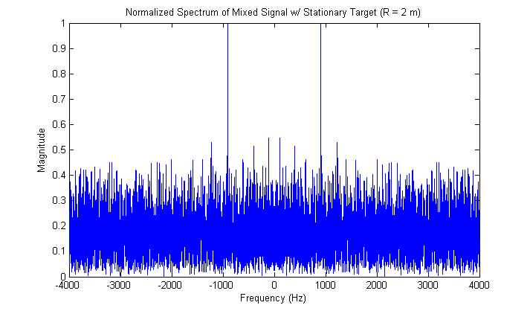
Fig. 1 – MATLAB Range Simulation (R = 2 meter)
Doppler Simulation
clc; clear all;
Fs = 1e3;
T = 1/Fs;
T0 = 8;
t = [0:T:T0];
w = 2 * pi * 2.4e9;
Tx = cos(w.*t);
alpha = .5;
d = 16*t; % Target is moving at 16 m/s
c = 3e8;
lambda = c / (w / 2 / pi);
Yx = alpha * cos(w.*t+(4*pi*d/lambda));
Rx = awgn(Yx,3); % Add white Gaussian noise
Sx = Tx .* Rx;
spec = fftshift(fft(Sx));
f = [-Fs/2:1/T0:Fs/2];

% Plot the figure
plot(f,abs(spec)/max(abs(spec)));
title('Normalized Spectrum of Mixed Signal w/ Moving Target (v = 16 m/s)');
xlabel('Frequency (Hz)'); ylabel('Magnitude');

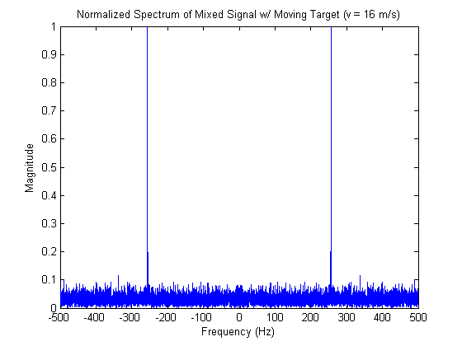
Fig. 2 – MATLAB Doppler Simulation (Speed = 16m/s)
Arduino Processing
Extracting Range Information

String xLabel = "Frequency";
String yLabel = "Values";
String Heading = "Arduino FFT";
String URL = "01/02/2010";
float Vcc = 255.0; // the measured voltage of your usb
int NumOfVertDivisions=5; // dark gray
int NumOfVertSubDivisions=10; // light gray

int NumOfBars=256; // you can choose the number of bars, but it can cause issues since you should change what the arduino sends
// if these are changed, background image has problems
// a plain background solves the problem
int ScreenWidth = 800, ScreenHeight=650;

////////////////////////////////Serial Port///////////////////////////
import processing.serial.*;
Serial myPort;
boolean firstContact = false;
int[][] serialInArray = new int[NumOfBars+1][NumOfBars*2];
int serialCount = 0;
String s="Processing";
int slowdown=0;
float tempor;
float samprat=9560/2;
float lastbin=0,avgbin=0;
int offset=0;

//////////////////////////////////////////////////////////////////////
int LeftMargin=100;
int RightMArgin=80;
int TextGap=50;
int GraphYposition=200;
float BarPercent = 0.4;
int value;
PFont font;
PImage bg;
int temp;
float yRatio = 0.58;
int BarGap, BarWidth, DivisounsWidth;
int[] bars = new int[NumOfBars];

void setup(){

bg = loadImage("BG.jpg");

////////////// NB SETTINGS //////////////////////////////////////////
myPort = new Serial(this, Serial.list()[0], 57600);
//////////////////////////////////////////////////////////////////////

DivisounsWidth = (ScreenWidth-LeftMargin-RightMArgin)/(NumOfBars);
BarWidth = int(BarPercent*float(DivisounsWidth));
BarGap = DivisounsWidth - BarWidth;

size(ScreenWidth,ScreenHeight);
font = createFont("Arial",12);

textAlign(CENTER);
textFont(font);
for(int i=0; i<NumOfBars; i++){
for(int j=0; j<NumOfBars*2; j++){
serialInArray[i][j]=0;
}
}
}

void draw(){
// background(bg); // My one used a background image, I've
background(255); // commented it out and put a plain colour
Headings(); // Displays bar width, Bar gap or any variable.
//Axis();
Labels();
PrintBars();
// Line();
// Dots();
}

///////////////////////// Send Recieve data //////////////////////////
void serialEvent(Serial myPort) {

// read a byte from the serial port:
int inByte = myPort.read();
if (firstContact == false) {
if (inByte == 'A') {
myPort.clear(); // clear the serial port buffer
firstContact = true; // you've had first contact from the microcontroller
myPort.write('A'); // ask for more
}
}
else {
// Add the latest byte from the serial port to array:
serialInArray[serialCount][offset] = inByte;
serialCount++;

// If we have 6 bytes:
if (serialCount > NumOfBars ) {

for (int x=0;x<NumOfBars;x++){

bars[x] = int ((serialInArray[x][offset]/256.0));

}
// Send a capital A to request new sensor readings:
myPort.write('A');
// Reset serialCount:
serialCount = 0;
}
}
}

////////////// Display any variables for testing here/////////////////
void Headings(){
fill(0 );
text("BarWidth",50,TextGap );
text("BarGap",250,TextGap );
text("DivisounsWidth",450,TextGap );
text(BarWidth,100,TextGap );
text(BarGap,300,TextGap );
text(DivisounsWidth,520,TextGap );
}

void PrintBars(){ //prints frequency number as well

int c=0,o=0;
for (int i=0;i<NumOfBars;i++){
//for (int i=NumOfBars-1;i>0;i--){
//fill((0xe4+c),(255-bars[i]+c),(0x1a+c));
for (int j=0; j<NumOfBars*2;j++){
//for (int j=NumOfBars;j>0;j--){
stroke(serialInArray[i][j]);
fill(serialInArray[i][j]);
line(LeftMargin+j, ScreenHeight-GraphYposition-i+0,LeftMargin+j, ScreenHeight-GraphYposition-i+0);
//point(LeftMargin+j, ScreenHeight-GraphYposition-i+0, color(serialInArray[i][j]));
//set(LeftMargin+j, ScreenHeight-GraphYposition-i+0, color(serialInArray[i][j]));
}
// fill(0x2e,0x2a,0x2a);
// text(float(bars[i])/(yRatio*(ScreenHeight))*Vcc, i*DivisounsWidth+LeftMargin+BarWidth/2, ScreenHeight-bars[i]-5-GraphYposition );
// text("A", i*DivisounsWidth+LeftMargin+BarWidth/2 -5, ScreenHeight-GraphYposition+20 );
// text(i, i*DivisounsWidth+LeftMargin+BarWidth/2 +5, ScreenHeight-GraphYposition+20 );
println(serialInArray[i][offset]);
}

//tempor = float((9800/(2*NumOfBars))*serialInArray[NumOfBars]);//-(9560/(NumOfBars*4)); ((samprat/NumOfBars*2)*(serialInArray[NumOfBars][offset]))+(samprat/NumOfBars*4);
tempor = serialInArray[NumOfBars][offset];

//avgbin = (lastbin*serialInArray[NumOfBars])/2;
//tempor = ((samprate/512)*(avgbin))+(samprate/1024);
//println(serialInArray[NumOfBars]);
s= str(tempor);
text(s,400,630);
//lastbin = serialInArray[NumOfBars];
offset++;
if (offset>= NumOfBars*2)
offset=0;
}

void Axis(){

strokeWeight(1);
stroke(220);
for(float x=0;x<=NumOfVertSubDivisions;x++){

int bars=(ScreenHeight-GraphYposition)-int(yRatio*(ScreenHeight)*(x/NumOfVertSubDivisions));
line(LeftMargin-15,bars,ScreenWidth-RightMArgin-DivisounsWidth+50,bars);
}
strokeWeight(1);
stroke(180);
for(float x=0;x<=NumOfVertDivisions;x++){

int bars=(ScreenHeight-GraphYposition)-int(yRatio*(ScreenHeight)*(x/NumOfVertDivisions));
line(LeftMargin-15,bars,ScreenWidth-RightMArgin-DivisounsWidth+50,bars);
}
strokeWeight(2);
stroke(90);
line(LeftMargin-15, ScreenHeight-GraphYposition+2, ScreenWidth-RightMArgin-DivisounsWidth+50, ScreenHeight-GraphYposition+2);
line(LeftMargin-15,ScreenHeight-GraphYposition+2,LeftMargin-15,GraphYposition+80);
strokeWeight(1);
}

void Labels(){
textFont(font,18);
fill(50);
rotate(radians(-90));
//text(yLabel,-ScreenHeight/2,LeftMargin-45);
textFont(font,10);

/* for(float x=0;x<=NumOfVertDivisions;x++){
int bars=(ScreenHeight-GraphYposition)-int(yRatio*(ScreenHeight)*(x/NumOfVertDivisions));
text(round(x),-bars,LeftMargin-20);
}*/

textFont(font,18);
rotate(radians(90));
text(xLabel,LeftMargin+(ScreenWidth-LeftMargin-RightMArgin-50)/2,ScreenHeight-GraphYposition+40);
textFont(font,24);
fill(50);
text(Heading,LeftMargin+(ScreenWidth-LeftMargin-RightMArgin-50)/2,70);
textFont(font);
fill(150);
text(URL,ScreenWidth-RightMArgin-40,ScreenHeight-15);
textFont(font);
}

Fig. 3 – Sine Wave Test with Low Frequency
Fig. 4 – Sine Wave Test with High Frequency

PICASO Programming
Test Demo – Object bouncing off wall

#platform "uVGA-II_GFX2"
/* 4DGL Demo */
#inherit "4DGL_16bitColours.fnc"

// constants for the viewport
#CONST
windowXpos 20
windowYpos 20
windowWidth 620
windowHeight 460
#END
#CONST
TRIANGLE 3
RECTANGLE 4
PENTAGON 5
HEXAGON 6
LEFTCOLOR 0xF800
RIGHTCOLOR 0xFFFF
TOPCOLOR 0x001F
BOTTOMCOLOR 0x07E0
#END
#CONST
LEFTHIT 20
RIGHTHIT 620
TOPHIT 20
BOTTOMHIT 460
#END

#constant XSPEED 3
#constant YSPEED 2
#constant WALL 20 // outer wall thickness

// constant object definitions
#constant ERASEBALL $ball_x, ball_y, 3, BLACK
#constant DRAWBALL $ball_x, ball_y, 3, ball_color
#constant LEFTWALL $0, 0, WALL , 480, LEFTCOLOR
#constant RIGHTWALL $640-WALL , 0, 640, 480, RIGHTCOLOR
#constant TOPWALL $0, 0, 640-WALL, WALL , TOPCOLOR
#constant BOTTOMWALL $gfx_Rectangle(0, 480-WALL, 640, 480, BOTTOMCOLOR)

var ball_x, ball_y, ball_r, ball_color;
var xdir, ydir;
var targetX, targetY;
var loops;
var buffer_1[16];

var Xcoords[6], Ycoords[6]; // coordinate matrix, maximum is a hexagon

//------------------------------------------------------------------//
func drawWalls()
gfx_Set(PEN_SIZE, SOLID);
gfx_Rectangle(TOPWALL); // Draw Top Wall
BOTTOMWALL; // Draw Bottom Wall
gfx_Rectangle(LEFTWALL); // Draw Left Wall
gfx_Rectangle(RIGHTWALL); // Draw Right Wall
endfunc

//------------------------------------------------------------------//
func collision()
if(ball_x <= LEFTHIT)
ball_x := LEFTHIT;
ball_color := LEFTCOLOR;
xdir := -xdir;
endif

if(ball_x >= RIGHTHIT)
ball_x := RIGHTHIT;
ball_color := RIGHTCOLOR;
xdir := -xdir;
endif

if (ball_y <= TOPHIT)
ball_y := TOPHIT;
ball_color := TOPCOLOR;
ydir := -ydir;
endif

if(ball_y >= BOTTOMHIT)
ball_y := BOTTOMHIT;
ball_color := BOTTOMCOLOR;
ydir := -ydir;
endif
endfunc
//------------------------------------------------------------------//

// blank the screen, draw random dots and then erase
func Blankout()
var n, x, y;
gfx_Set(PEN_SIZE, SOLID); // clear the window
gfx_Rectangle(0, 0, 640, 480, BLACK);
gfx_Set(CLIPPING, ON);

// dots
SEED(1234);
n := -3000;
while (n++<3000)
x := ABS(RAND()%windowWidth) + windowXpos;
y := ABS(RAND()%windowHeight) + windowYpos;
gfx_PutPixel(x , y , RAND());
wend

// undraw the dots
SEED(1234);
n := -3000;
while (n++<3000)
x := ABS(RAND()%windowWidth) + windowXpos;
y := ABS(RAND()%windowHeight) + windowYpos;
RAND();
gfx_PutPixel(x , y , 0);
//pause(1);
wend
endfunc

//------------------------------------------------------------------//
// Builds a polygon with a number of sides determined by var "sides"
// around the current origin. The distance from the origin to the
// equidistent vertices from origin determined
// by var "distance". var "angle" is the starting angle for the
// first virtices. Draws the polygon in color var "colr"
// NB make sure the array is big enough for the required number of sides
//------------------------------------------------------------------//

func MakePolygon(var angle, var sides, var distance, var colr)
var index, step;
index := 0;
step := 360/sides; // work out the step size
while (sides < 360) // until we do a complete polygon
gfx_Orbit(angle, distance);
Xcoords[index] := targetX; // build a polygon in the matrix
Ycoords[index] := targetY;
index++;
angle := angle + step;
sides := sides + step;
wend
gfx_Polygon(index, Xcoords, Ycoords, colr);
endfunc

//------------------------------------------------------------------//
// update the "Frames =" field and display buffer content and status flags

func UpdateCounter(var value)
var ch, n, ser1;
//ser1 := serin1();
com1_Init(buffer_1, 20, 0);
ser1 := serin1();
gfx_Set(CLIPPING, OFF); // turn off the clipping
gfx_MoveTo(100, 400); // move graphics cursor to message area
txt_Set(TEXT_COLOUR, CYAN);
txt_Set(TEXT_OPACITY, OPAQUE);// we want solid text so it erases old text
to(GFX); putstr("FRAMES: ");
to(GFX); putnum(UDEC3Z, value); // print and update the loop count
gfx_MoveTo(100, 300);// move graphics cursor to message area
//pause(1000);
print("BUFFER COUNT: ", ( com_Count() ));
to(GFX); putstr("\nBUFFER CONTENT: ");// show count of chars in buffer
to(GFX); putnum(DEC5, ser1); // print and update

print("\n_Sync = ",com_Sync());// show 1, we got a sync character
print("_Count = ",com_Count());// show how many chars in buffer
print("_Full = ",com_Full());// show buffer flag

print("\n:-");
//n := com_Count(); // use the count to extract the buffer
n := 16 // (or set to 20 so we try to 'over-read' which wont happen)
while(n--)
if( (ch := serin()) < 0) ch := '.'; // print the chars we received, substitute a period if 'over-reading'
putch(ch);
wend

print("\n_Sync = ",com_Sync()); // shows 1, we still remember we got a sync character
print("_Count = ",com_Count()); // shows 0, com buffer has been emptied
print("_Full = ",com_Full()); // shows 1, we still remember the buffer was filled

txt_Set(TEXT_OPACITY, TRANSPARENT); // switch back to transparent text
endfunc

//------------------------------------------------------------------//
var dly, angle;
loops := 0;
dly := 0;
angle := 0;

ball_color := WHITE; // initial ball colour
xdir := 1; ydir := 1; // initial ball direction
ball_x := 320; ball_y := 240; // initial ball position

// set generic target variables for the orbit command
gfx_OrbitInit(&targetX, &targetY);
// clears screen, turns off clipping
gfx_Cls();
// preset the clipping area, activated later...
gfx_ClipWindow(windowXpos, windowYpos, windowWidth, windowHeight);
// draw initial objects
drawWalls(); // draw the Walls
repeat
pause(14); // there is no sync control, pause
gfx_Set(CLIPPING, OFF); // turn off clipping so we can draw outside the clipped area
// remove the horizontal marker
if(ball_x < 640) gfx_Triangle(ball_x, 0, ball_x+3, 10, b all_x+6, 0, BLACK);
// remove the vertical marker
if(ball_y < 480) gfx_Triangle(0, ball_y, 10, ball_y+3, 0, ball_y+6, BLACK);

if (!(dly++ & 31)) // each 16 times through the main loop,
if (!(++loops & 31)) // if start a new pattern
Blankout(); // draw pixels to introduce next screen
ball_x := RAND()%127; ball_y := RAND()%127;
// set ball position
endif
endif

UpdateCounter(dly); // update the "Frames -" count
// undraw current object
gfx_Set(CLIPPING, ON); // now turn the clipping back on

if ((loops & 0x30) == 0x00)
gfx_MoveTo(ball_x, ball_y);
txt_Set(TEXT_COLOUR, BLACK);
to(GFX); print("TEAM 5!!!"); // erase the text
endif

if ((loops & 0x30) == 0x10)
gfx_Set(PEN_SIZE, SOLID);
gfx_Circle(ERASEBALL); // erase the ball
endif

if ((loops & 0x30) == 0x20)
gfx_MoveTo(ball_x, ball_y); // using the balls origin
MakePolygon(angle, TRIANGLE, 10, BLACK);
// undraw old triangle
endif

if ((loops & 0x30) == 0x30)
gfx_MoveTo(ball_x, ball_y); // using the balls origin
MakePolygon(angle, RECTANGLE, 10, BLACK);
// undraw old rectangle
endif

//--------------------------move to new position--------------------//
ball_x := ball_x + xdir * XSPEED; // move to new X pos
ball_y := ball_y + ydir * YSPEED; // move to new Y pos
collision();// detect collision
angle := angle + 10; // step to new angle

//------------------------------------------------------------------//
gfx_Set(CLIPPING, OFF); // now turn off the clipping
// redraw the box
if(ball_x < 640) gfx_Triangle(ball_x, 0, ball_x+3, 10, ball_x+6, 0, MAGENTA);
// redraw the box
if(ball_y < 480) gfx_Triangle(0, ball_y, 10, ball_y+3, 0, ball_y+6, ORANGE);
gfx_Set(CLIPPING, ON); // now turn on the clipping

// redraw required example
if ((loops & 0x30) == 0x00)
gfx_MoveTo(ball_x, ball_y);
txt_Set(TEXT_COLOUR, ball_color);

to(GFX); print("TEAM 5!!!"); // redraw the text
endif

if ((loops & 0x30) == 0x10)
gfx_Set(PEN_SIZE, SOLID);
gfx_Circle(DRAWBALL); // redraw the ball
drawWalls();
endif

if ((loops & 0x30) == 0x20)
gfx_MoveTo(ball_x, ball_y); // using the balls origin
MakePolygon(angle, TRIANGLE, 10, ball_color);
// make 3 sided polygon = triangle
endif

if ((loops & 0x30) == 0x30)
gfx_MoveTo(ball_x, ball_y); // using the balls origin
MakePolygon(angle, RECTANGLE, 10, ball_color);
// make 4 sided polygon = rectangle
endif
forever

endfunc
//------------------------------------------------------------------//

“Pong” Simulation

#platform "uVGA-II_GFX2"
/* 4DGL Simple Pong Demo */
#inherit "4DGL_16bitColours.fnc"
#CONST
TRIANGLE 3
RECTANGLE 4
PENTAGON 5
HEXAGON 6
LEFTCOLOR 0xF800
RIGHTCOLOR 0xF800
TOPCOLOR DARKGREEN
BOTTOMCOLOR DARKGREEN
#END

#constant WALL 20 // outer wall thickness
#CONST
LEFTHIT WALL
RIGHTHIT 640-WALL
TOPHIT WALL
BOTTOMHIT 480-WALL
#END

// constants for the viewport
#CONST
windowXpos WALL
windowYpos WALL
windowWidth 640-WALL
windowHeight 480-WALL
#END

// constant object definitions
#constant ERASEBALL $ball_x, ball_y, 3, BLACK
#constant DRAWBALL $ball_x, ball_y, 3, ball_color
#constant LEFTWALL $0, 0, WALL , 480, LEFTCOLOR
#constant RIGHTWALL $640-WALL , 0, 640, 480, RIGHTCOLOR
#constant TOPWALL $0, 0, 640-WALL, WALL , TOPCOLOR
#constant BOTTOMWALL $gfx_Rectangle(0, 480-WALL, 640, 480, BOTTOMCOLOR)

//------------------------------------------------------------------//
var ball_x, ball_y, ball_r, ball_color, ball_type;
var ard_input := 0;
var XSPEED, YSPEED;

// Set the color, width, and height of paddles
var lpaddle_color := WHITE;
var rpaddle_color := DARKGREEN;
var lpaddle_width := 10;
var lpaddle_height := 60;
var rpaddle_width := 15;
var rpaddle_height := 60;

// Set starting positions of paddles
var lpaddle_x1 := 30;
var lpaddle_y1 := 180;
var rpaddle_x1 := 600;
var rpaddle_y1 := 430;

// initialize the other coordinates for starting positions
var lpaddle_x2 := lpaddle_x1 + lpaddle_width;
var lpaddle_y2 := lpaddle_y1 + lpaddle_height;
var rpaddle_x2 := rpaddle_x1 + rpaddle_width;
var rpaddle_y2 := rpaddle_y1 + rpaddle_height;
var xdir, ydir, loops, angle, lscore, rscore, games;
var targetX, targetY;
var Xcoords[6], Ycoords[6];

//------------------------------------------------------------------//
func resetGame()
ball_type := 0;
angle := 0;
lscore := 0;
rscore := 0;
games++;
SEED(sys_T());
ball_type := ABS(RAND()%10);
splash();
resetBall();
drawWalls();
endfunc

func resetBall()
loops := 0;
angle := 0;
ball_color := WHITE; // initial ball color
xdir := 1; ydir := 1; // initial ball direction
ball_x := 320; ball_y := 240; // initial ball position

XSPEED := ABS(RAND()%100)/10;
YSPEED := ABS(RAND()%100)/10;

if(XSPEED < 3)
XSPEED := 3;
endif
if(YSPEED < 3)
YSPEED := 3;
endif
endfunc

func Score()
var n, x, y, r;
gfx_ClipWindow(ball_x-20, ball_y-20, ball_x+20, ball_y+20);
gfx_Set(CLIPPING, ON);
r := sys_T();

// a really cheap looking explosion of dots
n := -1000;
SEED(r);
while (n++<1000)
x := ABS(RAND()%ball_x) + ball_x;
y := ABS(RAND()%ball_y) + ball_y;
gfx_PutPixel(x , y , RAND());
wend

// undraw the dots
n := -1000;
SEED(r);
while (n++<1000)
x := ABS(RAND()%ball_x) + ball_x;
y := ABS(RAND()%ball_y) + ball_y;
RAND();
gfx_PutPixel(x , y , 0);
wend

gfx_Set(CLIPPING, OFF);
drawWalls();
gfx_ClipWindow(windowXpos, windowYpos, windowWidth, windowHeight);
endfunc

func drawWalls()
gfx_Set(PEN_SIZE, SOLID);
gfx_Rectangle(TOPWALL); // Draw Top Wall
BOTTOMWALL; // Draw Bottom Wall
gfx_Rectangle(LEFTWALL); // Draw Left Wall
gfx_Rectangle(RIGHTWALL); // Draw Right Wall
endfunc

func drawPaddle(var pad_x1, var pad_y1, var pad_x2, var pad_y2, var pad_color)
gfx_Set(PEN_SIZE, SOLID);
gfx_Rectangle(pad_x1, pad_y1, pad_x2, pad_y2, pad_color);
endfunc

func splash()
gfx_Set(CLIPPING, OFF);
gfx_Set(PEN_SIZE, SOLID); // clear the window
gfx_Rectangle(0, 0, 640, 480, BLACK);
var i := 0;
if(games%2)
repeat // display MITLL logo for a few seconds
while(!media_Init());
media_SetSector(0x0000,0x0000);
media_Image(0,208);
i++;
until(i>30);
else
repeat // display MSU logo for a few seconds
while(!media_Init());
media_SetSector(0x0000,0x00A1);
media_Image(50,0);
i++;
until(i>30);
endif
gfx_Set(PEN_SIZE, SOLID); // clear the window
gfx_Rectangle(0, 0, 640, 480, BLACK);
endfunc

func collision()
if(ball_x <= LEFTHIT)
ball_x := LEFTHIT;
ball_color := LEFTCOLOR;
xdir := -xdir;
rscore++;
Score();
resetBall();
endif

if(ball_x >= RIGHTHIT)
ball_x := RIGHTHIT;
ball_color := RIGHTCOLOR;
xdir := -xdir;
lscore++;
Score();
resetBall();
endif

if (ball_y <= TOPHIT)
ball_y := TOPHIT;
ball_color := TOPCOLOR;
ydir := -ydir;
endif

if(ball_y >= BOTTOMHIT)
ball_y := BOTTOMHIT;
ball_color := BOTTOMCOLOR;
ydir := -ydir;
endif
endfunc

func padCollision()
// left paddle collision detection
if(ball_y >= lpaddle_y1)
if(ball_y <= lpaddle_y2)
if(ball_x <= lpaddle_x2)
ball_x := lpaddle_x2;
ball_color := lpaddle_color;
xdir := -xdir;
endif
endif
endif

// right paddle collision detection
if(ball_y >= rpaddle_y1)
if(ball_y <= rpaddle_y2)
if(ball_x >= rpaddle_x1)
ball_x := rpaddle_x1;
ball_color := rpaddle_color;
xdir := -xdir;
endif
endif
endif
endfunc

// Displays various counters, score, debug information
func UpdateCounter()
//gfx_Set(CLIPPING, OFF); // turn off the clipping
gfx_MoveTo(100, 100); // move graphics cursor to message area
txt_Set(TEXT_COLOUR, BLUE);
txt_Set(TEXT_OPACITY, OPAQUE);
// we want solid text so it erases old text

txt_Set(TEXT_BOLD, OFF);
txt_Set(TEXT_WIDTH, 1);
txt_Set(TEXT_HEIGHT, 1);
to(GFX); putstr("FRAMES: ");
to(GFX); putnum(DEC5, loops); // print and update the loop count

gfx_MoveTo(100, 160);
txt_Set(TEXT_COLOUR, RED);
to(GFX); putstr("ball_type: ");
to(GFX); putnum(DEC3, ball_type);
//to(GFX); putstr("ard_input: ");
//to(GFX); putnum(DEC3, ard_input);

// update scores
gfx_MoveTo(50, 350);
txt_Set(TEXT_COLOUR, lpaddle_color);
txt_Set(TEXT_OPACITY, OPAQUE);
txt_Set(TEXT_BOLD, ON);
txt_Set(TEXT_WIDTH, 4);
txt_Set(TEXT_HEIGHT, 4);
to(GFX); putnum(DEC3, lscore);

gfx_MoveTo(480, 350);
txt_Set(TEXT_COLOUR, rpaddle_color);
to(GFX); putnum(DEC3, rscore);
txt_Set(TEXT_BOLD, OFF);
txt_Set(TEXT_WIDTH, 1);
txt_Set(TEXT_HEIGHT, 1);
endfunc

//--------------------------------------------------------------------
Builds a polygon with a number of sides determined by var "sides" around the current origin. The distance from the origin to the equidistent vertices from origin determined by var "distance". var "angle" is the starting angle for the first virtices. Draws the polygon in color var "colr" NB make sure the array is big enough for the required number of sides
--------------------------------------------------------------------//
func MakePolygon(var angle2, var sides, var distance, var colr)
var index, step;
index := 0;
step := 360/sides; // work out the step size
while (sides < 360) // until we do a complete polygon
gfx_Orbit(angle2, distance);
Xcoords[index] := targetX; // build a polygon in the matrix
Ycoords[index] := targetY;
index++;
angle2 := angle2 + step;
sides := sides + step;
wend
gfx_Polygon(index, Xcoords, Ycoords, colr);
endfunc

//------------------------------------------------------------------//
func main()
SEED(sys_T());
bus_Set(1);
gfx_OrbitInit(&targetX, &targetY);
splash();
loops := 0;

// preset the clipping area, activated later...
gfx_ClipWindow(windowXpos, windowYpos, windowWidth, windowHeight);
gfx_Cls();

// draw initial objects and init score
drawWalls();
resetBall();
lscore := 0;
rscore := 0;
repeat
pause(12); // there is no vsync control, pause
ard_input := bus_Read();
UpdateCounter();
++loops;
if((lscore || rscore) >= 1)
resetGame();
endif

// undraw ball and paddles
gfx_Set(CLIPPING, ON);
drawPaddle(lpaddle_x1, lpaddle_y1, lpaddle_x2, lpaddle_y2, BLACK);
drawPaddle(rpaddle_x1, rpaddle_y1, rpaddle_x2, rpaddle_y2, BLACK);

switch
case(ball_type == 0)
gfx_MoveTo(ball_x, ball_y);
txt_Set(TEXT_COLOUR, BLACK);
to(GFX); print("ECE TEAM 5"); // erase the text

case(ball_type == 1)
gfx_MoveTo(ball_x, ball_y); // using the balls origin
MakePolygon(angle, TRIANGLE, 10, BLACK);
// undraw old triangle

case(ball_type == 2)
gfx_MoveTo(ball_x, ball_y); // using the balls origin
MakePolygon(angle, RECTANGLE, 10, BLACK);
// undraw old rectangle

case(ball_type == 3)
gfx_MoveTo(ball_x, ball_y); // using the balls origin
MakePolygon(angle, PENTAGON, 10, BLACK);
// undraw old rectangle

case(ball_type == 4)
gfx_MoveTo(ball_x, ball_y); // using the balls origin
MakePolygon(angle, HEXAGON, 10, BLACK);
// undraw old rectangle

//case(ball_type == 5)
default:
if(ball_type >= 5)
gfx_Set(PEN_SIZE, SOLID);
gfx_Circle(ERASEBALL); // erase the ball
endif
//default:
endswitch

// move ball to new position
ball_x := ball_x + xdir * XSPEED; // move to new X pos
ball_y := ball_y + ydir * YSPEED; // move to new Y pos
collision();
padCollision();

angle := angle + 10; // step to new angle

// move paddles to new positions
// left paddle AI is random
lpaddle_y1 := lpaddle_y1 - (RAND()%40);
lpaddle_x2 := lpaddle_x1 + lpaddle_width;
lpaddle_y2 := lpaddle_y1 + lpaddle_height;
/*
// get new position from arduino
lpaddle_y1 := 2*ard_input;
lpaddle_x2 := lpaddle_x1 + lpaddle_width;
lpaddle_y2 := lpaddle_y1 + lpaddle_height;
*/
if(lpaddle_y1 <= TOPHIT)
lpaddle_y1 := TOPHIT;
lpaddle_y2 := TOPHIT + lpaddle_height;
endif
if(lpaddle_y2 >= BOTTOMHIT)
lpaddle_y2 := BOTTOMHIT;
lpaddle_y1 := BOTTOMHIT - lpaddle_height;
endif

// right paddle AI ALWAYS WINS!!!
rpaddle_y1 := ball_y - rpaddle_height/2;
rpaddle_x2 := rpaddle_x1 + rpaddle_width;
rpaddle_y2 := rpaddle_y1 + rpaddle_height;

if(rpaddle_y1 <= TOPHIT)
rpaddle_y1 := TOPHIT;
rpaddle_y2 := TOPHIT + rpaddle_height;
endif
if(rpaddle_y2 >= BOTTOMHIT)
rpaddle_y2 := BOTTOMHIT;
rpaddle_y1 := BOTTOMHIT - rpaddle_height;
endif

// redraw ball and paddles
switch
case(ball_type == 0)
gfx_MoveTo(ball_x, ball_y);
txt_Set(TEXT_COLOUR, ball_color);
to(GFX); print("ECE TEAM 5"); // draw the text

case(ball_type == 1)
gfx_MoveTo(ball_x, ball_y); // using the balls origin
MakePolygon(angle, TRIANGLE, 10, ball_color);
// draw triangle

case(ball_type == 2)
gfx_MoveTo(ball_x, ball_y);
MakePolygon(angle, RECTANGLE, 10, ball_color);
// draw rectangle

case(ball_type == 3)
gfx_MoveTo(ball_x, ball_y);
MakePolygon(angle, PENTAGON, 10, ball_color);
// draw rectangle

case(ball_type == 4)
gfx_MoveTo(ball_x, ball_y);
MakePolygon(angle, HEXAGON, 10, ball_color);
// draw rectangle

//case(ball_type == 5)
default:
if(ball_type >= 5)
gfx_Set(PEN_SIZE, SOLID);
gfx_Circle(DRAWBALL);
// draw the ball
endif
//default:
endswitch

drawPaddle(lpaddle_x1, lpaddle_y1, lpaddle_x2, lpaddle_y2, lpaddle_color);
//drawPaddle(rpaddle_x1, rpaddle_y1, rpaddle_x2, rpaddle_y2, rpaddle_color);
while(!media_Init());
media_SetSector(0x0000,0x0494);
media_Image(rpaddle_x1, rpaddle_y1);
forever
endfunc
//------------------------------------------------------------------//

