Proposal
Team 7
ECE 480
10/9/15

Spencer Krug
Nathan Vargo
Sun Tianhang
Wang Qifan
Yao Liqing

Table of contents
- Executive Summary
- Background Research
- Design Concepts
- Technical Approach
  - Hardware
  - Software
  - Integration
- Project Management
  - Budget
  - Deliverables
- Team Qualifications

Executive Summary

MSU is in the process of acquiring a 10 MW solar array. The solar array is shown in Figure 1. The yellow rectangles are representations of where the solar panels will be set, and will cover about one square mile. With this much electricity delivered by a renewable source a sudden change in cloud cover will create a reduction in electricity that will make costs to import backup power go up greatly. The present project aims to plan and construct an early warning system based on remote sensors, which will enable users to anticipate changes in the output of the solar array and take appropriate action in the load profile. MSU itself is the customer for the finished output of this project, and will be presented to the Executive Vice President for Administrative Service, as well as the Director of Power and Water.

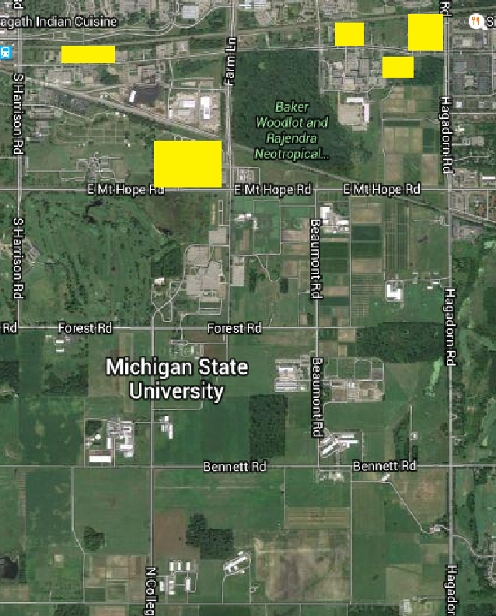
Figure 1. Solar array

Background Research

The initial steps in this project was to research products that could possibly be used in our design. The load profile time constant is around 1 MW per minute. Since the maximum power output is 12 MW, and cloud coverage can drop power output down to 15%, there will have to be a warning 10 minutes prior to the cloud front hitting the solar panels and dropping the load profile. An average cloud front moves at about 40 mph leading to a sensor radius of around seven miles. Since the area to protect is large, a cable connection between the sensors would be unrealistic, leading to the implementation of a wireless sensor network. The data should then be read from the wireless sensor network to a program which will create a real time simulation of the weather, and predict future weather movements. The program will have to take in the sensor location, value and time the sample was taken. Therefore the software needs to have the capability to parse through large amounts of data, as well as the ability to create a user interface.

Design Concepts

Multiple options surfaced when the research was started, leading to several design plans. There are three major components to this project, the sensor type, the wireless network and the software program.

Starting with the sensor type, several options were presented when brainstorming of design concepts started. The sensor will have to take measurements of the amount of sunlight, or irradiance, measured in W/m². The sun outputs an average of 1000 W/m² during the day. Therefore the sensor has to have the capability to reach this level of irradiance. There are commercial irradiance sensors, used in many solar panel applications, called pyranometers. Pyranometers are calibrated to sunlight irradiance and have an high sensitivity to changes in sunlight. These pyranometers are fairly expensive, costing around $200. Looking into less expensive solutions to this problem, a low cost pyranometer can be created from a phototransistor light sensor, and add a sunlight irradiance calibration to find the difference in irradiance values. This leaves the project with two directions, build a pyranometer to integrate or buy a pyranometer.

The problem of a wireless network still exists. A sensor that can integrate a wireless connection is essential for this project. When looking into the market for a pyranometer that has this capability, very little results were found. The pyranometers that have the ability to connect wirelessly, can only connect to a specific data logger. The maximum range of a pyranometer and data logger was around 1000ft, far to short for the scope of this project. Many wireless communication methods have a very short range of operation, for example, bluetooth or infrared. However for this project long range signals are needed. Researching into the types of signals that could reach the length required for this project only one stood out, radio frequency (RF). To create a RF signal RF antennas would need to be purchased, implemented into the sensors as well as research into legally integrating RF bands into the hardware and software. Researching more into it, Wi-Fi can be implemented if there is access to a Wi-Fi signal at the location of the sensor. This will not require external antenna, because of the shorter range of the signal. Thus a wireless sensor network could be built to accomplish the scope of this project. This can also be implemented via a microcontroller capable of sending Wi-Fi signals.

The software program needs to be able to take in data from the sensor array. The ability for the program to continuously take in data, parse the data files, and. The cloud movement will have to be simulated. One way to complete this is to create a user interface (UI) that has a real time simulation of the weather based on the incoming data from the sensors. There are multiple choices of programming languages that can be used to create a UI, and have the capability to handle large amounts of data such as C++, python, and ruby.

Technical Approach

This project consists of creating and interfacing a software program with hardware components. The software program encompasses taking a time series of information on solar irradiance at multiple random GPS point locations defined by the remote irradiance sensors and constructing a future forecast of weather movement. The hardware components that will be constructed contains an irradiance sensor with some support circuitry to enable wireless connectivity.

- Hardware

The hardware part of the project consists of interfacing sensors with a wireless network, and reading the data online via the software components. It will be broken down into two major components. The sensor and supporting hardware for this specific application.

There were several design options for the hardware part of this project. The two most important features of the hardware is to take an accurate measurements of the solar irradiance at any point and the ability to connect to wireless signal. The researched background proposed either making a more cost effective sensor, or buying a commercial pyranometer, which the latter is more expensive. Initially the only option that would remain within the budget for this design was to build a sensor out of a phototransistor. After learning Michigan State will fund the design, the ability to use a commercial pyranometer became an option. The time it would take to build a pyranometer from a phototransistor circuit would be too great to complete the project by the allotted time. Also a commercial pyranometer will have greater accuracy of readings and be much more durable. Therefore a commercial pyranometer will be the sensor type implemented in our design.

The sensor will be an Apogee all weather pyranometer that has an analog voltage output, calibrated to an irradiance value. This sensor was chosen due to its sensitivity, durability, and the ability to operate without a power supply. The sensor is integrated with a heater making it all season compatible which is essential in Michigan due to the vast weather difference in seasons. However this pyranometer outputs an analog voltage, so processing of this analog signal will be needed. To conduct the signal processing, the output will be fed to a microcontroller with Wi-Fi capability.

Adding a microcontroller to each remote location of the sensors will serve two purposes, process the irradiance signal and serve as an access point to the wireless network. Some support circuitry and parts will be needed including a power source as well as a waterproof housing to hold the microcontroller. The data collected will consist of an irradiance output, GPS coordinates as well as a time stamp. The data will be sampled every second to give a good understanding of the weather patterns. This data will then be uploaded via a wireless network to a server where the data will be available for the software program. Therefore the microcontroller has to have the ability to upload the data through a wireless network.

There were several options for a microcontroller with the ability to connect wirelessly to a server. The three that stood out the most were the arduino, particle photon, and electric imp. The arduino is a good competitor simply because it is cheap, very well known and has large amounts of documentation online. However, arduino’s do not have the capability to operate wirelessly. Incorporating a Wi-Fi signal with an arduino will take some time and may delay the design since an antenna would need to be created and properly coded for connectivity. The photon is also a great choice because it is cheap and the microcontroller includes built in Wi-Fi capability, however there is very little documentation. The programming of the photon may become difficult and with little experience in Wi-Fi communication could again delay the project. The third option, the electric imp, stood out the most. It is a little more expensive than the photon, but it comes with a very easy user interface to set up Wi-Fi connections. What was also very attractive about the electric imp is that it comes with an allocation of a cloud to store data. With this, the need to find a server to store data would no longer be an issue. There is also documentation that provides step by step assistance along with example codes. Due to the simplicity and quickness of the electric imp, it is chosen as the microcontroller to meet the scope of the project.

- Software

The software design will based on Microsoft Foundation Classes (MFC), which is widely used to create Office-Style user interface with multiple controls. The software will be designed flexible enough in order to meet the requirement of expending to commercial product in the future. Since the design will use MFC, which is a Microsoft application, the software will be developed using Microsoft Visual Studio and C++ programming language, and packaged into an executable file after the project is finished so that the customer can easily access to the software as long as there’s a Windows machine.

The overall objective of the software consists of reading a data value for each sensor, output the current value of solar power it is associated with. If the value sampled from the sensor is lower than a threshold, meaning the sensor is covered by a cloud, a warning will be prompted. From the data collected over each sample the program will be able to output an estimate range of time when the cloud will arrive to the solar panel. The user interface of the software will consist of a map of the area and a simulation of the cloud cover from the data. Initially a google map satellite image of the area around the solar array will be loaded, which is the area around the Michigan State solar panel by default. In this user interface there will be two modes, editing mode and warning mode. In the editing mode, the customer will be able to add an arbitrary number of sensors and solar panels in the map, both in the format of pictures, and simply grab the sensor or solar panel to whatever location in the map to match the real location. In the warning mode, these locations will be fixed and our warning algorithm will be activated.

In addition to the basic warning feature, the software will be able to save the position of the sensors and solar panels so that the user does not need to edit the location each time the software is started. The software will also be able to load the map provided by the user, which make the software more flexible. However, all the algorithms and calculation will be performed based on the sensor and solar panel location in the software instead of the real location, so the prediction will be accurate as long as the map loaded is drawn to scale and the sensor and solar panel location in the software is correct.

- Integration

Integration between the hardware and software platforms is the most essential part of this project. The hardware and software will be connected wirelessly. There are several ways to create a wireless sensor network, but what is difficult about this project is creating a wireless network that will stretch over 10 miles. Therefore creating a signal to be transmitted that distance would be very time consuming and difficult. If the sensors are placed on or near residential houses the sensors can connect to the wifi signal in the house and then the data can be migrated to an accessible server. A basic depiction of the communication between the sensors and software program is shown in Figure 2.

To complete the project in the time allotted a small scale version of the wireless sensor network will first be completed to test. The small scale version will consist of an array of sensors, and a microcontroller. This will be implemented in an indoor setting so a cloud simulation can be easily controlled, and integration of the sensors and software program can be easily accessible. In the beginning stages of the design, a cheap phototransistor light sensor will be used in place of the more expensive pyranometer. Using the cheap light sensor allows for a larger sensor array as well as the ability to test the microcontroller and software program indoors.
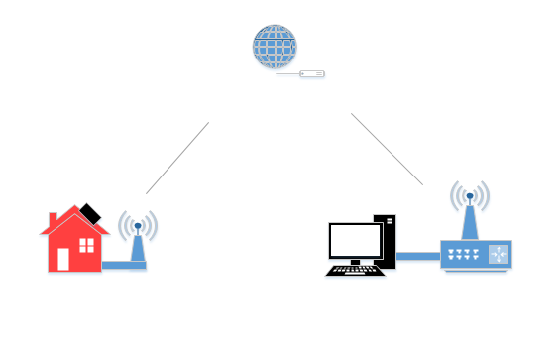

Using the fact that the sensors will have to be placed on residential homes, control of the sensor array will be lost, and a random array has to be implemented. However the speed and direction of the cloud movement can still be resolved with at least three sensors by taking the location of the sensors and the time the data was taken. The way this will be implemented in the software is by simple vector addition. Each sensor will have a distance recorded from itself to each other sensor. Therefore when a time value is recorded the velocity vector can be calculated. These velocity vectors will then be summed to give the speed and direction of the cloud. Also weather data taken at the solar panels, via a weather station, can be a tool to help resolve cloud speed and direction. However it can only be a tool because a weather station cannot predict specific cloud movement at the exact location of the solar panels.

Project Management

Project tasks break down to a software and hardware component. The software and hardware tasks are divided among the team to complete the project within the deadline. Nathan, Spencer and Liqing will be primarily responsible for creating and implementing the hardware, while Tianhang and Qifan will primarily be responsible for creating and managing the software. These sub team assignments however are flexible, and the team can shift its focus to whatever is needed at hand. The deliverables for this project are expected to be completed at the latest by November 23rd, one week before design day. A rough outline of the time allocation of each subtask is listed below:

Purchase Sensors: 2 weeks
Build Software Program: 8 weeks
Integrate Sensors and Software: 3 weeks
Test: 2 weeks
Debug: 1 week
Demo Prototype: 11/23/15
Final Report: 12/9/15
Design Day: 12/11/15

A more detailed outlined of the project structure can be seen in the gantt chart. Purchasing of our sensors and building our software can be worked on simultaneously. Once the software is built, integration and testing can begin leaving 13 weeks to complete this project.

  - Budget

The budget for this assignment can vary depending on the specific parts needed. The essential components of our design include a sensor, a microcontroller with the capability to connect to a wireless signal and computer to run our software. The computer is already available with all the appropriate software so there will be no cost to implement the software. However the hardware is where the majority of the budget will be spent. A high quality irradiance sensor, pyranometer, costs upwards of $235. While a microcontroller with wireless connectivity is around $40. This amounts to around $275 for a single sensor alone. In the design, multiple sensors will be needed to track the cloud movement. For an array of 10 sensors the cost of this project will be upwards of $2700. However the budget for this project is $500. Based on the amount of funding Michigan State will provide to this project, there can be a potential shift in the project's objective. Basic $5 light sensors will be purchased in the test phase of this design, and therefore will be an included cost in this project. The budget of this project will depend on the number of sensors purchased. Table 1 outlines the possible budget for the test phase of this design while Table 2 outlines the overall potential budget for this project.
Table 1: Estimated Budget for Test Phase
Part | Cost | Quantity
Light Sensor | $5 | 10
Microcontroller | $40 | 2
Total | $45 | $130
The test phase consists of only two microcontrollers (each microcontroller has 6 ADC inputs). Only two microcontrollers will be needed because this will be a “table top” experiment and the sensors will be close enough that they can connect to the two microcontrollers. However when this design is scaled to full version, a microcontroller will have to be at each sensor location. Table 2 outlines the estimated budget for the fully implemented project.

Table 2: Estimated Budget for Total Project
Part | Cost | Quantity
Test Phase | $130 | 1
Pyranometer | $235 | 10
Microcontroller | $40 | 9
Power Supply | $30 | 10
Total |  | $3140

  - Deliverables

Anticipated deliverables at the end of the semester should consist of the software system, which has been verified against real weather data test cases. This software system should be able to read out data provided by the irradiance sensors and make reliable predictions for cloud cover changes on campus.

Team Qualifications

The team contains two computer engineers and three electrical engineers. Although this is a software heavy project, the team can still program it step by step. The electrical engineers will get all the hardware parts assembled, assist the software where it is needed, and also provide thoughts to fix the software problems. As for the software part, the computer engineers will code and debug the program to make sure this system works well. This project will surely have many problems during our process, but the team is well qualified to make a great product to fit the customer's needs.

