Application Note Assignment
Tianhang Sun
11/13/2015
Abstract:
Object-Oriented Programming (OOP) is a programming paradigm based on the concept of "objects", which is widely used today, as well as in our application. In OO programming, computer programs are designed by making things out of objects that interact with one another. While interacting with objects in software, we often use design pattern, which is a general reusable solution to a commonly occurring problem within a given context in software design.

The project:
The task of our project is to perform early warning of when the cloud will arrive at the solar panel location in MSU campus. In this case, we need solar power sensor array, which is light sensor in our application, communicating with the software remotely, and then the software can perform the prediction. In this case, our software needs to be flexible enough so it can support random sensor array, and perform a simulation of the behavior of sensors and show the prediction.

Why OOP?
The most important reason we’re using OOP in our application is that it will be flexible. The sensors and solar panels are “objects” in the software, and we can create as many sensors or solar panels as we want, since it’ll be simply instantiate a sensor or solar panel “object” in code.

The How?
We’re using C++ programming language, which is a significant OO language. Similar to many other OO languages, C++ is “class” based; a class in C++ means an object type, so we’ll have our sensor class and solar panel class in order to simulate the real situations.
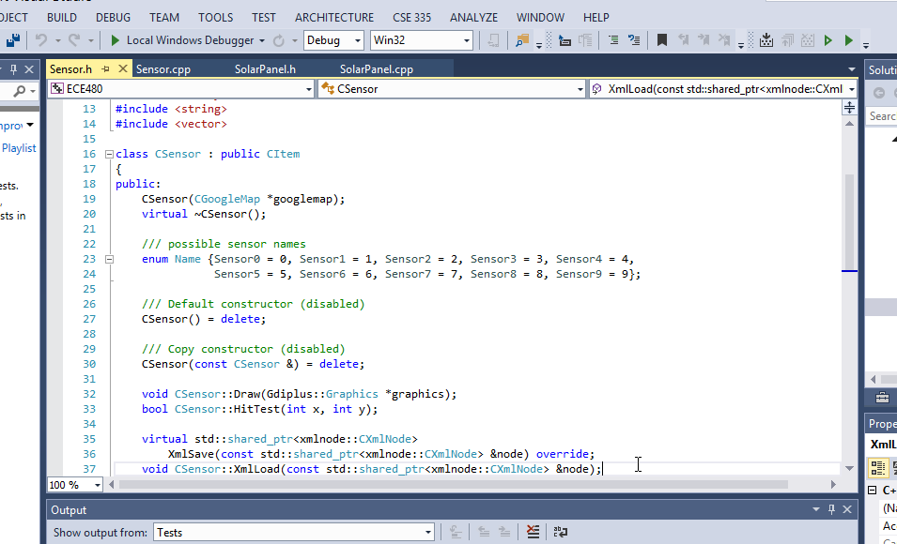
When we create a class, we can also have methods for the class, which are the “functionalities” of the object, and member variables, which are the “properties ” of the object. As you can see above, for example, the “enum Name”, which is the name of sensor while reading from the database, is the member variable, and the void “CSensor::Draw();”, which will draw the sensor onto the screen, is the method. In this case, it’ll be very easy to extend the functionality of our software, which is simply adding methods for each class.

Design pattern:
Software is not as clever as human, which makes the interaction between objects difficult. The object itself only knows the information of itself. How to know the information of others? The general solution is to add methods to take the information out. However, it is often the case that the objects are not linked together. For example, the sensor and solar panel in our application are different object, no ownership relationship, and no association; they’re not responsible to know each other because we may have multiple sensors and solar panels. The map, which is the container of both sensor and solar panels, on the other hand, can gather the information of both items. If we want hard coding, then we can get information in the map, and pass to other object. However, in this case, it’s will be very difficult to add functionality between different object because we need to add methods for each possible functionalities we want. The good news is that, someone else has already find a solution for us, they create a visitor, which is able to go over one type of object, and gather whatever information needed, and this is one kind of design pattern, called visitor pattern.

The how?
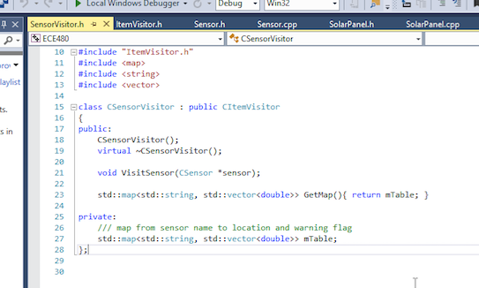
By using visitor pattern, we can simply have a visitor, go over sensors, and pass the information to the solar panels using another visitor. Whatever information we need, we can add the functionality in the visitor, for example, the GetMap(); function above, which is able to get a map, which is a data structure, from the sensor name to it’s associate voltage value. This is the way previous expert in programming found, and they just summarize as design patterns, so we can use in our application, in order to simply our software.

Summery:
OOP and design patterns really help us so that we can easily make software that is flexible, reliable, and understandable.

