Liqing Yao
ECE 480
Team 7
Application Note
11-13-2015

Introduction:
Our team is designing a warning system for the coming solar panel of our campus. The system has to be able to predict the solar irradiance changing of the next 10 minutes so the control center could have enough time to adjust the output of solar panel to minimize the lost of money. The following figure (figuer1) is the area around our campus that we will use to set our sensors to accomplish our project. The yellow spot is where the solar panel will be.
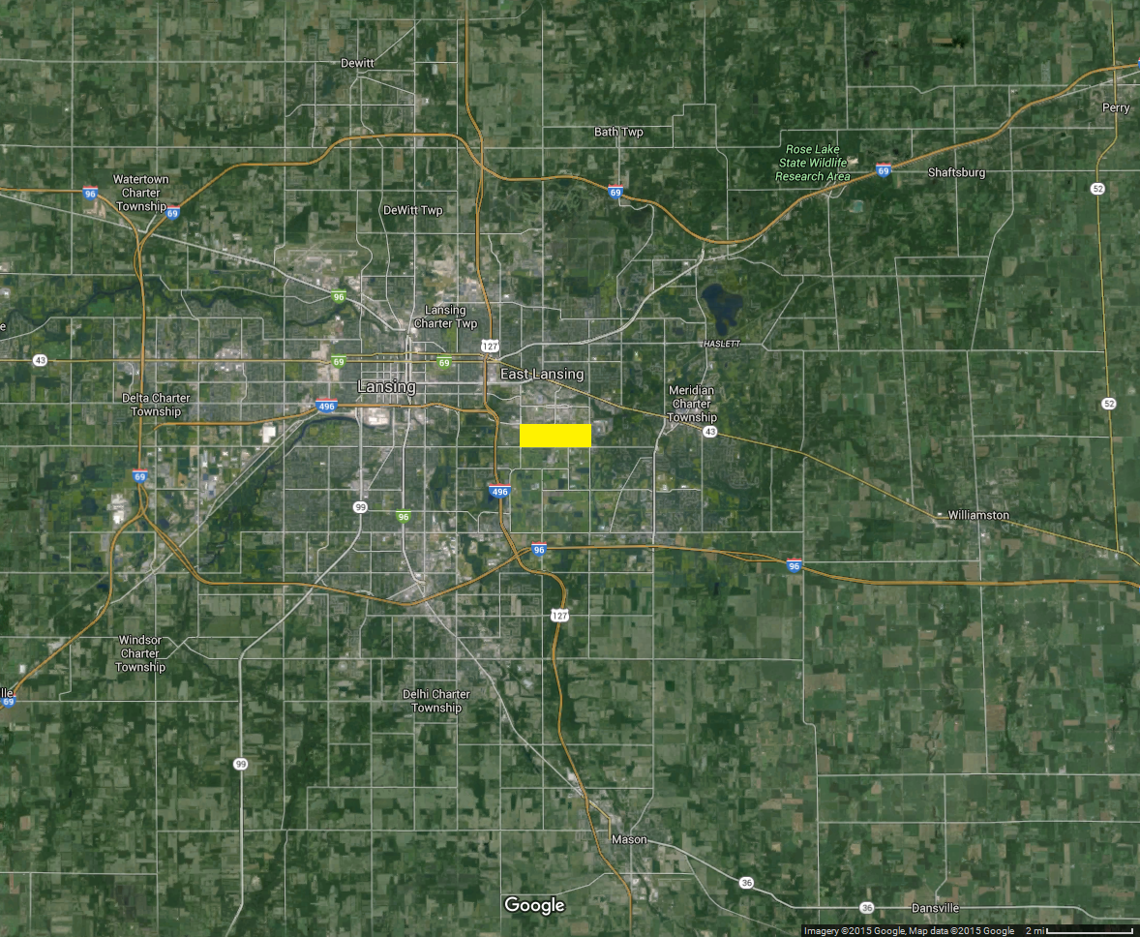
Figure 1

Further Implement:
We found this project very hard at first due to the complex reality of clouds. Because of the vary shape of clouds, we could not even move a little step forward. Thus we decided to do this project with some idea limit and get the whole thing done step by step. That’s how us engineers working with problems. Therefore we assume the clouds have infinite long straight-line edge. And this assuming saved us a lot of time to start coding the algorithm. We make the algorithm flowchart first to make sure we can get all calculation correct (figure 2).
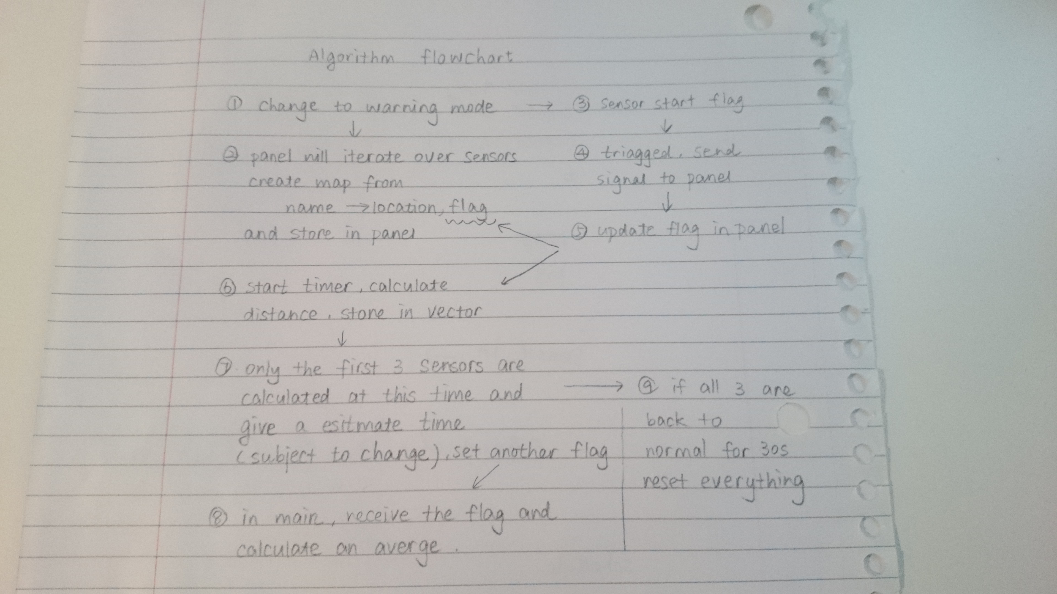
Figure 2

For the sensors, we decided to choose light sensor and simply scale the lightness by outputting the voltage from 0V to 5V. (0V means the darkest while 5V means the brightest.) Once we have the output voltages we collect all of them into our system and do the algorithm calculations to acquire the clouds moving direction and speed so that we can calculate the approaching time and power drop percentage. Then show the warning signal with all the information we need to the operator.

Demonstration related:
To have a good visual demonstration of our system, I found the project white board and print the map with appropriate size and nailed it onto the board with pins. Then our team starts to build all the wires and hardware part under the board and get all the sensors perfectly stick on the top with wires connecting them through the board. Make everything nice and tight. Also we found two woods to be the standers so that we have space under the board for all that stuff.
For the future weeks I will try to build a cover on the top that can be moved to simulate the clouds so that the whole system will work better.

