Application Note
Electric Imp Wireless Sensor Network
Abstract
A wireless sensor network has endless applications for monitoring the activities over a large area. This note will describe how to implement a wireless sensor network using only a microcontroller. In this application the wireless sensor network will be used for environmental monitoring.
Keywords: Wireless Sensor Network, Electric Imp, Solar Detection

Introduction
This document will provide information and code examples to set up and implement a wireless sensor network based on the Electric Imp microcontroller. The steps can be broken down into connection of the sensor to the web, and integration from the web to a user interface. The user interface is a software program is packaged into visual studio making it compatible with Windows and MacOS. The program is also open source letting the user program change the functionality of the user interface to the desired use.

Sensor to Web Communication
Getting Started
The electric imp microcontroller contains a wireless network card, allowing it to transmit data to the web, via Wi-Fi. The microcontroller can be connected to a Wi-Fi signal by following the blink up procedure ^{[1]}. The pinout of the electric imp can be seen in the electric imp datasheet ^{[2]}. It includes pins with UART, I²C communication as well as ADC’s and DAC’s allowing sensors to be input either as an analog, digital or even UART communication. The electric imp contains a web based IDE, which governs communication to the microcontroller as well as the internet. The IDE is based on the language squirrel ^{[3]}, and contains two API’s, the agent and device. The device deals with the communication with the microcontroller hardware. The agent controls communication with the web servers.
Sending Data to Unique URL
Each microcontroller has a unique URL with which it can communicate, known as the “agent URL.” This provides a simple way to send to and extract sensor data from the web. Data can sent to the agent URL via an http request and a http send command completed with http.onrequest, and response.send respectively. However only one string of data can be sent to the agent URL, and therefore string concatenation has to be implemented prior to sending sensor data. When this is completed however a unique URL for each microcontroller will contain only one string of information, making it easy to read into a program.

Web to Program Communication
The sensor software program has the ability to read in the sensor data from the URL and create a user interface based on the map of the location of sensors and sensor locations. The program is open source allowing users to create any application of sensors that is desired. The steps below show an example of how the user interface is used.
- Start the Program

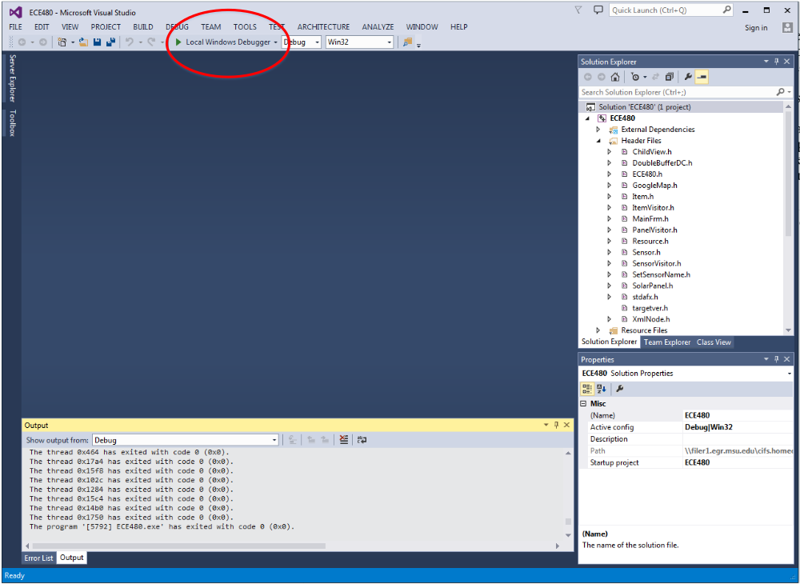

- Add sensors by selecting edit->Add Sensor

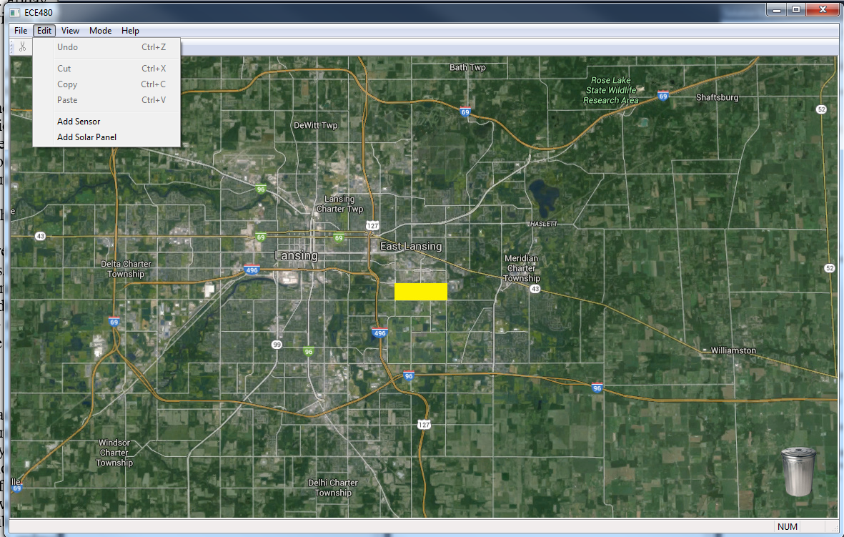

- Move sensors to desired location

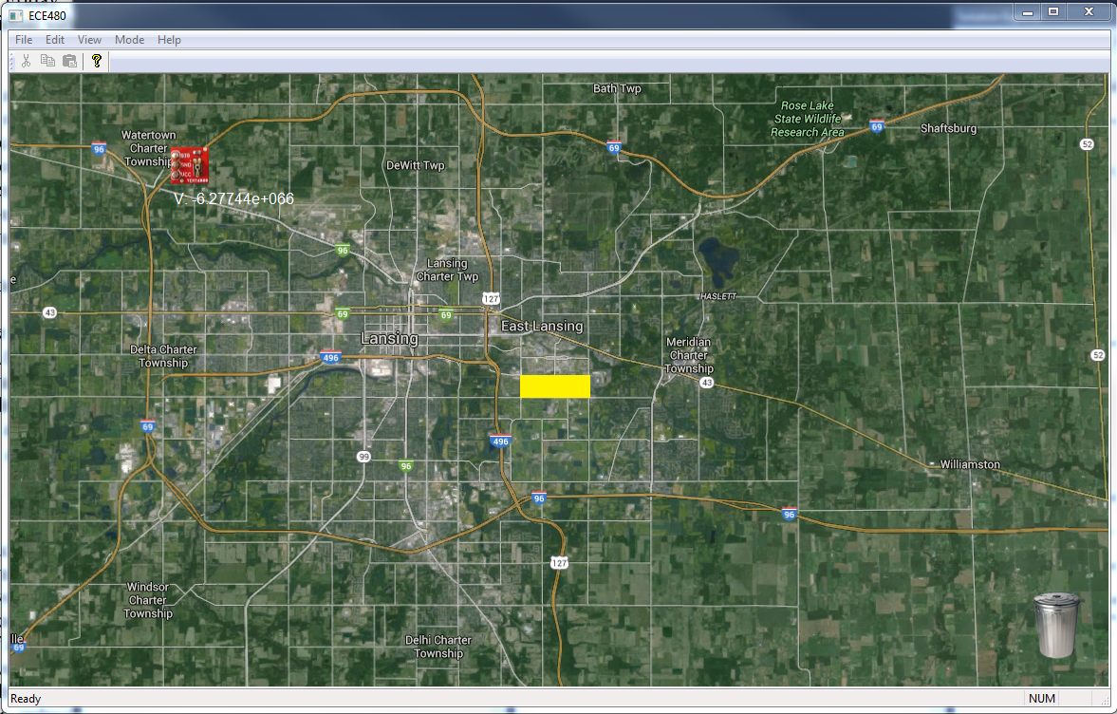

- Change from edit to warning mode



The editing mode allows the addition of sensors and has the ability to move the sensor location. The warning mode allows the user to implement any algorithm or data manipulation of the sensor data in the user interface. Since this code is open source the user can alter its operation.

Example
An example of a wireless sensor network using the electric imp is shown with early warning solar power detection. The input consists of a pyranometer which measures the amount of solar irradiance at one instant. This sensor is an input pin to an electric imp and the data is sent to the sensor software program wirelessly. The code for reading in the sensor data and sending the values to a URL is shown in Figure 1 and 2 respectively. The data is then used in the sensor program to create an early warning display when a cloud will drop the power output of a solar panel.

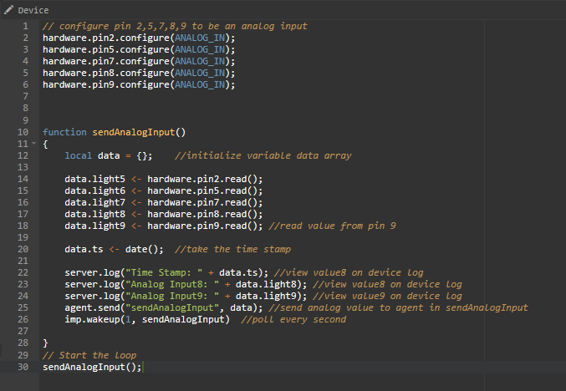
Figure 1: Device code for early warning solar detection

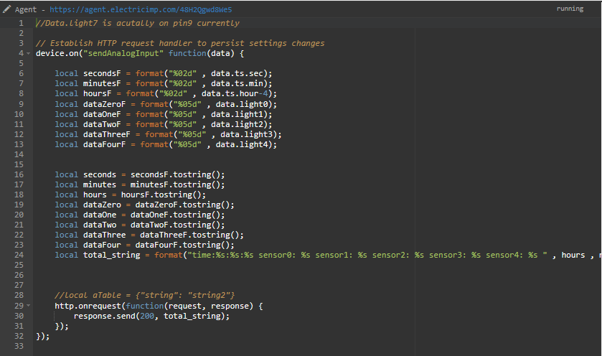
Figure 2: Device code for early warning solar detection

Conclusion
The electric imp 002 provides a good platform to create a wireless sensor network when Wi-Fi connection is available. Since the imp 002 needs to send data via Wi-Fi the best application for this wireless sensor network is in urban settings with Wi-Fi available. Monitoring of the sensor arrays can also be easily implemented with the sensor software program. This allows the user to customize the functionality of the sensor network.

References
[1] https://electricimp.com/docs/gettingstarted/blinkup/
[2] https://electricimp.com/docs/attachments/hardware/datasheets/imp002_specification.pdf
[3] https://electricimp.com/docs/squirrel/

