Michigan State University College of Engineering
ECE 480 Design Team 5 Project
3D Printing: Technology Application to Design and Print Project’s Component Box
Application Note

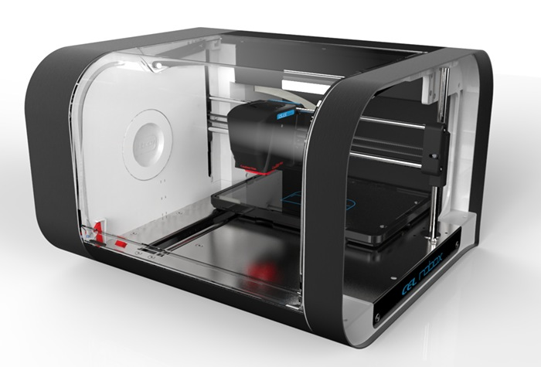
Author: Samuel Falabi

TABLE OF CONTENT
Cover Page………………………………………………………………………………………… 1

Abstracts…………………………………………………………………………………………….3

Introduction………………………………………………………………………………………..3

Objective…………………………………………………………………………………………….3

Steps in 3D Printing……………………………………………………………………………..3

Components Layout in the Box…………………………………………………………….6

Material Constraint……………………………………………………………………………..7

Summary……………………………………………………………………………………………..8

Reference…………………………………………………………………………………………….9

ABSTRACT
This application note discusses Team 5’s use of NX 10.0 CAD software to design and print 3D component box which houses the electrical circuit component of the team’s Safety System Design for AccerlorMittal. This technology is beneficial because it gives room for modifications and adjustments to the box prototype as the project progresses to accommodate changes as the need arises.

INTRODUCTION
3D printing is a process of making three dimensional solid objects from a digital file which is achieved using additive processes. In an additive process an object is created by laying down successive layers of material until the entire object is created. Each of these layers can be seen as a thinly sliced horizontal cross-section of the eventual object.
The virtual design of any 3D printed object is made possible by Computer Aided Design(CAD) software which can be used to design curves, surfaces, solids in both two and three dimensions. There are different CAD software in being used in the industry at the moment but NX 10.0 is being used for the purpose of this project.

OBJECTIVE
The objective of this Application Note is to familiarize with the technology of 3D printing and the application of it to design and make the component box of the project.

STEPS IN 3D PRINTING
- CAD Design: CAD software is used to produce a virtual dimension of the component box. The software provides some hint as to the structural representation of the box and what to expect from the completed product based on the parameters used such as the materials and the level of thickness chosen for the box. The file is then saved after all design requirements are met.

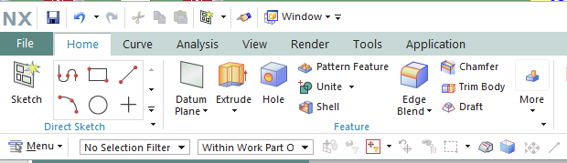
Fig 1: Sketch tools used on NX 10.0

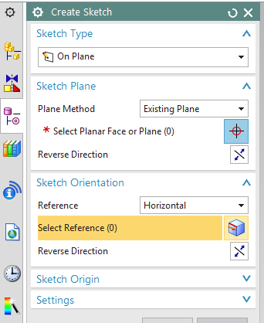
Fig3: Sketch Tools and Features

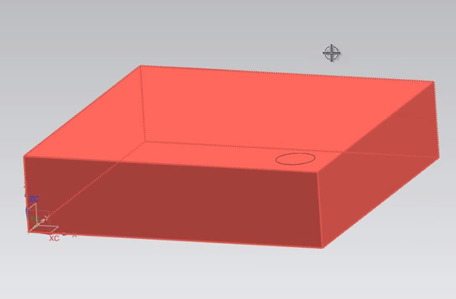
Fig 3: NX 10.0 CAD Software design of the component box

- Conversion to STL Format: After the design has been completed on the NX 10.0 CAD software, it is saved to a Standard Tessellation Language (STL) format. STL format is a file format developed for 3D Systems in 1987 for use by its Stereolithography apparatus. 3D printers can use STL files in addition to some proprietary file types such as ZPR

- Transfer of STL File to AM Machine: The STL file is copied over to 3D printer which is also known as Additive Manufacturing (AM) machine. This also the computer that controls the whole process of the 3D printing of the 3-D printer. We can designate the size and orientation for printing.

- Machine Setup: Each machine has its own requirements for how to prepare for a new print job. This includes refilling the polymers, binders and other consumables the printer will use. It also covers adding a tray to serve as a foundation or adding the material to build temporary water-soluble supports.

- Build: This process is mostly automatic. Each layer is built according to the specified requirement such as material and thickness made in the STL file. This process could take a while so it is recommended to periodically check on the printer to ensure there are no errors.

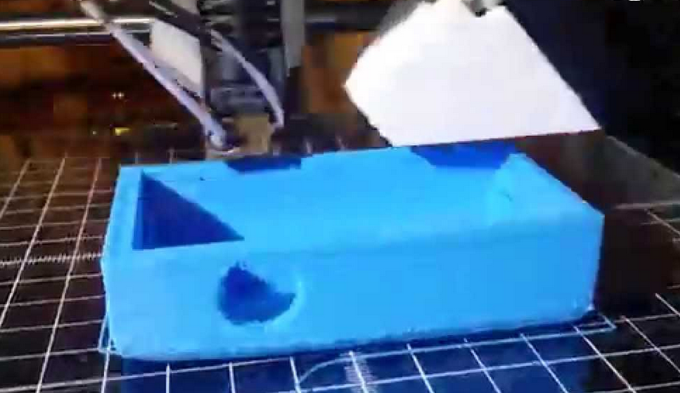
Fig 4: 3D Printing the component box

- Post-Processing: After the printing has been completed, the box component is allowed to cool off because it might require some time for the materials to solidify. Afterwards, the printed box is safely removed from the 3D printer. This process also includes removing and cleaning any remaining powder hanging around the printer.

COMPO NENTS LAYOUT IN THE BOX

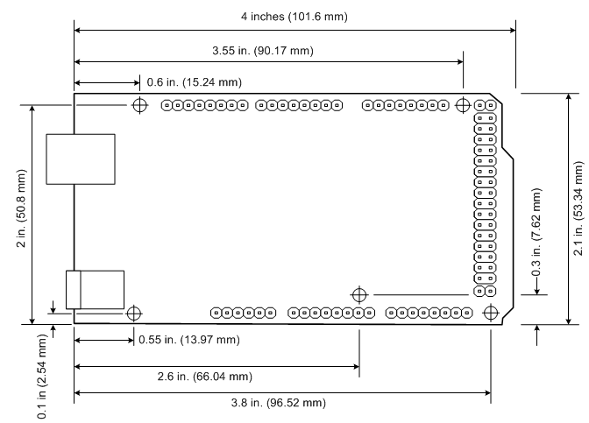AaaaaaAaaAaaaaaAaaAaaaaaAaaAaaaaaAaaAaaaaaAaa 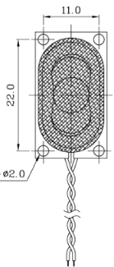

Arduino Micro-Controller Speaker

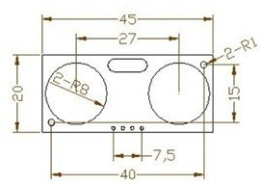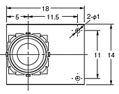
Ultrasonic Sensors D6T Thermal sensors

Fig 5: Layout of the compenent parts of the circuit in the box

MATERIAL CONSTRAINT
Based on the sensitivity of the sensors used in circuitry part of the Safety System, the material used for the component box and its level of thickness had to be carefully selected in other not to inhibit the functionality of the sensors. Certain materials perform poorly in moist environment or they could attract dust as the case may be.
For D6T Thermal Sensor used in our Safety System, its ability to sense radiant heat depends on the cover material used to cover it and its level of thickness as well. High-density polyethylene (HDPE) is a good and highly recommended option because it grades high in infrared transmission. If the cover is too thick, the thermal sensor’s ability to sense heat decreases. Below is a graph that depicts this illustration.

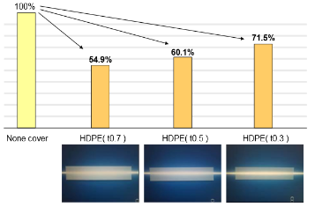
Fig 6: HDPE thickness vs transmittance

Furthermore into material selection, it is also observed that performance of transducer in the ultrasonic sensor can also be affected by heat, chemical components, and other magnetic field around. Since this safety system will be used in an industrial set up where the temperature of heavy metals could get really hot and powerful magnets being used for other purposes can create magnetic fields around has to be considered. Transducer’s ability to transducer depends on the crystalline molecular structure and its associated electromagnetic field. Using Curie temperature, one can determine the point where the transducer will stop working if it loses its magnetic property. Fig 7 is a table that shows leading ultra-high temperature piezoelectric materials.

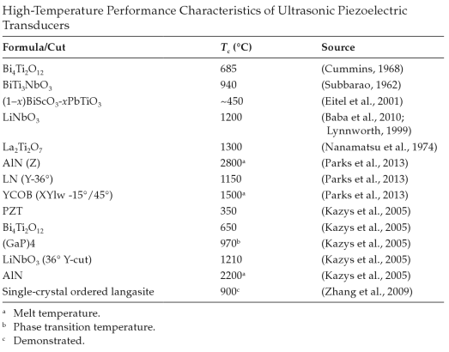
Fig 7: Ultrasonic Piezoelectric Transducers and their Curie Temperatures

SUMMARY
In conclusion, this application note shows the steps taken to design and print a 3D model of the component box that will be used to house the circuitry components of the safety system. Although, it is a prototype which will be modified as the project proceed due to other needs that will arise such as ventilation of the system among others. It also provided an opportunity to research further into material used for making transducers and how their components are affected by heat and other force fields around.

REFERENCE
"HC-SR04 User's_Manual." Web. 11 Nov. 2015.

"CDS-25148-L100." CUI Inc. Web. 11 Nov. 2015. <http://www.digikey.com/product-search/en?keywords=102-3545-ND>.

Web. 11 Nov. 2015. <http://www.omron.com/ecb/products/sensor/special/mems/pdf/AN-D6T-01EN_r2.pdf>.

"NX." 10 for Design: Siemens PLM Software. Web. 11 Nov. 2015.

Bar-Cohen, Yoseph. High Temperature Materials and Mechanisms. CRC, 2014. Web.
11 Nov. 2015.

