ECE 480 Capstone Design
Cone of Safety around a Crane Hook
ArcelorMittal

Executive Summary
This report has been assigned by Michigan State University and sponsored by ArcelorMittal to provide an analysis and evaluation on the implementation of safety on remote control cranes at ArcelorMittal. Statistics of injuries in the steel industry has motivated ArcelorMittal to implement a design to improve safety in the Finishing Department.
Research shows that safety can be improved by alerting the crane operator when they are within the vicinity of the crane’s “danger zone.” To achieve this Team 5 from ECE 480 in the fall of 2015 at MSU research and develop a solution to build a “cone of safety” to determine the danger zone around the crane’s load, detect the operator’s presence, and act upon the information by alerting the operator. The team must build a solution to meet certain criteria and implement a prototype.
This proposal will include the introduction to ArcelorMittal, background information on current industry standards and practices, analysis on research and conceptual designs, recommended design specifications, the project management plan, and a proposed solution.

Prepared by:
Xue Cheng, Samuel Falabi, Charlie Nguyen, Richard Szink, Lanea Williamson

Facilitator: Dr Radha

Table of Contents
Cover Page 1
Table of contents 2
introduction 3
Background 3
Design specifications 4
conceptual designs 6
Proposed solution 8
risk analysis 12
project management plan 13
budget 15
summary 15
references 16

Introduction
ArcelorMittal is the world’s leading steel and mining company with presence in 60 countries and has an industrial footprint in 19 countries. They are guided by a philosophy to produce safe and sustainable steel. They also pride themselves in providing a conducive and safe work environment for its employees. To further their commitment to the safety of their employees, ArcelorMittal is proud to be the sponsor of a Safety System Design at Michigan State University.
At ArcelorMittal, Electric Overhead Cranes (EOT) are used for transporting heavy products, parts, and materials. They are operated remotely by a Remote Control Crane Operator (RCCO). Crane operators and other employees that come in near proximity of the cranes are exposed to safety hazards that could lead to serious injuries or loss of life throughout the course of the work day. Due to this problem, safety measures have to be put in place to reduce such accident risks to the most minimum level. When a crane is in use, there is a minimum safe distance that must be observed to avoid pinch points and loads of steel as it moves. Areas of space too close to the cranes are considered danger zones, which increase whenever the crane moves vertically.
The Safety System Design involves placing sensors above the load of the crane. The sensors are to be configured in such a way that when a body part comes into the danger zone, it automatically triggers an alarm that sounds over 80dB to alert the crane operators of a potential accident so they can take safety measures to ensure no human part is within the danger zone. Also the Safety System must also include data recording of every instance an operator comes within the danger zone so ArcelorMittal can analyze the data and constantly improve safety in the workplace.
Background
Due to the hazardous conditions at ArcelorMittal, there is a need for safety precautions at the mill. Specifically, the crane systems lift heavy objects that can be fatal to operators near these sites. Previous accidents have motivated ArcelorMittal to implement a system that could help prevent future disasters. ArcelorMittal wants to implement a system that can sense an operator within a certain distance from the crane operating overhead.
At a steel plant, remote control overhead cranes are used to move up to thousands tons of steel daily. Cranes are operated at 21 turns (24 hours a day, 7 days a week) and the cranes, although well maintained, are usually older models. As recorded, there were more than fifty incidents that caused death of steelworkers from 1989 to 2010 in Northwest Indiana. (Reference)
ArcelorMittal has put a lot effort into safety issues, such like modernizing and electromechanically upgrading their old cranes in order to guarantee more reliable and safe functions. An ArcelorMittal site in Genk (Belgium) had modernization including, “new crane controls for bridge and trolley travelling and four new tongs, sensors, encoders, job generators, schedulers and sequencers for automatic crane operation. (Reference)”
Early research has shown that this is the first project of its kind. Overhead trolley cranes that go back and forth the length of the mill have anti-collision sensing systems that prevent them from colliding with other cranes and the same trolley, but research has shown none of these cranes are equipped with human sensing abilities near the load. The industry standard for sensing capabilities in the steel mill is photoelectric sensors, or photoeyes. Photoeyes are used primarily on machines and sense when an object has appeared in front of the sensor by time of flight techniques.
Electrical power to machines in a steel mill is provided by running cables through conduits either under the floor or high on the wall. Since the sensor will bolted to somewhere on the cranes arm or hook, providing the sensor with power without interfering without the operation of the crane is crucial. Recording each occurrence of entering the “cone of safety” is another important design goal. The industry standard for interfacing with electronic devices are programmable logic controllers, or PLCs. A PLC is programmed using ladder logic and is fed by wires in a conduit to a PLC cabinet.
The steel industry has a very rich history and has been the backbone of the modern world for over a century. Research has given insight into the industry standards that steel mills across the world utilize when completing projects. As the world becomes more technologically advanced, industry slowly becomes more advanced as well. Research, design, and prototyping will give the opportunity to pick the best design to guarantee the safest environment, whether that option be the industry standards or a new device.
Design Specification
The Team’s design goal for this project is to provide a solution to ArcelorMittal’s Safety System Design and the designed system must fulfill the customer’s need. The remote control cranes used in ArcelorMittal move heavy steel coil loads both vertically and horizontally. The team will research, design, and implement a solution to improve safety around remote control cranes. First of all, the designed system will detect any person within a dangerous range of a crane with a suspended load. The design will turn off when the load is suspended higher than 8 ft. in the air in order to save power and unnecessary warnings. When the load is within the vertical 8 ft. range, the system will automatically turn on and create a “cone of safety.” Whenever an operator enters the cone of safety, or the danger zone, the system will be able to sense the operator and send a signal to trigger an embedded alarm in the system to warn that person. When the alarm is triggered, the system will record the data to show details of the near-miss accident. This will be useful for ArcelorMittal to improve their safety standards and avoid any future accidents. A visual representation of these specifications can be seen in Figure 1.

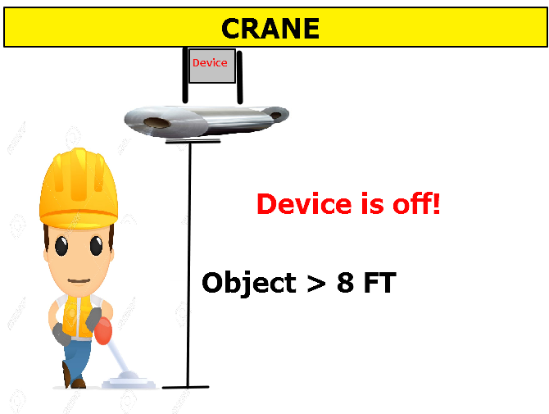

When the suspended load is greater than 8 ft. above the ground the system will be off.

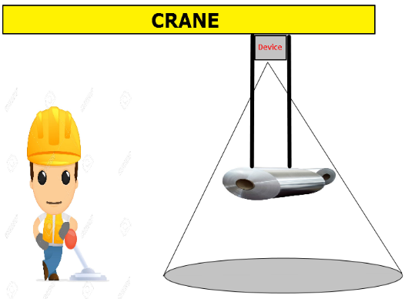
When the load is at 8 ft. or closer to the ground, the system is active and a cone of safety will be created.

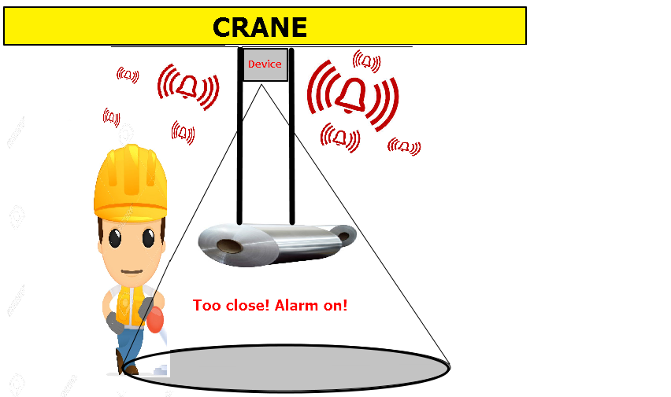

When the system is active and an operator enters the danger zone an alarm will sound and warn the operator

Design Specifications: Figure 1

Conceptual Designs
In order to design the best possible engineering solution for ArcelorMittal, a very high level design was agreed upon that satisfied the design specifications. To fulfill the specifications of turning on the “cone of safety”, detecting human presence, and recording the alarm data it was decided to use a combination of sensors, microcontrollers, and an alarm. ArcelorMittal has provided 250VDC power on the crane that will be stepped down to a VDC that will power these aforementioned devices. The design team was challenged to research different sensors that would be best suitable for ArcelorMittal’s situation and then create a conceptual design that took advantage of that sensors technology. The conceptual designs are shown below.
- Industry Standard Design
  - Referring to the background section of this proposal, it can be determined where the Industry Standard Design was created from. The Industry Standard Design consists of 6-8 proximity sensors arraigned on the trolley of the crane above the load in an octagon or hexagon shape to simulate a cone. Also, one more proximity sensor would be in the middle of the octagon or hexagon to sense the height of the load. When this proximity sensor outputted that the load was 8 ft. above the floor, a signal is sent to the PLC telling the other 6-8 proximity sensors to turn on. The return sensor will be attached to the remote control worn around the operator’s neck. When the operator enters the danger zone, a signal is sent to the PLC to trigger the alarm. Alarm triggering data would be stored on a memory card in the PLC cabinet.
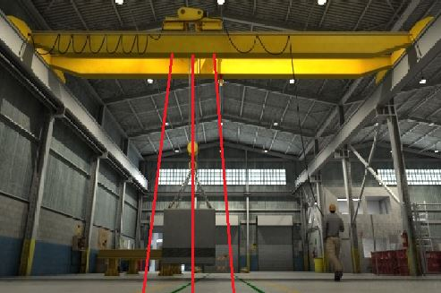
Figure 2 shows the front view of the design. A hexagon or octagon shape is created with 6-8 sensors and if the operator enters the danger zone an alarm is triggered.

Industry Standard Design: Figure 2
- Image Processing Design
  - Heat (a moving human). Thermal sensors create a matrix of temperatures so it would be possible to change the radius of the cone as the height changes. The sensor would use the same idea of using a proximity sensor to sense the load’s height and turning the thermal sensor on when it is 8 ft. above the ground. A box containing a thermal sensor, proximity sensor, an alarm, and a microcontroller to control the logic would be mounted on the crane trolley above the load.

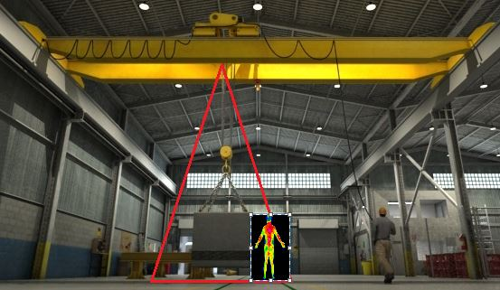
Figure 3 shows the effectiveness of sensing human presence by using thermal sensor technology.

Thermal Imaging Design: Figure 3
- Motion Sensor Design
  - Much like a motion sensor used to control outdoor lighting, a passive infrared (PIR) sensor would be used to detect human activity. The PIR sensor would work the same as the Thermal Imaging Design, only the thermal sensor is replaced with a PIR sensor. The PIR sensor makes a very good cone shape, but cannot change detection angle easily.
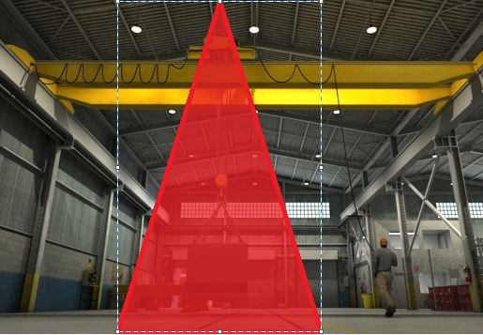
Figure 4 shows how a preset cone is made by a motion sensor that would in turn detect human movement using infrared sensors.

Motion Sensor Design: Figure 4
- Image Processing Design
  - This design is very similar to the Thermal Imaging Design, but instead the thermal sensor is replaced with a digital camera. Using an open source website, the camera can be programmed to act as a human detection sensor. This technology is not capable of sensing through an object. A microcontroller would turn the camera on and off and process the images using the open source code.
- Ultrasonic Sensor Design
  - Ultrasonic sensors are sometimes used in industry to detect moving objects. This design would consist of all the same features as the Industry Standard Design, but this sensor makes a cone shape naturally due to the sound field it uses to detect objects. Also, the ultrasonic sensor would be controlled by a microcontroller, not a PLC. Refer to Figure 2 (Industry) to see how the ultrasonic sensors would be arranged.
Decision Matrix
As previously discussed, there are many design specifications that need to be considered in order to selectively choose the best design to make a quality product for ArcelorMittal. Before considering these specifications and constraints in too much detail, conceptual designs were developed based loosely on the specifications. A selection criteria matrix can be implemented to effectively choose which conceptual design would best fit this project.
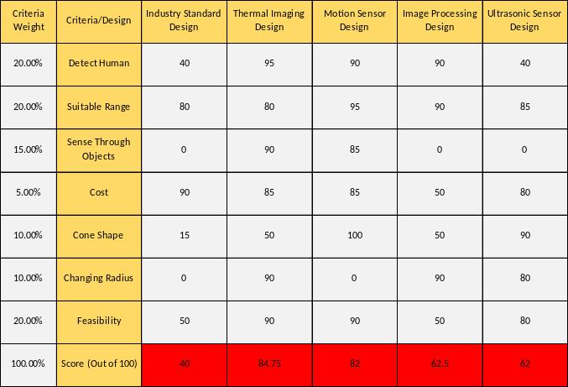
Figure 5 is a decision matrix comparing each conceptual design with the design specifications. Criteria is weighted on a percentage representing how important it is to the overall design. A score is then given to each design for each criteria, where 100 is the highest possible score in each category.

Decision Matrix: Figure 5
The results of the matrix show that while any of the designs will work, the Thermal Imaging Design and the Motion Sensor Design will follow the specifications most accurately. Taking into account that the Thermal Imaging Design is able to change the radius of the cone effectively makes the Thermal Imaging Design the most feasible design.
Proposed Solution
To begin building the prototype, a high level understanding must be met. There are a few key parts that are needed to complete the project: the sensors, alarm, data recorder, and a way to process information.
As previously mentioned, a sensor is needed to detect how far the crane's load is from the floor and differentiate between human and static objects. Secondly, a speaker is needed to alert the operator. Furthermore, means of data recording is used to further improve future safety through analyzing data. Implementation of this system requires a way to process all this information, input all the variables, and output ArcelorMittal's requirements.
Proximity Sensor
The first step to satisfying the design specifications is to be able to detect how far the crane's load is off the ground. This can be achieved through a proximity sensor. This sensor can detect distance by sending an ultrasonic sound out at a specific frequency. When the frequency is reflected off the focused object and is returned back to the proximity sensor, it can determine the distance through the difference of the time it takes for the wave to reach the object and return (Refer to Figure 6)
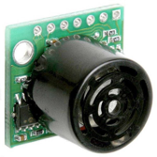
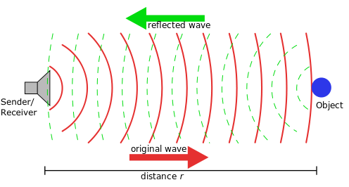
Proximity Sensor: Figure 6 How Proximity Sensor Works: Figure 7

By knowing how far the object is from a fixed point on the crane, the distance from the ground can be calculated. For example, the difference between the crane's height and object's height would determine the distance from the ground. (Refer to figure 7)
This sensor would allow our processor to determine whether the load is above 8 ft. However, a proximity sensor would only measure the distance of the load, but cannot detect a human. The next sensor would solve this constraint.

Thermal Sensors
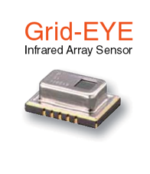
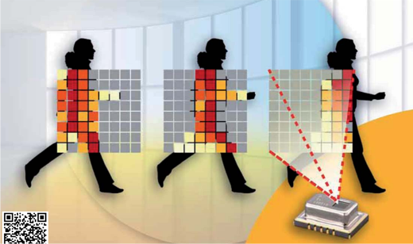
Thermal sensors can determine the temperature within a specific range. Figure 8 shows that the detected temperatures are translated into pixels and can be determined using x and y coordinates. The thermal sensors output can be processed and turn on an alarm to warn the crane's operator when the temperature is within a specific range. For example, the human's average temperature is 98.6 degrees so the range will be based on this temperature. Further research and testing in the real world has to be completed before an optimal range can be determined.
Thermal Sensor and Sensing Array: Figure 8
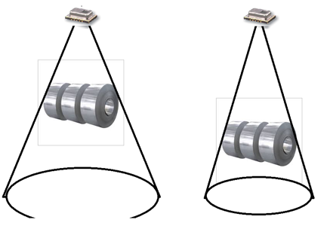
The two sensors used together can determine the distance of the load and the presence of a human within the angle of the thermal sensor. However, as the vertical distance of the load is increased or decreased the area around the load must also change. This way, the danger zone isn't too large when the load is near the ground and the danger zone is not too small when the object is near the top (refer to figure 9).
Radius of Cone Changing As Height Changes: Figure 9

A solution to this problem would be to change the angle of the thermal sensor. However, the thermal sensor is set to one angle. To work around this problem it is needed to pick the range of the sensor. By disregarding the outer rows and columns of the pixel array, a cone can be created and the angle can be changed (refer to figure 10 and figure 11). The red squares are the data used in processing and the white squares are disregarded.
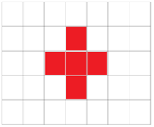
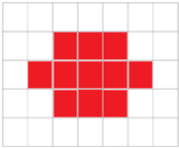

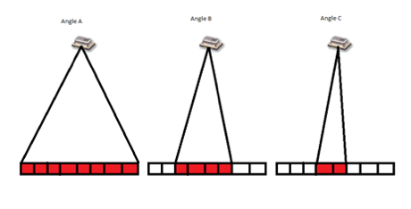
Cone Changes by Selected Pixels: Figure 10
2D View: Figure 11

Alarm
This section determines the criteria for a sound alarm system. The type of alarm and sound will be chosen after a site visit to ArcelorMittal. The only criteria that is known is that the sound must be above 80db. Figure 12 shows a sample speaker to be used to sound the alarm. Other factors that must be determined are:
- Frequency of sound that would optimal for the work environment
- Actual amplitude sound above 80db
- Angle of directional sound required
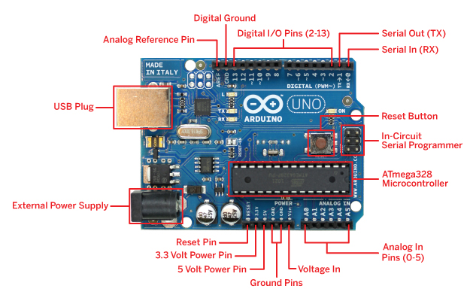
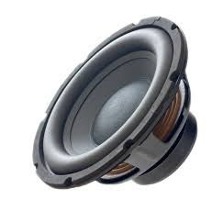

Alarm Speaker: Figure 12 Arduino Uno: Figure 13

The sensors and alarm system are the work horse of the system, but a processor is required to integrate all the individual parts and store alarm data.

Microcontroller
The microcontroller Arduino Uno has been chosen to process the information (refer to figure 13). This specific microcontroller has been chosen because of ample documentation that is readily available online, cost, a USB port for data writing, and multiple input and outputs. The sensors output into the microcontroller and are coded to output to an alarm and USB storage device.
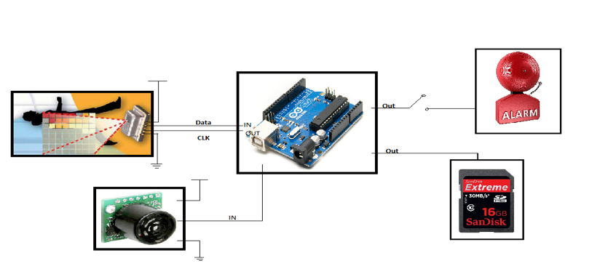
Overall Design
Overall Design: Figure 14
Above, Figure 14 proposes the high level design for the implementation of the system. The proximity sensor measures the crane's load's distance from the ground and output the information to the micro controller. If the load is above 8 ft. off the ground then the device is idle and only measure the distance. Once the load is within the 8 ft. range, the microcontroller activates the thermal sensor. If the thermal sensor detects a presence within the temperature range, then the microcontroller outputs to the alarm system and writes data to the data drive.
Risk Analysis
ArcelorMittal prides itself on safety within its environment. Creating a system that would increase the safety of their employees while working would increase their overall safety environment, however, every new device has risks and constraints during the research and development phase. Constraints for the implementation of a human sensing system above remote control cranes include the mounting of devices, creating a sound loud enough for operators, and differentiating a human from a static object.
All devices must be securely attached to the crane structure when such that if they fail, they do not fall to the ground below. The system will be bolted onto the crane trolley, not welded or any other means of fastening to ensure safety. Also, remote control cranes vibrate so the system will be securely fastened inside a metal box to ensure proper functionality of the system. Due to the rugged environment of steel mills, the metal box containing the system will be dust proof and clear lenses will be placed over the sensors lenses to ensure a debris-free lens. This can be seen in Figure 15 and Figure 16.
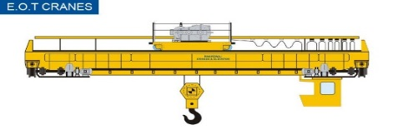
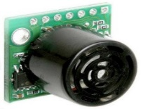
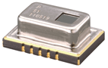
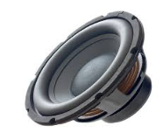
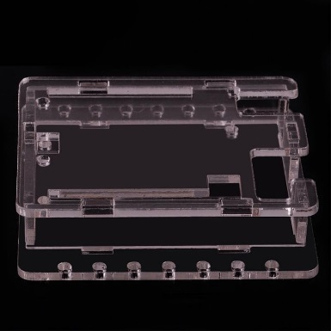

Mounting Location on Crane: Figure 15 Protective Case: Figure 16
When creating a sound to alert the operator of an entrance into the danger zone some constraints arise. The sound should be of the correct frequency as so not to startle the operator and cause a distraction, but to be startling enough to alert them of their presence in the cone of safety. Also, the sound should be directed in the proper angle to effectively reach the operator. A site visit to ArcelorMittal will help the design team determine the proper noise and direction of noise to effectively to keep the operator safe.
Differentiating between human heat and static heat (a machine temperature) is the largest constraint to successful implementation of the design. Steel mills have many machines that run at different temperatures that may confuse a sensor if they are sensing a human temperature or a machine temperature. This constraint is solved by using a thermal sensor that specializes in sensing human temperature vs. static temperature. This can be seen in more detail in the Proposed Solution section of the proposal.
Project Management Plan
Personnel
Xue Cheng – On top of preparing team presentations, Xue’s responsibilities involve researching sensors and designing the safety cone. This will include picking the correct thermal sensor after much research into data sheets of several of viable sensors. Also, Xue will aid in the programming of the turn on/off proximity sensor and changing radius of the cone.
Samuel Falabi – Samuel is responsible for preparing the teams documents, but also the power supply and alarm system. This includes finding the right step-down transformer for this project and programming the microcontroller to turn the alarm on when the danger zone is penetrated.
Charlie Nguyen – Charlie is in charge of designing the team’s website, as well as research and design of the sensor and microcontroller programming. Charlie is the lead programmer on the team and will oversee each individual members coding contributions and the overall code. Also, Charlie will work with Xue to pick the correct sensor.
Richard Szink – Richard is in charge of project management and overseeing personnel. Richard will aid in all levels of the design, prototyping, and programming. The choosing of the overall high-level design was overseen and ran by Richard. Richard will aid in the selection of the sensor, selection of the microcontroller, and design work.
Lanea Williamson – Lanea’s role is lab ordering and set-up responsibilities. Lanea will also work with Sam on the alarm design and will be in charge of the mounting, noise, and noise level of the alarm. Lanea will also be in charge of purchasing and cost estimating.
Resources/Facilities
Prototyping and testing will occur in the ECE 480 laboratory. A prototype will consist of a scaled down version of our design consisting of an 8 ft. tall frame that will allow a load to hang from it with the system mounted at the top of the frame. The height of the ceiling in the 480 laboratory and Engineering Building hallways is adequate to fit our prototype for testing and it will be designed so the frame can be folded in half and stored in the lockers in the laboratory. All hardware will either be available in the ECE shop, ECE laboratory, or ordered from a certified online vendor. Table 1 details the hardware to be acquired and Table 2 details the software.
Hardware | Qualified Vendor(s)
Prototype Frame | Home Depot, Lowes
Thermal Sensor | Omron, Mouser, Amazon
Proximity Sensor | Omron, Fargo, ECE Lab, Amazon
Microcontroller | Adruino, Amazon
Alarm | Amazon
Power Supply | Mouser, Amazon
Hardware: Table 1
Software | Qualified Vendor(s)
Microcontroller Code Composer | Adruino
Microsoft Project | ECE Lab
Software: Table 2
Schedule
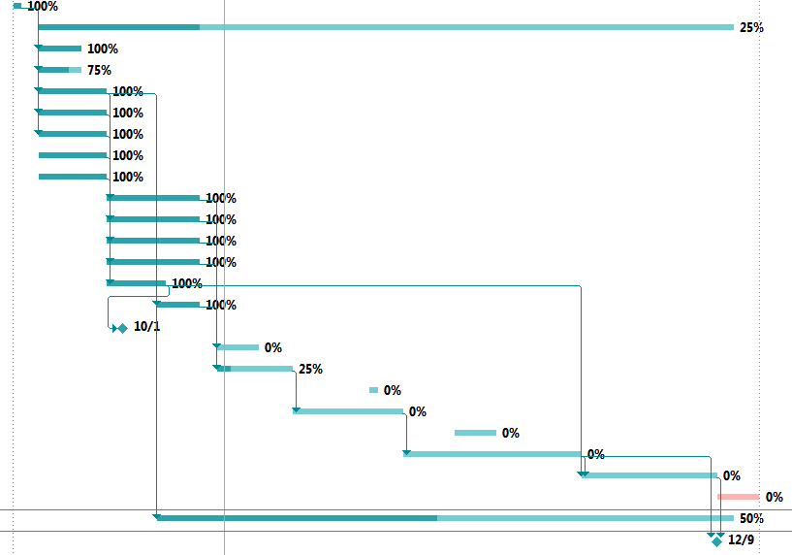
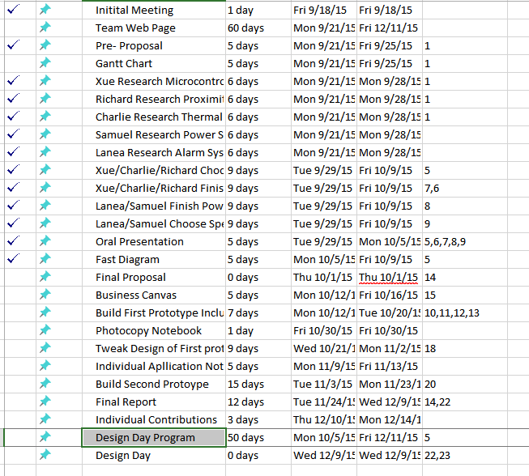

Gantt Chart and Timeline: Figure 17
As seen in the Gantt chart, there are many important dates that need to be reached in order to successfully complete the project in time. The Gantt chart, shown in Figure 17 works successfully as a timeline that shows the critical path to complete the project in time.
Budget
For this project, the team is given an overall budget of $500 to use on research, prototyping, and testing of the designed system. To ensure quality in the designed product, the team will select parts based on high performance that can be purchased within the budget instead of using the cheapest available parts in the market. Figure 18 shows a list of estimated costs. For the design part, excluding the parts provided with ECE shop, the team will purchase a thermal sensor, proximity sensor, alarm, and protective case along with the mounting equipment to accomplish the designed system. The total cost for design will be under $240. Other than that, the team is going to ArcelorMittal for a site visit and an estimation of $150 will cover the team’s expenses for the trip. The team will have over $100 left for unforeseen costs left in the budget.
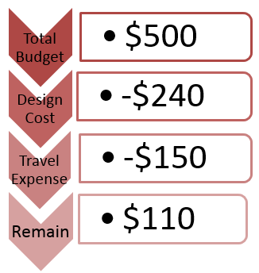
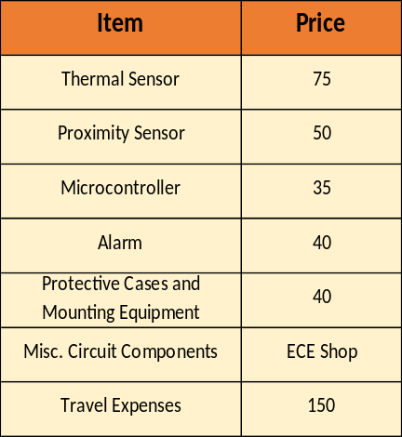

Budget: Figure 18
Summary
The safety and protection of operators working in industry is an extremely important task that should never be taken for granted. ArcelorMittal is committed to going above and beyond the required safety standards to ensure that their operators are able to go home to their families each and every time after they clock out in the exact physical condition they clocked in that day. The proposed project will further these exact safety values ArcelorMittal has instilled in their work environment. Crane operators will no longer be in a safety hazard zone every time they arrive at work to do their job. A cone of safety around the crane hooks will allow these operators to focus more on providing a quality product, rather than periodically worrying about the crane’s load striking them. Detailed research, careful design, and attention to detail will allow our team to successfully guarantee safety for crane operators at ArcelorMittal’s facility. Success will be determined by how well the team can accomplish all the previously mentioned technical goals in the Project Management Plan, how well the team can implement a successful prototype, and how well the team can successfully follow the Proposed Solution to implement the correct design.

References
"Northwest Indiana Steelworker Deaths." Nwitimes.com. The Times, 09 Jan. 2010. Web. 13 Oct. 2015.
"Crane Safety. General Design." (n.d.): n. pag. KoneCranes. konecranes.com.
Infrared Array Sensor Grid-EYE. Panasonic. Data Sheet. 2014.
Ultrasonic Sensor HC-SR04 Distance measuring Module. Universal. Data Sheet.
Arduino Uno. Arduino. Data Sheet. 2015.
"Primary Metals." The Steel Making Industry. Primary Metals, n.d. Web. 13 Oct. 2015.
"Steel Mill." Wikipedia. Wikimedia Foundation, n.d. Web. 13 Oct. 2015.

