Distance Sensing Using a HC – SR04 Ultrasonic Sensor
Application Note
Richard Szink
11/13/15
Executive Summary
This report has been assigned by Michigan State University and sponsored by ArcelorMittal to provide an analysis and evaluation on the implementation of safety on remote control cranes at ArcelorMittal. Statistics of injuries in the steel industry has motivated ArcelorMittal to implement a design to improve safety in the Finishing Department.
Research shows that safety can be improved by alerting the crane operator when they are within the vicinity of the crane’s “danger zone.” To achieve this Team 5 from ECE 480 in the fall of 2015 at MSU research and develop a solution to build a “cone of safety” to determine the danger zone around the crane’s load, detect the operator’s presence, and act upon the information by alerting the operator. The team must build a solution to meet certain criteria and implement a prototype.
This proposal will include the introduction to ArcelorMittal, background information on current industry standards and practices, analysis on research and conceptual designs, recommended design specifications, the project management plan, and a proposed solution.
Products:
HC – SR04
Arduino Leonardo Microcontroller
Arduino 1.6.5 Software
Serial LCD Display with LCD2S-204 for 4x20 LCDs

Objective
This application note describes distance sensing using the HC-SR04 ultrasonic sensor operated by an Arduino Leonardo microcontroller. A LCD display is also used and the note describes how to write to the LCD. The Arduino 1.6.5 program is used to program the microcontroller. The microcontroller outputs the distance, in feet to the LCD display.

Table of Contents
1 Introduction
2 Arrangement of Devices
3 Initializing the HC-SR04
4 Initializing the LCD Display
5 Results
6 References

Introduction
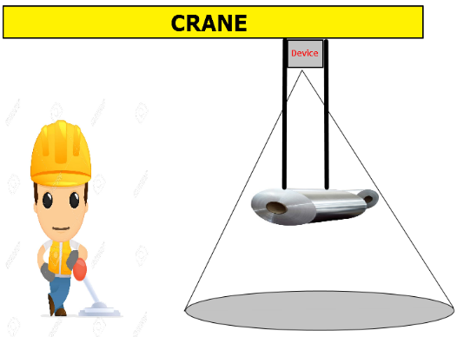
In order to ensure safety while operating cranes at ArcelorMittal’s steel mill it is necessary to take further measures in the sensing around the loads being carried by the cranes. This can be done by implementing a system that can sense the distance to the suspended load and then turn on a thermal sensor that can sense humans too close the load when the load is at a certain height. To sense the distance to the crane’s load an ultrasonic sensor can be used. This can be seen in Figure 1.

Distance

Figure 1: System Senses Distance to Load
To accomplish the part of the system that involves sensing the distance to the crane’s load a HC-SR04 ultrasonic sensor can be read by an Arduino microcontroller to interpret the results. The sensor will use the power and ground outputs from the microcontroller along with digital pins on the board. The clock and data pins on the board can be used to output the results, generated by the programming of the microcontroller, to a LCD display screen.
Ultrasonic Sensor
Figure 2 shows the HC-SR04 ultrasonic sensor. This sensor has 4 pins: Vcc (Voltage in), Trig (Trigger), Echo, and GND (Ground). The Vcc pin requires 5 VDC and the GND pin needs to be properly grounded. The Trig pin receives a pulse to start ranging and sends out a burst of ultrasound. The Echo pin receives the signal and calculates the time between sending a signal and receiving it. The formulas in Equations 1 and 2 show how the distance to an object is calculated.
$$Distance \left(cm\right)=\frac{Time \left(uS\right)}{58}$$
$$Distance \left(Inch\right)=\frac{Time \left(uS\right)}{148}$$
Equation 1: Distance Calculation
$$Range=\frac{\left(High Signal Time\right)\left(Speed of Sound\right)}{2}$$
Equation 2: Range of Sensor
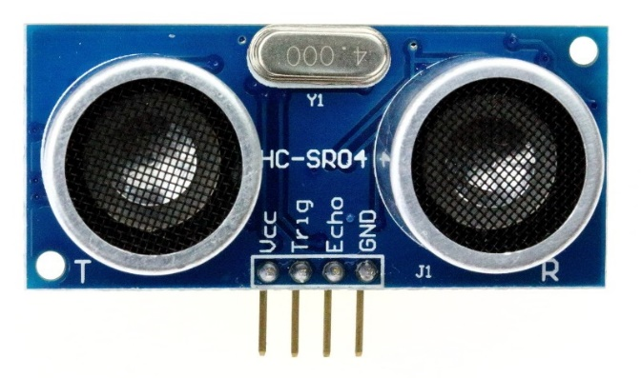
Figure 2: Ultrasonic Sensor
Arduino Leonardo
The Arduino Leonardo microcontroller board has 20 digital input/output pins capable of various things such as PWM, analog input, ICSP, and 5 VDC power supply and ground when given a 9 VDC input. The board can be programmed using the Arduino 1.6.5 software downloaded from the Arduino website. Connecting the board via Micro USB to a computer also powers the board and allows for loading Arduino sketches onto the board. The board has 32 kb of flash memory which is more than enough for this application and clock and data outputs for the LCD initialization. Figure 3 shows the Arduino Leonardo board.
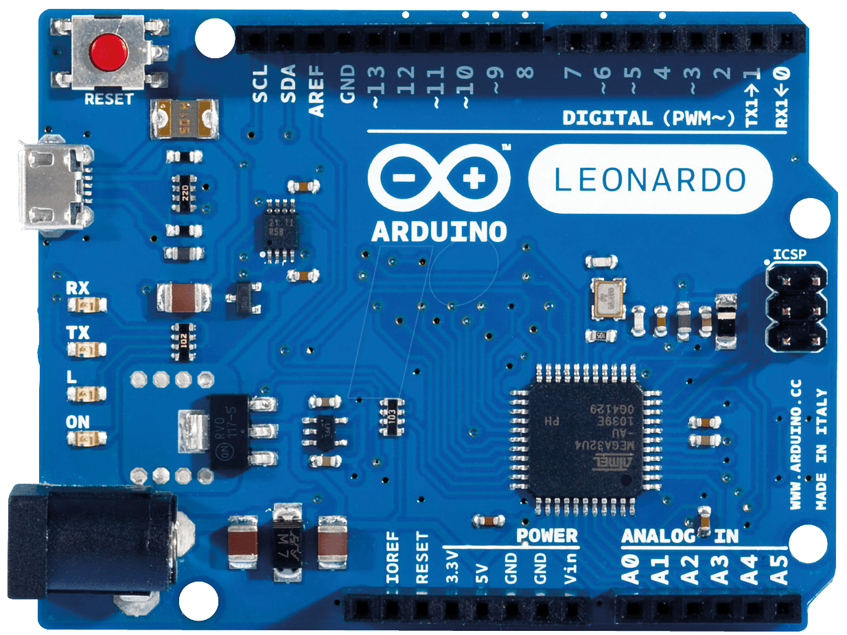
Figure 3: Arduino Leonardo Board
Serial LCD Display
The Serial LCD Display is 4 rows by 20 columns and has an illuminated backlight. The display requires 5 VDC power input and a ground along with data and a clock. The inputs can be supplied by the microcontroller and also programmed to output the necessary information. The serial LCD display can be seen in Figure 4.
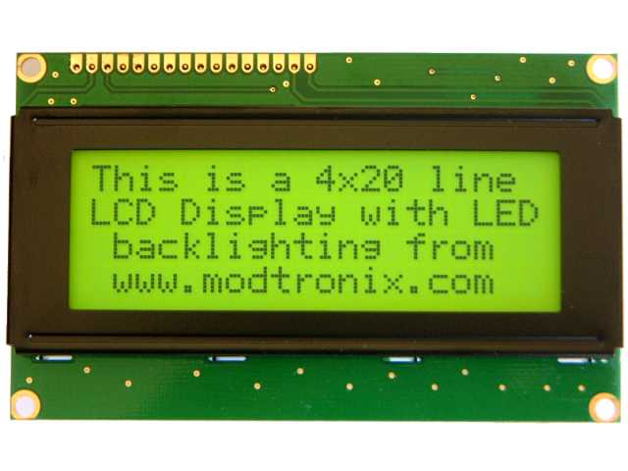
Figure 4: 4x20 Serial LCD Display
Arduino 1.6.5 Software
This software is capable of creating the sketches (code) for the Arduino board. The 1.6.5 software has built in error checking and compiling, but debugging will need to be done through a separate program (debugging is not necessary for this Application Note because the code is provided later in the document). The 1.6.5 software has built in libraries as well as the capability to download and implement libraries from the internet. The latter feature will be utilized for the initialization of the ultrasonic sensor. A blank sketch screen is shown in Figure 5.
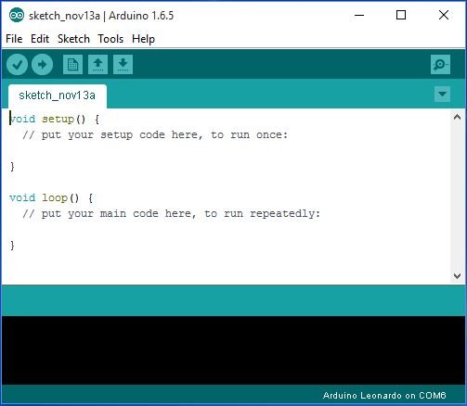
Figure 5: Arduino 1.6.5 Software
Arrangement of Devices
The Arduino board is the focal point of the design. The board supplies the power and ground strip to the protoboard, which is then supplied to the sensor and LCD display. The board also supplies the Echo and Trig pin to the ultrasonic sensor and the data and clock line to the LCD display. For the final design, it is imperative to have the sensor in the middle of all the components to ensure accuracy, but for testing, the sensor can be in any configuration as long as the sensor stays steady.
Either a wall wart or a Micro USB will power the Arduino board. The next few sections of the application note will describe how to make a sketch and load it onto the board to properly use the sensor and output the result to the LCD. A wire will run from the 5 VDC output of the Arduino board to the positive strip of the protoboard and a wire will connect the ground of the board to the ground strip of the protoboard. Wires will connect the Vcc and GND pins of the sensor to the 5 VDC strip and ground of the protoboard. The same goes for the LCD display.
Pins 11 and 12 will be utilized on the Arduino board for the Echo and Trig pins. Pin 12 will be connected to the Trig pin and Pin 11 will be connected to the Echo pin. The LCD display has clock and data pins which will be connected to the clock and data outputs on the Arduino board. A complete arrangement of these devices can be seen in Figure 6 and Figure 7.
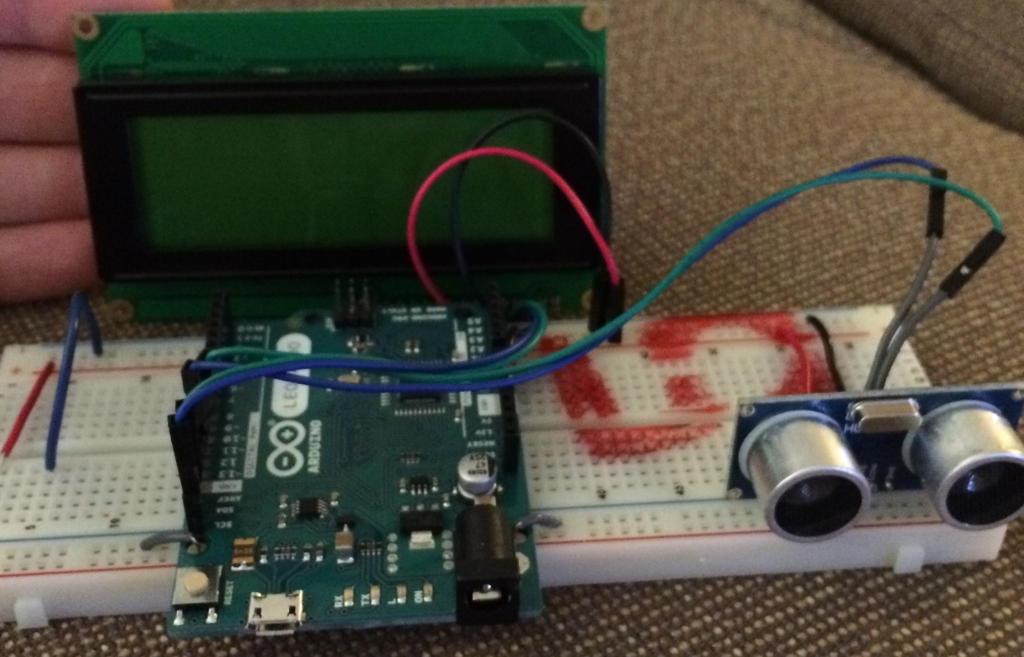
Figure 6: Arrangement of Devices
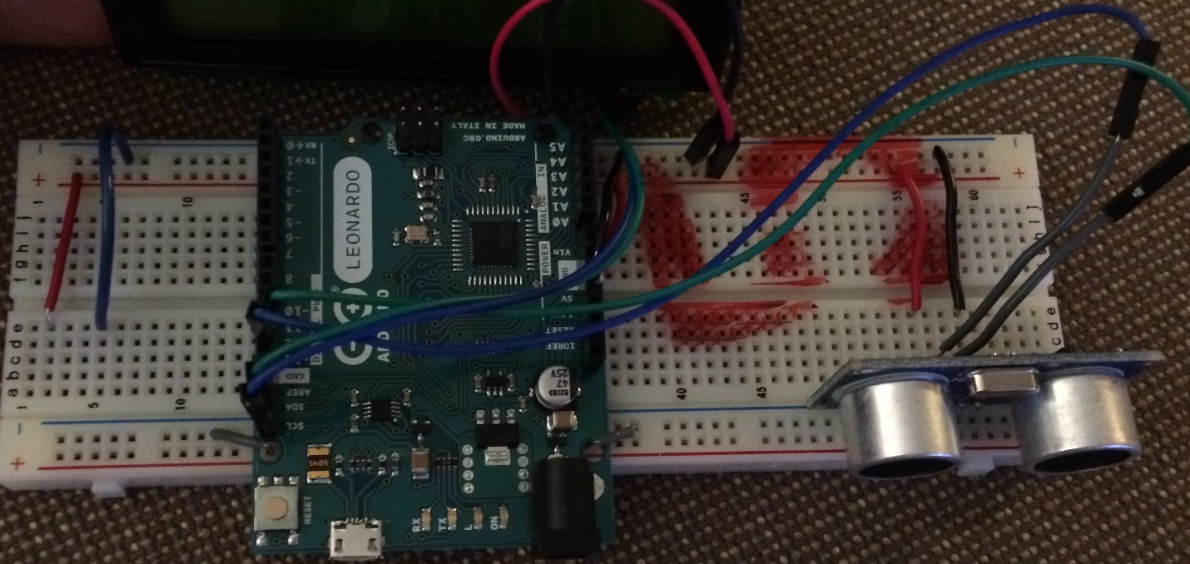
Figure 7: Arrangement of Wires

Initializing the HC-SR04
Now that the ultrasonic sensor has been physically connected to the Arduino board, the board needs to be programmed to send the proper signals to the sensor. Using the Arduino 1.6.5 software and the “NewPing” library (downloadable from Arduino’s website’s learn area), the sensor can be properly initialized. The first step is to use the ECHO_PIN and TRIGGER_PIN names to define the output pin on the Arduino board. After defining the outputs, defining the max distance the sensor should sense (in cm) is necessary to let the echo pin know that it did not receive an echo in time and the object being sensed is too far away. The NewPing library has a function declared “NewPing” that needs to be set to turn on the sensor. Since the LCD screen is not yet set up, the serial monitor can be used to view the distance for now.
The serial monitor is set up in the setup function by setting the baud rate. There are many options, but 9600 is what the sensor is running at so it makes sense to normalize to that value. The next step is to write the main function, which is called “loop” in the Arduino environment. Setting a small delay allows for time between pings of the sensor (sending a new signal) so the original signal has time to return to the receiver uninterrupted. Using the sonar.ping function of the NewPing library, we can begin the transmission and receive of a ping. The time it took to send and receive a ping is recorded in microseconds. This time can then be converted to cm (and later feet for our application). Using Serial.print, the values can be shown in the serial monitor window. The full code can be seen in Figure 8.
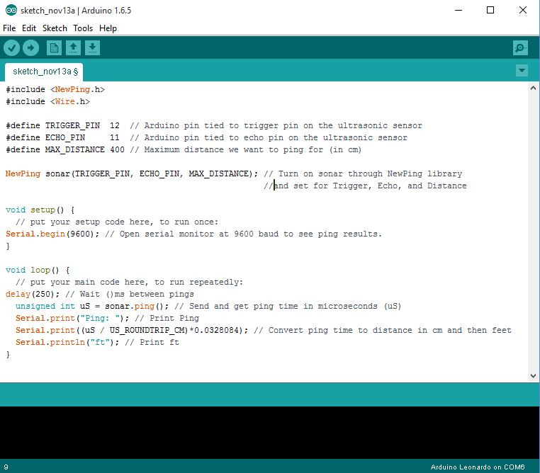
Figure 8: Ultrasonic Sensor Code

Initializing the LCD Display
It is more practical to output the distance to a screen, such as a LCD display, rather than the serial monitor in the Arduino software. To do this, some code needs to be added to the existing code for the ultrasonic sensor. The Wire library is included in the Arduino software and should be added at the top of the code. The I2C address of the LCD needs to be added before the setup code. This address was found in the data sheet for the LCD.
In the setup loop the Wire.begin function needs to be implemented along with the initialization of the LCD. A function for the LCD needs to be made. The function needs to include the address to communicate with the LCD, the register in the LCD to write to, and the command to stop transmitting to the LCD.
The LCD is now setup to write to. Using the wire.write command, it is simple to write to the LCD screen. There are more complex commands that allow the writing to scroll and change rows, but for this application those will not be needed. The transmission to the LCD will need to begin and be written to the correct address from the data sheet, but after this step anything can be written to the LCD. The transmission will stop using Wire.endTransmission.
For the design this LCD is being used for it is necessary to sense (using the ultrasonic sensor) how far the load is from the crane hook and turn on the other parts of the system at that height. Using an if-else statement it is possible to put the LCD write information for each case (above predetermined distance or below or equal to predetermined distance). The final code can be seen in Figure 9. The items not mentioned in the past two sections have to do with outputting a Boolean variable to turn the rest of the system on or off.
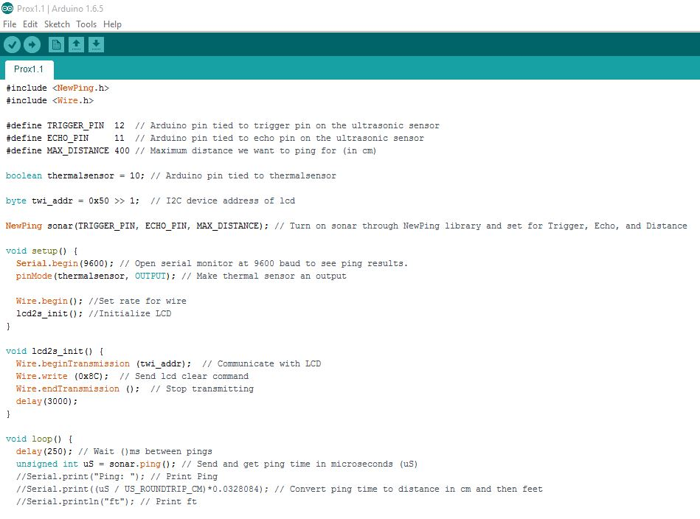
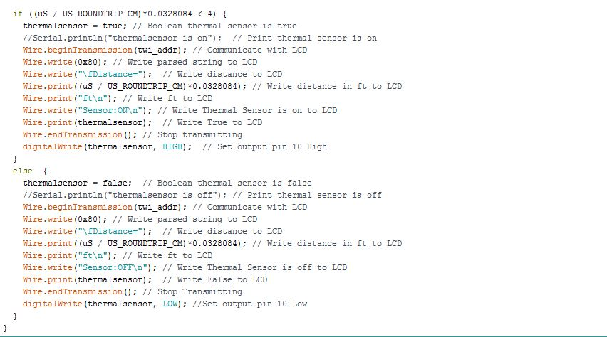
Figure 9: Final Code Including LCD Initialization
Results
The simple configuration of these devices paired with proper programming produced great results. The LCD screen displays the distance an object is away from the sensor (in feet) and also if the thermal sensor (rest of the design) will be turned on or off. By putting the sensor in a casing it can be protected from dust and debris as well as vibrations. The sensor is very accurate to objects (besides humans) and will serve its purpose in the overall design. Figure 10 shows an object close to the sensor and Figure 11 shows an object further away from the sensor.
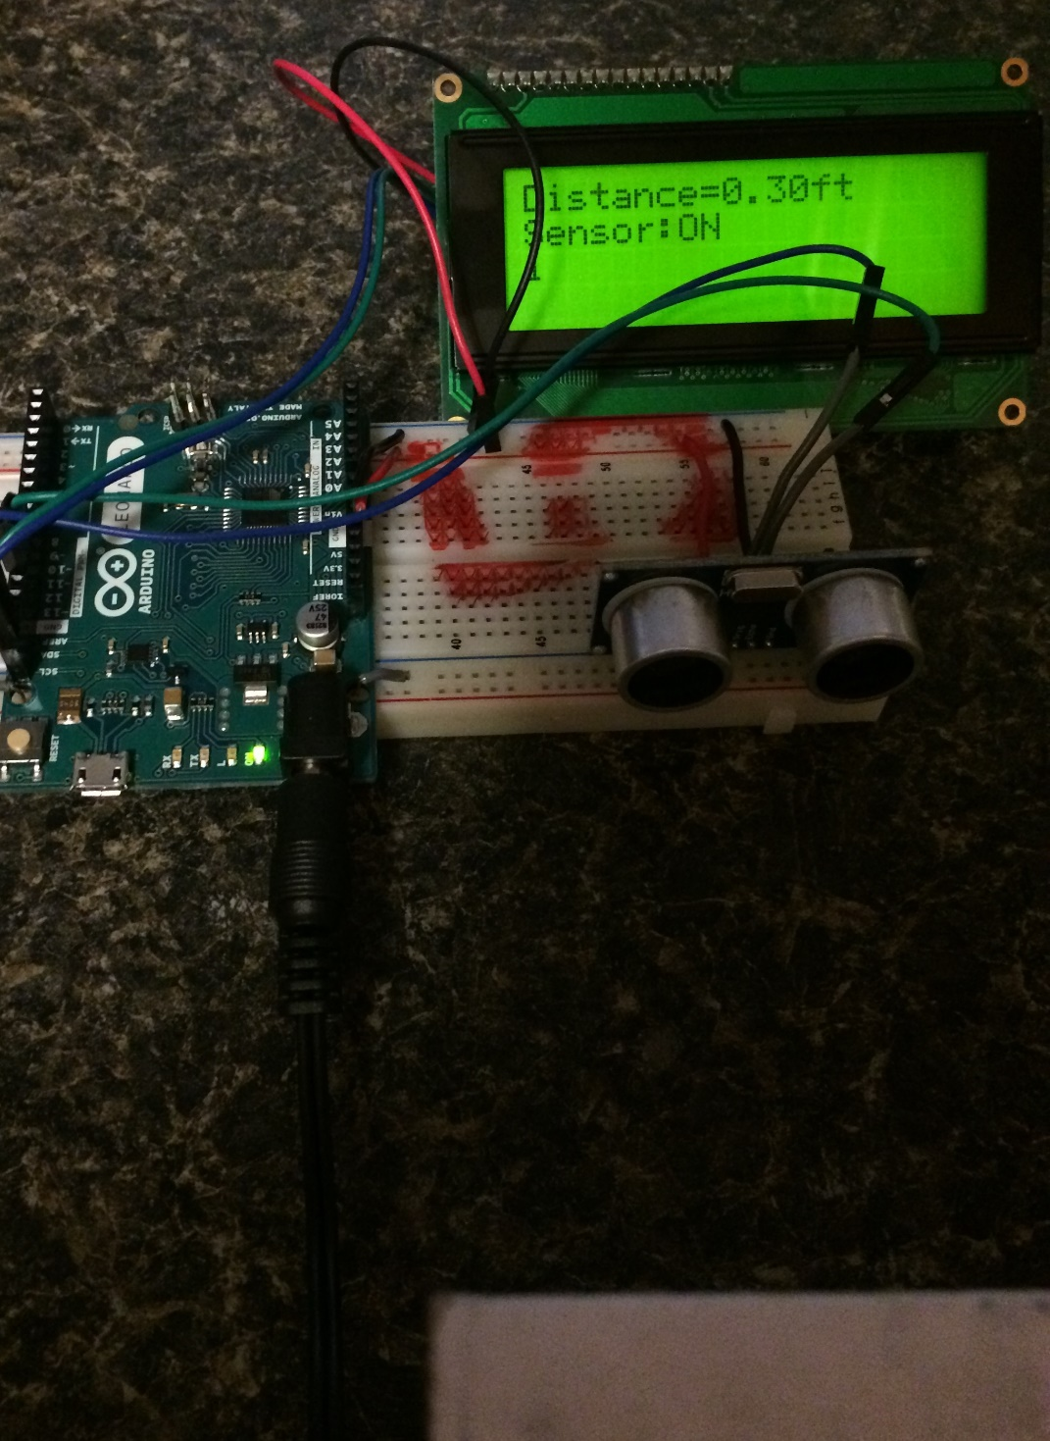
Figure 10: Object Close to the Sensor
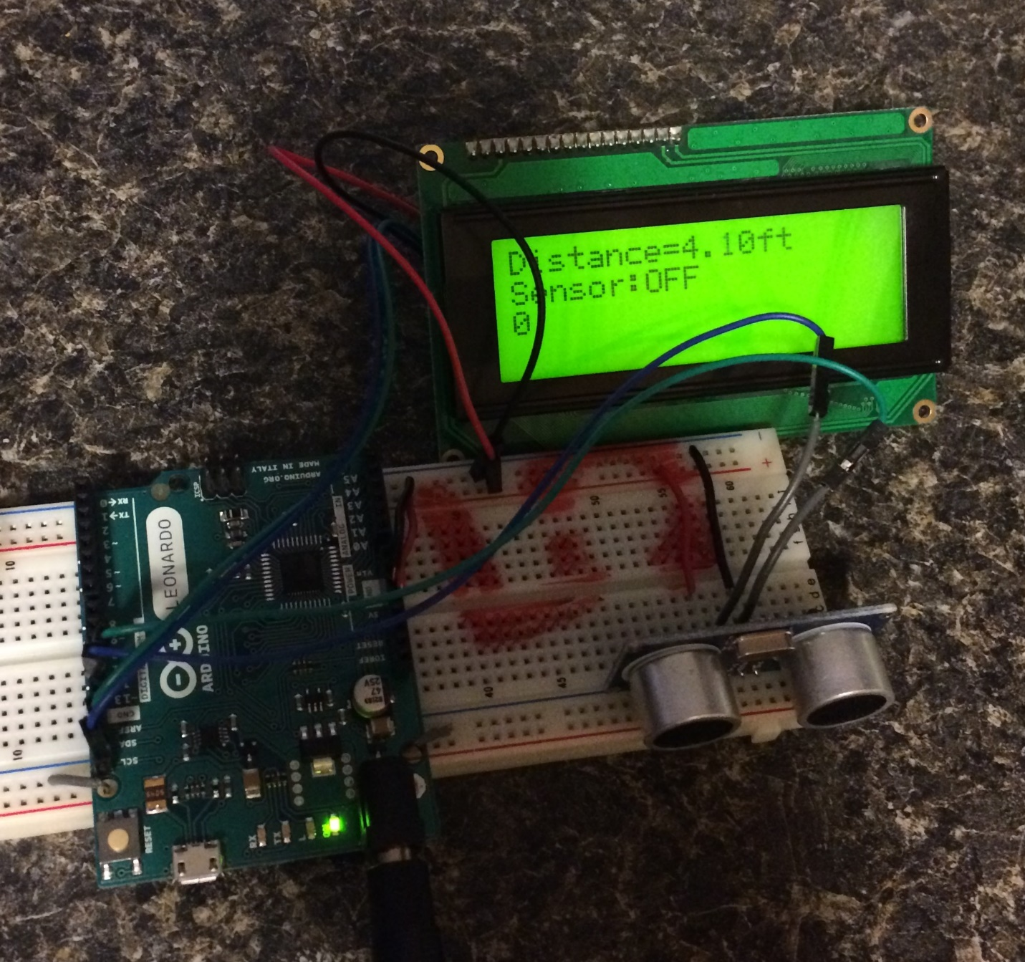
Figure 11: Object Further away from Sensor

References
Figure 1: System Senses Distance to Load
Figure 2: Ultrasonic Sensor
Figure 3: Arduino Leonardo Board
Figure 4: 4x20 Serial LCD Display
Figure 5: Arduino 1.6.5 Software
Figure 6: Arrangement of Devices
Figure 7: Arrangement of Wires
Figure 8: Ultrasonic Sensor Code
Figure 9: Final Code Including LCD Initialization
Figure 10: Object Close to the Sensor
Figure 11: Object Further away from Sensor
Equation 1: Distance Calculation
Equation 2: Range of Sensor
[1] Ultrasonic Ranging Module HC-SR04. Data Sheet and Product Features. Elec Freaks. http://e-radionica.com/productdata/HCSR04.pdf
[2] Arduino Leonardo 8-bit Microcontroller with 16/32K bytes of ISP Flash and USB Controller. Datasheet. Atmel. http://www.atmel.com/devices/atmega32u4.aspx
[3] Systronix 20x4 LCD Brief Technical Data. 21 July 2000. Data sheet and technical data. Systronix. http://www.systronix.com/access/Systronix_20x4_lcd_brief_data.pdf
[4] Arduino Playground NewPing library. Arduino. http://playground.arduino.cc/Code/NewPing

