December 3, 2014



Bottle Orientation Interface System (BOrIS)

Sponsored by Bekum America Corp.
Facilitated by Dr. Lixin Dong
Presented by: Sam Saia, Emily Skipton, Zain Syed,
Gurwinder Singh, Alec Joiner

MICHIGAN STATE UNIVERSITY COLLEGE OF ENGINEERING
ECE 480 – DESIGN TEAM 1

EXECUTIVE SUMMARY
The current user interface included with the FANUC Bottle Orientation robot requires operators to use the attached pendant in order to enter a new bottle configuration. Although this pendant allows for high customization, it includes many non-user input menus and superfluous steps that make it difficult for an operator with a high-school level of education and minimal training to operate efficiently. The goal of this project was to create a user-friendly touch screen interface that would be a substitute to the pendant. The UI is a web application that sends requests to a j2ee java server. This server is where all the hard-code, written in java, will send automated steps and receive the corresponding robot controller responses.

ACKNOWLEDGEMENTS
LIXIN DONG
Thank you to our facilitator, Lixin Dong, who provided the guidance and direction necessary for the success of this project.
BEKUM AMERICA CORPORATION
Special gratitude also goes to Kirk Myers, and Ben Sterling, from Bekum America Corp., who were always there to provide access to the R30iB robot controller and provided all of the necessary FANUC and Bekum documentation needed to complete the User Interface.
PROFESSORS AND FAMILIES
We especially thank our professors and families for providing us this opportunity to grow as professionals.

TABLE OF CONTENTS
Executive Summary 2
Acknowledgements 3
1 | Introduction and Background 8
Introduction 8
Background 9
2 | Exploring the Solution Space and Selecting a Specific Approach 12
Decomposition of the problem 12
FAST Diagram 13
Conceptual Design 13
Ranking of Conceptual Design 17
Proposed Design Solution 18
Resources and Facilities 21
Timeline 21
Cost 21
GANTT Chart 22
3 | Technical Description of Work Performed 24
Hardware Design 24
- Touch Screen Display 24
- Factory Standard Enclosure 25
- The FANUC Robot 25
- Mounting and Display 25
Hardware Implementation 26
- Surface Pro 2 26
- Factory Setting 26
- Robot Configuration 27
Software Design 28
- The Graphical User Interface & Platform Considerations 28
- HTML, CSS, and Javascript 29
- Interaction 29
- Communication 29
- Automation 30
- Menu Flow and Screen Design 30
- Internationalization 32
Software Implementation 32
- Polymer.js 32
- Web Services & The KAREL Command Line 33
- Putting It All Together 34
Issues Faced 35
- Lack of FANUC Software 35
- Precompiled Built-in Programs 36
- Motion Commands 36
- Robot Configuration 36
4 | Test Data with Proof of Functional Design 37
Design Failures 39
- FANUC Proprietary Software Availability 39
- Motion Controls and Macros 39
- Internal I/O Flags 40
- iRVision 40
- Incompatibility 40
- Overall Failure 41
5 | Final Cost, Schedule, Summary, and Conclusions 42
Redesign Approaches 43
- KAREL Socket Messaging Server 43
- The Robot Server Control 43
- GE-FANUC OLPC 44
- HMI & SNPX 44
- ROS 44
- User Prompts 45
- TPP Background Logic 45
Appendix 1 – Technical Roles, Responsibilities and Work Accomplished 46
Appendix 2 – Literature and Website References 54
Appendix 3 – Detailed Technical Attachments 55
Appendix 4 – Final Project Schedule 72

CHAPTER 1
Introduction and Background
The understanding of the problem at hand by researching its components aids with the design and implementation of the BOrIS system. This research includes stating the customer needs, defining the end user, and exploring concepts of how best to solve the problem based on prior knowledge.

Introduction
The ultimate user, in the case of the Bottle Orientation Interface System, is Bekum’s customers: manufacturing plants that will buy this bottling machine. The operators at these manufacturing plants will need to change the configuration of the bottling machine depending on the bottle and be able to create new bottling settings. From this created interface, the user should be able to re-calibrate the iRVision camera and robotic arm and select the next bottle to be processed. The calibration of the iRVision camera and robotic arm will require the user to set a grid under the camera, as well as a new bottle. To minimize human error and streamline the process, visual and textual prompts should tell the user when and where to place the grid and bottle. The user would then select a “next step” option when finished with each action. When users select a saved bottle, that selection should automatically load the previously saved parameters for that bottle.

The operators must be able to easily, and efficiently perform the configurations with only a high school education level and minimal training. Therefore, how much the operators struggle with learning the configuration process will be used as a judge for the feasibility of a design. This criteria is the most important when considering the success of the design. Other criteria that will need to be considered are whether or not the configurations are saved correctly, the number of steps the operator must perform, and the time it takes the operator to complete the configuration process. Two of these criteria are at odds with each other: the speed at which the configuration can be complete, and the ease with which the operator can navigate the interface. It would be easier for the operator if every step was broken into smaller tasks but too many menus can make the process time consuming.

The display will be a fully-functional Windows PC, and will host the client software which will operate within the Chrome browser. The back-end of the software will have to communicate with the Fanuc Robot controller over ethernet using the available Web Services provided by the LR Handling Tool. The back-end of the software must be designed to appropriately modify values stored on the robot controller using the communication methods that Fanuc provides. The approach will be limited by the functionality FANUC exposes over the available Web Services. This approach will be successful as we will be able to mimic iPendant behavior and communication to the robot controller through a networked device, thus producing a viable alternative interface to complete the procedures to operate Bekum’s Bottle Orientation System. The ability to interact with an external interface explicitly designed for operation of the machine results in the ability to eliminate or minimize interaction with the confusing iPendant device, and allows for a streamlined end-user experience.

Background
Adding a custom user interface to a Fanuc robot is a common requirement. Fanuc initially supplies a proprietary device that displays technical configuration screens and provides access to machine commands, states, and variables. However, this approach lacks a streamlined end-user experience as the robot is designed by Fanuc for customization and not ease of use. Once the robot is repurposed by Bekum to meet the expected functionality required by their customers, complex procedures are involved to set-up the robot for each new bottle. These tasks include: calibrating the camera that detects bottle positions, creating the vision process, setting up configurations for new bottle types, setting up the tracking frame, and the tool frame, and teaching the machine to pick up the containers. The new interface will automate these processes as much as possible in order to enhance the user experience and improve ease of use. A block diagram illustrating the current system is shown below in (Figure 1).
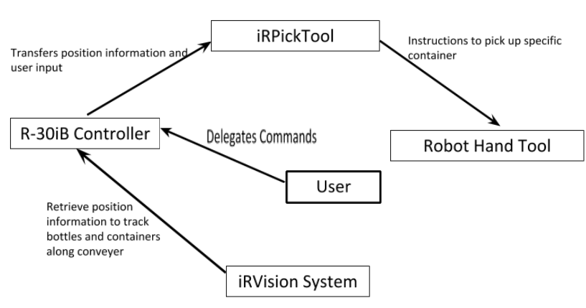
Figure 1: Block Diagram of Current Design’s Communication

The Fanuc robot controller being used for the project is the R-30iB Controller, with the iRVision camera system, and the iRPickTool. The R-30iB Controller is a versatile robot controller for industrial robots and with flexibility to interface with external hardware and software. The controller communicates with the iRVision system to retrieve information from the camera to track bottles and containers along the conveyer. This information is relayed to the iRPickTool, which prepares instructions for the robot hand tool to pick up the specific container type.
The R-30iB Controller includes several options for I/O with external computer devices. These include socket communication, machine level protocols, and HTTP web services. In order to create a custom interface for the controller, the client device, a touch screen PC, must communicate with the controller over one of these methods. The device will have access to a front-end client interface that would consolidate the required user procedures for configuring the robot into selectable automated stored procedures. Front-end actions would be processed by back-end logic on the client that translates user actions into a series of instructions for the Fanuc robot.

The goal of the new interface is to reduce the number of user interactions required to complete tasks. The screen flow should be designed to prompt the user to the next task, followed by simple instructions for any required input. Processes between input prompts will be automated and should report progress as well as relevant system variable states. When designing user interfaces there are many principles regarding the user experience to consider. These principles must be followed in order to create a workflow intended to efficiently complete the task at hand in an intuitive way. Tasks should be dissected into subroutines that are executed between designed user prompts that indicate to the user what to expect in terms of necessary input and output, without drawing attention to the design itself. A user interface should also allow the user to switch between program states in order to back out of initiated processes. The result of such efforts will produce a new streamlined user experience with exceptional ease of use to operate a complex system.

CHAPTER 2
Exploring the Solution Space and Selecting a Specific Approach
In order to characterize which design approach is most effective, a FAST diagram is essential for understanding the subsystems of the problem. Additionally, House of Quality techniques are used to determine which components of the problem are the most important to address, these are called the Critical Customer Requirements. Feasibility and Decision matrices are then used to choose, among proposed solutions, the most appropriate design.

Decomposition of the Problem
The requirements laid out by Bekum for the design of the Bottle Orientation Interface System are as follows:
- A touch screen must be used for the user interface and meet factory standards for durability.
- The user should be able to re-calibrate the iRVision camera and the robotic arm for a new bottle “recipe”.
- The new interface should reduce the number of steps the current interface requires the user to perform.
- The user should be able to select the next bottle to be processed
- When the user selects a new bottle, that selection should automatically load the iRvision and robotic arm calibrations that have been previously set.
- The interface should provide prompts for any human action that needs to be taken outside of the touchscreen menu in order to reduce human error and streamline the process.

How we will implement these objectives into our design is outlined in the FAST Diagram shown in Figure 2.
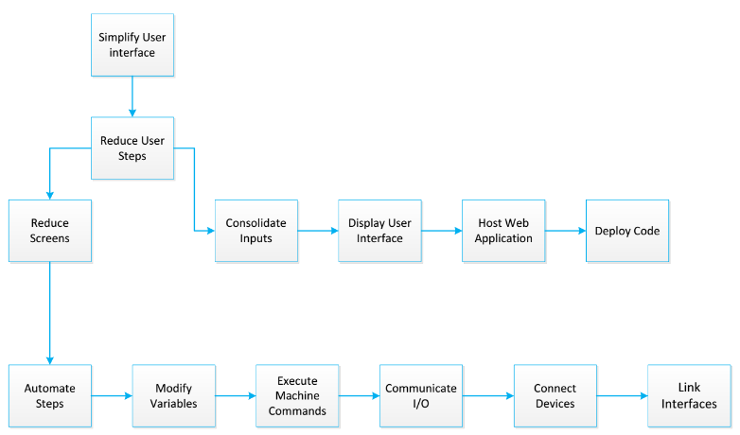
Figure 2: FAST Diagram for the Implementation of the Bottle Orientation Interface System (BOrIS)

Conceptual Design
In order to achieve the ideal user interaction goals, we'll need to automate processes by explicitly changing system variables and states and running internal programs. This can be achieved using Fanuc's built-in controller machine language KAREL (See Appendix 3). KAREL is a scripting language which compiles and executes directly on the Fanuc robot [1]. The language is capable of accessing and modifying any data register on the controller from a processor within the controller itself. KAREL programs can be executed using the Enhanced Web Services made available by the LRHandlingTool for the robot controller. With these tools available, full task automation can be achieved for all values that don't require user input, such as recipe selection, unique data entries, and physical procedures involving the machine to calibrate the Camera and teach the pick tool. The procedures are: Setup Tool Frame, Set Tracking Frame, Calibrate Camera, New Container Setup, Create Vision Process, Teach Pick Position, and Teach Place Position. Currently, all these procedures are done on the pendant, which is the device that has the software to control the BOS. A new interface needs to be created to help make the BOS user friendly.
With functional automation we are able to compress each procedure from a lengthy complex set of instructions for the user to a self-executing linear process that prompts for user input only when unique values are required that could not otherwise be calculated with previously stored information. This sort of automation satisfies the project's ultimate goal by reducing total user interactions and producing a straight-forward process for the end-user to execute redundant procedures. Automated procedure times will be bounded only by the time it takes for the machine to execute the stored subroutines, as well as the time it takes the user to navigate the user-interface. With the described functionality available, the user-interface can also be designed intuitively to require the least amount of user-interactions possible. By the end of an average procedure operation, the time required to complete the procedure, considering a constant average time for each user interaction, should be significantly reduced in an automated environment as compared to solutions that require interaction with the Fanuc iPendant.

One option for an interface design is to display each procedure as its own option. The user can click each option. After clicking a procedure, the screen will display all the steps that need to be done on the pendant for that procedure. It would also display pictures or a video further explaining those steps. The user will then use the pendant and complete the steps.
Another option for an interface would involve displaying the procedures as options as well. In this design there will not be separate options for every procedure on one screen. Some of the procedures are related. The New Container Setup procedure requires the user to complete the Teach Pick/Place procedures, and the Create Vision Process procedure. On the main menu there will be an option of New Container Setup and if this option is clicked there will be a submenu displaying the options of the related procedures. The Setup Tool Frame, Set Tracking Frame, and Calibrate Camera procedures will have separate options on the main menu also. Currently, some of these procedures require navigation through multiple menus and menu options on the pendant (Figure 3 on following page).
This could be automated by the new interface. The interface would take the user directly to what needs to be inputted so the user does not have to waste time navigating through multiple menus and screens.
The second option is the ideal option. The first option would have the user going back and forth between the interface and the pendant. This second option is more user-friendly and would only require the user to use the pendant when needed. The input would be easier to enter with the second design. Much of the work could be done on the new interface with the second option. The comparison of these two strategies is shown in Table 1, Table 2, and Table 3 on the following pages.

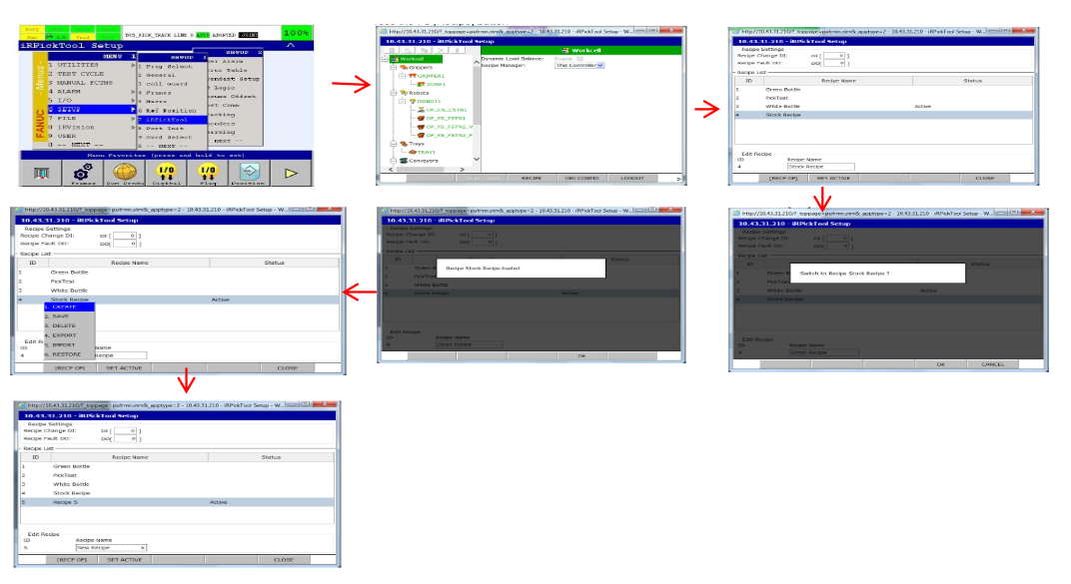
Figure 3: Flowchart illustrating all the menus a user has to go through, currently, in order to enter a new recipe

Ranking of Conceptual Designs
Table 1: Ranking of Conceptual Design Options

Design | Total Number of User Interactions | Estimated Average Length of Time for Completion
Full Automation | 29 | 30 minutes
External iPendant Operation with Interface Prompts | 71 | 1 hour 30 minutes
Table 2: Solution Selection Matrix
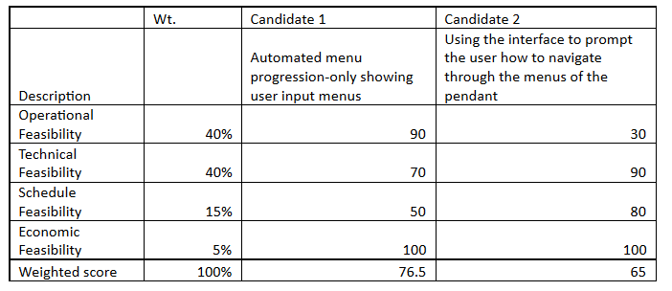

Table 3: Feasibility Matrix
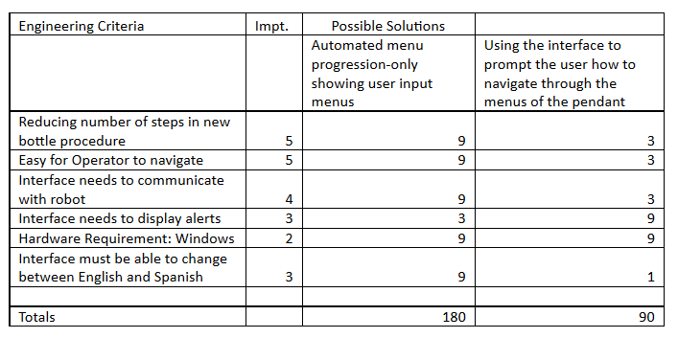

Proposed Design Solution
In order to simplify the end user’s interactions with the bottle orientation system, we will be introducing a front-end UI component and a back-end control service component. The front-end component will provide a simple set of commands that represent common tasks the system’s operator would need to perform. The back-end component will interface into the existing system in order to translate the high-level commands on the UI into low-level commands which can be used to drive the existing pieces of the system. Figure 4, on the following page, diagrams the modes of user interaction that this new design would implement.

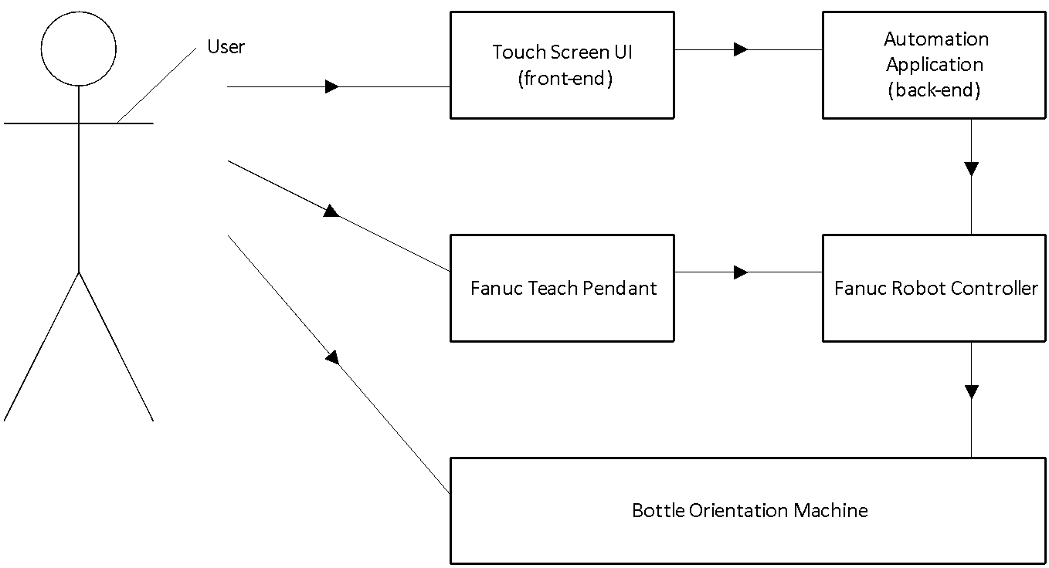
Figure 4: Diagram of the Different User Interaction Modes in the Proposed Design

The user of the system will interact primarily through the touch screen UI for tasks which have been simplified by our applications. For tasks which have not been simplified, the user will interact with the system through the teach pendant as before. Physical interactions with the machine, such as installing the vision mat, will also be carried out manually as before.
The basic design of our solution is to condense typical interactions with the bottle orientation system into high level commands. Goals which would take dozens of steps and menu interactions on the teach pendant will be represented as single items on our touch screen UI. We will then use Java EE’s JAX-RS specification to define a web service which exposes these high level commands as items that can be triggered from our user interface. When the user selects a command in the UI, the UI relays that command to the web service, which will trigger all of the individual steps and menu interactions necessary to complete the higher-level goal the user is trying to accomplish. These steps and interactions will be completely silently using the Fanuc controller’s web interface, saving the user several interactions with the system. The back end web service will also subscribe to any alarms triggered on the Fanuc controller as an RSS feed, and provide this information back to the user interface, which will display these alarms to the operator directly on the touch screen interface. The software interaction between the front and back-end of the interface is illustrated in Figure 5.
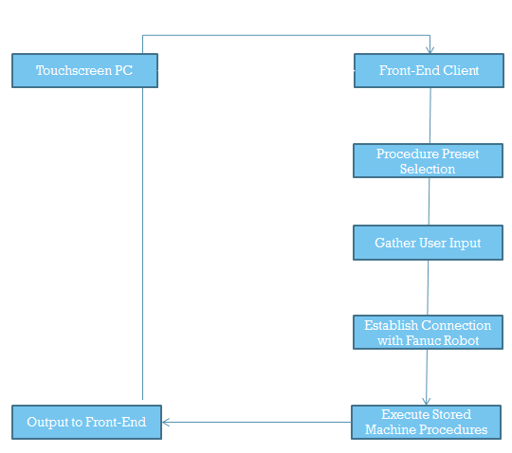
Figure 5: Diagram Illustrating the Interaction between the Front and Back-end of the Interface

The front end UI will be written in HTML5 using Google’s Polymer framework [See Appendix 3]. The polymer framework is designed specifically to be touch-screen friendly, and will allow us to ensure that our interface works well with a touch screen. Using polymer’s built in two-way data-binding and the Fanuc Robot controller’s network socket interface, we can verify that users have entered all of the necessary inputs and verify that the system is in the correct state before allowing them to continue, making the system far less prone to mistakes caused by missing information or skipped steps. The interface will also be able to display example videos and photos as help items to ensure that the operator clearly understands any instructions they are being given.
Resources and Facilities
The hardware required to complete the design project will be a touchscreen PC. The project sponsor suggested the Beckhoff “Economy” Panel PC CP72xx touch screen. This item was beyond the scope of the budget; however, so it was replaced by a Microsoft Surface Pro 2 and AmorActive Full Metal Jacket enclosure. The software required to complete the design project will be Polymer, Tomcat, Chrome, iRvision, and iRpicktool. All of the softwares used are free source software.

Timeline
The GANTT chart for the Bottle Orientation Interface System is illustrated by Table 4 and Figure 6 on the following pages.

Cost
All software was free source and the touch screen, enclosure, and connectors that were purchased through Bekum totaled $856.

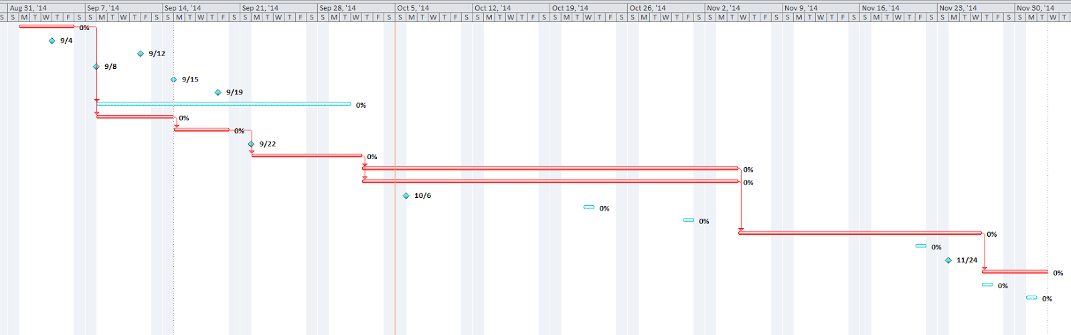
Figure 6: GANNT Chart

Table 4: Textual list representation of Team 1’s GANTT Chart
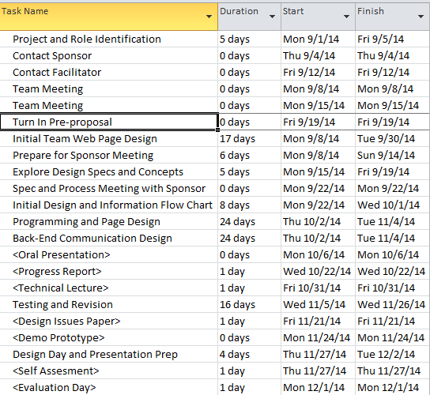

CHAPTER 3
Technical Description of Work Performed
The technical details of the design and implementation process for the BOrIS system involves critical design decisions to produce the desired functionality with coherently chosen components. The overall system design involves both hardware and software specifications.

Hardware Design
In designing the implementation of the hardware requirements for the project, there were several elements to consider.
Touch Screen Display
The key hardware component to the design is the touch screen display. The display would require an internal CPU, storage, and a familiar Operating System and relevant software capabilities, in order to directly develop and deploy software on the device that could operate in a stand-alone fashion. This would allow the external interface to be an all-encompassing solution without a requirement for peripheral components, such as a separate server for computations and logic. For our purposes, any standard consumer tablet computer can meet these requirements. The tablet would however need to meet minimum software criteria for optimal performance. As later detailed, the client software would ultimately be implemented as a web application deployed in a web browser. For these purposes, the tablet computer would have to support a web browser with high compatibility with emerging web technologies such as modern Javascript libraries, HTML5, and CSS3 [See Appendix 3]. The processing power of the tablet as well as the available memory should be enough to not only run a dynamic web application within the web browser, but also run necessary background processes such a local server, which can often utilize high amounts of computing resources and networking bandwidth. The tablet should also include networking hardware with the appropriate software drivers bundled with the Operating System. In order to facilitate efficient user-input, the tablet computer should also include input mechanisms for not only touch interactions, but text prompts with a standard ASCII keyboard input. The tablet may have an external hardware keyboard or may implement a touch screen keyboard through the Operating System. The last important software feature to be provided by the Operating System will be the ability to enter a full-screen “kiosk” mode, designed to lock the end-user within the interface application during operation.
Factory-standard Enclosure
The tablet must have an available compatible enclosure to meet factory standards, such as an air-tight seal to prevent exposure to dust and particles commonly produced in manufacturing settings.
The FANUC Robot
Hardware design considerations also involved physically interfacing the tablet with the provided Fanuc robot controller. The Bottle Orientation System uses Fanuc’s R30iB controller, which boasts built-in networking capabilities over the TCP/IP network protocol [2]. The controller is already connected over Ethernet to Bekum’s internal LAN network and is exposed to the internet via a private-VPN. The tablet computer thus has the option of connecting to the robot controller over wireless LAN or connecting directly to the robot over an ethernet line using a CAT5 cable.
Mounting and Display
Lastly, the hardware may require a mount to the existing machine, with sensible placement relative to the user’s main operation zone as well as the existing iPendant system and mount. The mount must also meet factory standards and requirements.

Hardware Implementation
The appropriate hardware was selected by measuring the value of tablet features against our unit budget and requirements.
The appropriate hardware was selected by measuring the value of tablet features against our unit budget and requirements.
Surface Pro 2
The chosen touch screen for the project was the Microsoft Surface Pro 2. The Surface Pro brand by Microsoft is a feature-rich line of tablet computers hosting Microsoft’s Windows 8.1 Pro operating system. The tablet features a high resolution 10.6-inch display capable of displaying clear vivid visuals. The Surface Pro 2 model purchased is powered by NVIDIA Tegra 4 Quad-Core processor with a clock speed of 1.5GHz and on-board graphics processing using an integrated Intel 4200 chip. The same model also includes 128 gigabytes of internal storage and 4 gigabytes of RAM. Powered by a 36 Watt power supply, the Surface Pro can be connected to any standard wall outlet. The tablet includes a Wi-Fi 802.11 ac/b/g/n networking card to connect to the Bekum’s wireless LAN, as well as hardware USB data ports separate from the charging port. With all the features of a full Windows PC, the software capabilities of this model of the Surface Pro are more than enough to handle the performance requirements of the BOrIS software solution.
Factory Setting
The Surface Pro 2 weighs a mere 2 lbs, physically compacted into its hardware dimensions of 10.81” x 6.81” x 0.53”. Though the tablet is optimized for portability, several heavy-duty enclosures are sold for this specific model. The enclosure selected was Armor Active’s Full Metal Jacket which is made from 16 gauge steel.

Robot Configuration
The robot and controller provided by Bekum, as previously mentioned, is the R30iB controller. This controller is one of Fanuc’s recent flagship products, and includes hardware and software accessory features such as the iPendant, FANUC iRVision (integrated vision), line tracking, positioners, external axis, and force sensors. The Handling Tool, Spot Tool, Arc Tool and Paint Tool are software tools enabled on the robot that accommodate communication and development for the robot. One specific feature the Handling Tool provides for communication is the Enhanced Web Server [3]. This web-server is built into the controller and exposes interfaces to the controller’s internal file system and machine commands over the HTTP protocol. This enables the easiest path of communication from a client web-app. The FANUC robot executes compiled KAREL code internally, translated to the machine language. The ideal software solution will execute the appropriately KAREL commands corresponding to iPendant actions.
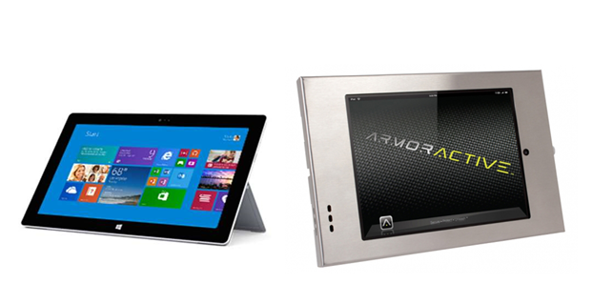
Figure 7: Pictures of the Surface Pro 2 (left) and Armor Active’s Full Metal Jacket (right)

Software Design
When designing a software application on any operating system, a software platform and development environment must be chosen as the basis for the entire application.
The Graphical User Interface & Platform Considerations
When designing our client, we made a distinction between two types of client interfaces, an offline application and a web application.
An offline application would have its Graphical User Interface (GUI) rendered through the Operating System’s native API calls. This means that the application would be a compiled process that runs directly against the machine, or a virtual machine environment. The operating system makes drawing functionality available to produce screen output, and the application calls these functions to display its user interface. A framework such as this encapsulates all computational logic within a single process, as the front-end rendering and back-end logic are all executed using the same operating system functionality.
In contrast, a web application is an application that can be accessed through a web browser. Web browsers commonly operate over the HTTP protocol. The browser will request a page, and render components to the screen after parsing the Document-Object-Model (DOM) it receives in response, formatted in Hypertext-Markup-Language (HTML) and stylized by Cascading Style Sheets (CSS). A web application will serve dynamic content when page requests are made based on session information and previous user interactions, and underlying data. An interface built in a web browser allows for ultra-portability, as most modern operating systems by default support internet browsing. This sort of model however would require a two tiered structure, where user interactions are handled by the client, but background computations, commonly known as business logic, would be processed by a separate software service.
For the purposes of BOrIS, the web application model offers greater advantages. Although the model may require greater performance overhead on the system, it requires less development overhead, as the portability and dynamic abilities of HTML, CSS, and Javascript (a browser scripting language used to make changes to the DOM), offers rapid software prototyping with minimal compiling [See Appendix 3]. The modular nature of the overall solution allows for a simple plug-and-play environment when implementing components of the front-end, with changes to the application reflected instantly in the browser container.
HTML, CSS, and Javascript
Designing the GUI contained in a web browser implies creating input elements such as buttons and text boxes, as well as display elements such as labels and dialogs, produced by HTML mark-up and styled by CSS rules. Interaction with such elements would be tied to Javascript events, fired by the web browser, that would execute some custom scripts and produce a result. For example, a button may be an HTML <div> tag, with a “button” style class applied to it, that would do “some stuff” when executed:
<div class=”button” onclick=”doSomeStuff()”>Button Text</div>
There are free Javascript powered frameworks available to simplify this process, and structure the code in an object oriented manner.
Interaction
The specific design of the client’s GUI will also need to include key features of operation. These features include a sequence of screens for each user procedure, components for user input, the ability to cancel the operation or access a previous screen, and the ability to asynchronously fire HTTP requests to a server and wait for a response using Asynchronous Javascript & XML (AJAX). AJAX calls are the main communication component of a dynamic web application. A Javascript call may fire a request for an HTTP resource that will return an Extensible Markup Language (XML) formatted response, that can be parsed by Javascript, and the resulting data is used to update the DOM, thus modifying the page’s content. These calls would be used to query the server for executing automation on the robot and retrieving results.
Communication
The application will need to execute communication with the robot in order to send commands and receive program states and variables. As detailed earlier, the FANUC robot controller includes the built-in web server which allows for interfacing with the controller over HTTP. An Application Programming Interface (API) must be designed on the controller or our local server which our client will use to retrieve values and execute allowed statements. This API should redirect the web requests to execute against the machine command line and interpret the resulting output and produce a response.
Automation
All the automation of our procedures will operate over this API. With this in mind, the sequence of screens and prompts the user will interact with must be designed, and the underlying corresponding automation must be specified. In order to discover what steps must be automated, the procedure screens on the iPendant must be studied. The source for some of these screens is available in the FANUC controller storage. In order to discover the data being modified, the requests the iPendant sends to the controller over CGTP, an HTTP facing protocol for remote operation of the iPendant, must be captured and analyzed, as well as the parameters of the iPendant controls in the DOM. These messages will include the command type, and associated parameters, when an action is performed on the iPendant device. These messages can be captured using packet-sniffing software, such as Fiddler. Packet-Sniffing software is a service that acts a local proxy on a computer’s network adapter, and forwards requests to their intended destination, but not without logging a copy of the data being sent. This allows us to monitor activity on the iPendant so that we can mimic the behavior. This behavior includes modifying variables and executing macros. In order to operate the iPendant remotely and properly view the controls, Fanuc’s iPendant PC Controls kit must also be installed on a Windows PC.
Menu Flow and Screen Design
From the information collected, it can then be determined what steps actually require a user input and which steps are common to every “recipe” building process. The process can be greatly condensed and simplified by automating the common steps and only prompting the user for the information that is unique or requires their input. Table 6 in Appendix 3 illustrates the comparison between steps involved in the current interface and the ones implemented by Team 1.
After determining which variables require user input, the graphical design of the user interface could be made. It is important to note at this juncture that the determination of what is “good” or “appropriate” can be very subjective, but that several guidelines exist that can aid in designing a widely successful interface. The first, and perhaps most important, consideration in the design process is to determine who the end user of the interface will be. The overall theme, appearance, and navigation of the interface must be understandable and relatable to the end user. The end user description given by Bekum for this project was that of a high school graduate working in factory conditions. This means that any jargon or highly specific engineering references had to be eliminated from the current system and referred to in more colloquial terms.
Once the target end user has been determined, the process of menu organization begins. The first subtask of organization is consistency. Consistency refers to the idea that the same conventions and rules are applied to all aspects of the interface, existing platforms and cultural conventions are followed, and conventions are consistent with real world experiences and perceptions. The second organizational consideration is screen layout. The layout should be clean and uncluttered with a grid like structure and like elements grouped together. The last consideration under organization is navigability. Each screen should follow the preceding screen in a logical order that leads the user to their desired result. Title bars, menus, and other different areas of each screen should also be easily recognizable and distinguishable as different from one another.
Following general organization, there are several other headings under which subjective decisions must be made to accommodate the target end user including simplicity, clarity, efficiency, communication, color, and forgiveness. Simplicity means that each menu should only include elements that are most important for user input. The menus should be as self-effacing as possible and stylistic choices should not detract from the clarity. Clarity refers to using objects that are only usually interpreted as having one meaning and are instinctively interpreted. Efficiency is the interpretation of the user’s needs as opposed to simply employing access to all lists of features. Communication refers to how text should appear to the user. The text should be large enough to read, but not so large as to make the screen crowded. The font should be pleasing but also extremely legible. There should not be too much variation in point sizes or type sizes in the text. A good rule of thumb is a max of three typefaces, three point sizes, and 40 to 60 characters per line of text. Color is useful for grouping related objects, components, and topics. It also aids in the end user’s learning process and can be used as a symbolic link between various screens. Lastly forgiveness is an important consideration for all interfaces. All users make mistakes and options like undo, back, and deleted data retrieval system give the end user opportunities to correct their mistakes without large time and effort investments. Team 1 accounted for all of these considerations when designing the user interface shown in the following Figure.
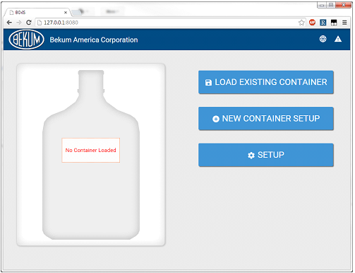
Figure 8: Screenshot of BOrIS UI layout
Internationalization
The software will also be required to be able to toggle between languages at any point in time. Efforts regarding language and locale are commonly known as internationalization (stylized as i18n). A system must be designed on the client framework that will enable all components that display text to specify a string to display based on the selected language.

Software Implementation
Polymer.js
In order to implement the outlined software architecture above, Team 1 has chosen to build the web application’s front-end using the Polymer Javascript library, by Google. The Polymer library is a cross-browser compatible component framework designed for rapid UI prototyping for web applications. It includes a convenient HTML import system that allows for isolated development of components that can be used interchangeably and nested within each other. In this manner, all UI elements are to encapsulated into Polymer components, such as buttons, toolbars, information panels, and screen containers.
Within this framework, we must create components for all of our screens, and menus. A list of defined components we used or created can be found in the appendix 3 as well as example sources. Polymer is unique syntactically for a component framework in that its implementation resembles native HTML. An example of a Polymer component is constructed using the mark-up below:
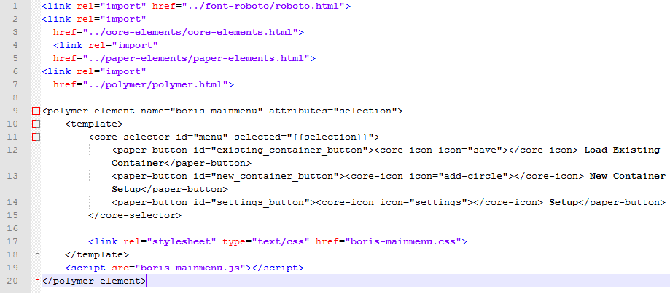
Figure 9: The full HTML source of our Main Menu component, which is nested within a larger screen framework, and displays the three main menu buttons shown in Figure 7.

Web Services & The KAREL Command Line

The key to automating with the FANUC robot controller is the KAREL Command Line (KCL) interface. KAREL is a Fanuc machine programming language that allows processes to modify and execute KAREL commands on the robot. The KAREL Command Line is a way to translate and execute KAREL commands on the fly. The KCL is exposed through the robot’s Enhanced Web Services suite. A Server-Side directive can invoke a KCL command, as demonstrated on the following page:
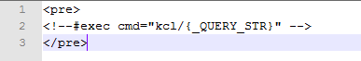
Figure 10: The full source of kcl.stm. A server-side directive redirects a query string from the request URL to be executed through the KAREL Command Line.
In the above example, the #exec server-side directive is used to execute KAREL code. The controller has a number of directives that can be used [2].

For example, using the file from the previous figure, one could execute a KAREL command through a simple URL using the syntax: http://robot/fr/boris/kcl.stm?kcl_command_here. For a more specific example, a command could be specified in the query string to read the global “$Version” variable. When accessing the KCL through HTTP, it’s important to URL encode spaces or unknown characters. The following is an acceptable use: kcl.stm?show+var+$Version. Such a query would yield results similar to those below:
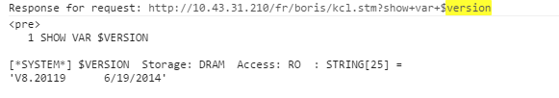
Figure 11: An example output of a KCL command executed through the web interface.
FANUC’s server-side directives and the access to KCL power the automation, with the ability to process multiple #exec commands interpreted sequentially in a single .stm file.
Putting It All Together
Using this information, remote communication from a web application to the robot can be invoked over HTTP using AJAX calls (See Appendix 3). Polymer provides built-in ajax functionality using the core-ajax component. The component accepts parameters to specify the URL to query, data to post, and client actions to take upon a response.
With the ability to dynamically send requests to the robot that execute commands, and receive a response, the client software can then execute the required automation between screens and interpret the results.
Issues Faced
In designing and implementing the BOrIS system software as designed, several obstacles were met that produced limitations on our software capabilities.

Lack of FANUC Software
Do to the competitive nature of the robotics technology industry, FANUC places tremendous effort on ensuring that only licensed customers have access to FANUC support resources and software development kits. The FANUC PC Developer’s Kit, a core part of Fanuc’s PC software suite known as Roboguide, is often thought of as a critical component to program software for FANUC robot controllers. The developer’s kit includes the WinOLPC control which allows developers to programmatically control the robot’s internals represented in the “Robot Server” ActiveX object. This object enables developers to program software to the robot in the development environment and language of their choice.

Similarly, the Roboguide includes the only method of translating KAREL Ascii sources (KL files) to compiled machine p-code (PC) files that are executable on the controller. The ktrans.exe tool, which is responsible for translate KAREL sources is only available with the WinOLPC component.

In communication with FANUC and Bekum America, Team 1 was unable to obtain this critical development software. FANUC has already licensed a development trial to Bekum that has since expired, and licenses cannot be transferred between machines. FANUC denied Team 1 registration to the customer portal website where the software can be downloaded, for lack of proving an association with Bekum America, despite providing Bekum’s information as well the Robot’s F-Number (FANUC’s robot identity code).

The lack of this software is what drove this project in the direction of implementing communication primarily over the web server rather than interfacing directly with the controller.

Precompiled Built-in Programs
Several pieces of the machine procedures particularly involving the iRVision software, were not able to be automated. This is a result of being unable to analyze what changes were being made to the robot from iRVision software. The software communicates with a built-in compiled partial KAREL program on the robot web server that requires undocumented parameters. As these programs are already compiled on the robot, it is impossible to view their sources to determine how to successfully interact with them. This limited the amount of our design that could successfully automate. The approach was changed to provide prompts for these sections that direct interaction with the original screens. The screens, however, can be displayed on the touchscreen and housed in a container in the Polymer app, as they are already hosted on the internal web server.

Motion Commands
An inherent flaw to the approach using the web server rather than using the PC Developer’s Kit, is the lack of the ability to perform motion commands on the robot controller remotely. The KAREL command line by default restricts the user to only a subset of available KAREL commands, and the web server restricts the available commands further, for security purposes. These limitations could have been avoided with the appropriate software. Rather, for any motion commands, the user must interact directly with the iPendant when prompted by the BOrIS software.

Robot Configuration
The FANUC robot is highly configurable and the scope of available features is extensive. As such, many unexpected configuration elements were encountered on the server that often disabled the ability to perform the goal tasks, including remotely executing Teach Pendant programs. These configuration elements can be changed often internally, and as such, the BOrIS software must monitor these configuration settings and modify them when necessary. Some of these configuration settings however may only be available to modify on the hardware Standard Operator’s Panel, such as the E-Stop and the Auto / Manual mode key-switch. For steps involving these components, the software must prompt the user to manually switch the mode. BOrIS can monitor the values of these switches, however, and can detect whether a mode change is required.
CHAPTER 4
Test Data with Proof of Functional Design
This section showcases BOrIS’s performance in addressing the Critical Customer Requirements, and shows which features were successfully communicated.

The procedure to enter a new bottle recipe into the FANUC controller was performed via the touchscreen to test the successful communication between the user interface and the FANUC controller, as well as the functionality of the java hardcode responsible for changing the appropriate registers. Successfully performing the procedures in fewer steps via the touchscreen is a measure of the success of the project. However, since there was little success in communicating with the robot, none of the procedures could be completed in their entirety. A table illustrating what the interface could successfully and unsuccessfully control in terms of features on the BOS is shown below. The reasoning of why the feature could not be controlled is also outlined in Table 5 on the following page.

Table 5: A table illustrating the feature name, the measure of success in controlling the feature, and if unsuccessful, why?

Feature | Is BOrIS capable of operating? | If unsuccessful, why?
Robot Arm Movement | 
Set Digital Outputs
Run Teach Pendant Macros |  | Requires access to Motion Control group
Emulate iRPickTool |  | Internals of Programs are invisible to us (FANUC proprietary)
Emulate iRVision Process |  | Internals of Programs are invisible to us (FANUC proprietary)
Set Flags |  | KCL does not allow access to flags
Monitor Robot Modes
iRVision Lights (home, vision and cycle)
Toggle Robot hand action
Vacuums

Design Failures
Throughout the implementation process of the BOrIS system several obstacles were encountered. These obstacles limited the effectiveness of the design of the system, and necessitated numerous redesigns toward the functionality of the overall system. These redesigns and corresponding results are detailed below.
FANUC Proprietary Software Availability
A critical point of failure that was encountered during the implementation process was the unavailability of FANUC’s “Roboguide” software suite. The Roboguide software suite is a developer’s toolkit provided by FANUC that enables engineers to directly develop software on the controller using Robot Server communication, as well as the KAREL language. The KAREL language was a key component to the original architecture design of the BORiS system. A KAREL socket messaging server was to be implemented, as detailed in FANUC’s Internet Options Setup & Operations documentation [1]. A socket messaging server would enable a remote client to issue commands to the server over a protocol designed specifically for our goals. A distinction between running compiled KAREL code directly against the machine controller rather than against the KAREL Command Line is the availability of features and access to variables. The KAREL Command Line is restricted by inherent limitations, preventing users from runnings Teach Pendant macros, executing Motion Commands, and accessing internal I/O variables directly. These limitations prevented successful completion of the proposed design.
Motion Controls and Macros
As detailed previously, the designed communication pathway for the BOrIS system is limited in capabilities. Specifically, one major deficiency of accessing KCL over an HTTP interface is the inability to run KAREL or TEACH PENDANT macros that include motion controls. The fundamental functionality of the BOS bottle take-out system includes programmatically moving the robot arm and conveyor belts. The existing BOS functionality on the robot controller was implemented as Teach Pendant macros that also include motion controls, or are classified in the motion control program group. These macros are unable to be run remotely. In order to work around this limitation, several strategies were considered, including executing command sequences through the KAREL Command Line in replacement of these macros.
Internal I/O Flags
Analyzing the sources of the BOS system’s Teach Pendant macros reveals that much of the code executed involves reading and setting I/O port variables. Many robot input and output signal ports are tied to robot functions such as conveyor movement, hand gripping, and light systems. Recent model of FANUC controller’s include the ability to map flags which resemble I/O port variables. Unfortunately, unlike other I/O ports, these flags are only able to be modified from processes internal the controller. This limitation is undocumented in FANUC’s KAREL reference manual. These further limitations were only discovered after redesigning the communication pathway for the KAREL Command Line, rather than socket messaging.
iRVision
A large portion of the BOS system’s operating procedures involved the usage of the iRVision Pendant Screens. These screens are able to be accessed remotely through a web browser. However, the specifics of the network communications of these screens is ambiguous. The iRVision software is a feature pre-installed onto robot controllers with accommodating configurations. As such, the built-in functions that these screens access exist on the controller as compiled KAREL programs. The sources for these programs are not available, and thus discovering the internal functionality of these processes is nearly impossible. Without an understanding of these programs or the parameters that they expect, the BORiS system is not able to automate the iRVision software.
Incompatibility
Upon the iRVision integration failure, a compromised design was approached involving displaying the iRVision screens embedded in the web app. This redesign failed as the Polymer framework is not supported in Internet Explorer. However, remote iRVision interface is only supported by earlier versions of Internet Explorer.
Overall Failure
Considering the above outlined points of failure, the BORiS system was unable to be implemented according to the original design. The ability to set and retrieve port information and system variables was successfully achieved, as well as communication with the web application. However, Bekum’s intent to replace the current operation procedures with simpler user interactions could not be met. These obstacles prevented successful completion of the project.

CHAPTER 5
Final Cost, Schedule, Summary and Conclusions
This section summarizes the project findings, successes, failures, final budget, final schedule, and suggestions for future work.

The BOrIS project highlighted the need for a simple user interface for FANUC robots. The existing iPendant option is complex, long, and involves the navigation of several extraneous menus. The team successfully distinguished between actions that should be automated and those that required user input. These kinds of small procedural reductions in user interaction resulted in a system that requires fewer entries from the user therefore reduces the total time and complexity of the entire process. However, the team encountered several points of complication that required four redesigns. The first design strategy was to communicate via socket messaging with a KAREL Server. We were not able to achieve this because we were denied a trial of a KAREL compiler. In order to communicate without the use of this compiler, the second design proposed using the KAREL command line exposed over the web server. This design failed because it did not have the capabilities to fulfill the needs of the procedure such as setting flags, running macros, or emulate the iRVision and iPicktool software. The third design was to embed the iRVision panel directly into the web application in order to resolve the incapabilities present in the second design. This failed because of browser incompatibility conflicts. These revisions caused the original schedule to skew drastically and is reflected in the schedule breakdown in Appendix 4.
The initial budget for the project was a range from $1000 to $4000. This budget coincided with the expected cost of the recommended Beckhoff “Economy” Panel PC CP72xx touch screen. Upon further investigation, the actual cost of the recommended touch screen exceeded the available budget. This led to selection of the Microsoft Surface Pro 2, Armor Active Full Metal Jacket enclosure, Surface USB to Ethernet adapter, and OmniMount mounting kit. The resulting final was $856. This new total cost was well within the initial budget. The final project schedule did vary from the initial projected schedule. During the initial back-end design phase, the team made assumptions regarding how information would be transferred between the touch screen and the robot controller. These assumptions were discovered to be incorrect during the testing and revision phase; so the team had to devise four different methods for back-end communication. These various design iterations came with altering ability to communicate with the FANUC controller and caused the alteration of the screens already developed, the creation of new screens, and change to the proposed menu flow. These alterations pushed back the total design process by a month and forced additional testing and revision to also be completed later than anticipated.
Redesign Approaches
Considering the success of most front-end components of the project, redesigns focus on overcoming the limitations prohibiting successful robot communications.
KAREL Socket Messaging Server
With access to a KAREL compiler, one could implement a socket messaging server on the FANUC robot written in KAREL. As documented in FANUC’s Internet Options Setup and Operations manual, a socket messaging KAREL server is able to receive commands remotely with low overhead and run corresponding compiled KAREL code against the machine internally. Such an approach would eliminate limitations involving motion controls and setting internal variables. This would be an ideal solution.
The Robot Server Control
The ROBOGUIDE software that includes the KAREL Translator tools also includes a unique ActiveX component known as the Robot Server. The Robot Server control acts as single instance of a virtual robot object, with methods and property access to all robot internals. This component can be used in any development environment that allows for ActiveX components. FANUC’s documentation and software recommends legacy Visual Basic 6.0, however ActiveX components are compatible with Microsoft’s recent .NET platforms, including C# and VB.NET. A redesign involving the robot server control would be similar to the proposed solution for the BOrIS system, where the local .NET powered back-end may execute commands directly against the machine and produce a response for the Polymer front-end.
GE-FANUC OLPC
OLPC’s are offline robot program development software suites intended to replace Programmable Logic Controller functionality. Roboguide’s OLPC, as well as third party OLPC’s compatible with GE-FANUC drivers, are available for license. This software allows developers to program and test robot functionality on virtual robot controllers on the local PC, before implementing them on the actual robot. This software also includes built-in communication drivers for Fanuc robots and includes unrestricted remote I/O access to robot internals.
HMI & SNPX
HMI (Human Machine Interface) screens are a typical industry solution between a host interface and machine controllers. HMI displays generally operate over external PLC’s, however some include built-in SNPX protocol ability. The SNPX protocol is another communication driver developed to ease programmatic machine automation.
ROS
ROS industrial is an open-source manufacturing robot software communication suite, designed for ease of use, installation, and operation. The key components to the ROS industrial system, include the KAREL server, and the ROS client software. The KAREL server replaces the socket messaging option detailed earlier with a full command wrapper tied into a remote communication protocol. The ROS client software exposes robot internal commands to a PC with communication access. The open-source nature of the software project implies that it is free to use, distribute, and improve upon.

User Prompts
Detailed in our earlier conceptual designs, interface prompts could be used to direct the user to operate directly on the machine or the iPendant. Considering our achieved ability to monitor variables using the KAREL command line, prompts could be designed to advance between procedure steps, and robot communication can be used to determine whether or not the steps have been completed or the robot is configured for the appropriate modes between steps.
TPP Background Logic
One theoretical method given the restrictions already in place on KCL and the robot, would be to add code to the Teach Pendant Background Logic program. On FANUC controllers, background logic is code that Is repeatedly scanned and interpreted through robot operation, with no automatic interruptions. Currently, the background logic program redirects outputs for the existing BOS system. This background logic could be used to wait for digital outputs that are enabled to be set via the command line, and then subsequently execute corresponding macros. These macros can be used to successfully complete the procedure operations.

APPENDIX 1 –TECHNICAL ROLES, RESPONSIBILITIES AND WORK ACCOMPLISHED

SAM SAIA – User Process Efficiency and Menu Flow

Mr. Saia’s technical roles focused on maximizing the efficiency of the user interface in terms of steps and time required of the user by performing screen reduction analysis and menu flow design.
The first step in the screen reduction analysis was to determine what the interface should accomplish. In the case of the Team 1 project, the interface should allow the user to program new “recipes” for the Fanuc robot arm and iRVision components. The second step is to determine the processes by which the interface will accomplish the previously determined goal. There are usually many processes that are viable options, but for Team 1 there are already processes in place that act as a guide through the desired procedures. The next step in the design process is to determine which steps of the process require an interaction from the end user. In order to create a simple and efficient interface, the end user should be required to do as little as possible while still achieving the desired end result. In the case of Team 1’s project, this process involved observing the current system in operation and noting the steps taken, options selected, and information exchanged between the iPendant and the robot controller. The information exchange was monitored by a program named Fiddler which is a free web debugging proxy. With this information it was then be determined what steps actually require a user input and which steps are common to every “recipe” building process. By automating the common steps and only prompting the user for the information that is unique or requires their input, the process can be greatly condensed and simplified. The results of screen reduction analysis were then used to determine what screens and menus should exist in the new interface and how they should flow together. The end achievement of screen reduction and menu flow is a faster, more efficient, and simpler experience for the end user.


EMILY SKIPTON – Communication and Distinguishing of User Input and Automated Variables
The task of being able to establish the overview of a dual-way communication between the Bottle Orientation System and Team 1’s created UI was entrusted to Ms. Skipton. Before designing how BOrIS was going to fit in with the current communication design, the relationships between the system components needed to be established. Through studying FANUC’s documentation and interacting with the FANUC/Bekum Bottle Orientation System, Emily was able to discern the current communication web. The Bottling System itself has three major system components: the iRPickTool, the R-30iB Controller, and the iRVision System. She found that the R-30iB Controller receives user information through the connected pendant, and bottle position information from the iRVision system and transfers the user and position information to the iRPickTool which instructs the hand tool how to pick up the container. Since the project was to design a user interface, the logical point of communication would be inputting to the R-30iB controller to replace the communication from the pendant with information from a touchscreen.
After researching the systems through the FANUC documentation, Mrs. Skipton discovered that there were several options that the team could choose from to communicate with the R-30iB controller. These ways included socket communication, machine level protocols, and HTTP web services. Through further research outlined in the FANUC documentation, it was discovered that KAREL programs could be executed through web services made available by Fanuc’s LRHandlingTool. KAREL is a Fanuc proprietary language that was studied by the team. The decision was then made to create a web-application that would automate the variable changes to reduce the number of user-input interactions for a procedure. In order to create this web-app, the names and locations of the procedure variables used by KAREL, Fanuc’s own machine language, had to be defined and categorized into those that could be automated at the back-end and those that required user-input or use of the pendant. Ms. Skipton created a graphical pseudo-code that represented these variables, their status, and linear processes by going through the procedures herself and recording the variable name changes. Menu dialogue and logic are also represented in this diagram. A portion of this pseudo-code is shown on the following page.

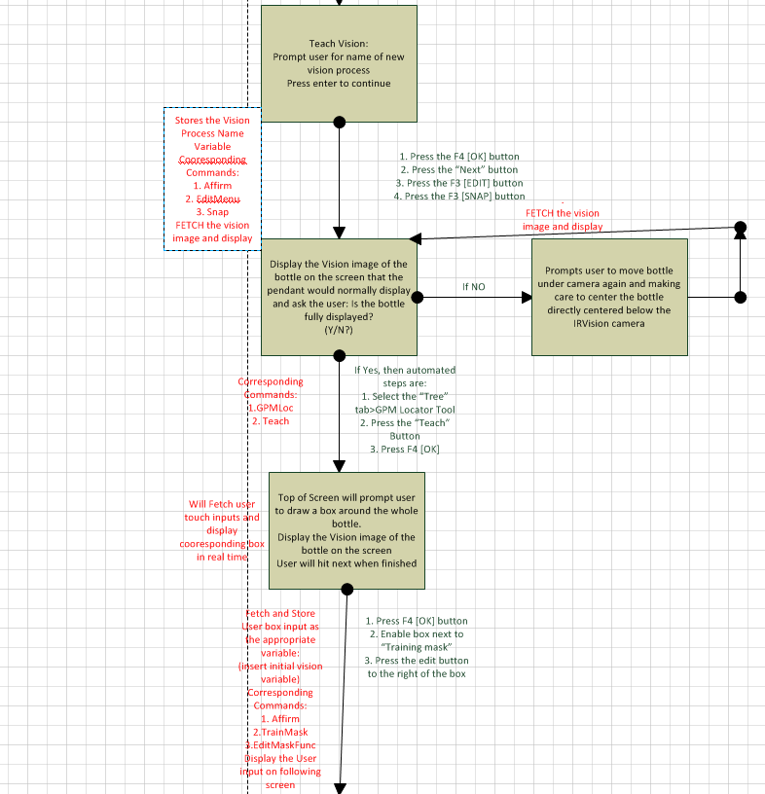
Figure 12: A flowchart outlining the order of displayed menu screens (boxes), the original procedure steps that are being automated in between (black text to the right of arrows), and the corresponding variable names to automate along with times to fetch or store variables (red text to the left of arrows)


ZAIN SYED – Software Engineering ZAIN SYED
Zain Syed, a Senior Computer Engineer, served as a key software designer and implementation engineer for the BOrIS system. His role included researching existing FANUC systems, communication pathways, and implementing front-end components. He contributed the bulk of the code logic necessary to execute commands to the FANUC controller.
Syed’s design phase role of investigating the FANUC robot was a critical task necessary to define the relationships between our system components. This role involved frequently communicating with FANUC support, as well as Ben Sterling, an Electrical Engineer contact at Bekum, over phone and email, in order to gain insights about the capabilities of the robot controller. Researching the robot and established communication practices also heavily involved thorough exploration of the Robot controller documentation, the documentation of associated software, as well as a base of user knowledge. Zain designed the main method of data communication between the interface and the robot.
During the implementation phase of the project, Zain performed lead developer duties in creating and assigning technical tasks involving the web client. Syed also implemented several features of the software, including the communication API on the robot, as well as many of the screen components.


GURWINDER SINGH – Polymer buttons and Internationalization
The work Mr. Singh has done on the Bottle Orientation System (BOS) project deals with the user interface designed for the BOS. The user interface is called BORIS. Mr. Singh has helped in the creation of some of the screens. Polymer was used to create the screens. Polymer is a computer language similar to html that Google has created to make designing web applications and websites easier. Polymer is great for designing a user interface. It has many built in elements like buttons, dropdown menus, icons, and etc.
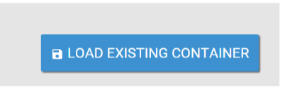
Figure 1: Button designed in Polymer that was used in the BOrIS
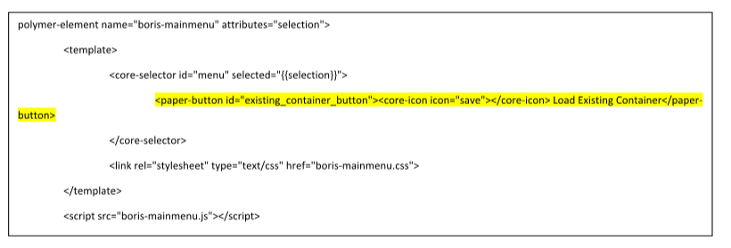
Figure 2: Code from BOrIS where the highlighted portion accounts for the creation of the button in Figure 1
Figure 1 shows a button that was created on the main menu of Boris and Figure 2 shows the line of code Mr. Singh used to create that button. The code highlighted in that figure is for the button. Although Mr. Singh did assist in the creation of the screens, most of his contribution was the internationalization/globalization of the user interface.
Internationalization/globalization of the user interface is making it available in multiple languages. Mr. Singh internationalized BORIS for English, and Spanish and creating a way to allow the user to change languages from English to Spanish and vice versa. All the text and prompts on every screen had to be translated to Spanish as well as coded. On the top of all screens in BORIS there is a button with a ‘globe’ icon which can be clicked to change the language from English to Spanish and vice versa.

Figure 3: Globe icon used for internationalization


ALEC JOINER – Lab Coordinator
Alec was responsible for helping evaluate the communication facilities available on the existing components such as the Fanuc controller, and then working with the rest of the team to identify a solution architecture which was both practical to implement and suitable for meeting the project’s technical requirements. Alec explored several Model-View-Controller style user interface technologies and identified and proposed the Polymer JavaScript library as being an optimal choice. Alec also selected and configured a portable web server used to host our Polymer-based front-end. Alec worked with other members of the team to develop our touch-screen user interface in Polymer and JavaScript, and leveraged Polymer’s two-way data-binding technology to structure the UI code in a way which was highly maintainable. After identifying that the originally selected touch-screen display did not meet the project’s budget requirements, and that lower-priced models did not meet our application’s technical requirements, Alec also worked with Bekum’s contact and other members of our team to select a hardware configuration based on the Microsoft Surface tablet with an industrial kiosk enclosure, which was very well suited to the application’s technical needs while managing to be significantly more cost-effective than the previously evaluated options and well under budget.

APPENDIX 2 –LITERATURE AND WEBSITE REFERENCES

- FANUC Robotics SYSTEM R-30iA and R-30iB Controller KAREL Reference Manual (REVG ed.). (2013). Rochester Hills, MI: FANUC Robotics America Corporation.

- FANUC Robotics SYSTEM R-30iB Controller Internet Options Setup And Operations (REVD ed.). (2013). Rochester Hills, MI: FANUC Robotics America Corporation.

- FANUC Robotics SYSTEM iPendant Customization Guide. (2013). Rochester Hills, MI: FANUC Robotics America Corporation.

- FANUC America Features an Interactive Software Kiosk Demonstrating the New Zero Downtime (ZTD), Remote Connectivity, and ROBOGUIDE at IMTS 2014. (2014, September 8). Retrieved December 1, 2014, from http://www.fanucrobotics.com/FanucAmerica-news/press-releases/PressReleaseDetails.aspx?id=45

APPENDIX 3 –SOURCES AND DOCUMENTATION
Table 6: the comparison between steps involved in the current interface and the ones implemented by Team 1
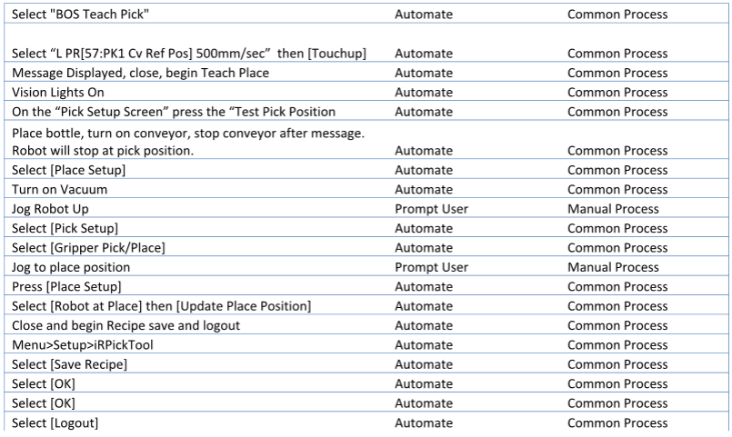
Polymer.js
The BOrIS web app’s front-end is powered by Polymer.js, a free UI-component framework developed by Google. Polymer and relevant resources can be found on the polymer project’s website: http://polymer-project.org/. The Polymer “Core Elements” and “Paper Elements” packages were used and imported in full to the project.

Web Components
All of BOrIS’s client code is encapsulated in custom Polymer components. Components are created for individual UI controls, and can then be nested into larger components that represent larger UI sections, such as specific screens, tabs, or panels. A list of our custom defined Polymer components (all custom component’s names are prefixed with the “boris” tag):
- boris-alarm-manager
- boris-home-screen
- boris-interface
- boris-mainmenu
- boris-mainstatus
- boris-newcontainerscreen
- boris-teachpick
- boris-toolbar
The sources for these component’s can be found in the Sources section of this appendix, in the Polymer app directory listing. Aside from our custom components, the necessary building blocks for these components were the UI elements provided by Polymer’s Core Elements and Paper Elements packages. Commonly used components include:
- core-ajax
- core-animated-pages
- paper-input
- paper-button
- paper-toolbar

Several more provided components were used in the project. Please see the project’s full source in the Source section in this appendix.

Robot Web Services
The R-30iB controller’s built in Enhanced Web Services is a core component to the BOrIS system.
Server-Side Include Directives
A key feature of the server is the ability to process server-side directives before displaying a web page. This enables server-side code that can execute statements on the robot and produce results. These server side directives are inserted as HTML comments, for example:
<!-- #read var=”$Version” →
Will display the version number of the robot controller software. The following is a list of all allowed server-side directives:
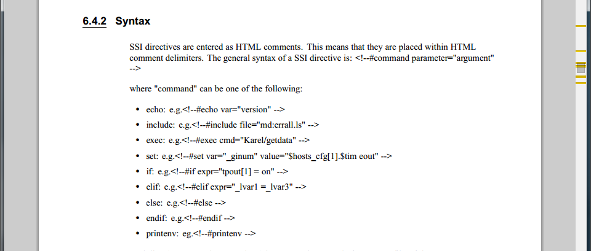

More information on available internet options and server-side capabilities are found in the Internet Options Setup and Operations Manual found in the LR Handling Tool Documentation.
Robot Server Web API
The ability to process server-side code on the robot enables the ability to design an API directly on the robot to process and format robot data over web requests. The following .stm (FANUC server HTML extension) files were created and implemented on the robot’s web server, with necessary URL parameters attached:
- kcl.stm?command - Executes the specified KAREL command against the KAREL Command Line and produces the results.
- read.stm?variable - Displays the value of any robot variable, register, or port.
- file.stm?drive:filepath - Displays the full source or web output of any file available on the robot’s exposed filesystem.
- is_fault.stm - Produces a value indicating whether the robot is faulted.
- clear_faults.stm - Clears all robot faults and resets the robot cycle.
- diag.stm - Displays current robot status, server status, and local variables, for diagnostic purposes.
The full sources for these .stm files can be found in the Sources section of this appendix, under the robot server subsection.

KAREL Command Line
The primary programming language used in FANUC’s robot controllers, is the KAREL machine language. KAREL code is written in ASCII and translated to p-code on the robot controller and executed against the machine. KAREL is syntactically similar to FORTRAN. Full documentation of the KAREL language can be found in the KAREL Reference Manual, found in the LR Handling Tool documentation.

The KAREL command line is an interface to the built-in robot KAREL translator, that allows for individual KAREL statements to be executed. BOrIS’s robot server API exposes the KAREL command line to our web app, and thus is chosen as the primary robot automation method for the project. Full usages of KCL commands can be found in the project sources, within the screen sources AJAX call parameters, as well as the robot server API.

Project Sources
Robot Server
The following files are placed on the Fanuc robot’s web server, in the robot’s F-ROM storage:

fr/boris/functions/kcl.stm:
<pre>
<!--#exec command="{_QUERY_STR}" -->
</pre>

fr/boris/functions/read.stm:
<pre>
<!--#echo var="{_QUERY_STR}" -->
</pre>

fr/boris/functions/file.stm:
<pre>
<!--#include file="{_QUERY_STR}" -->
</pre>

fr/boris/functions/is_fault.stm:
<pre>
<!--#echo var="TPOUT[1]" -->
</pre>

fr/boris/functions/diag.stm:
<pre>
<!--#printenv -->
</pre>

fr/boris/functions/trans.stm:
<pre>
<!--#exec cmd="kcl/TRANSLATE+{_QUERY_STR}" -->
<!--#exec cmd="kcl/COPY+{_QUERY_STR}.LS+MD:\{_QUERY_STR}.LS" -->
</pre>

Polymer App
The following files are the full source to the polymer web-app as well as the local server software.

server/index.html
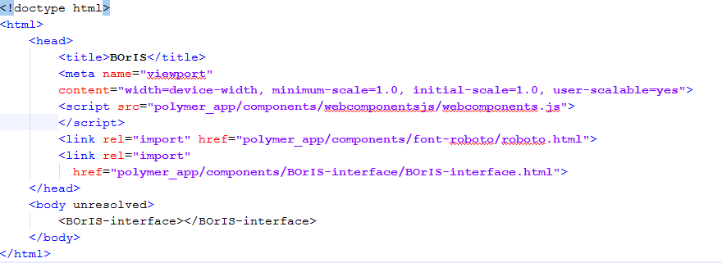
server/polymer_app/components/boris-alarm-manager/boris-alarm-manager.html
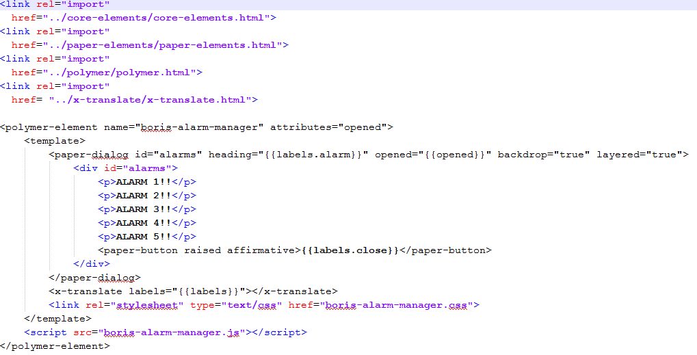
server/polymer_app/components/boris-alarm-manager/boris-alarm-manager.js
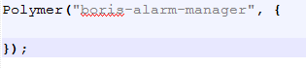
server/polymer_app/components/boris-alarm-manager/boris-alarm-manager.css
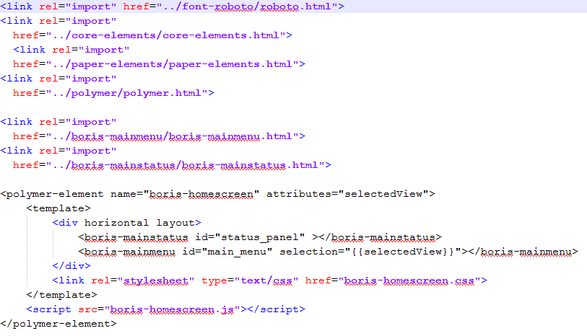
server/polymer_app/components/ boris-homescreen/ boris-homescreen.html
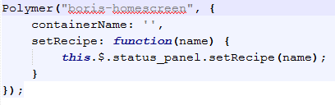
server/polymer_app/components/ boris-homescreen/ boris-homescreen.js
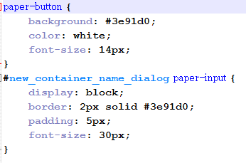
server/polymer_app/components/ boris-homescreen/ boris-homescreen.css

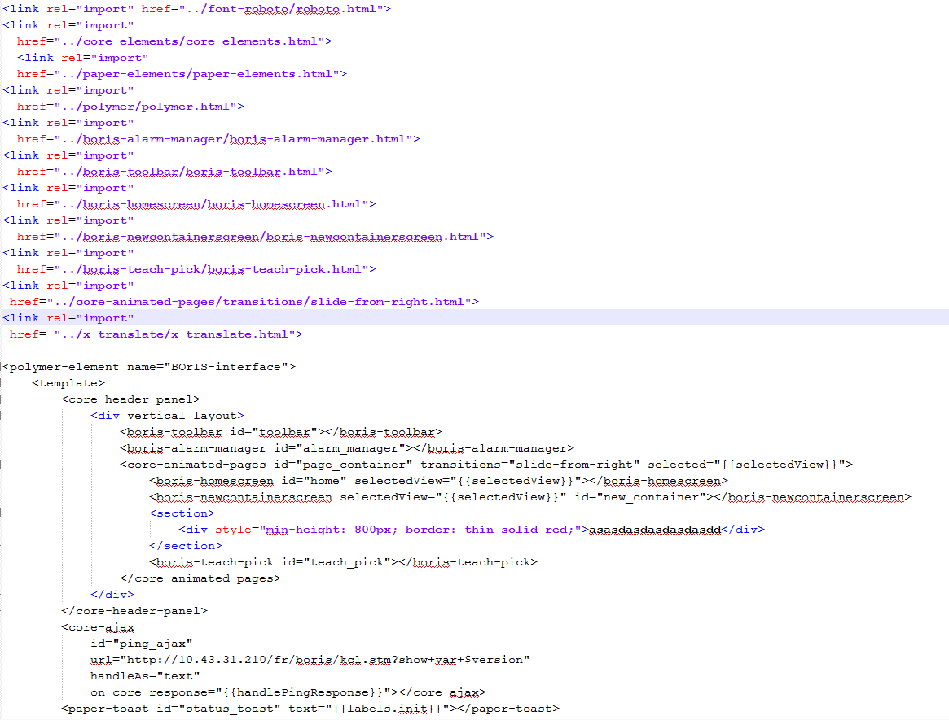
server/polymer_app/components/ boris-interface/ boris-interface.html
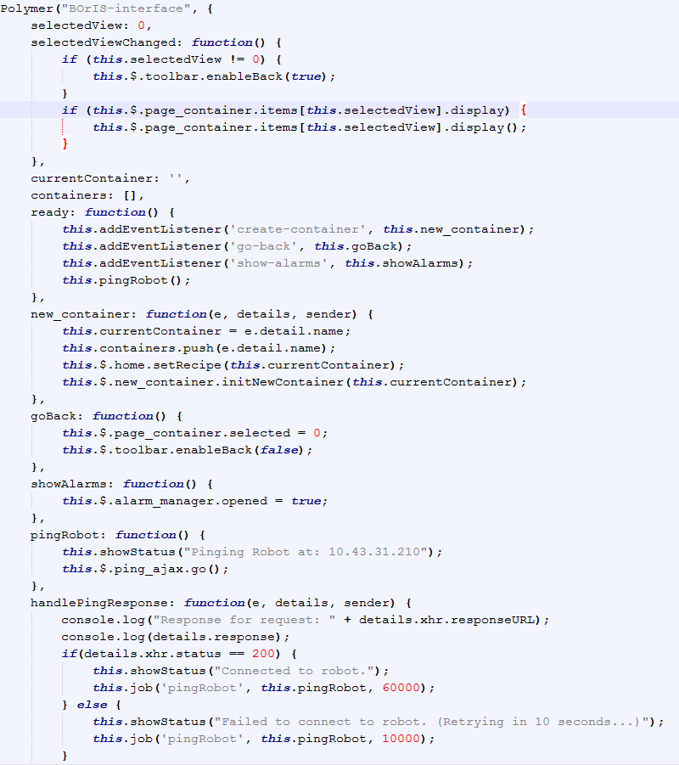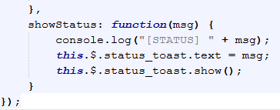
server/polymer_app/components/ boris-interface/ boris-interface.js
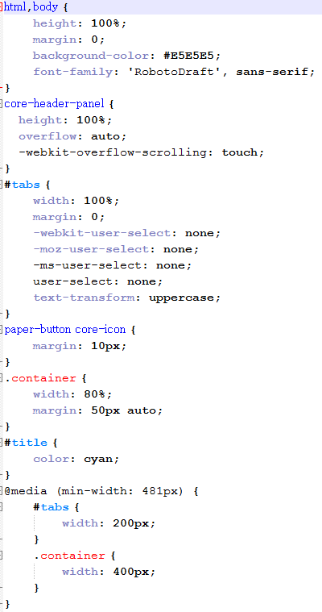
server/polymer_app/components/ boris-interface/ boris-interface.css

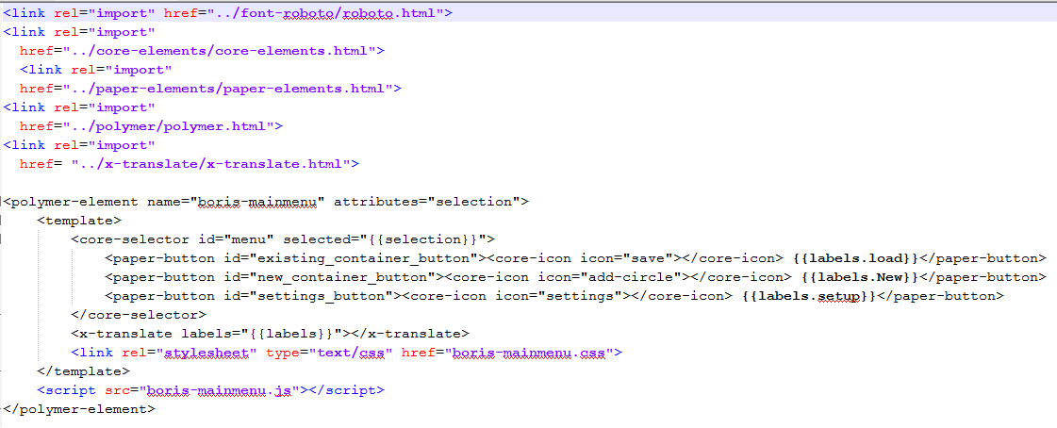
server/polymer_app/components/ boris-mainmenu/ boris-mainmenu.html
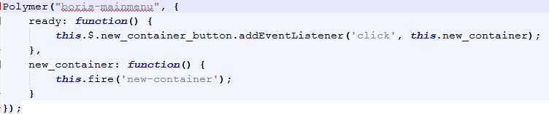
server/polymer_app/components/ boris-mainmenu/ boris-mainmenu.js
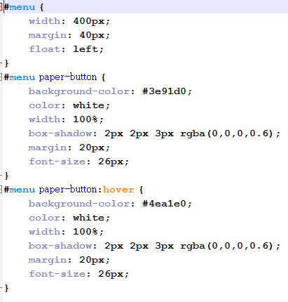
server/polymer_app/components/ boris-mainmenu/ boris-mainmenu.css

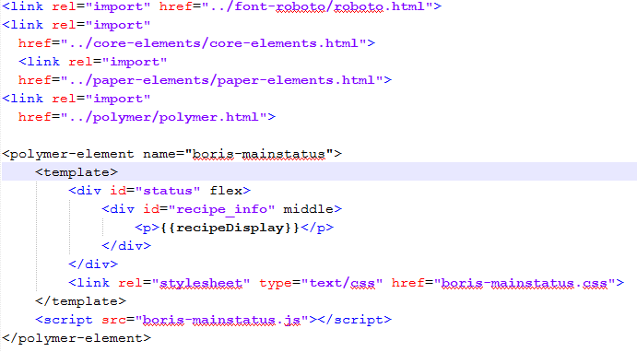
server/polymer_app/components/ boris-mainstatus/ boris-mainstatus.html
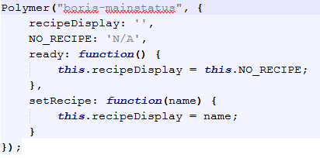
server/polymer_app/components/ boris-mainstatus/ boris-mainstatus.js
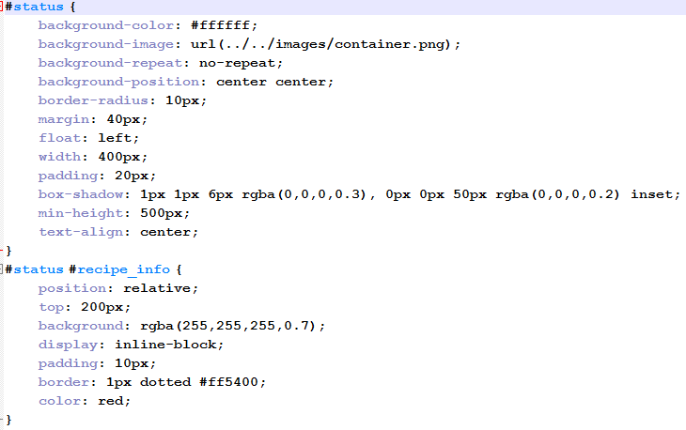
server/polymer_app/components/ boris-mainstatus/ boris-mainstatus.css
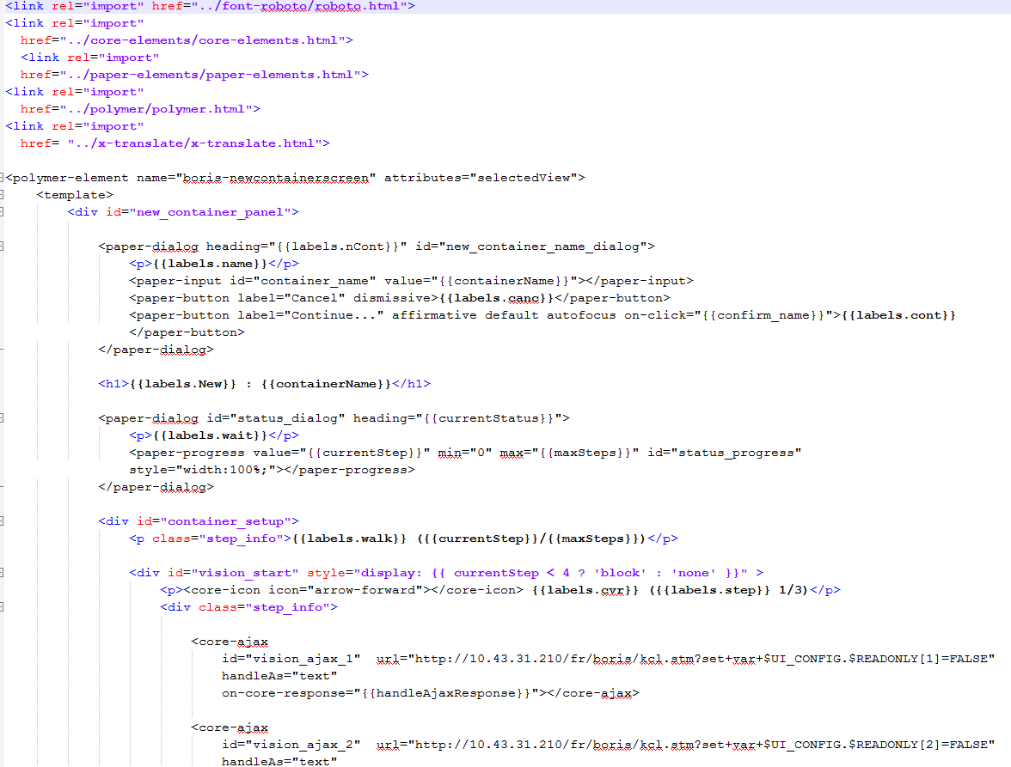
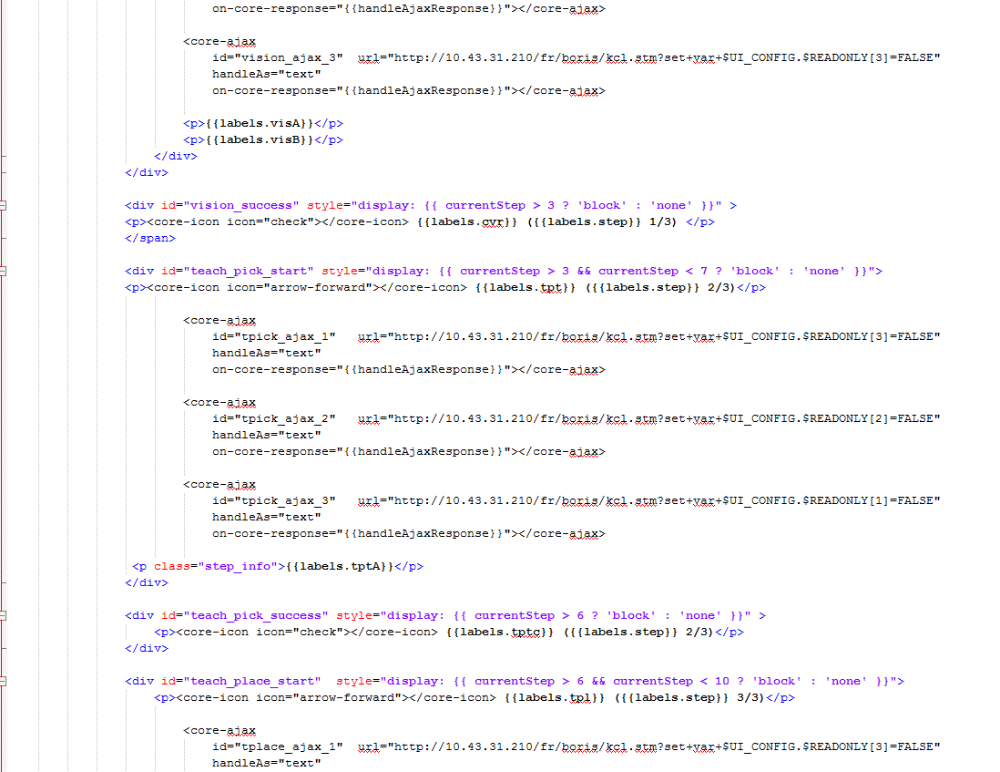
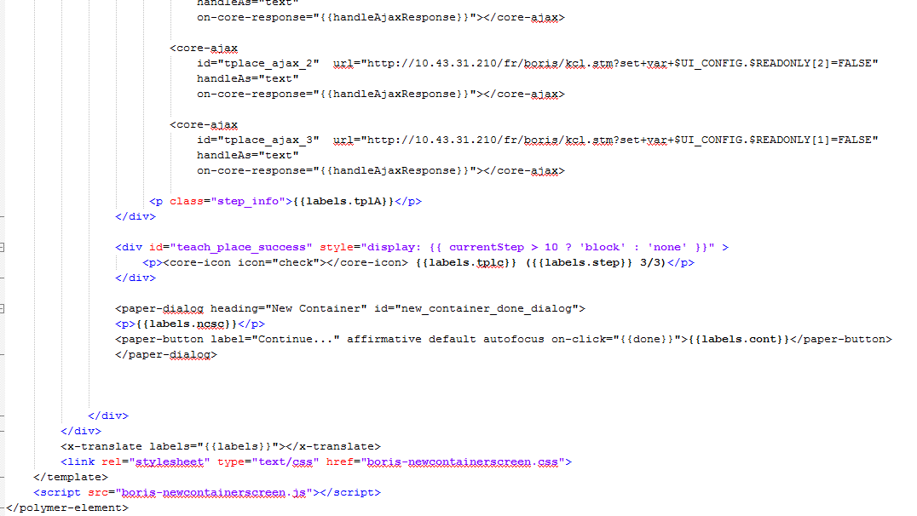
server/polymer_app/components/boris-newcontainerscreen/ boris-newcontainerscreen.html

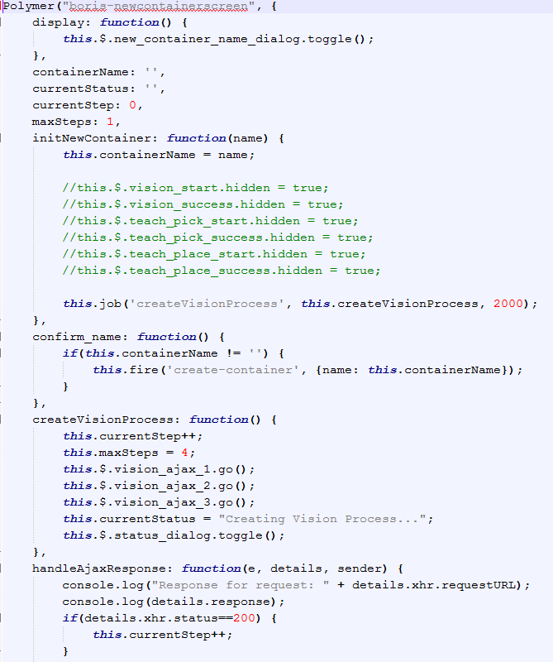
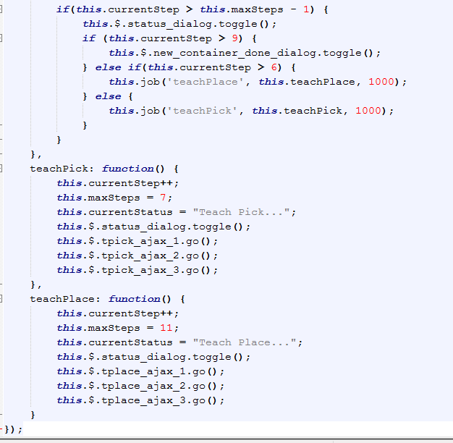
server/polymer_app/components/boris-newcontainerscreen/ boris-newcontainerscreen.js
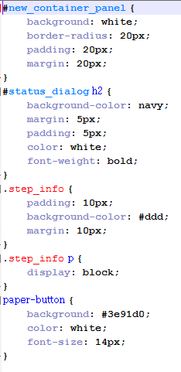
server/polymer_app/components/boris-newcontainerscreen/ boris-newcontainerscreen.css
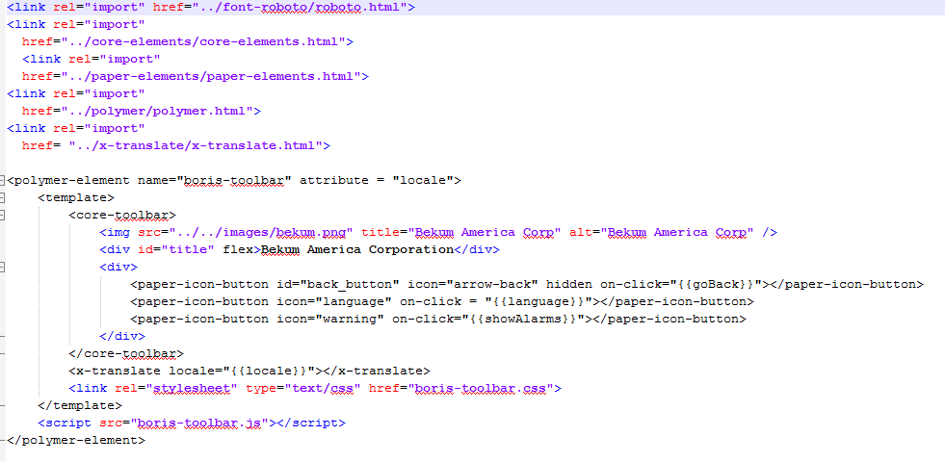
server/polymer_app/components/boris-toolbar/ boris-toolbar.html
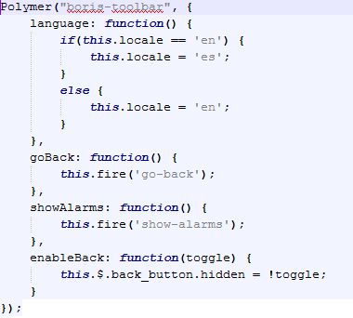
server/polymer_app/components/boris-toolbar/ boris-toolbar.js
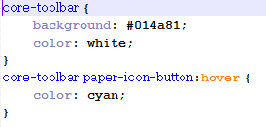
server/polymer_app/components/boris-toolbar/ boris-toolbar.css
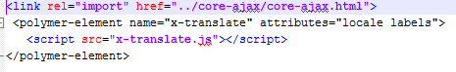
server/polymer_app/components/x-translate/ x-translate.html
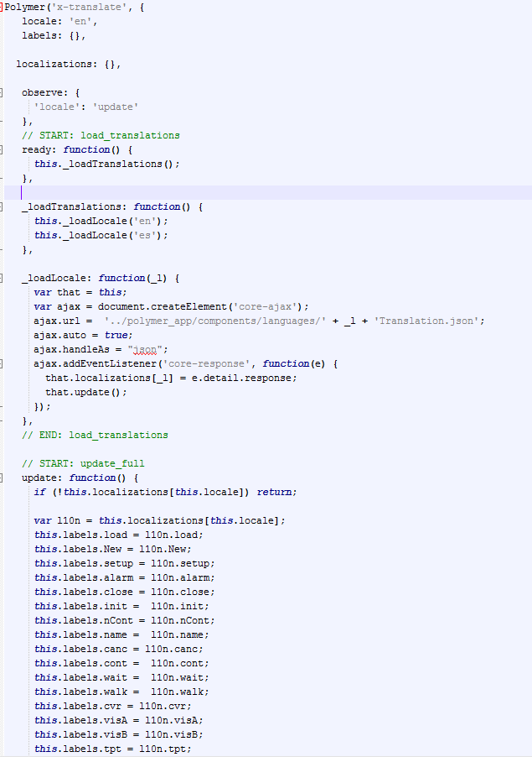
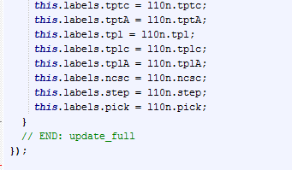
server/polymer_app/components/x-translate/ x-translate.js
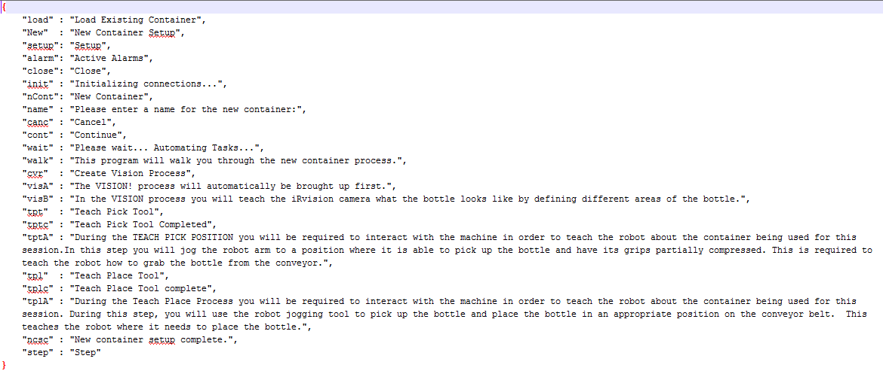
server/polymer_app/components/languages/ enTranslation.json
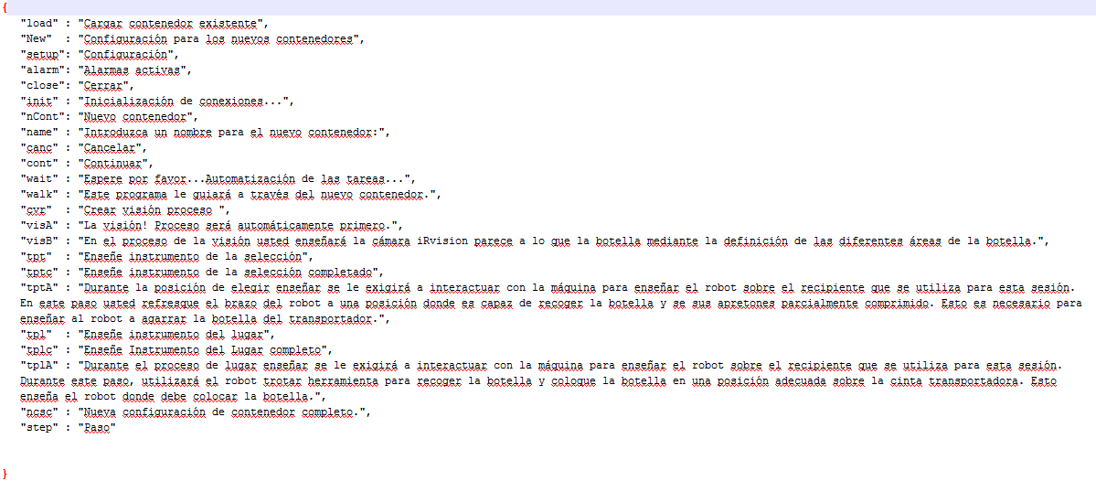
server/polymer_app/components/languages/ esTranslation.json

Appendix 4: Final Schedule
