Proposal
9/22/14
Bottle Orientation Interface System
Sam Saia
Alec Joiner
Emily Rose Skipton
Zain Syed
Gurwinder Singh

Executive Summary
Problem:
The current user interface included with the FANUC Bottle Orientation robot is too complicated for an average user to operate in order to change the robot configuration for different types of bottles.
Solution:
Create a user-friendly touch screen interface that is able to be operated by someone with a high-school degree of education. The user will be able to change the robot’s configuration with minimal training.

Introduction

The ultimate user, in the case of the Bottle Orientation Interface System, is Bekum’s customers: manufacturing plants that will buy this bottling machine. The operators at these manufacturing plants will need to change the configuration of the bottling machine depending on the bottle and be able to create new bottling settings. From this created interface, the user should be able to recalibrate the iRVision camera and robotic arm and select the next bottle to be processed. The calibration of the iRVision camera and robotic arm will require the user to set a grid under the camera, as well as a new bottle. To minimize human error and streamline the process, prompts should tell the user when and where to place the grid and bottle. The user would then select a “next step” option when finished with each action. When users select a new bottle, that selection should automatically load the parameters for the new bottle.
The operators must be able to easily, and efficiently perform the configurations with only a high school education level and minimal training. Therefore, how much the operators struggle with learning the configuration process will be used as a judge for the feasibility of a design. This criteria is the most important when considering the success of the design. Other criteria that will need to be considered are whether or not the configurations are saved correctly and the time it takes the operator to complete the configuration process. Two of these criteria are at odds with each other: the speed at which the configuration can be complete, and the ease with which the operator can navigate the interface. It would be easier for the operator if every step was broken into smaller tasks but too many menus can make the process time consuming.
The display will be a fully-functional Windows PC, and will host the client software which will operate within the Chrome browser. The back-end of the software will have to communicate with the Fanuc Robot controller over ethernet using the available Web Services provided by the LR Handling Tool. The back-end of the software must be designed to appropriately modify values stored on the robot controller using the communication methods that Fanuc provides. The approach will be limited by the functionality Fanuc exposes over the available Web Services.

Rough Outline of Project Life-cycle
1st : Explore approaches to communicate with the FANUC robot/ design screen workflow
2nd: Choose an approach of communication with the FANUC robot
3rd: Set-up design of how to query to the FANUC robot and receive inputs and outputs / figure out what can be communicated across the network
4th: Implement screen framework based on restrictions of queries, inputs, and outputs
5th: Implement communication functionality
6th: Implement procedure screens including robot automation
7th: Testing and revising
8th: Design Day

Background

Adding a custom user interface to a Fanuc robot is a common requirement. Fanuc initially supplies a proprietary device that displays technical configuration screens and provides access to machine commands, states, and variables. However, it lacks a streamlined end-user experience as the robot is designed by Fanuc for customization, and not ease of use. Once the robot is repurposed by Bekum to meet the expected functionality of the project, complex procedures are involved to set-up the robot to achieve this goal. Specifically, tasks include calibrating the camera that detects bottle positions, creating the vision process, setting up configurations for new bottle types, setting up the tracking frame, and the tool frame, and teaching the machine to pick up the containers. These processes are to be automated as much as possible in order to enhance the user experience and improve ease of use. A block diagram illustrating the current system is shown below (Figure 1)
Instructions to pick up specific container
Transfers position information and user input
iRPickTool

Delegates Commands
Robot Hand Tool
R-30iB Controller

User
Retrieve position information to track bottles and containers along conveyer

iRVision System
Figure 1: Block Diagram of Current Design
The Fanuc robot controller being used for the project is the R-30iB Controller, with the iRVision camera system, and the iRPickTool. The R-30iB Controller is a versatile robot controller for industrial robots and with flexibility to interface with external hardware and software. The controller communicates with the iRVision system to retrieve information from the camera to track bottles and containers along the conveyer. This information is relayed to the iRPickTool, which prepares instructions for the robot hand tool to pick up the specific container type.
The R-30iB Controller includes several options for I/O with external computer devices, including socket communication, machine level protocols, and HTTP web services. In order to create a custom interface for the controller, the client device, a touch screen PC, must communicate with the controller over one of these methods. The device would have access to a front-end client interface that would consolidate the required user procedures for configuring the robot into selectable automated stored procedures. Front-end actions would be processed by back-end logic on the client that translates user actions into a series of instructions for the Fanuc robot.
The goal of the new interface is to reduce the number of user interactions required to complete tasks. The screen flow should be designed to prompt the user to the next task, followed by simple instructions for any required input. Processes between input prompts are automated and should report progress as well as relevant system variable states. When designing user interfaces there are many principles regarding user experience to consider. These principles must be followed in order to create a workflow intended to efficiently complete the task at hand in a natural expected process. Tasks should be dissected into subroutines that are executed between designed user prompts that indicate to the user what to expect in terms of necessary input and output, without drawing attention to the design itself. A user interface should also allow the user to switch between program states in order to back out of initiated processes. The result of such efforts will produce a new streamlined user experience with exceptional ease of use to operate a complex system.

Objectives or Design Specification
The requirements laid out by Bekum for the design of the Bottle Orientation Interface System are as follows:
- A touch screen must be used for the user interface and meet factory standards for durability.
- The user should be able to recalibrate the iRVision camera and the robotic arm for a new bottle “recipe”.
- The new interface should reduce the number of steps the current interface requires the user to perform.
- The user should be able to select the next bottle to be processed
- When the user selects a new bottle, that selection should automatically load the iRvision and robotic arm calibrations that have been previously set.
- The interface should provide prompts for any human action that needs to be taken outside of the touchscreen menu in order to reduce human error and streamline the process.
- How we will implement these objectives into our design is outlined in the FAST Diagram shown in Figure 2.

FAST DIAGRAM
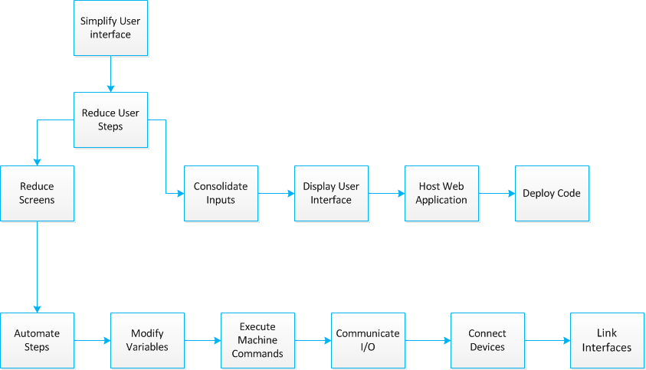

Figure 2: FAST Diagram for the implementation of the Bottle Orientation Interface System

Conceptual Design
In order to achieve the ideal user interaction goals, we'll need to automate processes explicitly changing system variables and states and running internal programs. This can be achieved using Fanuc's built-in controller machine language KAREL. KAREL is a scripting language which compiles and executes directly on the Fanuc robot. The language is capable of accessing and modifying any data register on the controller from a processor within the controller itself. KAREL programs can be executed using the Enhanced Web Services made available by the LRHandlingTool for the robot controller. With these tools available, full task automation can be achieved for all values that don't require user input, such as recipe selection, unique data entries, and physical procedures involving the machine to calibrate the Camera and teach the pick tool. The procedures are: Setup Tool Frame, Set Tracking Frame, Calibrate Camera, New Container Setup, Create Vision Process, Teach Pick Position, and Teach Place Position. Currently, all these procedures are done on the pendant, which is the device that has the software to control the BOS. A new interface needs to be created to help make the use of the BOS user friendly.
With functional automation we are able to compress each procedure from a lengthy complex set of instructions for the user to a self-executing linear process that prompts for user input only when unique values are required that could not otherwise be calculated with previously stored information. This sort of automation satisfies the project's ultimate goal by reducing total user interactions and producing a straight-forward process for the end-user to execute redundant procedures. Automated procedure times will be bounded only by the time it takes for the machine to execute the stored subroutines, as well as the time it takes the user to navigate the user-interface. With the described functionality available, the user-interface can also be designed intuitively to require the least amount of user-interactions possible. By the end of an average procedure operation, the time required to complete the procedure, considering a constant average time for each user interaction, should be significantly reduced in an automated environment as compared to solutions that require interaction with the Fanuc iPendant.
One option for an interface design is to display each procedure as its own option. The user can click each option. After clicking a procedure, the screen will display all the steps that need to be done on the pendant for that procedure. It would also display pictures or a video further explaining those steps. The user will then use the pendant and complete the steps.
Another option for an interface would involve displaying the procedures as options as well. In this design there will not be separate options for every procedure on one screen. Some of the procedures are related. The New Container Setup procedure requires the user to complete the Teach Pick/Place procedures, and the Create Vision Process procedure. On the main menu there will be an option of New Container Setup and if this option is clicked there will be a submenu displaying the options of the related procedures. The Setup Tool Frame, Set Tracking Frame, and Calibrate Camera procedures will have separate options on the main menu also. Currently, some of these procedures require navigation through multiple menus and menu options on the pendant (see figure 3 on next page).

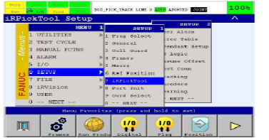
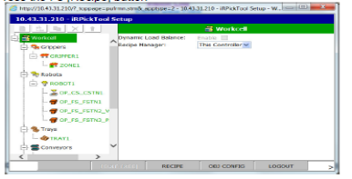
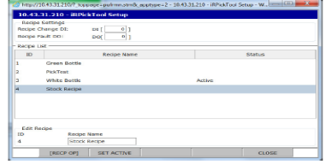
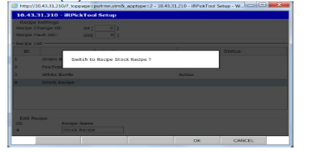
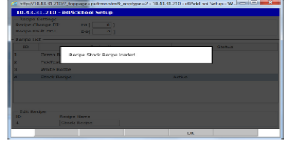
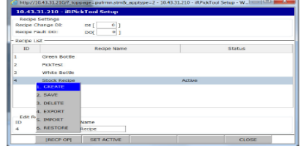
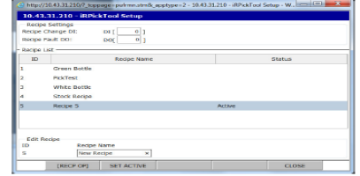
Figure 3: Flowchart illustrating all the menus a user has to go to in order to enter a new recipe

This could be automated by the new interface. The interface would take the user directly to what needs to be inputted so the user does not have to waste time navigating through multiple menus and screens.
The second option is the ideal option. The first option would have the user going back and forth between the interface and the pendant. This second option is more user-friendly and would only require the user to use the pendant when needed. The input would be easier to enter with the second design. Much of the work could be done on the new interface with the second option. The comparison of these two strategies is shown in Table 1.

Ranking of Conceptual Designs
Table 1: Ranking of Conceptual Design Options
Design | Total Number of User Interactions | Average Length of Time for Completion
Full Automation | 29 | 30 minutes
External iPendant  Operation  With Interface Prompts | 71 | 1 hour 30 minutes

Proposed Design Solution
In order to simplify the end user’s interactions with the bottle orientation system, we will be introducing a front-end UI component and a back-end control service component. The front-end component will provide a simple set of commands that represent common tasks the system’s operator would need to perform. The back-end component will interface into the existing system in order to translate the high-level commands on the UI into low-level commands which can be used to drive the existing pieces of the system. The resulting figure diagrams the modes of user interaction that this new design would implement:
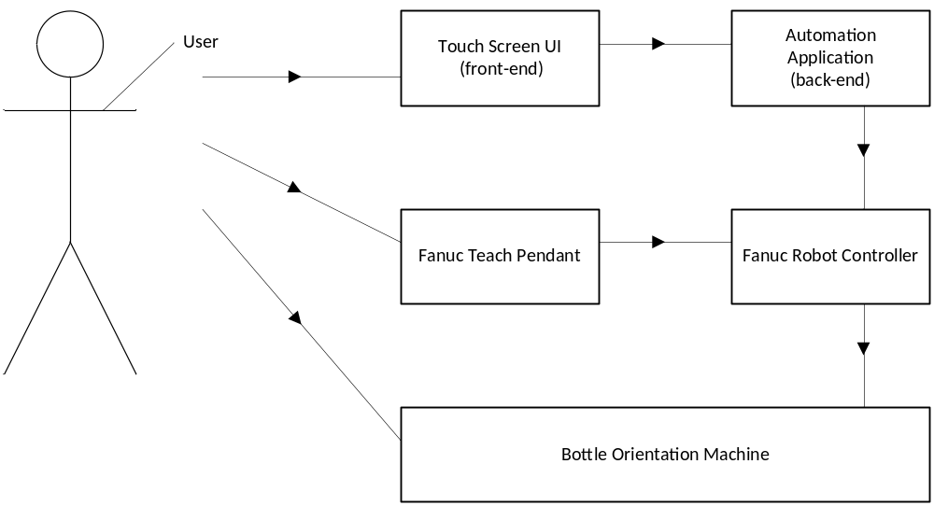
Figure 4: Diagram of the Different User Interaction Modes in the Proposed Design

The user of the system will interact primarily through the touch screen UI for tasks which have been simplified by our applications. For tasks which have not been simplified, the user will interact with the system through the teach pendant as before. Physical interactions with the machine, such as installing the vision mat, will also be carried out manually as before.
The basic design of our solution is to condense typical interactions with the bottle orientation system into high level commands. Goals which would take dozens of steps and menu interactions on the teach pendant will be represented as single items on our touch screen UI. We will then use Java EE’s JAX-RS specification to define a web service which exposes these high level commands as items that can be trigged from our user interface. When the user selects a command in the UI, the UI relays that command to the web service, which will trigger all of the individual steps and menu interactions necessary to complete the higher-level goal the user is trying to accomplish. These steps and interactions will be completely silently using the Fanuc controller’s web interface, saving the user several interactions with the system. The back end web service will also subscribe to any alarms triggered on the Fanuc controller as an RSS feed, and provide this information back to the user interface, which will display these alarms to the operator directly on the touch screen interface. The software interaction between the front and back-end of the interface is illustrated in Figure 5.
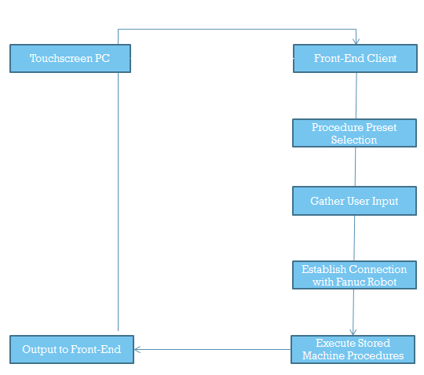
Figure 5: Diagram illustrating the interaction between the front and back-end of the interface
The front end UI will be written in HTML5 using Google’s Polymer framework. The polymer framework is designed specifically to be touch-screen friendly, and will allow us to ensure that our interface works well with a touch screen. Using polymer’s built in two-way data-binding and the Fanuc Robot controller’s network socket interface, we can verify that users have entered all of the necessary inputs and verify that the system is in the correct state before allowing them to continue, making the system far less prone to mistakes caused by missing information or skipped steps. The interface will also be able to display example videos and photos as help items to ensure that the operator clearly understands any instructions they are being given.

Risk Analysis
The potential risks associated with this project are data integrity and component interaction. Both risks associated with the bottle orientation system are present regardless of design solution undertaken. Both are also risks that if not mitigated can prevent successful completion of the design project.
In order to mitigate the risks presented by improper use by the operator, software validation checks will be implemented to confirm whether user input is appropriate and within range. The user will be able to go backwards in menu flow if they recognize errors. Certain parameters, such as the jog speed of the robotic arm, will be limited to prevent machine damage from occurring.
The software risks present within the confines of the Bottle Interface System revolve around the front and back end being able to communicate effectively. After a stored procedure is executed that modifies machine memory registers, the contents of those registers will be compared to the values expected of the system. If the values are as expected, then the integrity of the communication system is validated.

Project Management
Personnel
Alec Joiner is the team lab coordinator. His technical tasks to complete the project will be design back end interaction between touchscreen and robot controller.
Samuel Saia is the team manager. His technical tasks to complete the project will be design front end user interface.
Gurwinder Singh is the team presentation preparer. His technical tasks to complete the project will be design back end interaction between touchscreen and robot controller.
Emily Skipton is the team document preparer. Her technical tasks to complete the project will be design front end user interface.
Zain Syed is the team webmaster. His technical tasks to complete the project will be design back end interaction between touchscreen and robot controller.
Resources and Facilities
The hardware required to complete the design project will be a touchscreen PC. The project sponsor has suggested the Beckhoff “Economy” Panel PC CP72xx touchscreen. This item is not available in the ECE 480 lab and will have to be purchased from an outside vender. The software required to complete the design project will be Polymer, Tomcat, Chrome, iRvision, and iRpicktool.
Timeline
The GANTT chart for the Bottle Orientation Interface System is shown on the following page.

Cost
The sponsor has suggested the Beckhoff “Economy” Panel PC CP72xx touchscreen for the design project. Depending on model and options selected, the price of the touchscreen suggested ranges from $1000 to $4000.

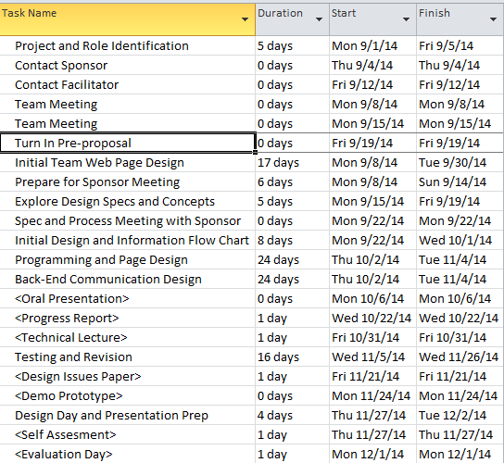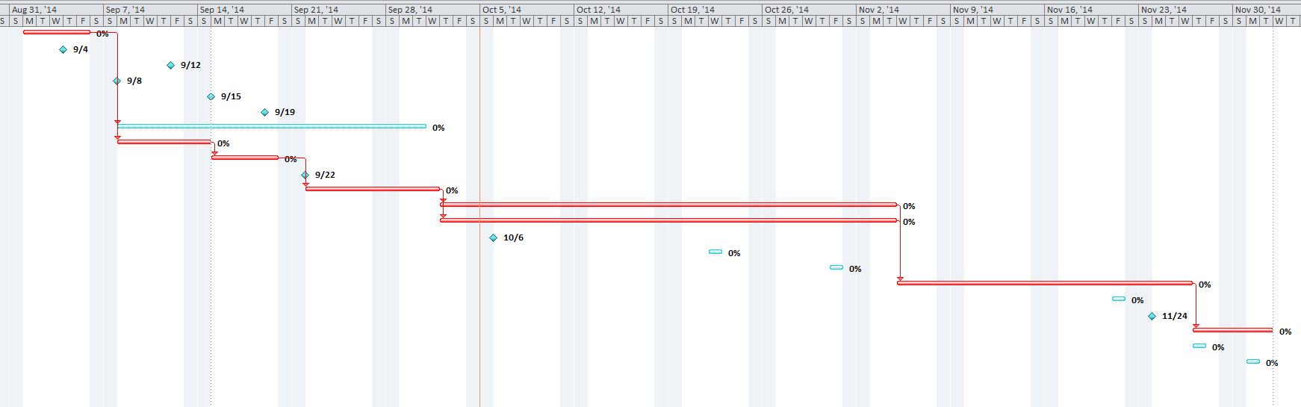
Figure 6: GANTT Chart
Table 2: Outline of GANTT Chart

