Emily Skipton
Application Note
ECE 480
Design Team 1
Explanation of how to design a UI that can interface with a FANUC robot
11/14/14

Overview of Our Design Solution

The Fanuc controller has a webserver on it and the pendant sends requests to the api, application protocol interface, over http, and the server on the controller interprets and processes these requests. The requests that get sent to the server tell the server which variable in which file to change.
We will use fiddler, a local network proxy, to allow us to log and analyze http requests. This enables us to know what variables in which files are being changed so that we can hardcode these sequences in order to automate superfluous user steps.
We are building a web app that runs in the browser on the touchscreen and will be built with javascript, html, and css language. Javascript provides the interactivity, html provides the structure, and css provides the style. This user interface is our front end component that will send requests to our local back-end component, a j2ee java server running on NJINX, a lightweight web server. The back-end is where all of our hard code, written in java, that will automate requests to the FANUC controller. The back-end will receive user input from the webapp which will prompt the backend to open up a connection to the controller in order to send our automated steps and receive the corresponding controller responses. When the local back end receives responses from the controller and then it will parse that information and display the relevant information to the user. (Figure on following page)
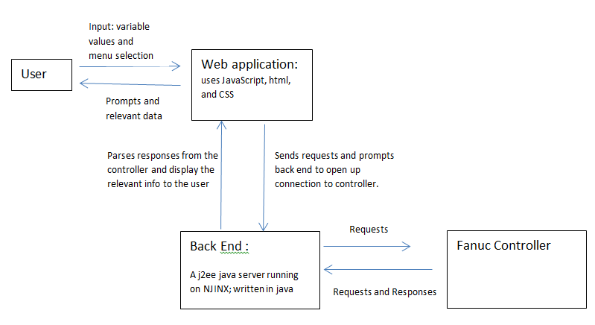
Figure 1: Flowchart of the Information Exchange between the UI and Fanuc Robotic System

Personal Contributions:
In order to create the back-end hard code, written in java, that will automate requests to the FANUC controller, the request variable names must be outlined. In order to find out these variable names, fiddler, a local network proxy, was used to monitor the http requests while we performed various procedures. These procedure steps were recorded with their corresponding http requests in order to keep track of which variables in which files should automated, fetched, stored, or changed as the user progresses through the procedure.
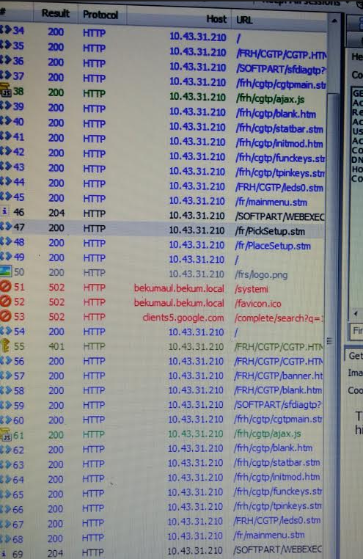
Figure 2: The fiddler software displaying the http requests from the FANUC controller

The design of the menu flow and pseudo-code needed to be executed in order for our programming to have a clear direction and organization. From my observations performing procedures and observing the http requests, I was able to develop a flow chart displaying the menu flow, the steps that are being automated between menus, their corresponding variable name, and times where user input needs to be stored or variables need to be fetched. The first part of this flowchart is shown below.
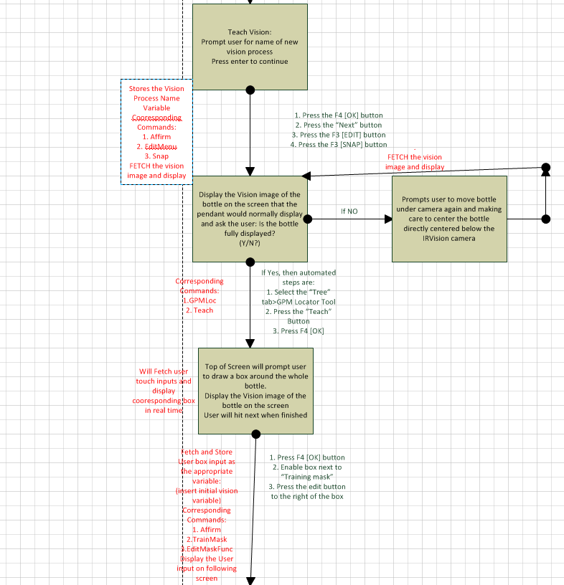

Figure 3: A flowchart outlining the order of displayed menu screens (boxes), the original procedure steps that are being automated in between (black text to the right of arrows), and the corresponding variable names to automate along with times to fetch or store variables (red text to the left of arrows)

The basic menu layout and how the alerts would be displayed on the page also needed to be defined before proceeding because having a consistent page format makes for an easier to understand format for the user. The basic design of each format is as follows:

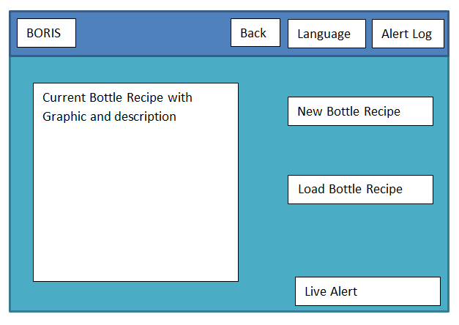
Figure 4: Basic Layout of Initial Menu
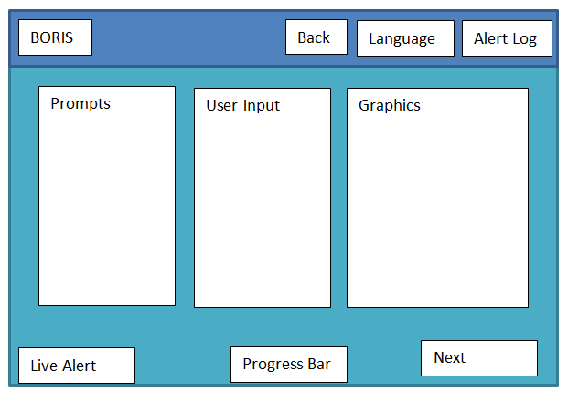
Figure 5: Basic Layout of Menu Steps that will guide the user through the making of a new bottle

In conclusion, my contributions to this design process have been the assembling of pseudocode, the gathering of variable changes and their corresponding automated process, determining which process should/can be automated, and assisting with the design layout of the menu display.

