MSU Solar Racing
BLDC Motor Controller
Michigan State University
Senior Design – ECE 480 – Team 9
Fall 2013

Project Sponsor:
MSU Solar

Project Facilitator:
Binseng Wang

Team Members:
Jaime Alvarez
Scott O’Connor
Matt Myers
Chris Sommer
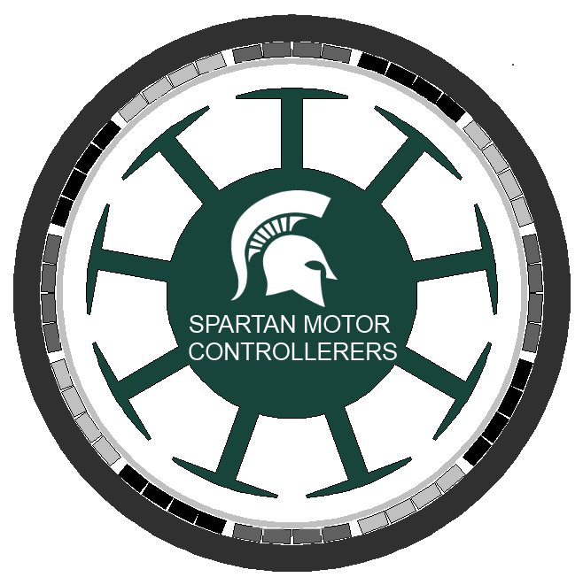



Executive Summary

The Solar Car Team is one of the latest racing teams to take hold at Michigan State University. Since 2010 the team has participated in two races. The Michigan State Solar Car Racing Team competed in the American Solar Challenge for the first time in 2012. Ten miles into the race the NGM motor controller being used on the car failed. The motor controller was over ten years old and the team decided it was time for a new motor controller.
Looking at BLDC motor controller’s it was quickly released that making our own motor controller would not only save money but help the team gain knowledge of how a BLDC motor controller works. One of the Michigan State Solar Car’s ideals is to make our cars open source. Being open source is multifaceted goal that serves multiple purposes for our team and the solar community. Sharing the work we did helps young teams that are struggling to get off the ground. Building an open source motor controller bring diversity into a competition dominated by only a few types of controllers.
In order to build a more effective motor controller we must look into improvements in the four main sections of the motor controller which include the control inputs, the microelectronics, the control algorithm, and the high voltage controls. Since time is limited, the goal of this project is to have a basic motor controller that will demonstrate each element of the motor controller.

Acknowledgement

The following individuals and companies deserve special recognition for their contributions to the final product and the success of our semester.

Binseng Wang: Without his knowledge and guidance we would not have the ability to finish this motor controller. We appreciate all of the time that he set aside during his day for the weekly meetings and also all the invaluable amount of advice and knowledge that he shared with our team.

Solar Car Team: The Solar car team is the basis of our project. The team provided financial backing as well as the moral support. This was crucial for our project as we would not have been able to pursue it without the monetary support allotted to our part of the solar car team.

STMicroelectronics: We would have been over our budget if we did not get free samples from STMicroelectronics. We were able to receive all of our MOSFETs as free samples which saved our team $438.50.

Texas Instruments: For our lack of knowledge about gate drivers in the beginning we were fortunate enough to receive free samples from TI to be able to test and understand how they function before buying our own.

Greg Mulder and Brian Wright: Part of our success derived from the fact that they were almost always available in the Electrical and computer engineering service center and checked up on us if they saw the team working on our project. They made our first PCB in a day and gave us multiple parts from the shop allowing for the completion our design. They also gave us advice on how we could improve our product.

Mike Koschmider: Helped us with the mechanical part of our project. He made sure that we drilled holes in the correct spots and that every component is as straight as it can be.

Roxanne Peacock: She made sure that all of our components would arrive at a timely manner.

Table of Contents
Chapter 1: Intro/Background………………………………………………………………4
Chapter 2: Decompose Problem…………………………………………………………10
Chapter 3: Technical Description………………………………………………………..16
Chapter 4: Test Data………………………………………………………………………..38
Chapter 5: Summary………………………………………………………………………..46
Appendix 1: Technical Roles……………………………………………………………...51
Appendix 2: References…………………………………………………………………....54
Appendix 3: Matlab Scripts, Arduino, NX Designs, Schematics……………………55

Chapter 1 - Intro / Background

A motor controller is an electronic component of a drive system that converts a DC voltage into a three phase AC signal that can drive an AC motor. The motor controller converts the DC to AC using a 6-step inverter which is implemented with high power MOSFETS. The motor controller also includes controls that determine the AC output of the controller. It is necessary for the AC output to be variable so that the user can change the speed of the motor. The motor uses information taken from the motor via Hall Effect sensors and the user input to determine the output. All the calculations necessary to evaluate the output are done with a Digital Signal Processor (DSP). The DSP then sends a pulse width modulation signal to the MOSFETS that switch on and off and create 3 separate sine waves. These sine waves form together to create a three phase AC signal. This AC signal is sent directly to the motor and causes it to spin.

Most modern motor controllers are also equipped with regenerative capabilities. Regeneration allows the motor controller to gain back energy that it has already put out when the driver is braking. This is especially important in electric vehicles because of the limited amount of energy in the batteries.

Brushless DC motors are becoming more common in a variety of motor applications such as fans, pumps, appliances, robotic automation, and automotive drives. The reasons for their increased popularity are better speed versus torque characteristics, high efficiency, long operating life, and noiseless operation. In addition to these advantages, the ratio of torque delivered to the size of the motor is higher, making it useful in applications where space and weight are critical factors.

The stator of a BLDC motor is similar to that of an induction machine but the windings are distributed quite differently. The stator windings can be seen on the outside ring of figure 1.1. The two different common distributions of the windings are distributed and sinusoidal. A distributed winding will have a trapezoidal back EMF while a sinusoidal winding will have a sinusoidal back EMF. For more information on back EMF see this note (Appendix 2 Section A). This application note will focus on BLDC motors with distributed stator windings. The rotor of a brushless DC motor is different in the fact that the rotor contains permanent magnets instead of additional windings. This is represented by the north and south poles in figure 1.1.

Unlike a brushed DC motor, the commutation of a BLDC motor in controlled electronically. To rotate the BLDC motor, the stator windings should be energized in a sequence. In order to make sure the motor controller is energizing coils in the correct sequence; Hall Effect sensors must be used to detect the position of the rotor in the motor. When the rotor is spinning inside the motor either a North or South Pole will pass by the Hall Effect sensors which will cause the sensor to output which section of the rotor is passed.

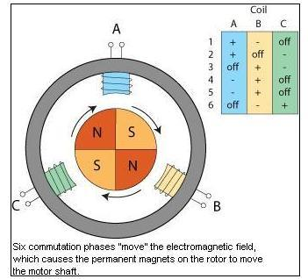
Figure 1.1

At the start of the semester when the team was defining its goals for the semester the objectives for the project were defined. In order to consider this endeavor a success, the team not only wanted to have a functioning prototype that could control a brushless DC motor in some manner but also to begin compiling a knowledge base that future members of the Michigan State University Solar car team could build on.

These two goals that were important to our design team because it would give the Solar car team an operational prototype to work with right away while also ensuring that the knowledge was there to create a new design in the future. Although the prototype that will be completed at the end of the Fall 2013 semester may not be car application ready, it will serve as a development platform that can be used to create a professional grade motor controller in the future.

The underlying goal of this senior design capstone projects is to give the Michigan State solar car team a fundamental understanding of how a BLDC motor controller works. During the race the solar car broke down and had to leave the race due to a faulty motor controller. There were several problems that the team faced when this happened. The first was only one member of the team knew how a motor controller works. This lack of knowledge prevented anyone from helping to fix the motor controller. The NGM motor controller that was in the solar car previously is not built to be taken apart. Making a motor controller that is more serviceable would be ideal. The motor controller that we want to make will be easy to debug and will contain components that are easily replaced in case of failure. Even though our motor controller needs to be modular it still must to be built robustly to survive under harsh environmental conditions.

By designing our own motor controller we can reduce the cost significantly. High end BLDC motor controllers can cost several thousands of dollars. It is advantageous for the team to have multiple motor controllers at a race in case a motor controller fails. Another reason for multiple motor controllers is the fact that world solar challenge is moving to four wheel cars. This would require two motors and motor controllers for each adding more to the overall cost.

Even though solar car racing is a competition, the point of being part of a racing team is to learn and promote renewable energy. The team struggled in the past learning how to build custom parts, for the solar car. Another objective our team has is to contribute to the opensource community. Opensource is a place to share the knowledge learned about solar cars with other teams for the general benefit of all participating. This project is a great way to add to our knowledge and the solar car communities knowledge because best way to learn how something works, like this motor controller, is by building one.

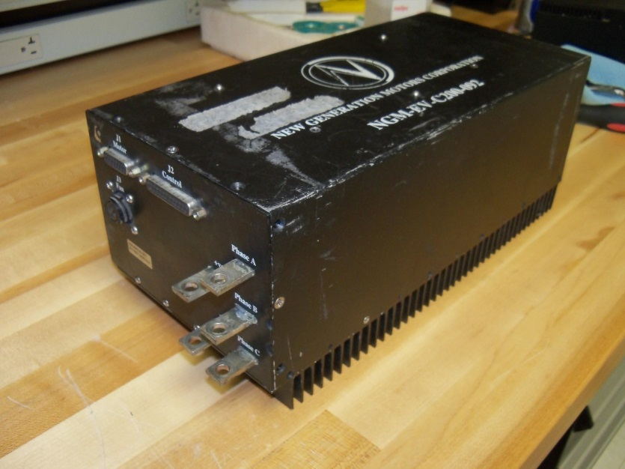
The New Generations Motor and Controller is the de facto drive system on solar cars today. In the last American solar challenge 10 out of 16 teams had the NGM Power system in their car, figure 1.2. The reason for popularity is due to the limited number of Axial flux permanent magnet brushless DC motor and motor controllers on the market. The NGM system is limited to only 120 volts. A Higher voltage limit would be valuable to reduce the current and therefore the I^2R losses. The NGM is also an older motor controller and has proprietary hard and software. If anything breaks and you open the motor controller you void the warranty and you have to reverse engineering the controller. The solar car team currently has a reassembled NGM motor Controller. This will need to be updated in the next few years. Other teams also had controller failures using this system. Figure 1.2

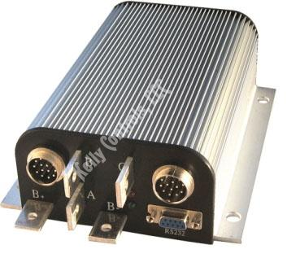
The Kelly KHB opto-isolated BLDC Motor Controller, figure 1.3, is a second motor controller option. Again the voltage is limited to only 120 volts. This motor controller has a current sensor on all three motor phases as well as a voltage monitoring system on the three motor phases, bus, and power supply. This has ultra-low drop and fast PWM to achieve very high efficiency. This motor is not strong enough to really drive the car. The team also had a controller failure using it at the race. The controller could not be easily debugged.
Figure 1.3

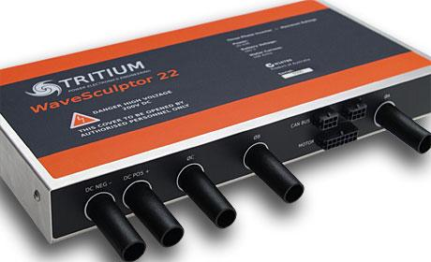
The Tritium Motor Controller, figure 1.4, is becoming the replacement motor for the NGM that most team upgrade to. The Tritium Motor Controller has a continuous DC bus voltage of 165V and 170 volts peak. The max power output is 20KVA and it uses 200V MOSFETs as the power switching elements. The controller is also CAN enabled. This controller is not open source and also cost $6000. While this is a good option it is expensive. This controller also does not come with a heat sink.
Figure 1.4

We are limited with the amount of money we can spend on this motor controller therefore; we are limited to the types of components we can obtain. The components that we need will add up to well over our budget if we pick the most advanced ones. Due to the motor controller being so old we can have components that are better than the current ones but not necessarily the best that is available on the market. The following are changes that we will make when we compare it to the NGM motor controller.

More robust MOSFETs

The MOSFETs in the NGM motor controller discussed above had a maximum voltage rating of 200 volts which does not leave enough head room for the voltage spikes that can occur when the car must accelerate or brake quickly. By switching to a more modern power MOSFET we can attain a peak voltage of 650 volts while keeping the peak current the same. One goal with this solution is to keep the on resistance of the MOSFETs around 80 milliohms per phase in order to maintain efficiency in the power distribution system.

Increase Repairability

The NGM motor controller that the MSU solar car team currently uses contains four different boards that combine to control the MOSFETs in the controller. Our goal is to combine the separate gate driver and micro-controller boards into a single board which will be much easier to replace if it should fail. The team also will increase repairability by making this project open source and keeping all of our development information on the web. This data will help future teams by allowing them to replace parts and alter code easily.

Higher performing Heat sink on MOSFETs

Major cause of Motor controller failures is insufficient heat dissipation. We hope to improve upon other designs by using a bonded heat sink as opposed to an extruded aluminum heatsink. A bonded heatsink allows for longer fins in a closer proximity than an extruded version of the same size. The extruded type would be limited to an inch by the manufacturing processes while the bonded heatsink would allow us up to four inches.

Include Upgradeability

Upgradeability will be important as the solar racing team at Michigan State University grows. The ability to adapt the motor controller to different battery pack voltages as well as different motors is important to consider in design.

We plan to accomplish this by adding higher voltage capacitors that are necessary for our current pack and motor specifications. By increasing the values from 200 volts to 250 volts we allow for the capability to handle more power in the future. There is only a $10 price difference between the 200 and 250V capacitors so this feature comes at a small cost to the team. Keeping this an open source project as discussed above also improves the upgradeability of our motor controller.
A success for our team is defined as getting a BLDC motor, of any size, and have it spin using our motor controller. With the success of this initial motor controller designs we will have a better idea of how the different components interact with each other in the motor controller. This will be served as a platform for future members of the solar car team to build upon and upgrade as more technology becomes available. Our development of this motor controller will not end this semester. We plan to keep working on this project until it is able to control the current motor that the solar car is using. Our ultimate end goal is to use this exact motor controller in the upcoming solar car race during the summer of 2014.

Chapter 2 - Decompose Problem

The Function Analysis System Technique (FAST) Diagram below, figure 2.1, is a way to show all of the functions that the motor controller system will implement. This diagram moves from left to right dealing with the main function first and transitioning to the primary function and finally the numerous secondary functions following the primary. The main function of this system is to control the motor. The next column is the different primary functions that are needed for the primary function to work. The next subsequent columns are secondary functions that describe how the primary or secondary functions will be achieved. This FAST diagram is an easy way to visualize the basic functions of the system and how they rely on one another.

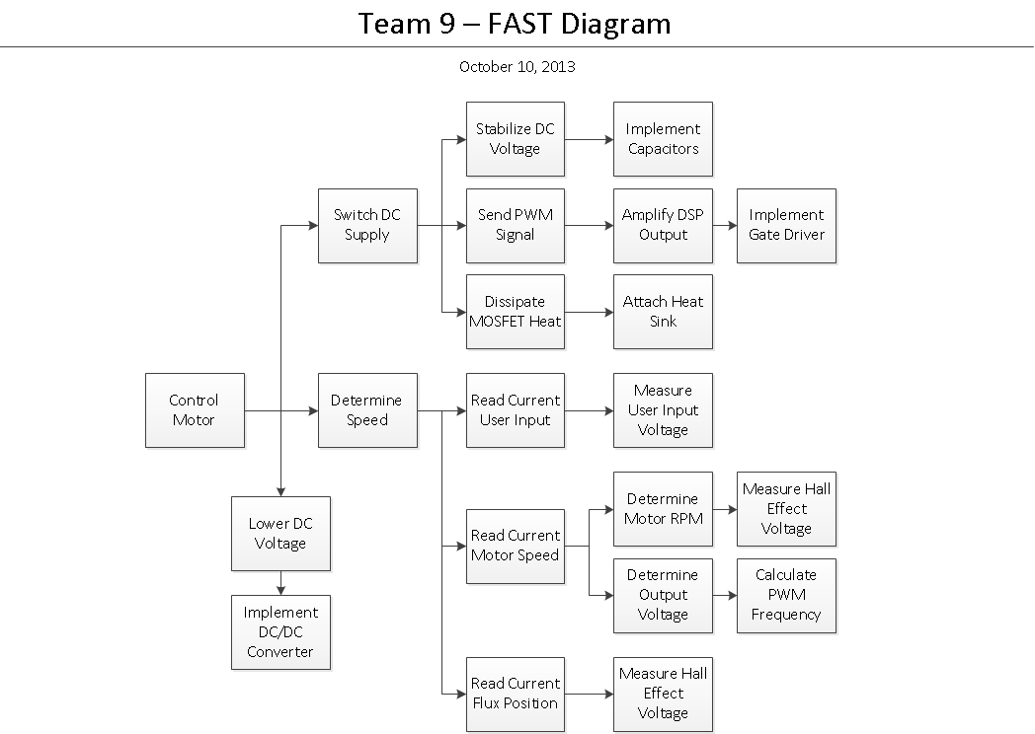
Figure 2.1

There are two different sides to this motor controller, the programming and hardware side. For the hardware side we would need to implement a DC/DC converter when wanting to lower the DC voltage. This switches the DC supply and there are certain events that occur once this happens. We need to stabilize the DC to be able to control the motor we would need to be able to first determine its speed.

The needs of the customer can be determined based on the House of Quality technique. The customer sent us certain requirements that we had to meet while building this motor controller and they are bulleted below.

- Efficiency over 90%
- The size of the case needs to be 12”x8”x12”
- Need to weigh 11 pounds or less
- Forward and Reverse inputs via potentiometer
- DC input Max Voltage 160V
- DC input Max Current 150A
- Three Phase output to 7.5KW Motor
- Reliable- must be able to operate in high heat over 105 F
- Easily Repairable

After we have all the customer requirements we related these to the House of Quality design. The House of Quality measures the critical customer requirements and ranks them to what is most important to the customer. It is very important to meet all these specifications in order to deliver a usable product for the customer to use in the upcoming race. These customer requirements also affect our decisions on how to design our motor controller which is discussed in the next section.

The main differences between brushless DC motor controllers are the types of control algorithms that are implemented on their microcontrollers. The two main types of control algorithms are sensored and sensorless control. Sinusoidal and trapezoidal are the two different output types that must be picked from after a control method is selected. The team examined the different aspects of these control methods carefully before selecting the algorithm and output type for our motor controller.

Sensored

In a sensored control algorithm hall effect sensors in the motor are used to determine the position of the rotor flux at all points in time. The microcontroller uses the outputs of the 3 sensors to calculate the position of the rotor. The rotor flux can be in 6 possible states because the three hall effect sensors output either a 1 or a zero and they cannot all be on or off at the same time. The microcontroller then uses the position that it calculated to determine the next output of the motor controller. The output changes by controlling 6 switches that are incorporated in the high voltage bridge of the motor which is discussed later in the MOSFET section of the report.

A sensored control algorithm has a smooth response over the entire speed curve including low speeds and starting speeds because the hall effect sensors always know the position of the rotor. The downsides to this method are the facts that it requires more expensive hardware to implement and the motor to be controlled must have hall effect sensors for the motor controller to be compatible. This means that this type of motor controller is not able to be used with a wide variety of motors.

Sensorless

A sensorless control algorithm is much more complex than the more standard sensored control algorithm. It uses the back EMF of the unused phase of the motor in order to calculate the position of the rotor flux. The back EMF is induced in the unused coil of the motor as the rotor magnet passes by it. By reading the voltage caused by the back EMF a microcontroller can determine the position of the flux. Similar to the other control algorithm the microcontroller would use this position to determine which MOSFET switches to turn on and off.

One of the main flaws with this type of control algorithm is that the exact position of the rotor cannot be read at low or starting speed because there is not enough back EMF at this speed. This means that the performance of these motors is poor at lower speeds. This also makes starting the motor much more complex because the position at the beginning is not known which means additional software is needed to get the motor going. The benefit of this type of algorithm is the fact that it is more reliable due to the fact that it has no sensors and it is cheaper because it requires fewer components. Sensorless control also offers greater software customization which allows a single motor controller to be used on a wide variety of motors.

In order to decide on the right motor control method the team decided to split it up into three different designs. Each design is judged on its effectiveness and feasibility. The next three design ideas are made in such a way that will help our team make our final product with as little error as possible.

Ranking Conceptual Designs:

In order to see the best design solutions, the prior three designs were compared using a feasibility matrix which is table below titled Prototype Conceptual Design Stages below. This matrix has three important details to each of the designs which are cost feasibility, implementation complexity, and lead time. The three designs are ranked on a scale from 1-5 in each category with a rating of 5 representing a great feasibility option and a rating of 1 representing an infeasible option on table 2.1.
Design # | Description | Cost Feasibility  (5-great 1-poor) | Implementation Complexity  (5-simple 1-difficult) | Lead Time  (5-best 1-worst) | Average Feasibility Rank
1 | Sensored Trapezoidal | 5 | 3 | 5 | 4.33
2 | Sensored Sinusoidal | 3 | 2 | 3 | 2.67
3 | Sensorless Trapezoidal | 2 | 2 | 2 | 2
Table 2.1

The team had to carefully choose each individual component to make sure it was within a reasonable price range. The budget that we had to adhere to was $500. With this budget we had to search for other ways to receive these different components in order to not go over the budget. We made a concerted effort to find components that meet our needs and are also available for free. There are a few companies that gave us free samples to help us make our motor controller as cheap as possible. STMicroelectronics is one of them and they gave us around 25 MOSFETs as free samples. Texas Instruments is the other company that has given us free samples to use which are the gate drivers. We implemented these on our initial design and learned from them to help us decide on the actual gate drivers we needed

The budget table below, table 2.2, show how much it would have cost if we actually bought each component. Since we got the MOSFETs for free we saved over half of our budget. We also bought two small motors just in case we accidentally destroy one of them. The actual price of our final product will be described in chapter 5 titled Final Budget. It is important for us to buy more than we will use just in case we damage some components from testing them. We are still below budget even though we bought more components than we needed.

Preliminary Budget Estimate
Product | Part # | Description | Qty. | Price/per | Total
N-Channel MOSFET | STW88N65M5 | 650V 84A 0.024 Ohm TO-247 package | 25 | $ 17.54 | $ 438.50
10x8" HeatSink | Link | 10.080"x8" heatsink with 2.5" Fins Extruded Al. | 1 | $ 55.00 | $ 55.00
C2000 Launchpad | LAUNCHXL-F28027 | TI DSP Board with F28027 processor | 1 | $ 17.05 | $ 17.05
9"x6" PCB | PC81 | 4 oz. 9x6" Copper PCB Unperforated | 1 | $ 19.80 | $ 19.80
3-Phase Bridge Driver | IRS2332SPBF-ND | 600V with 250ma peak current. 500ns delay | 3 | $ 6.35 | $ 19.05
Opto Isolators | FODM453-ND |  | 3 | $ 2.17 | $ 6.51
Copper Bar | 3350K15 | .25" D x 1" W x 48" L Ultra Conductive Copper | 1 | $ 89.10 | $ 89.10
Insulated Material | 739-A15397-03 | Thermally Conductive Insulator 2.5W/C 12"x18" | 1 | $ 20.67 | $ 20.67
Capacitor | 667-EET-UQ2E222LA | Snap In 2200uF 250V 0.098 ESR | 6 | $ 9.65 | $ 57.90
 |  |  |  | Total Cost = | $723.58
Table 2.2

This Gantt chart is a way for the group to stay organized and have an overview of the different tasks needed to complete this project in the time allotted. Naming the individual tasks, giving each one a deadline, and putting it under different categories will keep us organized. The Gantt chart will allow us to be able to see what tasks need to be done and monitor the progress in a visual way. By using this tool, we can easily change the length it takes to do each task depending on how long each part takes. The Gantt chart below, figure 2.2, will start from the research aspect of the project to the finalized product which will be displayed on design day.
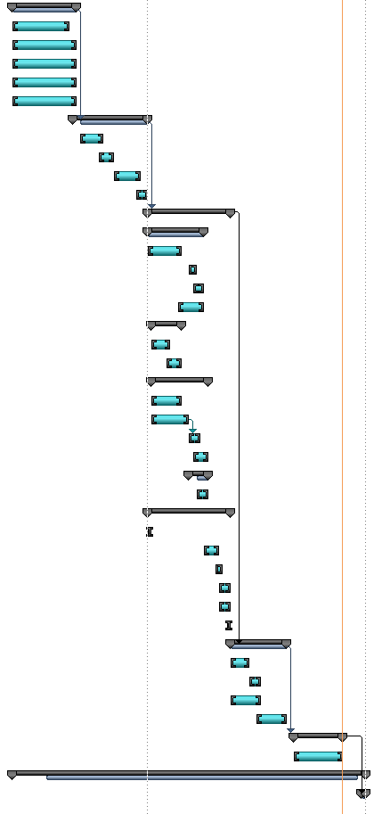
Figure 2.2: Gantt chart

This project was split into multiple sections and sub sections. There are seven main sections which are the research of the different components, ordering the parts, our first prototype, the second prototype, some final testing, due dates, and the design day. What we changed on our final Gantt chart is to have more time during the entire research process. We needed to do more research about the different components of the motor controller due to not having enough knowledge on how everything works together. Some of the parts also took longer to arrive than expected which delayed some of our progress and changed the Gantt chart as well. The subsections are all under the first prototype section and they are all of the components, the DSP, gate drivers, MOSFET-Power Hardware, mounting onto heatsink, and all connections. We initially had three prototypes scheduled but due to the time allotted and when the team was working on the subsections of the project we decided only to make two different prototypes. The due dates were just included to remind us when certain reports are due and when presentations will be made. This Gantt chart has helped us significantly on deciding the priority in which certain tasks need to finished by and it helps us know what other tasks we can individually work on.

Chapter 3 - Technical Description

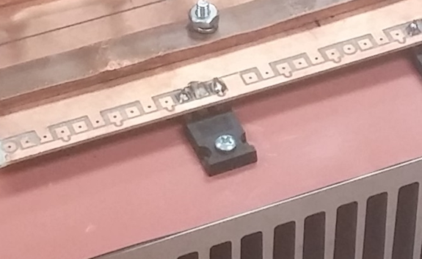
MOSFET
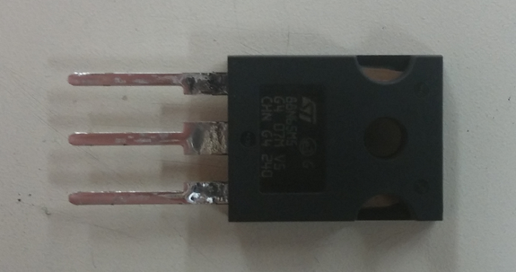
Figure 3.1 Figure 3.2

These are the MOSFETs that we have chosen to use, figure 3.1. They are the STW88N65M5 from STMicroelectronics. They have been soldered onto the PCB and have been bolted onto the heatsink with a thermal pad in between them, figure 3.2.

The MOSFET bank is also known as the H-Bridge for a 3-phase motor. The H-Bridge is the circuit that converts the DC voltage to the 3-Phase AC voltage which is needed to spin the motor of the MSU solar car. The conversion takes place by having six MOSFETs in a specific way shown in Figure 3.3. This figure also shows how the different stages are connected and interact with one another.

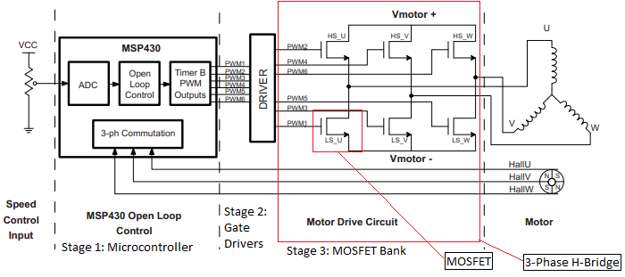
Figure 3.3
Stage 1 takes the input from the voltage reference, usually from a potentiometer, to the microcontroller which then outputs a PWM signal. Stage 2 is a buffer between Stage 1 and Stage 3 because the microcontroller does not have enough current to turn on the MOSFETs so there needs to be a gate driver to provide the current. Stage 3 takes the PWM signal and turns the MOSFETS on in a specific way to create the 3-Phase AC voltage that is then outputted to the motor.

H-Bridge Design:

In this implementation the MOSFETs are working as switches by turning on and off the current to the motor. In order for the MOSFETs to work as a switch, it must operate in the saturation region indicated in Figure 3.4. There are 6 MOSFETs needed, all NMOS transistors, to design a 3-Phase H-Bridge where two are needed for each phase. In each phase there is a high side MOSFET, meaning that the drain of the MOSFET is connected to the positive side of the power supply, and there is a low side MOSFET. There is also the source of the MOSFET connected to ground or the negative side of the power supply.

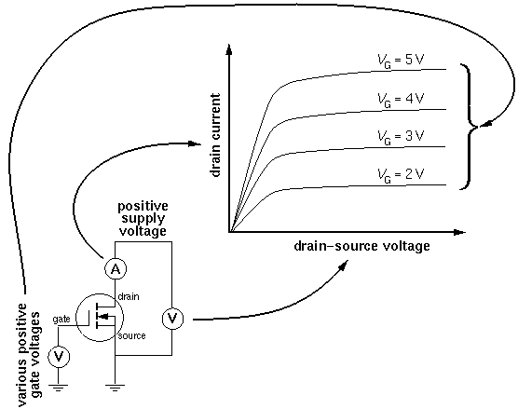
Figure 3.4 NMOS Characteristic Curves: The Saturation Region is the region of the characteristic curve that the MOSFET will provide a constant current.

The way the current flows in the H-Bridge is very unique because it only uses 2 of the 3 phases in every instant in time. Current flows from the positive terminal of the power supply to the negative terminal. The current starts by going through the MOSFET in phase U on the high side. The current continues to the winding in phase U then goes through the phase V winding. From there, the current goes through the MOSFET in phase V on the low side. Then the timing from the microcontroller will make the current flow through the different phases at different times indicated in Table 3.1. There needs to be some caution here since the timing must be correct or the power supply will be shorted. The power supply will be shorted if the MOSFETs in the same high and low phase U, V, or W are on at the same time.

Time Instant | High Side MOSFET turned on | Low Side MOSFET turned on
1 | Phase U | Phase V
2 | Phase U | Phase W
3 | Phase V | Phase W
4 | Phase V | Phase U
5 | Phase W | Phase U
6 | Phase W | Phase V
7 | Phase U | Phase V
Table 3.1 Turn on time of the MOSFETs

MOSFET Selection:

The following tables below are all taken from the data sheet of the MOSFET chosen for our motor controller. Depending on the specifications of the motor and power supply the MOSFET will vary.

Table 3.2 shows the first table from the datasheet. One of the most important parameters that should be considered first is the continuous drain current (I_{D}). The continuous drain current is measured in Amps. There are two drain currents here because the drain current will change based on the operating temperature of the MOSFET. The MOSFET needs to be chosen by looking at the higher temperature because it is the more realistic drain current value. The drain current is very important because it is the current that is going to the motor. This current needs to match or exceed the current rating on the motor. Another important parameter is the gate to source voltage (V_{GS}) since it also needs to be matched to the voltage that is being received from the gate drivers.
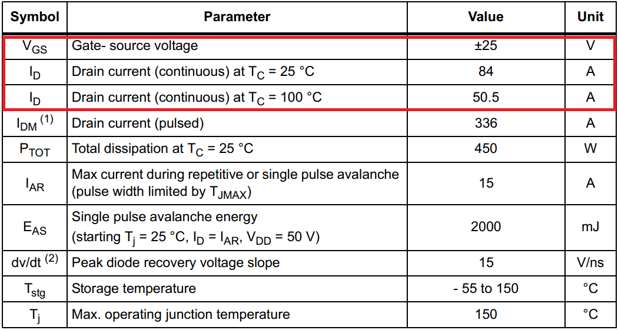
Table 3.2 Absolute maximum ratings

Table 3.3 is the next table on the data sheet and it shows the thermal data. There is only one parameter needed in this table which is the thermal resistance junction-case max (R_{thj-case}). This value is important because it is needed to measure power loss in heat and the heat transfer to the heat sink. It is good design practice to choose a MOSFET with a low thermal resistance junction-case max value. Having a lower thermal resistance junction-case max means that the heat generated by the MOSFET will be sent to the heatsink better and it will keep the MOSFET at a cooler temperature. The units are read as degrees Celsius per Watt.

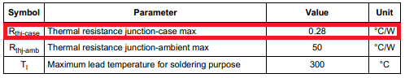
Table 3.3: Thermal Data

The drain-source breakdown voltage (V_{(BR)DSS}) shown in table 3.4 is one of the parameters needed to be considered when selecting the proper MOSFET for the H-bridge. If the breakdown voltage is exceeded the MOSFET may explode. So choosing a breakdown voltage much higher than the supply voltage is needed for the MOSFETs protection. Another important parameter is the static drain-source on resistance (R_{DS(on)}). Minimizing the on resistance will minimize the power loss of the MOSFET.
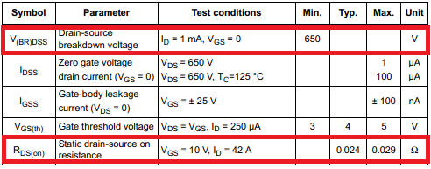
Table 3.4: On/off states

Table 3.5 shows the parasitic capacitance of the MOSFET. Output capacitance is an important parameter because it is how to calculate switching losses. By minimizing the output capacitance the switching losses will be minimized. Total gate charge is another parameter that needs to be checked since it is used to calculate the gate capacitance which will affect the turn on time of the MOSFET. A smaller gate capacitance will make the MOSFET turn on faster.

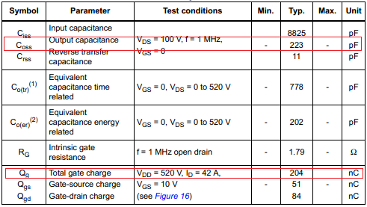
Table 3.5: Dynamic
There are many parameters that need to be considered when selecting the proper MOSFET for the motor controller. There are different types of package types that do not affect the performance of the MOSFET but are chosen due to how it will be implemented. For high powered motors, MOSFETs can be put in parallel to increase the current to the motor. By putting them in parallel the on resistance will decrease and all the parasitic capacitance will increase. All the important parameters will affect the protection, power loss, and efficiency of the motor controller.

Gate Driver

Gate drivers are important to have since they get the signal from the microcontroller to turn on the MOSFETs. Most microcontrollers operate at 5 volts or 3.3 volts and can output a small amount of current. Larger MOSFETs usually need much higher voltage, 10V - 20V, and higher currents to switch the MOSFET on or off at high frequencies. A three phase inverter also presents an interesting challenge in turning on the high side of the MOSFETs. The gate source voltage rides on top of the three phases. In order to produce V_{GS} an isolated power supply is needed.

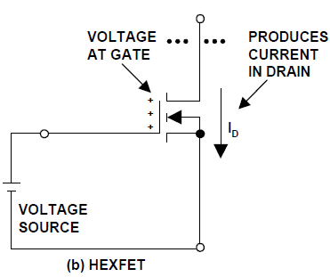
Gate Capacitance and Gate resistance are two very important parameters we looked at. A MOSFET is a voltage controlled current source. The voltage applied to the gate determines how much resistance there is between the drain and the source, figure 3.6. Once the MOSFET is on, no current flows in or out of the gate. Only during the turn on and turn off process is there a need for high currents. The amount of current to turn on a MOSFET can be modeled as an RC circuit, figure 3.7. Figure 3.6

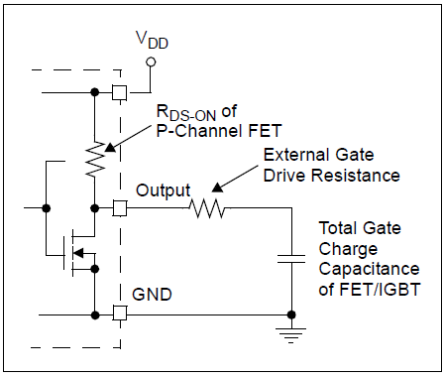
Figure 3.7

The total total time to turn on the MOSFET depends on the total gate charge capacitance, the external gate drive resistance, the P-Channel MOSFET resistance, and the voltage from the gate driver.

Source/Sink Current

Choosing a gate driver that can supply the correct amount of current to the gate of the MOSFET is critical in the design of the motor controller. The amount of current that the gate driver can supply affects how fast the MOSFET can turn on. We looked at the characteristic of the MOSFET to find how much current is needed to turn on the MOSFET. Unlike BJT or IBJT’s the gate is controlled by a voltage. Extremely small amounts of leakage current are consumed when the MOSFET is on. This is negligible in power circuits so it is safe to assume that no current is consumed when the MOSFETs are on. All the current to turn on the MOSFET is to drive the gate capacitance. There are two capacitances that directly affect the gate drivers even though the MOSFETs have multiple capacitances. These two capacitances are the gate to source capacitance and the gate to drain capacitance. Gate to source capacitance is the capacitance seen between the source of the transistor and the gate of the transistor. While the drain to gate capacitance is needed to figure out the miller capacitance.

The capacitance of the total gate charge of the MOSFET is needed when estimating the current output needed by the gate drivers. A good estimation is to take the total gate charge and divide it by the time required for the MOSFET to turn on or off.

800nf/1us=.8 A

This above estimation is the average current to turn on the MOSFET. The current output given by the MOSFET is usually the max current. This max current will only be seen when the capacitor is going through the miller capacitance. It is recommended to double this number. This would mean a 1.6 Amp current output would be needed. A more accurate way of finding the current requirement of the gate driver is to model it as an RC circuit. The gate capacitance current is limited by the resistance of the gate of the MOSFET And the resistance of the gate driver.
A three phase BLDC motor controller’s gate drivers work on the similar principles as a single gate driver. The ways they differ is when the gate to source voltage for the three high sides of the MOSFETs are floating on the phase voltage and changing independently.
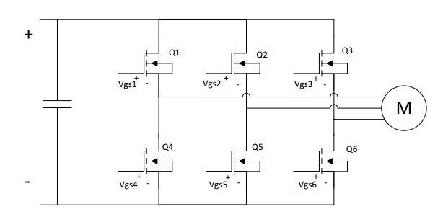
Figure 3.8

Since all the lower transistors are all connected to ground their Vgs will not float. This means that one isolated power supply can provide all the power for the low side gate drivers. The high side of the MOSFETs must each have an isolated voltage source for Vgs as shown above in figure 3.8. There are a few ways on isolating the voltage source such as the transformer method and the bootstrap method.

Transformer Method
The transformer method uses a transformer to isolate the voltage to turn on the MOSFET. The transformer supplies the gate source voltage to the high side MOSFET. In some cases, a double transformer can be used to control both the high and low MOSFET, as shown below in figure 3.9 and 3.10.
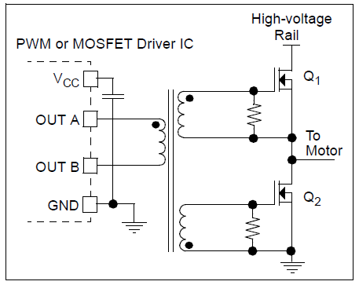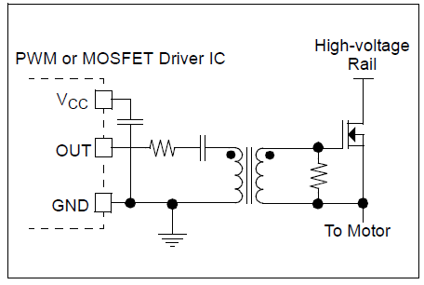
Figure 3.9 Figure 3.10
Bootstrap Method
The “Bootstrap Method” uses an IC and a capacitor. The supply voltage of the IC charges the capacitor when the phase is low. When the phase goes high, the voltage and the charge in the capacitor is used to turn on the MOSFET.
This method is great for low cost and simplicity but has a few drawbacks. The switching frequency is limited to the time it takes to charge the capacitor. Since the current is shutting off quickly there is a negative voltage spike on Vs. The voltage across the capacitor is the voltage of the IC power supply plus the voltage of this negative spike, figure 3.11. This needs to be taken into account when choosing the capacitor.
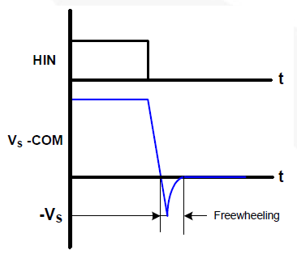
Figure 3.11

Gate Driver Prototype 1

The gate driver used in the motor controller is the IRS3223, figure 3.12. This is a 3 phase inverter bootstrap gate driver. The microcontroller will output to the six IRS 3223 active low inputs. The driver also has a built in logic controller so that it will be impossible to turn on the high side and the low side of a single phase at the same time. The gate driver also contains a built in delay between the high side turning on and the low side turning off. When switching at high frequencies the added delay will ensure that the high side will be turned off before the low side turns on and vice versa. The gate driver soldered onto the board is shown in figure 3.13.

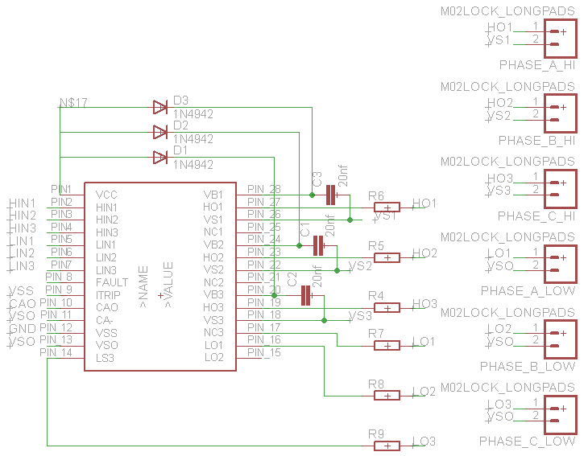
Figure 3.12

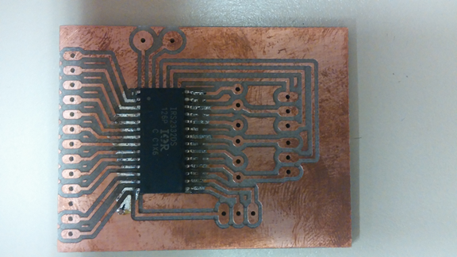
Figure 3.13

Gate Driver Prototype 2

A lot was learned when doing this project which quickly made us realize that the gate driver prototype 1 lacked the proper amount of current to turn on the MOSFET as quickly as possible. The second gate driver looked at was the IRS21834. This gate driver has a high side and low side drive with the bootstrap topology. Three drivers were added since each driver can only control one phase. The IRS21834 has a built in logic and delay to prevent cross conductance. One of the major differences is the need for external bootstrap diode. This addition allows for higher currents to be let into the capacitor. Opto-isolators were also looked into for the second prototype. These are necessary for keeping the transients from destroying the low voltage side of the circuit. The second gate driver design is shown in figure 3.14.

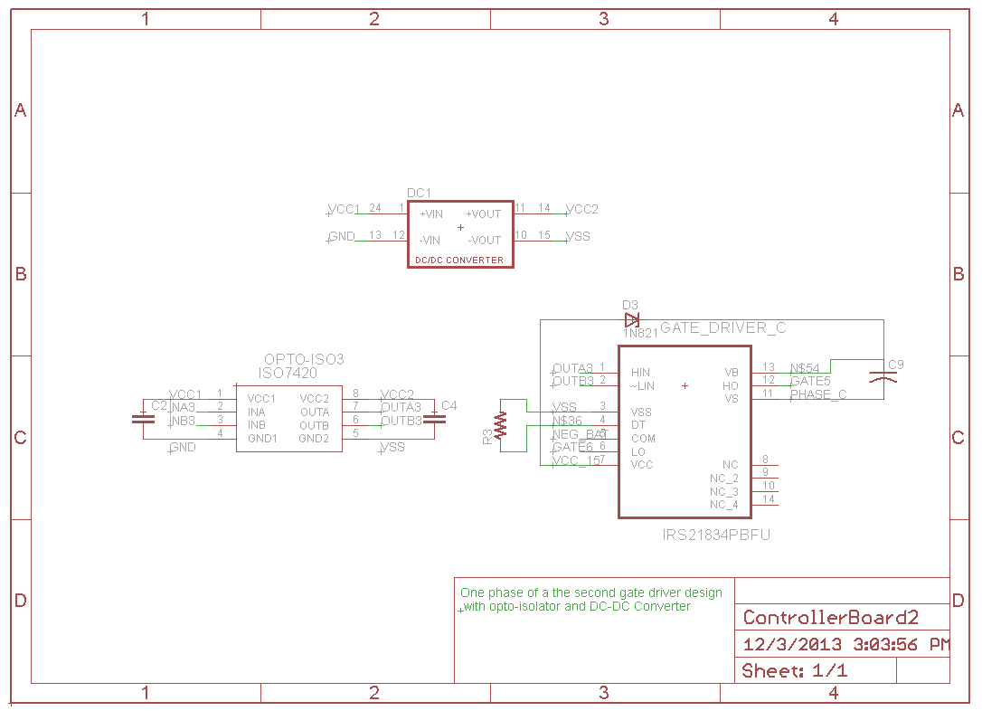
Figure 3.14
Gate Driver Prototype 3

The third prototype idea came from learning about RLC gate drivers and using a 4 coil transformer. Originally, the bootstrap topology was chosen due to its simplicity. As more research was made about the gate drivers the more feasibly it seemed to properly implement a transformer gate driver. This would allow much faster turn off times.

Reducing the wire length from the gate to the gate driver reduces the inductance. In general, the MOSFET needs to switch on and off as fast as possible until the transient voltage spikes occur due to the inductance.

A major problem the team encountered regarding the gate drivers is finding one that worked for our application. It took a month of researching to gather the knowledge on how to implement the three phase gate driver. Once we tested the first gate drivers we got, we realized that the amount of current that they can deliver is way too small. The calculations made to estimate the current was not correct. These calculations lead to the second design of the gate driver.

Heat Sink

MOSFET power dissipation is a large concern when designing a high voltage motor controller. When functioning at maximum capacity the MOSFETs that are used in our design dissipate approximately 400 Watts of power in heat. A heat sink is used to keep these devices from overheating. A heat sink is selected based on its thermal resistance which is a value that gives the amount of heat a unit can dissipate in $℃/W$. A desired thermal resistance can be found when using the thermal resistance of the MOSFET, the contact material between the MOSFET, and the maximum amount of current to be transmitted by the MOSFET. The exact procedure to find the value needed is described below.

The first thing to look at is how much current the selected MOSFETs can carry safely. The data sheet gives a number stated as $I_{d(max)}$ which is supposedly the maximum current the device can handle. This is a misleading number because it is only possible if operating at room temperature. It would not be possible at the given value of 84 Amps. This means that the $I_{d(max)}$ number given is not possible. The next line in the MOSFET data sheet most likely shows the maximum drain current at 100$℃$ which is the more reasonable number and it also shows that the current and temperature are related.

The maximum junction temperature $T_{j}$ is needed to create a model of the device. This value is given in the data sheet. Another detail that is needed is the relationship between current and temperature which is a value given as $R_{thj-case}$ which is given in$℃/W$. This value gives the thermal resistance between the MOSFET junction and the case of the transistor. For our particular application, this number is .28$℃/W$. This number means that the junction increases .28 $℃$ higher for every additional Watt of power dissipated. The power dissipated in the transistor is governed by the electrical law $P= I^{2}R$ where R is the MOSFETs drain to source resistance also known as $R_{DS(on)}$. The value can be computed by solving for the power dissipated if the case is at 25 $℃$ and the junction is at its maximum rating of 150$℃$. This equation can be used to acquire this value

$P = (T_{j} - 25 ℃)/R_{thj-case}$ or $P = 446.42 Watts$.

The next step is to solve for the resistance by using the following equation,
$R_{DS\left(on\right) 150}=P/I_{d(max)}$. This gives us a resistance value of 0.0633$Ω$ at an assumed junction temperature of 150$℃$. This does not match the value given on the data sheet because the assumed junction temperatures differ. The value needs to be divided by 2.25 to approximate the value given on the data sheet. The reason that it needs to be divided is because the $R_{DS\left(on\right) }$value varies with the temperature. A graph of this relationship is normally provided on the data sheet. This shows that at 84 Amps our transistor would be dissipating close to 446 Watts of heat. All of this heat would have to instantaneously be removed from the MOSFET in order to keep it from overheating. To accomplish this task it would take a very large heat sink or an expensive cooler. This number is helpful when creating the power dissipation model of the transistor but it is not that realistic.

This model can be used to calculate how much current the MOSFET can handle standing in free air. The thermal resistance from the junction to ambient air, $R_{thj-amb}$, is located on the data sheet. Given that the ambient temperature is around room temperature, 25$℃$, the maximum power in free air as well as the max current can be calculated as shown below.

$$P=\frac{150℃-25 ℃}{R_{thj-amb}}= 2.5 Watts$$

$2.5 W=I^{2} * 0.0633 Ω → I^{2} = \frac{2.5}{0.0633} = 39.5 →I_{\max{free air}}=6.284 A$

It is recommended to redo this calculation using a higher ambient temperature such as 40$℃$ in order to accommodate other factors that may affect the transistor. This will also allow for a safe operating range where the transistor is not on the edge of its maximum capacity. When the above calculations are redone under these new conditions our max operating current was approximately 5.9Amps which is roughly 0.4 Amps less than with a 25 $℃$ ambient.

The calculations for the H-bridge design can be done after all the free air limitations are known. It would be possible to take the maximum desired current and then divide that number by the free air current rating that we calculated above to attain the number of MOSFETs needed for that particular design. If we approached the problem with the same thought process as above, we would see that the maximum current desired for our design is 125Amps and dividing it by 6Amps will give us 21 MOSFETs per section of the H-bridge. Given that there are six sections in a 3-phase BLDC H-bridge, the motor controller would need to be constructed with 126 MOSFETs. This would be impractical because of the large cost as well as the problems that would occur when trying to switch 21 MOSFETs on and off simultaneously. The number of MOSFETs per section can be reduced by adding a heatsink to each device. This would eliminate the reason to use the actual amount of MOSFETs.

The thermal resistance of the heatsink can be calculated once the desired number of MOSFETs get chosen. For example, our design will use four STMicroelectronics power MOSFETs. Given the desired current rating of 125 Amps each of the devices are needed to be able to switch 31 Amps of power, which is much higher than the free air rating that was determined above, 6.284 Amps. In order to find the heatsink that will allow operation in this range another value will be needed. The value needed is the thermal constant between the case (c) and the heatsink (s), $R_{theta-cs}$. This is given by the material between the heatsink and the case of the MOSFET. For our application this was an insulating sheet that had a $R_{theta-cs}=1.1 ℃/W$. The next step is to calculate the worst case power dissipation with temperature at 15$℃$ as well as our 0.0633$Ω$ on resistance.

$$P=I^{2}*R_{DS(on)}= {31.25}^{2}*0.0633Ω=61 Watts$$

Using this variable, the thermal constant needed for the heatsink can be found. The temperature differential between the junction at 150$℃$ and the ambient air at 40$℃$ is going to be 110$℃$. From the calculation above, it is known that 61 Watts are dissipated. This leads us to find the thermal constant of the heatsink in $℃/W$.

$$\frac{110℃ }{61 W}=1.8 ℃/W$$

The motor controller will be able to handle a 125 Amp load with a high degree of certainty if the value above is met or exceeded by the heatsink. Additionally, burst current calculations can be done if the thermal mass of the heatsink is known. In order to automate the process described above a MATLAB script was developed by our team. This script can be found in the software section of Appendix 3 located at the end of this report. It can be used to do the above calculations for a different project by simply changing the variable declarations.

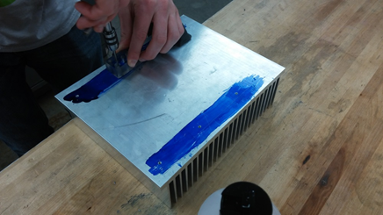
Figure 3.15. Heatsink being tapped

The heatsink that our design team decided on was a 10.080”x8” wide extruded aluminum heatsink from Heatsink USA, shown on figure 3.15 above. This heatsink has 2.5” fins and a thermal constant of 0.8 $℃/W/3"$ because the heatsink is 8” our overall thermal constant is around 0.3 $℃/W$. Our desired thermal constant calculated above is $1.8 ℃/W$ but this also included the electrically insulating layer between the MOSFETs and the heatsink, which has a thermal constant of 1. Therefore the overall thermal constant of our heatsink is 1.33 $℃/W$ which is still far below our desired rating. This means that our motor controller will operate safely within the desired current limits that were stated earlier in this section. There is more information about how the heatsink performed under operating conditions in the testing section below.

Bus Capacitors
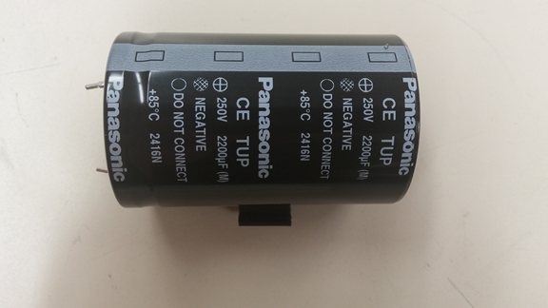
Figure 3.16

Capacitors are needed to be used to shield the rest of the motor controller from the high frequency switching transients. They are also used for protecting the motor controller from the voltage spikes that occur when the current is suddenly turned off. The capacitor that we chose to use is seen at figure 3.16.
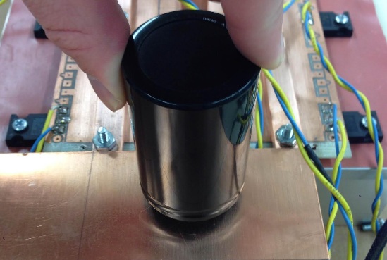
Figure 3.17

We placed the capacitor as close to the MOSFETs as possible so that the resistance and inductance of the bus between them are both very low.. Where our capacitor will be placed is shown at figure 3.17.

The equation below shows that the voltage ripple depends on the duty cycle that it is operating at, the switching frequency, and the current. We chose our capacitor while keeping in mind the voltage ripple.

$$∆V= \frac{I}{C}∆t =\frac{D*I_{Motor}}{C}*\frac{1-D}{f_{sw}}$$

Control Algorithm and Microcontroller

Inverter Bridge

Every AC motor controller will have a high voltage bridge that feeds current into the separate phases. A diagram of this system can be seen in figure 3.18. This bridge consists of six MOSFET switches that force current through two of the three phases of the motor as seen in figure three. The top three MOSFETS are attached to the positive side of the DC voltage while the bottom three MOSFETs are attached to the ground side of the DC supply. This allows the motor controller to create a negative voltage by changing the direction the current travels through the inductor. Figure 3.19 below, shows one of the six possible positions the switches can be in. In order to prevent shorts only a single MOSFET on the top and bottom rows can be closed at one time.

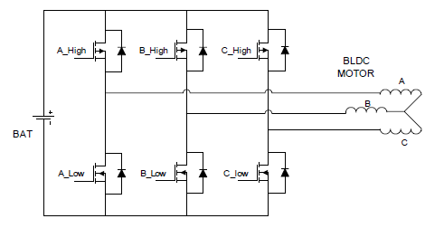
Figure 3.18
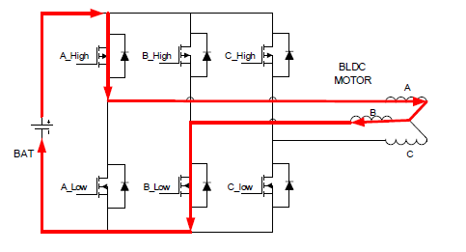
Figure 3.19

Commutation

Commutation is process of switching the state of the MOSFETS in the H-bridge in order to keep the motor spinning. As mentioned previously there are six possible states that can be used to drive a BLDC motor, the table below, figure 3.20 shows the six states as well as the hall effect sensor combination which represents it state. A graphical representation of these states can be seen in figure 3.21.

Hall A | Hall B | Hall C | Phase A | Phase B | Phase C | Sector | MOSFET ON
1 | 0 | 1 | DC+ | DC- | NC | 1 | A_H, B_L
0 | 0 | 1 | DC+ | NC | DC- | 6 | A_H, C_L
0 | 1 | 1 | NC | DC+ | DC- | 5 | B_H, C_L
0 | 1 | 0 | DC- | DC+ | NC | 4 | B_H, A_L
1 | 1 | 0 | DC- | NC | DC+ | 3 | C_H, A_L
1 | 0 | 0 | NC | DC- | DC+ | 2 | C_H, B_L
Figure 1.20

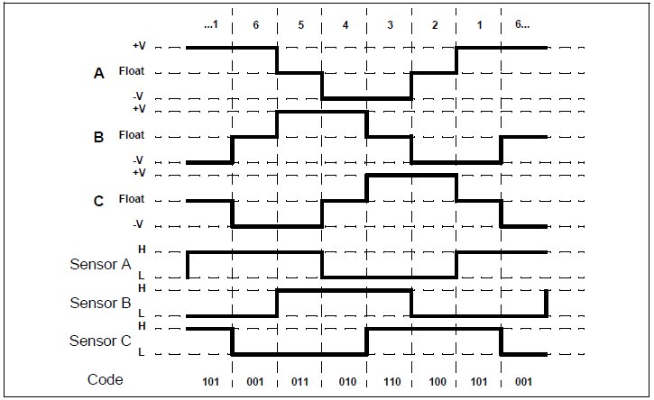
Figure 3.21

The graphs above (Figure 3.20 & 3.21) both give the state graph for clockwise rotation of a BLDC motor. There are 4 different commutations one for clockwise motion, one for counter-clockwise motion, one for coasting, and one for regeneration. Regeneration is the state where the motor is able to harness the energy used while braking and put it back into the batteries of the vehicle. This state is essential for applications where high efficiency is critical and speed varies often such as in automobile applications.

Arduino Implementation

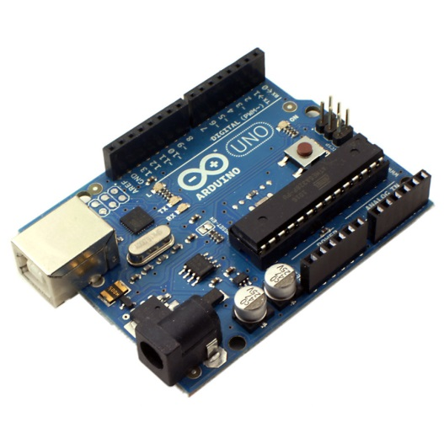
This concept can be implemented in its most simple form using a simple 16-bit Atmel microcontroller. In order to expedite the programming and prototyping process and Arduino Uno microcontroller can be used (Pictured in Figure 3.22). The Arduino includes a USB port, power adapter, reset button, and pin headers which all help use the ATMEL328 chip for a prototype. It also has free software available for download online. Following the link will bring you to the download page. Where the software is available for several different common operating systems.
Figure 3.22
Select the operating system that corresponds to your uses. After installing the Arduino software you are ready to start coding. If you need more help installing the program visit the Arduino site here. The main window of the software should look similar to the window pictured below in figure 3.23.

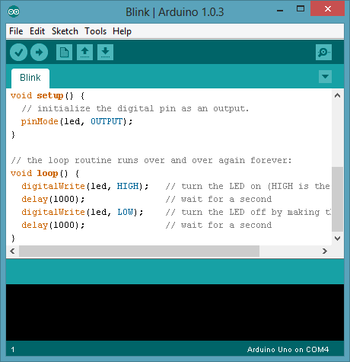
Figure 3.23

Coding with the Arduino

To start coding connect your Arduino to the computer via the USB connection. The USB connection provides communication as well as power to the chip. If you are unfamiliar with the Arduino coding environment these tutorials on Youtube are helpful. Now the chip is ready to be programmed. Below a simple example will be explained to get your motor spinning.

The code below shown in figure seen gives the basic variables that need to be defined. These variables will store the hall effect sensor states and the current speed that is desired for the motor, figure 3.24. Next the pin modes must be set. Each pin on the Arduino has either an output or an input mode. In figure 3.25 below, the pin setup is shown. The pin setup must be contained within your void() loop.

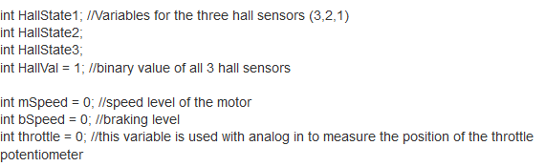
Figure 3.24

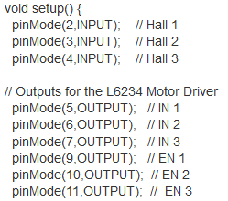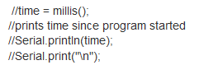
Figure 3.25 Figure 3.26

Next you must setup the PWM pins so that the frequency they operate is 32 kHz. This can be accomplished in a few different ways and is outside the scope of this document. There is a great tutorial for accomplishing this task here. Now that the pin modes, variables, and other settings are correct the main loop of the program can be constructed.

It is helpful to instantiate the serial communication available on the Arduino; this allows you to debug the program as it is running in real time. The code to start the serial communication is shown in figure 3.26 above. The code above will need to be uncommented in order to work properly. Next the program will need to read information from the user and the hall effect sensors from the motor.

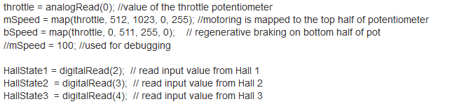
Figure 3.27

Figure 3.27 shows the code necessary to set variables equal to the inputs on the microcontroller. The final step of programming is to implement the 6-step commutation in code. The example code for this step is given in the Commutation Code Example of Appendix 3. This section of code is a state machine that switches state depending on the input from the hall effect sensors. These states will change the outputs of the microcontroller so that the PWM is applying the correct voltage to each phase in turn. These changes can be seen in Figure 3.28 and Figure 3.29 below.

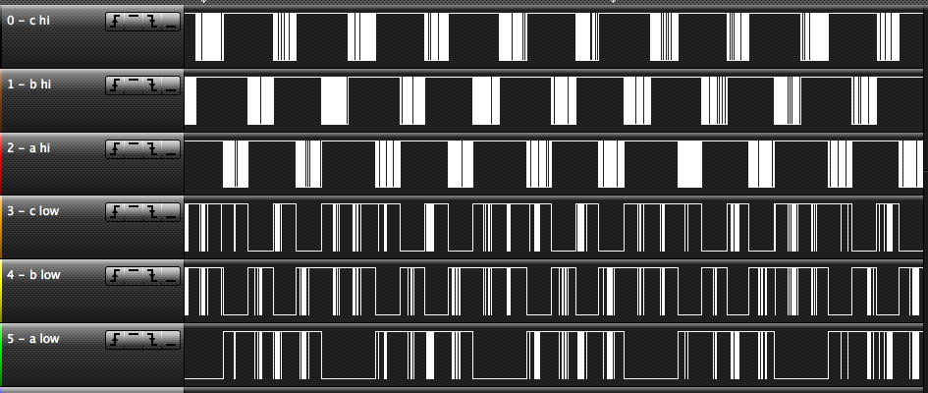
Figure 3.28 – Motor PWM at constant speed

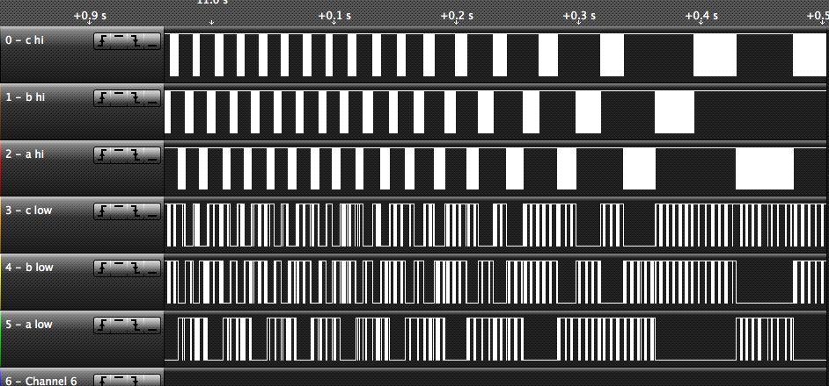
Figure 3.29 – Motor PWM slowing down

Additional Circuits

There were several additional circuits added along with the microcontroller to add features and allow non-prototype functionality. One such circuit is the 5 volt regulator which powered our microcontroller from the 12 volt supply given to the board. The circuit can be seen below in figure 3.30.

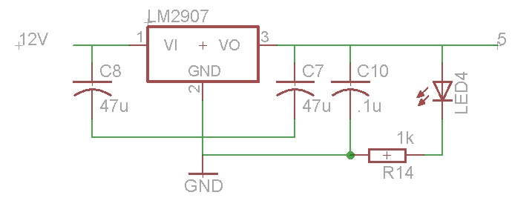
Figure 3.30
Another system we added to the low voltage side was a fan to cool the H-bridge heatsink. In order to control this fan via the microcontroller a fan controller was added. This circuit can be seen below in figure 3.31. This circuit is used in tandem with a temperature sensor on the heatsink so that the fan is only active when a high temperature is detected. The fan can also change speed depending on how hot the heatsink is which allows us to increase energy efficiency.
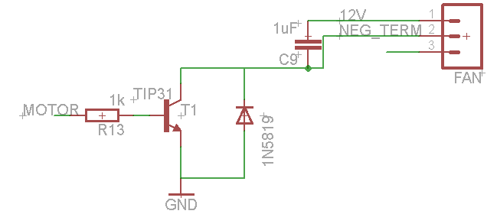
Figure 3.31

Motor
One of the first problems we ran into was finding the correct BLDC motor to test our motor on. The Solar Car team does not have any back up motors to test the motor controller because of the exorbitant cost of a large BLDC motor. The team decided that it was not a good idea to use high powered BLDC motors when testing the algorithm for the first time because of the possibility of burning components of the motor controller. This led us to looking for a small BLDC motors that would accommodate our needs. After some searching, we realized that RC cars use sensored BLDC motors. This took more time than estimated and resulted in a delay of some planned testing. The first BLDC motor that we acquired is the REEDY SONIC 540, figure 3.32. This used motor was bought at a nearby hobby shop and had all the specifications needed to test our design.

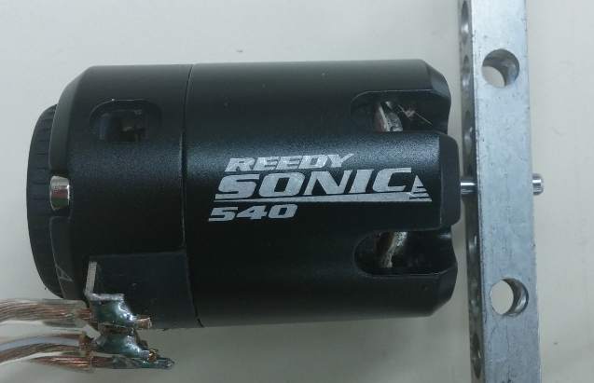
Figure 3.32

Chapter 4 - Test Data

Initial Testing

Before testing our system as a whole our design team tested individual sections of our design to ensure they were working properly before they were assembled together. The four main sections tested were the gate drivers, inverter, microcontrollers, and Hall Effect sensors. Each system was tested separately in order to allow quick trouble shooting as well as giving the team the ability to spread the work among individuals. The testing procedures and results were as follows.

The gate drivers amplify the signal from the microcontroller and pass the signal to the gates of the MOSFETs to switch them. In order to test them a square wave signal from a function generator was applied to the six individual inputs on the gate drive chip. Using an oscilloscope the output signal of each individual output pin was read to ensure that it was following the signal applied on its corresponding input pin. Using this method we ensured that the input signal would be passed to the output with an increased voltage. While testing this part, it was found that one of the fault wires that was active low was not attached to ground so the gate driver would not operate. In the prototyping stage this error was easy to remedy by attaching that pin of the gate driver to the ground rail of our protoboard. After this test was completed the gate drivers were ready to be added to the first prototype.

The inverter is the high voltage section of our motor controller which switches the DC supply voltage to a three phase voltage that powers the motor. To test this component of the motor controller several individual tests had to be done. Most of the tests performed were to test for shorts in our electrical system which would cause failure to our device. The first test performed was the MOSFET turn on test. This test was used to determine what the minimum threshold voltage we could effectively operate our MOSFETs at. Using two separate power supplies, one drain to source and the other gate to source, it was determined that the minimum voltage necessary for turn on in our application was 6 volts. This number was important in later testing where we used a low voltage motor. The other tests that we performed were all continuity tests for short circuits in the separate parts of the inverter. These parts include the PCB, Bolts, Washers, and Heatsink as seen in the diagram below (Figure 4.1). We used predetermined test points on all parts of the inverter along with a Ohm meter to determine if there was a short or open circuit there. These tests helped us determine how to modify our PCB to prevent shorts between the three phases of our motor as well as the DC bus. After this test was completed the inverter section was ready to be added to the final prototype.
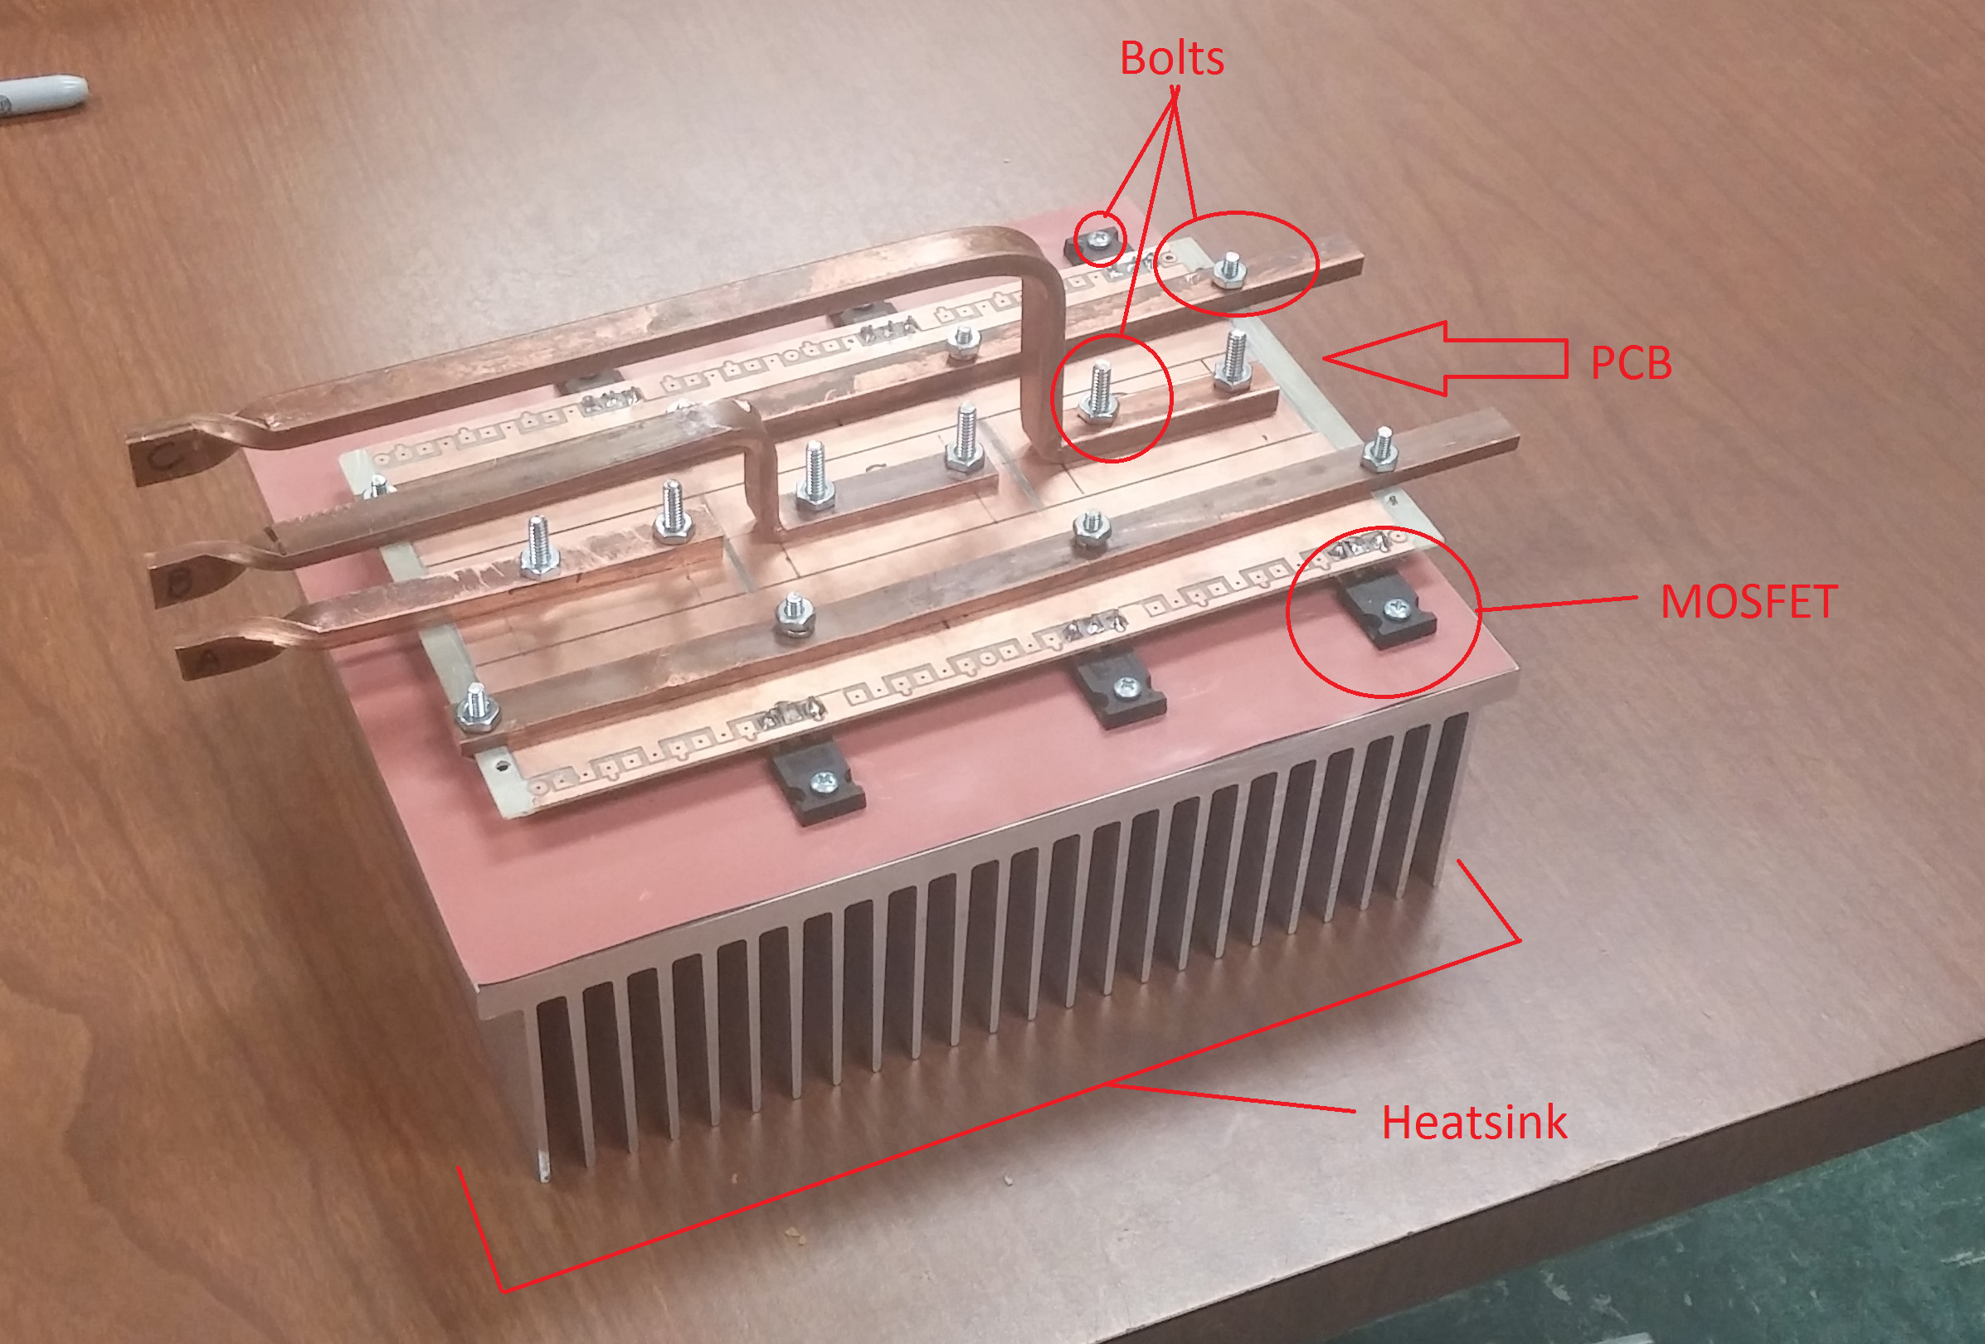
Figure 4.1

The microprocessor is the brains of the motor controller. It receives information from the motor controller sensors and sends a pulse width modulation control signal to the gate drivers which will in turn control the MOSFETs in the inverter. One problem we encountered during the testing of our Arduino microcontroller was the lack of a Hall Effect sensor input to test the control signals. To remedy this issue, a dummy Hall Effect sensor was created using a extra Arduino microcontroller. The simulated Hall Effect sensors were implementing on the Arduino using a simple six step state machine that changed switching frequency based on a user input. The Hall Effect sensor outputs from one Arduino were fed into the other Arduino which simulated the feedback the microcontroller would normally receive from the motor. We recorded the output of these Hall Effect signals to ensure reliability. These can be seen in figure 4.2 below. The waveform shows three square wave signals with each phase shifted 120 degrees from each other. This waveform represents a motor Hall Effect sensor signal correctly.

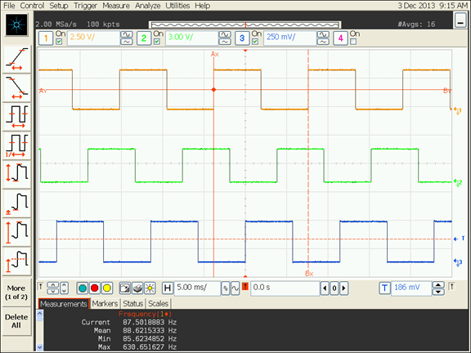
Figure 4.2

After adding the hall effect input the main control algorithm of the motor could be tested. This was done by using the oscilloscope to measure the PWM outputs of the Arduino, figure 4.3. This waveform allowed the team to see which MOSFETS were being turned on and ensure only two MOSFETs, one high side and one low side, were turned on at a time. This test also showed us concrete evidence that the event of the same MOSFET phase, high and low, would never turn on at the same time. Safety is a major concern for us and this test was needed

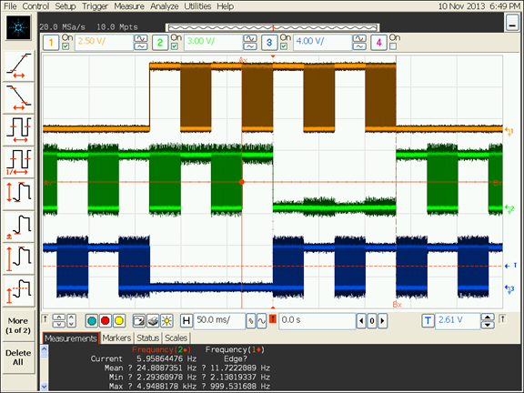
Figure 4.3
This graph also shows when the PWM voltage control is active on each phase, it is represented by the thick regions of each phase. The rate of pulse width modulation was also monitored using the oscilloscope. The team was able to verify that the duty cycle of the signal was changing on the scope as the potentiometer was adjusted.

The Hall Effect sensors are sensors on the motor that provide position information to the microcontroller. Testing these sensors was critical to ensure proper feedback from the motor. We again used the oscilloscope to monitor the Hall Effect signals. The testing setup is pictured in the figure below, figure 4.4.

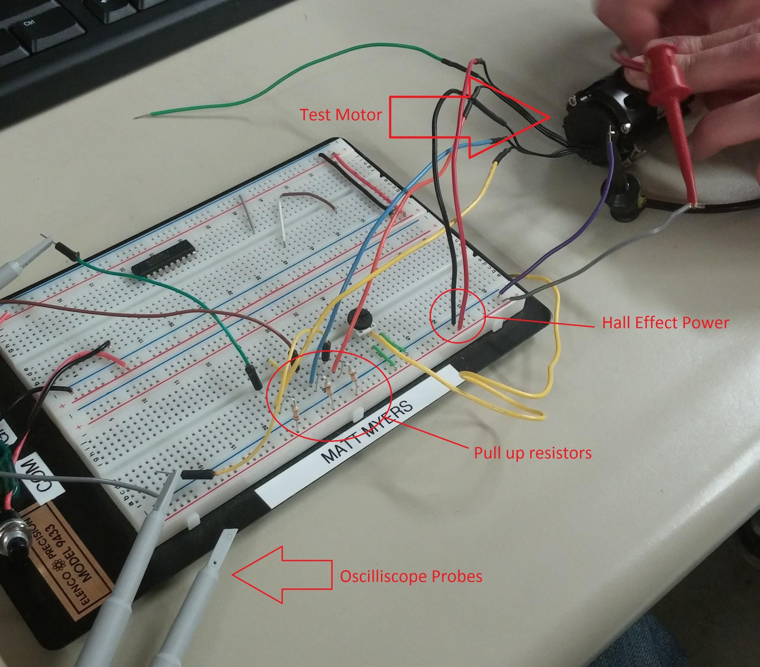
Figure 4.4
When initially analyzing the signals from the Hall Effect sensors the waveforms were not correct. After further testing, it was realized that the resistors needed to operate these Hall Effect sensors were pull-up not pull down resistors. After changing the circuit to a pull-up configuration, correct operation of this section was verified. This test concluded our initial testing phase.

First Prototype Testing

This phase of testing involved combining individual sections and using the lab equipment to verify correct operation. The first test that was performed was the verification of the microcontroller with the motor Hall Effect sensors and the other control inputs. Serial communication was also used to monitor variables in the control algorithm on a PC. The program that was used to view the data was called the Arduino Serial Monitor which is pictured in figure 4.5. This example shows the throttle value changing as the potentiometer is adjusted.

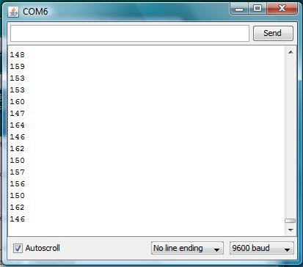
Figure 4.5

Another testing technique was three LEDs used to indicate the activity of the hall effect sensors; when a hall effect was active the corresponding LED would light. This test bed is shown below, figure 4.6.

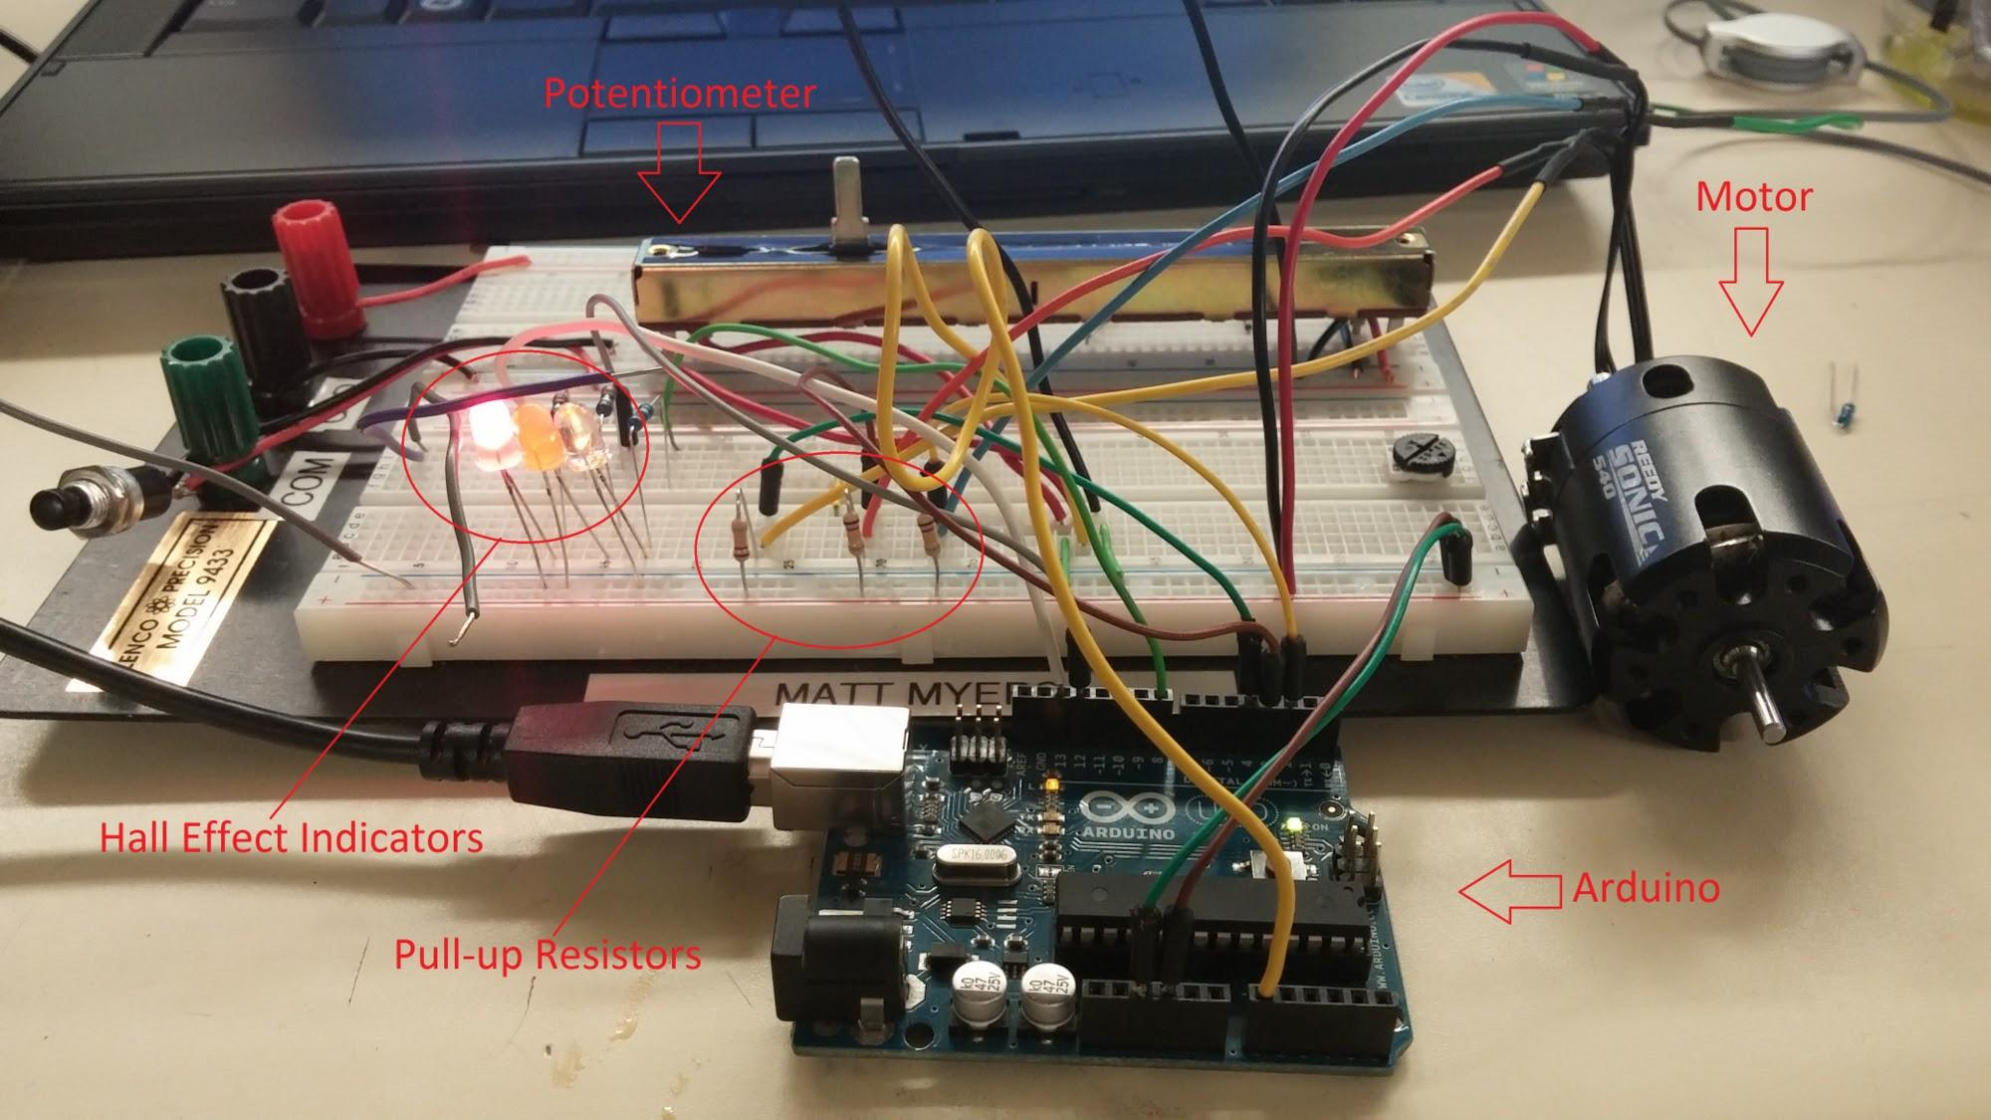
Figure 4.6

The PC connection was also used to view the throttle response as the potentiometer was adjusted. This test was used to verify the positioning of the slide potentiometer related to the correct speeds in the Arduino program. When sliding the slide to the right, from this side angle, it increases the throttle by increasing the duty cycle. The slide potentiometer is different from the other types because it has four leads. This potentiometer acts like a regular type with three leads. The two outer leads are for pin 2 the inner left pin, looking at it from this side, is for pin 1 and the inner right pin is for pin 3.

The next step in prototype testing was connecting all four sections, that were individually proven, and ensuring that the system was operational. This prototype is shown in figure 4.7 below. The system was proven using three individual power supplies as well as the oscilloscope, ohm meter and logic analyzer.

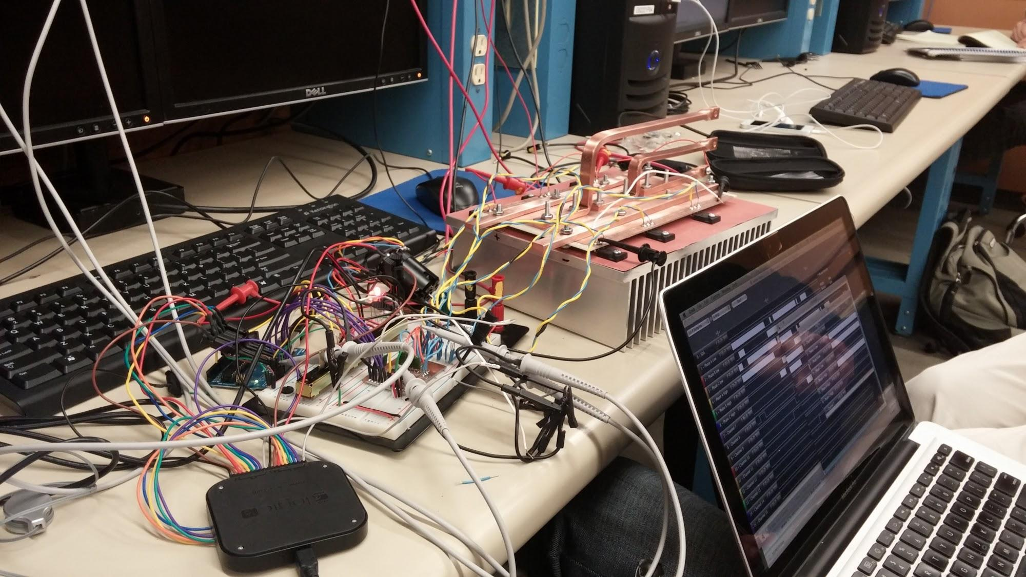
Figure 4.7
The ohm meter was used to determine if MOSFETs were turned on when certain hall states were obtained. To switch the hall states the shaft of the motor was manually turned so that the hall effect sensors would read a different position. The first time this test was attempted only the low side MOSFETs would switch on. The high side MOSFETs had a slight voltage rise on the gate but then the voltage would drop back to its ground state. This phenomenon is depicted in the graph (Figure 4.8).

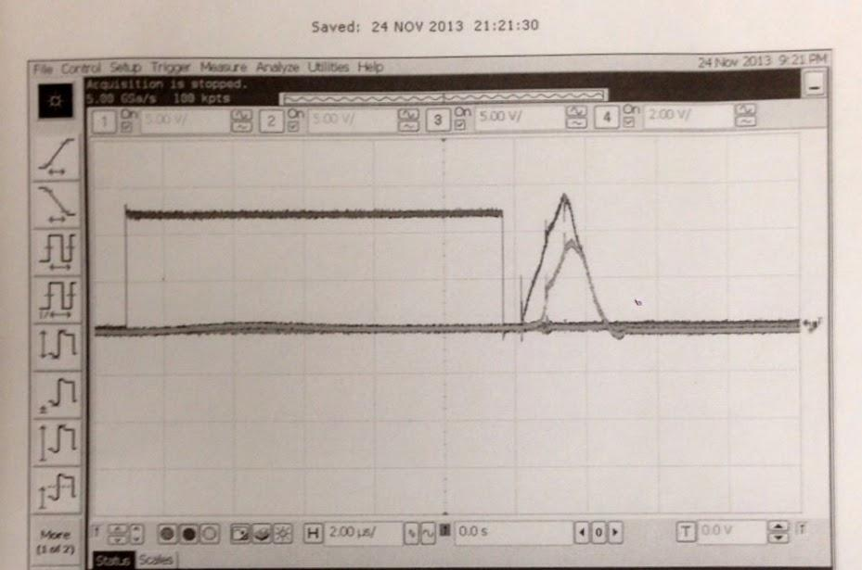
Figure 4.8
This issue was resolved by examining the gate driver data sheet more closely. The information provided showed that additional diodes where necessary to prevent current from flowing back into the supply when the voltage started to rise on each of the three phases. After the diode issue was resolved our prototype was almost functional which we could tell because the motor began to vibrate as the throttle was increased.

The next step in this phase of testing was to analyze the outputs of the microcontroller to ensure that the correct commutation sequence was being executed properly in the code. Some logic analyzer results are shown in the control systems section of chapter 3. After the microcontroller was proven to be working with the gate driver the prototype was closer to fully functional but the motor was still having trouble with no assistance. This issue was resolved by increasing the amount of voltage being supplied to the gate driver. This alteration allowed the gate driver to operate properly and switch the MOSFETs appropriately. At this point our motor spun but had difficulty due to limited supply current. This problem would be resolved in the last stage of prototype testing.

Final Prototype Testing

For the last stage of prototyping all systems were fully connected, a new power supply was used for the high power stage, and the forward and reverse control algorithm. Other systems that were tested in this stage were the newly added fan controller, voltage regulator, shunt resistor, capacitor. Figure 4.9 shows an example of the setup that we used for testing, notice the larger power supply to the right.

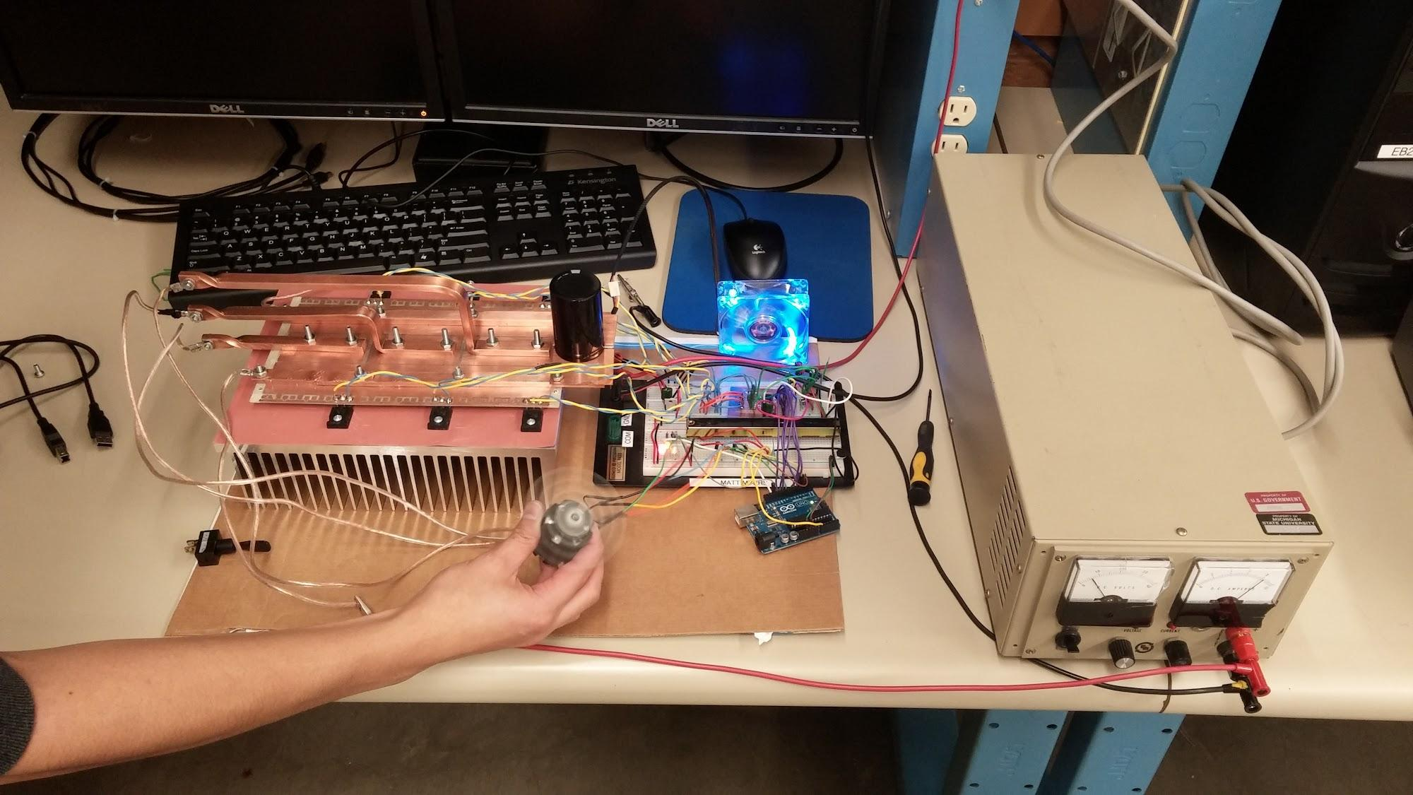
Figure 4.9

The forward and reverse capabilities were fairly easy to test. The team simply watched the motors reaction as the potentiometer was slid back and forth. The voltage regulator that powers the microelectronics was tested using a digital multi meter to verify the voltage being supplied was correct. The fan controller was tested using the micro controller with PWM output this allowed us to see the change in speed of the fan as the duty cycle was varied. The capacitor on the DC bus was verified using a digital multimeter as well. To make sure the shunt resistor was correctly placed to measure current the team measured the resistance with the DMM and recorded it. Then while the system was operating a DMM was again used to measure the voltage drop across the resistor. Then using ohms law the current through the resistor was calculated; using the current reading on the power supply this value was able to be verified. At this point our prototype was fully functional and our testing was concluded.

Chapter 5 - Final Cost

Summary

The project was a success. We constructed a BLDC motor controller that got a small motor to spin. We were able to implement throttle control and forward and reverse. The team was able to work successfully together without any major disputes. One of the biggest successes was the amount of knowledge we learned on this project. After designing a motor controller we now know what design requirements are the most critical. The entire semester was continual learning process. Even at the end of the project we were finding things we could do better.

The cost of our motor controller was under budget as shown by this table at the end of this chapter titled, Final Budget.

Success and failures

Biggest success on this project was getting the small motor spinning. This was a great demonstration that we could implement what we learned on this project and we understand the basics of BLDC motor controllers. This project was more complicated than we expected. Getting the small motor working and having all the systems and gate drivers working was a big accomplishment.

One of the failures was not getting a motor controller to spin the big motor. There are several reasons for this. One of the reason is we would have to make a stand big enough for the entire motor. This would take time away from the projects in other aspects. We also had trouble finding a power supply to handle high voltage. The motor we have is the only motor the solar car team had. We were not going to hook up the motor controller until further testing was done with high power resistors. The failure is not a huge deal. The gains we received in knowledge offset the gains we would have if we spent time building a motor mount and testing.

Suggestions for the future

There are several things we want to do in the future. We are thinking of using a different package of MOSFET’s. SOT-227 MOSFET package has a couple of advantages over the T0-220 package. The SOT-227 has a heat pad on the package that is isolated from the MOSFET. This allows better heat transfer to the heat sink. This would also allow us to eliminate the insulating pad from our design.

This MOSFET package will also have the ability to screw the bus bar to it, figure 5.1. This would make the bus bars have a strong electrical connection. Since you can screw things to the MOSFET, we would be able bolt gate driver board really close to the gates of the MOSFET, figure 5.2. The reduction in inductance on the gate of the MOSFET allows a faster switching speed to be used and therefore saving power.

The gate driver would also change. Six RLC gate drivers would be advantageous to use. These gate drivers store the energy in the gate in a LC circuit. This again reduces energy. Since there would be six gate drivers, four isolated power supplies would be used. The isolated power supply can be formed with a transformer that has 4 output coils. The new gate driver would also be able to output more current and be able to turn on the MOSFET faster.

The third major change we would like to make in the future is to use TI’s C2000 processors. This would give us much more power than the Arduino could do. This would allow us to implement current limiting and PID loop. C2000 DSP’s are dual core and dedicate one processor for the time critical data. The second core is used for non-critical information such as CAN bus etc. This processor is much hard to program and would take longer to implement. A second advantage of this processor is would couple implement sensorless control on the motor. Sensing the voltage on the unused phase can determine the placement of the rotor.

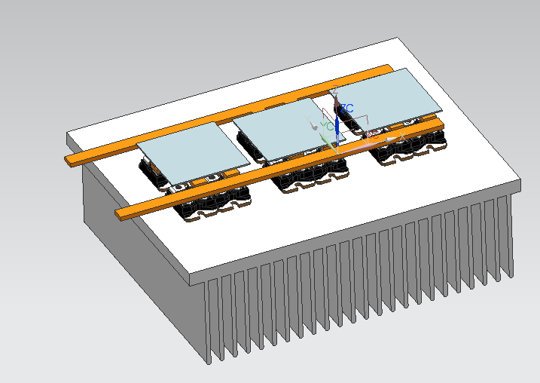
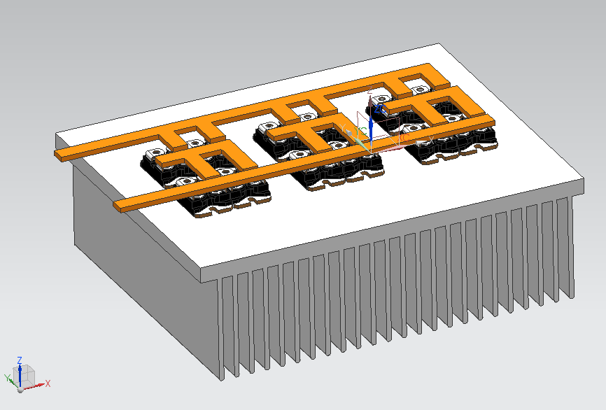
Figure 5.1 Figure 5.2

Final Budget
 | Product | Description | Qty. | Price/per | Total
Low voltage component parts, Including Microcontroller, Gate Drivers, Power supply, and Fan control | Arduino UNO | DSP creates PWM signal from analog input | 1 | $23.95 | $23.95**
 | Arduino Software | Software included with the Arduino UNO | 1 | $0.00 | $0.00
 | USB cable | Connects the Arduino UNO to computer. Included with Arduino UNO | 1 | $0.00 | $0.00
 | Gate Driver IC | Model: 667-EET-UQ2E222LA , 600V with 250ma peak current. 500ns delay | 1 | $ 6.35 | $ 6.35
 | Capacitors | 20 nF bootstrap capacitors | 3 | $0.16 | $0.48**
 |  | 47 uF power supply filtering capacitor | 2 | $ 0.32 | $ 0.64**
 |  | 1 uF Filter capacitor for transients in fan motor | 1 | $ 0.18 | $ 0.18**
 |  | 0.1 uF power supply filtering capacitor | 1 | $ 0.16 | $ 0.16**
 | Resistors | Pull up Resistor of 120K Ohm for Hall effect sensors | 3 | $ 0.12 | $ 0.12**
 |  | Gate Driver current limiting Resistors | 6 | $ 0.10 | $ 0.10**
 |  | 100K Ohm Pull up Resistor for forward and Reverse motor direction | 1 | $ 0.10 | $ 0.10**
 |  | 1K Ohm Resistors for LEDs | 4 | $ 0.10 | $ 0.10**
 | PCB | Low voltage printed circuit board which holds the Arduino Gate Driver power supply and fan control | 1 | $61.00 | $61.00**
 | LED lights | Yellow power 5mm LED | 1 | $ 1.19 | $ 1.19**
 |  | Red 5mm LED for Phase A | 1 | $ 1.21 | $ 1.21**
 |  | Green 5mm LED for Phase B | 1 | $ 1.47 | $ 1.47**
 |  | Orange 5mm LED for Phase C | 1 | $ 0.95 | $ 0.95**
 | Voltage regulator | LM7805 12V to 5V Voltage regulator | 1 | $ 0.69 | $ 0.69**
 | BJT transistor | TIP31A, NPN Transistor Medium Power Linear Switching Applications | 1 | $ 0.63 | $ 0.63**
 | 12V fan | 90mm blue LED computer fan | 1 | $ 12.99 | $12.99**
 | Diodes | 1N5819 | 4 | $ 0.14 | $ 0.56**
 | Wires | Proto wire for Gate | 12 | $0.05/m | $0.60**
 |  | 12 Gauge Phase wire for motor | 6 | $ 1.19/ft | $ 7.14**
 | Potentiometer | Slide pot to set the speed of motor | 1 | $ 2.55 | $ 2.55**
High voltage Power inverter parts | MOSFETs | 650V 84A 0.024 Ohm TO-247 package model number STW88N65M5 | 6 | $ 17.54 | $105.24*
 | Heat Sink | 10.080"x8" Heat sink with 2.5" Fins Extruded Al. | 1 | $ 55.00 | $ 55.00
 | Thermal Pad | Thermally Conductive, Electrically Insulative, 2.5W/C 12"x18" | 1 | $ 20.67 | $ 20.67
 | PCB | High voltage power inverter Printed Circuit Board | 1 | $ 61.00 | $61.00**
 | Copper bars | 0.5” x 0.25” x various lengths ranging from 12” to 24” | 5 | $ 4.00 | $ 20.00
 | Capacitor | Snap In 2200uF 250V 0.098 ESR | 1 | $ 9.65 | $ 9.65
 | Nuts and Bolts | #6 bolt size to attach the MOSFETs to Heat Sink | 6 | $ 0.50 | $ 3.00**
 |  | #8 bolt size to attach the + and - copper bars | 8 | $ 0.50 | $ 4.00**
 |  | #10 bolt size to attach Phase copper bars | 6 | $ 0.50 | $ 3.00**
Motor Component Parts | Motor | Reedy Sonic 540 RC Motor | 1 | $ 40.00 | $ 40.00
 | sensor connector | Connects Hall effect sensor to Arduino UNO | 1 | $10.00 | $ 10.00
 | Motor Load | Custom 3D printed 4” disc | 1 | $ 5.00 | $ 5.00**
* Free sample from manufacturer
** Donated from ECE shop, Machine shop, or Sponsor

Totals
Total without Donations | $338.72 | $459.72
Total with Donations | $145.67 | $161.67

Appendix 1
Technical Role


Jaime Alvarez- The technical role that I played on this project is the mechanical assembly and testing individual parts of the project. After the PCB was made, I made sure that the MOSFETs each had their leads straight up and soldered correctly. I also made sure that the MOSFETs were straight and aligned on the heatsink. I measured where the holes on the heatsink were needed to be, how much of the phase bus bar needed to be on each individual phase and where the screws will be placed, and also how spread apart the bus bars needed to be apart from each other to make sure that they would not contact each other. I attached the capacitor by soldering it onto two small copper plates to be attached to the DC bus bars. It is important that the copper plates were cut to the correct measurements so that the capacitor can be mounted onto them and also not have a chance of having any types of shorts occur.
After all of the connections I tested the entire motor controller for any shorts and made sure they were not electrically conducting with other parts. I used the continuity test to make sure the current is flowing where I want it to. When we put the thermal pad between the MOSFETs and the heatsink it was important to test every MOSFET and parts of the PCB to make sure nothing is electrically conducting with the heatsink but only thermally conducting.
I measured out and tapped holes onto the heatsink to have our second PCB have the ability be screwed onto the side and made sure that the PCB is not electrically conducting with the heatsink either. Using NX design, I made the circular wheel, that got 3D printed, that will be attached to the end of our motor to show, more noticeably, that the motor is spinning.


Scott O’Connor- The technical role I took on this project was designing the gate drivers. My first task was to figure out how gate driver work. I researched the different types of gate driver and how to properly design them. The gate drivers went through three design phases. The first design consists of a bootstrap gate driver that controls all three phases of the power section from one chip. The thought process was to simplify the design as much as possible. This gate driver works and is on our prototype but lacked current needed to turn on MOSFETs at higher speed.
The second design used three bootstrap gate drivers. This second design improved the first design by allowing more current to turn on the MOSFET due to each phase having its own gate driver. Simulation played an important role in figuring out how much current to provide. A basic Matlab script written to figure out how much current was needed.
The third design of the gate driver further improves upon the second design. This design is a different style of gate driver that recovers the energy from the gate when turning off the MOSFET. This design will also have 4 isolated power supplies to allow even greater turn and off speed.
The knowledge gained by the project will be used in the next version of the gate drivers after this semester is over.
The second major role I played was getting PCB made. I designed two PCB boards this semester one for the gate driver prototype and one for the control board that will be shown on design day. The gate driver board was made to test the gate driver in a breadboard. The gate drivers are surface mount components and needed a break out board.
The second board was our entire low voltage portion of the project. This included the gate drivers, atmega328, pin outs for a throttle; forward/reverse button, LED’s to display the current hall effect position. This board was a dual layer board made at the ECE shop.
I also played smaller roles on the team helping out with the three phase construction, debugging hall effect sensor problem, Drawing components in NX 8.0 and helped writing technical reports.


Matt Myers - The technical role that I played on this project was developing the microcontroller systems for our project. The microcontroller section of our project consisted of three main parts the physical microcontroller, the software, and the supporting low voltage systems. This system was crucial for the operation of our motor controller because it is essentially the brains of the motor controller and allows the user to have accurate and consistent control of the motor. I was also involved in discussions about how to create other parts of the controller including writing a script for the heatsink calculations.
For the microcontrollers, it was my job to decide which controller would be ideal for our needs. This was basically a selection between a Freescale chip, the TI C2000, and the Arduino. In order to decide what controller to go forward with I researched each chip individually and made a list of all features available. After comparing the features available to the features that the team needed. As seen from earlier in the report the Arduino was selected. The software that I developed was coded for Arduino and consisted of a basic speed control loop. The software portion that I took on also involved downloading and installing all software needed for programming and testing. The downloads included motorware, design suite, code composer, Arduino, and the driver necessary to J-TAG an XDS2000 type Texas Instruments chip. I also designed the supporting systems for the microcontroller including the hall effect interface, fan controller, and 5V power supply for the microelectronics section. All of these systems are discussed in chapter 3.
The smaller technical role I played on the team was support on other projects. I created the heatsink script for calculating power losses and desired thermal constant for the heatsink. I also was involved in measuring and cutting parts for the H-bridge. The final way I contributed was in technical documentation including the proposal, design issues paper, technical presentation, and the final report.


Chris Sommer – My technical role in this project was to design and manufacture the high voltage power inverter. My tasks included selecting the proper MOSFETs, designing the PCB layout, selecting the proper heat sink, and bending and attaching the copper bus bars to the PCB. Other tasks that were part of the high voltage side of this project was finding a small scale motor and a small scale power supply that would work with the small scale motor.
When selecting the MOSFETs, I researched online using mouser.com to see what options for MOSFETs where available. In the research I spent a lot of time looking over data sheets and comparing the different characteristics of the MOSFETs to make the best selection. For selecting the heat sink I went online to heatsinkusa.com because they can make a heat sink in almost any size and I chose the one best suited for our size requirements. I learned how to use Eagle to design the PCB layout and had the ECE shop make it. In Eagle I custom made the layout by placing individual pads and traces to fit the MOSFETs, copper bars, and on the heat sink. The ECE shop mills the PCB so there was a lot of unwanted copper left on the board so I used a chisel to remove the unwanted copper. I used the machine shop downstairs to cut and bend the copper bus bars along with drilling and tapping the mounding screw holes on the heat sink for the MOSFETs.
I found the small scale motor by luck; I went to a hobby shop that sold RC car parts. Talking with one of the employees there I learned that racing RC car motors are sensored brushless motor and would work for our project. The small scale power supply had to be larger than those supplied in the ECE 480 lab so I went to the ECE shop and found the small scale power supply.

Appendix 2
References of all data

A. Back EMF
http://physics.bu.edu/~duffy/sc545_notes04/back_emf.html
B. MOSFET
http://www.physics.csbsju.edu/trace/nMOSFET.CC.html
http://www.ti.com/lit/an/slaa503/slaa503.pdf
http://www.st.com/web/en/resource/technical/document/datasheet/DM00042858.pdf
C. Gate Driver
http://www.digikey.com/product-detail/en/IRS2332SPBF/IRS2332SPBF-ND/2354168
D. Capacitors
http://www.mouser.com/ProductDetail/Panasonic/ECE-T2EP222FA/?qs=sGAEpiMZZMtZ1n0r9vR22QqzopUJ6WFXzYYyGln8hJw%3d
E. Heat Sink
Heatsink Purchase Site
http://www.heatsinkusa.com/10-080-wide-extruded-aluminum-heatsink/
Heatsink Power Specifications Information
http://www.mcmanis.com/chuck/robotics/projects/esc2/FET-power.html
Heatsink that was considered for the project
http://www.broadcastconcepts.com/coax-heatsinks-power-supplies-resistors-fans-/Pallet-Amplifier-Heat-Sinks/9%22%20Bonded%20Heat%20Sink
F. Thermal Pad
http://www.mouser.com/ProductDetail/Laird-Technologies-Thermal-Solutions/A15397-03/?qs=sGAEpiMZZMsiS1%252bJOF5PnyF85lkWV4zTb3IHq90WKBI%3d
G. All other data sheets
Motor Controllers found today
-Kelly Motor
http://kellycontroller.com/khb1215124-120v150aopto-bldc-controllerwith-regen-p-50.html
-Tritium Motor
http://tritium.com.au/products/wavesculptor22-motor-inverter/

Appendix 3

Heatsink Matlab Script

% Spartan Motor Controllers
% Resistances Losses and efficiency calculator
% By : Matt Myers
% 10/11/2013
% Information from http://www.mcmanis.com/chuck/robotics/projects/esc2/FET-power.html

% Background Information
%--------------------------
% TO-220AB current limit is 75 Amps
% Rtheta_case gives the ratio between the junction and case temperatures
% P = I^2*Rdon gives the power that the FET is dissipating
% Max Junction temperature - Room temperature = Rtheta_case*watts where watts
% are the power dissipated

% Current MOSFET is ST microelectronics STW88N65M5

% when Tc is 25 °C continuous Id is 84 amps. Tc = continuous Temperature
clear all
Tc_84 = 25;
Tc_50 = 100; % when Tc is 25 °C continuous Id is 84 amps.
Max_ID = 25; % Given in deg C. This is found on the data sheet Id @ 25 c
Max_junction_temp = 150; % found in data sheet and given in °C
R_ds_on = .029; %drain-source on resistance in ohms
Rtheta_jc = .28; % °C/W junction-case thermal resistance
Rtheta_ja = 50; % °C/W junction-ambient thermal resistance
Rtheta_cs = 1; % from the data sheet of the thermal bonding pad
Irms_25 = 84; % Drain to source current at 35
P_loss = Irms_25^2 * R_ds_on; % power dissipation at max current

power_25 = (Max_junction_temp - Tc_84)/Rtheta_jc; % power dissipated @ 25 °C this should match the number on the data sheet
R_ds_on_150 = power_25/Irms_25^2; % gives us Rd_on @ an assumed 150 °C

% Now we can verify the number on the datasheet by calculating Rdon at 25 °C
R_ds_on_25 = R_ds_on_150/2.25; % by looking at the graph on the data sheet the divisor can be estimated

% So far we have just calculated numbers on the data sheet. Now lets
% calculate current carrying capabilities in free air

Temp_diff = 150-40; % in °C gives the difference between room temp and melting temp
P_freeair = Temp_diff / Rtheta_ja; % Absolute max amount of power in watts the FET can disapate in free air
MaxCurrent_free = sqrt(P_freeair / R_ds_on_150); % absolute max current in Amps for free air.
Rtheta_total = Rtheta_jc + Rtheta_cs; % total resistance in series from junction to heat sink

%Now we can calculate the necessary heatsink for our design
% we will take the number of MOSFETS and divide the max current between the
% total number
Max_current_desired = 125; % this value can be changed to reflect our design.
FET_number = 4; % This is the total number of MOSFETS
P_disapated = (Max_current_desired/FET_number)^2*R_ds_on_150;

% The heatsink must be able to dissipate the ambient and total temperature
% difference divided by the total power.

heatsink = (Temp_diff / P_disapated) - Rtheta_total % minimum heatsink rating in °C/W

Resistance_vector = R_ds_on_25:.0005:R_ds_on_150; % Resistance from 25 C to 150 C
temp_vector = (25:1.761:150);

Motor_MaxPower = 7800; % This is the max power of the motor in Watts
Power_vector = 0:Motor_MaxPower; % Total range of power the motor can handle.
Current_vector = Power_vector ./ 100;
Power_disapated_vector = Current_vector.^2*R_ds_on_150;

for i = 1:(Motor_MaxPower+1)
efficiency_vector(i) = abs((Power_vector(i)-Power_disapated_vector(i))/Power_vector(i));
end

for i = 1:71
Power_resistance_vector(i) = 15^2*Resistance_vector(i);
end
figure(1)
plot(Power_vector, efficiency_vector)
xlabel('Power of Motor Controller (W)')
ylabel('Efficiency of MOSFETS (W)')
title('Efficiency of the MOSFETS vs Motor Controller Power')
figure(2)
plot(Power_vector,Power_disapated_vector)
xlabel('Power of Motor Controller (W)')
ylabel('Power Disapated in MOSFETS')
title('Power Disapated in MOSFETS vs Motor Controller Power')
figure(3)
plot(temp_vector,Power_resistance_vector)

Commutation Code Example

switch (HallVal)
{
case 3:
//PORTD = B011xxx00; // Desired Output for pins 0-7 xxx refers to the Hall inputs, which should not be changed
PORTD &= B00011111;
PORTD |= B01100000; //

analogWrite(9,mSpeed); // PWM on Phase A (High side transistor)
analogWrite(10,0); // Phase B off (duty = 0)
analogWrite(11,255); // Phase C on - duty = 100% (Low side transistor)
break;
case 1:
//PORTD = B001xxx00; // Desired Output for pins 0-7
PORTD &= B00011111; //
PORTD |= B00100000; //

analogWrite(9,mSpeed); // PWM on Phase A (High side transistor)
analogWrite(10,255); //Phase B on (Low side transistor)
analogWrite(11,0); //Phase B off (duty = 0)
break;
case 5:
//PORTD = B101xxx00; // Desired Output for pins 0-7
PORTD &= B00011111; //
PORTD |= B10100000;

analogWrite(9,0);
analogWrite(10,255);
analogWrite(11,mSpeed);
break;
case 4:
//PORTD = B100xxx00; // Desired Output for pins 0-7
PORTD &= B00011111;
PORTD |= B10000000; //

analogWrite(9,255);
analogWrite(10,0);
analogWrite(11,mSpeed);
break;
case 6:
//PORTD = B110xxx00; // Desired Output for pins 0-7
PORTD &= B00011111;
PORTD = B11000000; //

analogWrite(9,255);
analogWrite(10,mSpeed);
analogWrite(11,0);
break;
case 2:
//PORTD = B010xxx00; // Desired Output for pins 0-7
PORTD &= B00011111;
PORTD |= B01000000; //

analogWrite(9,0);
analogWrite(10,mSpeed);
analogWrite(11,255);
break;
}
}

NX design
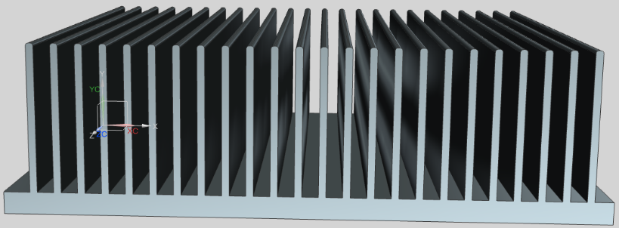
Heatsink
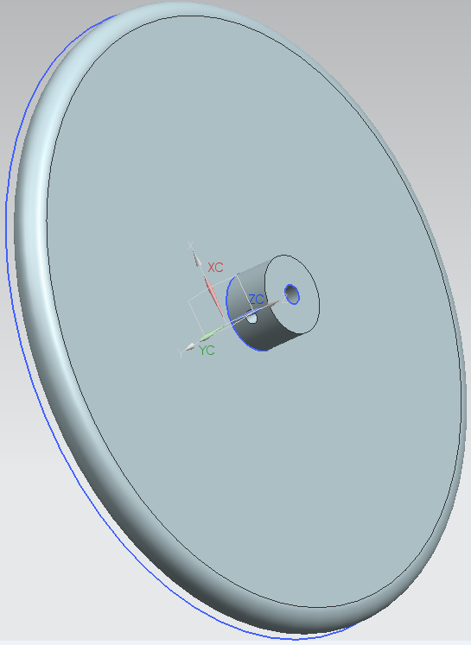
Wheel Attached to Motor
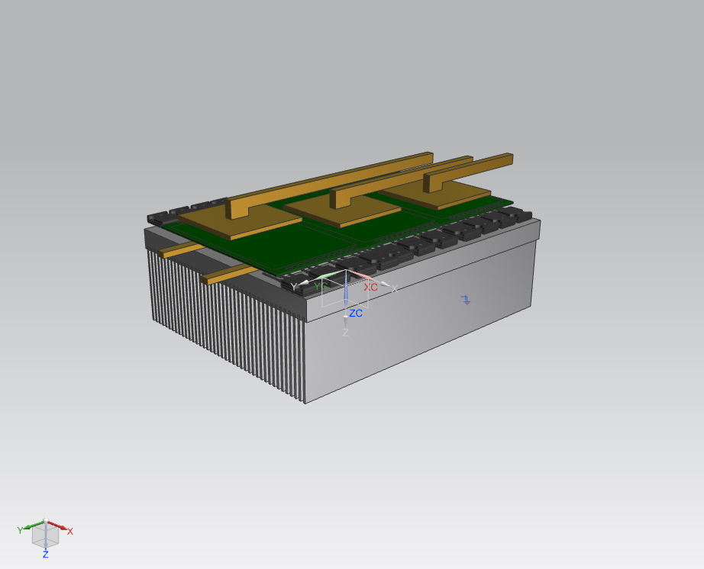
First Prototype

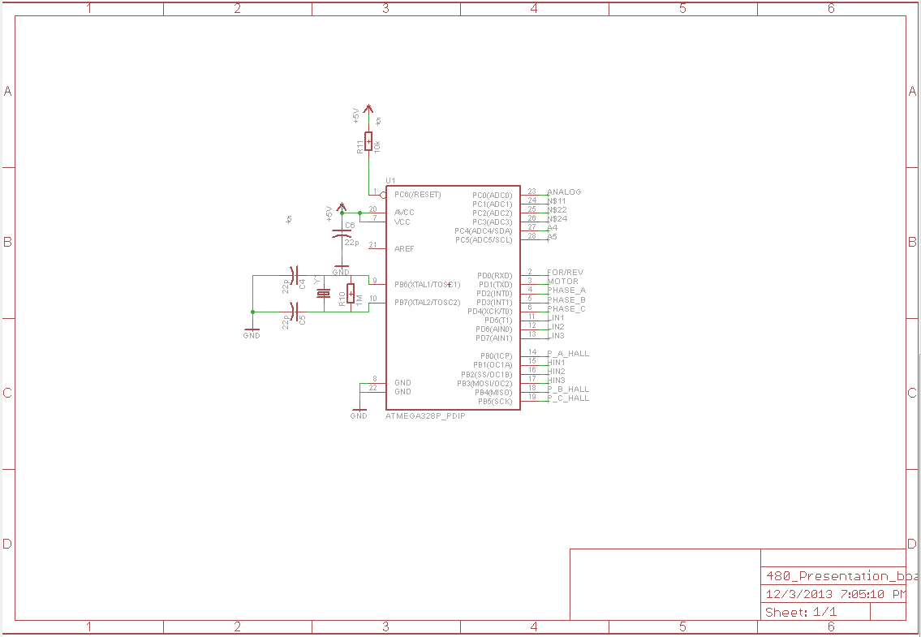
Arduino
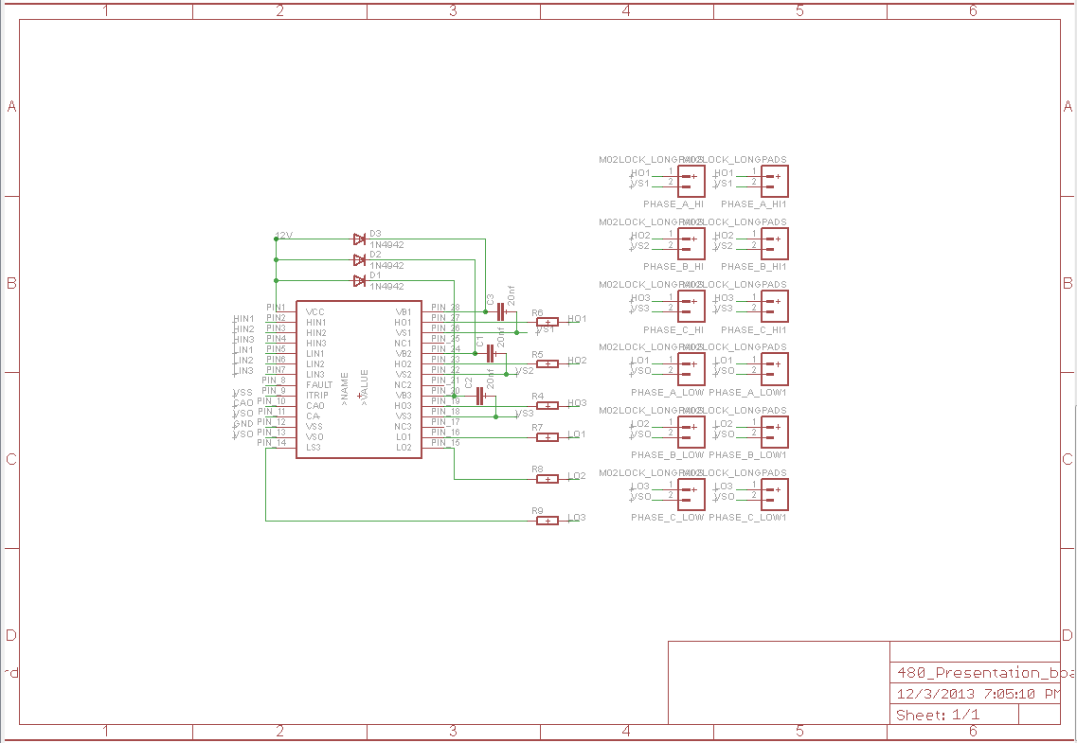
Gate Driver
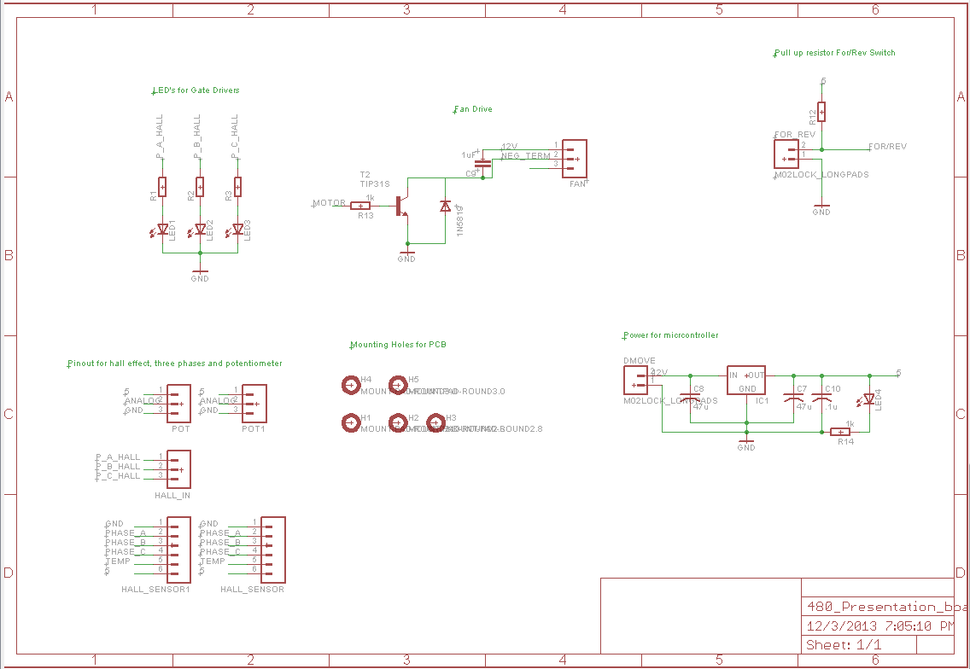
Power Circuits
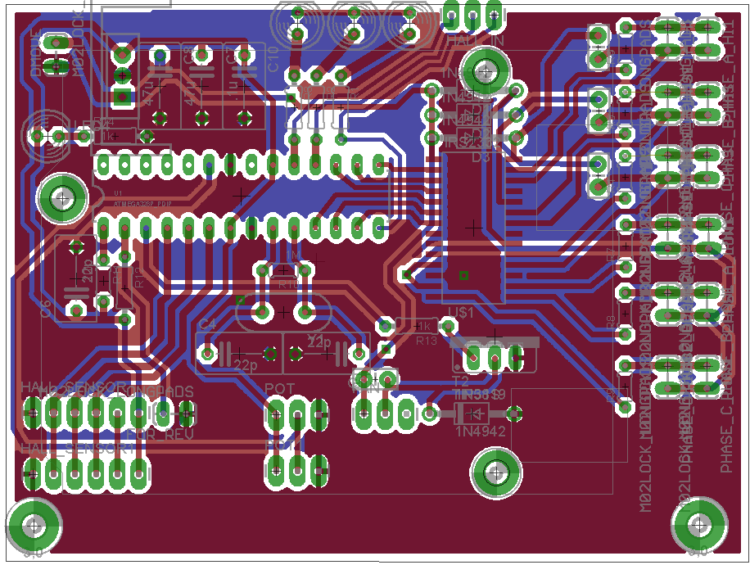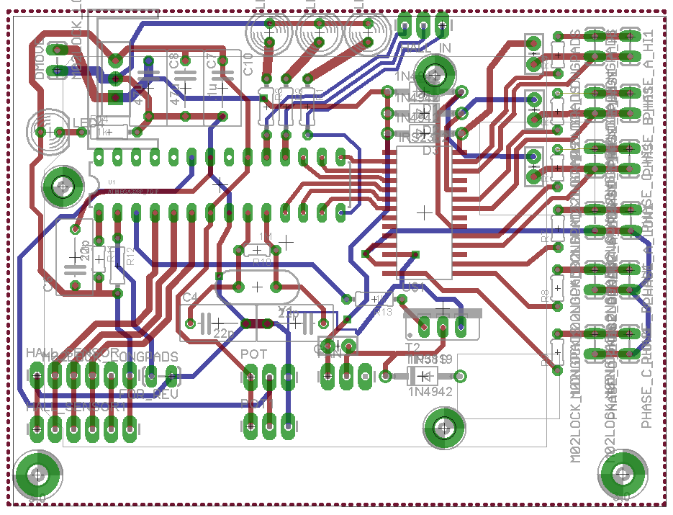
Control Circuitry Top Side
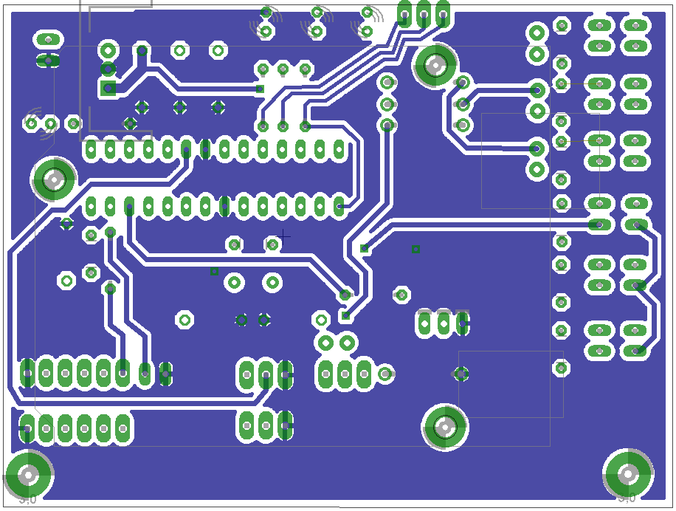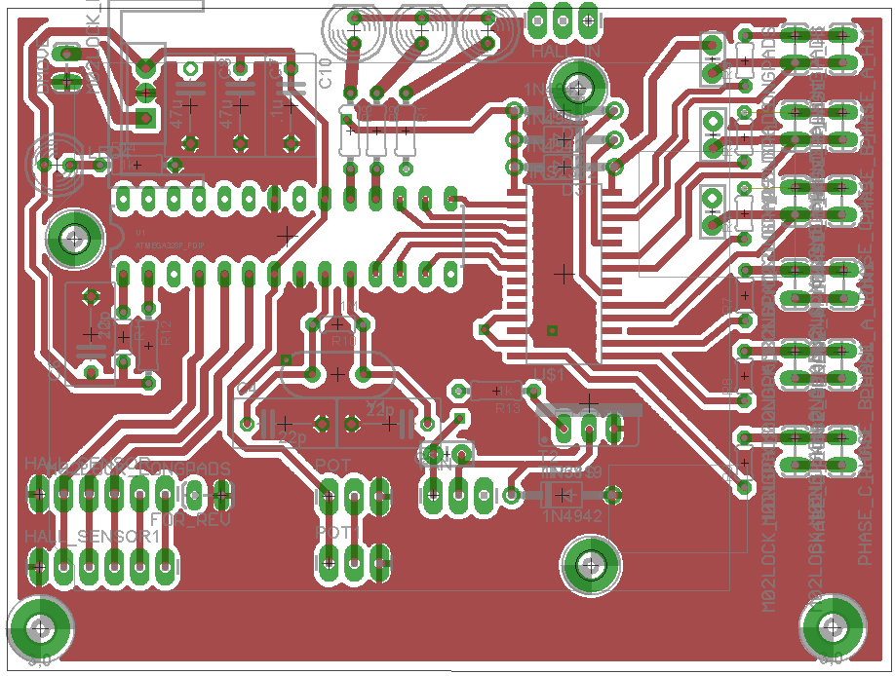
Control Circuitry Bottom Side

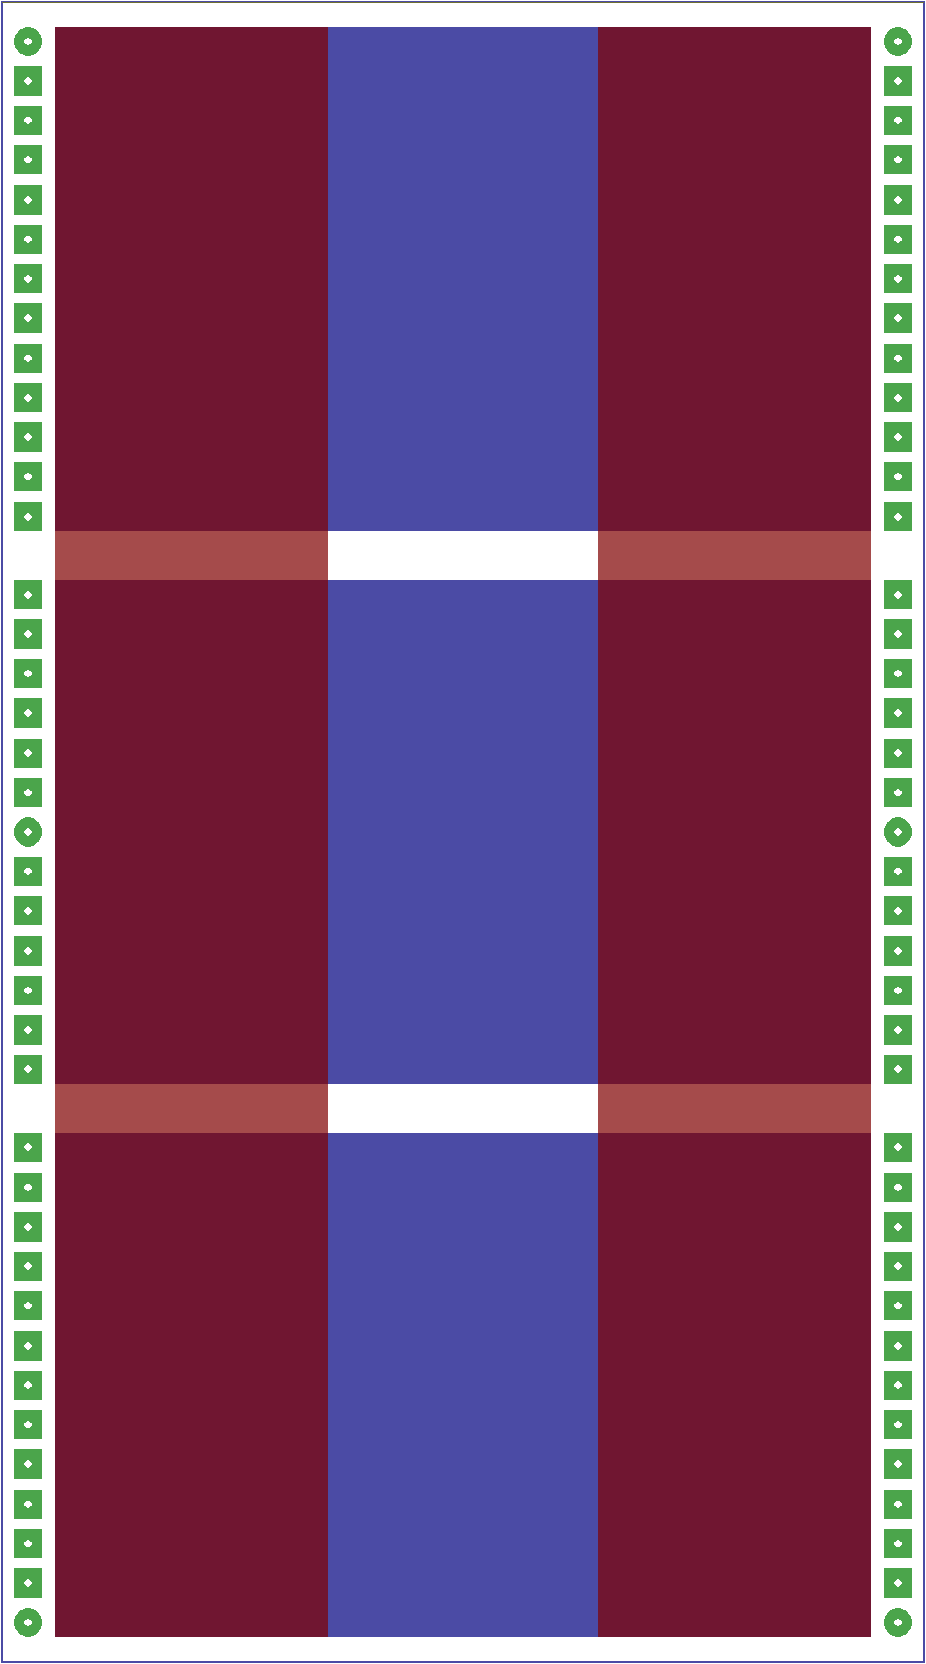
PCB for Three Phase Inverter

