Hall Effect Sensors

Jaime Alvarez
11/8/13

Abstract
There are many applications in which a Hall Effect Sensor can be used and in this case it is used for monitoring the rotation of the motor. It senses how fast the motor is going and is able to be updated in real time depending on the commands given.
Keywords
Pulse Width Modulation, Brushless DC electrical Motor,
Table of Contents
Abstract 1
Introduction 3
Why to use Hall Effect Sensors 3
Hall Effect Sensor Layout 4
Mechanical Setup of Hall Effect Sensor 5
Hall Effect Sensors PWM 7
Conclusion 8
References 9

Introduction
How Hall Effect Sensors are operated is based off what happened in the year 1879. An American scientist, Edwin H. Hall, discovered a new electrical phenomenon. By applying an electric current to a piece of metal and inserting it between two magnets, it created another voltage in the metal. This information made it possible to create a switching device to produce an on-off square-wave digital voltage signal. After the semiconducting materials got introduced in the 1950s, Hall Effect Sensors found its first applications. Hall Effect Sensors are very simple, have low cost, and high-speed operation make them irreplaceable in the semiconductor industry.
Why to use Hall Effect Sensors
As stated above, here are a few more reasons as to why Hall Effect Sensors are used in multiple places. They are capable of high-speed operations for fast data exchanges. There are no moving parts making it an ideal component since it has a more robust design than components that have moving parts. The sensors also have a good operating temperature range ranging from -40 to +150 °C. Lastly, they have a long life expectancy, which makes them a durable choice since they do not need to be replaced.

Hall Effect Sensor Layout
Figure 1 is showing how a Hall Effect Sensor looks like and the three different pins. The first pin is how the Hall Effect Sensor gets its power and is 5V in this case. The middle pin is for ground and the last pin is for the output, which goes either high or low depending on the motors rotation.
This figure 2 is block diagram of how a Hall Effect Sensor works. There are various ways for the Hall Effect Sensor to receive its power. In this diagram there is a voltage regulator that regulates the unstable input voltage to around 5VDC, for this specific kind of sensor. The usual sensors range from 3.8VDC to 28VDC input voltage. There is a magnet that will either make the voltage go to max or minimum depending on the orientation of the magnet whether it is the north or south side. When there is no magnetic field present the output will be zero. The LM124 is a good amplifier to use that will correctly amplify the output signal of the Hall Effect Sensor. Without this amplifier the output will have too much electrical noise and cover the useful information. Figure 3 is a perfect example of how the electrical noise can hinder the ability for the Hall Effect Sensor to function to its intended potential.
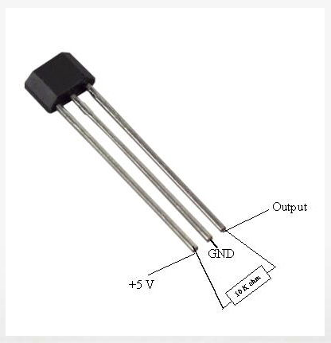
Figure 1

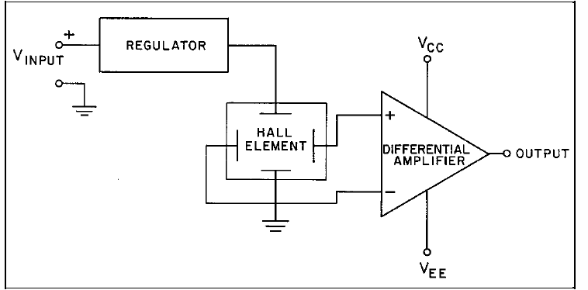
Figure 2
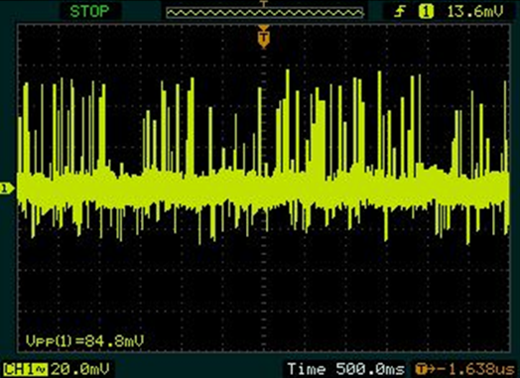
Figure 3
Mechanical Setup of Hall Effect Sensor
Most large brushless DC electrical motors (BLDC) are often manufactured with Hall Effect Sensors inside the motor. For example, a HD motor would not have Hall Effect Sensors so installing these sensors would be required. There will need to be three sensors that are mounted to the exterior of the motor that will be used for position detection as the motor rotates. There needs to be a magnet ring that will be inverted and mounted on top of where the motor will be controlled. These three sensors will be mounted like the picture in figure 4 where they will be just above the magnet ring exactly 30 degrees apart from each other causing there to be a 120 degree in the motor rotation.
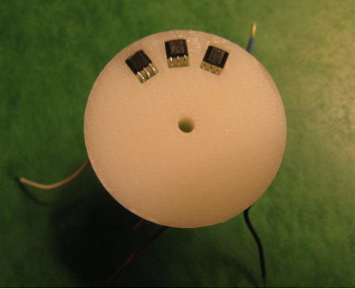
Figure 4
Hall Effect Sensors PWM
The Hall Effect Sensor has an “on” setting where it will be at a steady voltage output, say 5V. At 5V the duty cycle is at 100% making it the top of the square wave. The opposite of this is also true, at 0V the duty cycle is at 0% making it the bottom of the square wave. The constant voltage signal can change abruptly from maximum voltage to minimum, nearly zero, voltage regardless of the engine speed. The square wave that is produced as the output signal can be easily used by the microcontroller for timing purposes. Figure 5 shows the characteristics of the signal. It looks exactly like the PWM wave making it a good component to use for that application.
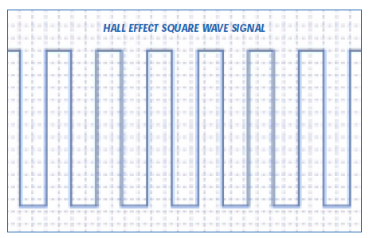
Figure 5
When the motor is spinning there are Hall Effect Sensors that turn on depending on the orientation of the motor. The table below, table 1, shows the Hall Effect Sensors that are labeled as H1, H2, H3 and are the three different phases, Phase A, Phase B, and Phase C respectively. This shows what Hall Effect Sensor is triggered on and if it either the upper or lower phase. The phases turn on in the order shown while the motor rotates.

H1 | H2 | H3 | Phase A | Phase B | Phase C
1 | 0 | 1 |  | Lower | Upper
1 | 0 | 0 | Upper | Lower
1 | 1 | 0 | Upper |  | Lower
0 | 1 | 0 |  | Upper | Lower
0 | 1 | 1 | Lower | Upper
0 | 0 | 1 | Lower |  | Upper
Table 1
Conclusion
There are many places to get Hall Effect Sensors. Most are already embedded into the motor if it is a brushless DC motor. There are some Hall Effect Sensors that can be bought like the AD22151. This is a Sensor that is offered by the Analog Devices Company and it is one of the newest types of Hall Effect Sensor. The sensor is around $2.45 which is an affordable price but there is also a different Hall Effect Sensor that is sold from Sparkfun, the COM-09312 which is $0.95 and will do the same thing.
References
[1] http://www.instructables.com/id/BLDC-Motor-Control-with-Arduino-salvaged-HD-motor/?ALLSTEPS
[2] https://www.sparkfun.com/products/9312
[3] http://www.analog.com/en/other-products/hall-effect-sensors/products/index.html
[4] http://www.wellsve.com/sft503/Counterpoint3_1.pdf
[5] http://sensing.honeywell.com/index.php?ci_id=47847
[6] http://www.nist.gov/pml/div683/hall.cfm
[7] http://www.instructables.com/id/Monitoring-residential-water-usage-by-reading-muni/step2/

