
Michigan State University
ECE 480
Design Team 3
October 22, 2010

FPGA Implementation of Driver Assistance Camera Algorithms
Final Proposal

Manager | Jeff Olsen
Webmaster | Fatoumata Dembele
Document Preparation | Pascha Grant
Lab Coordinator | Chad Eckles
Presentation Preparation | Emmett Kuhn
Rover | Tom Ganley
Facilitator | Professor Mukkamala
Sponsor | Xilinx

Executive Summary
Passenger safety is the primary concern and focus of Automobile Manufacturers today. In addition to the passive safety equipment, including seatbelts and primary airbags, technology based active safety mechanisms are being incorporated more than ever and may be soon required by law. Current trends are requiring automobile manufacturers to include a multitude of technology based safety equipment including ultrasonic sensors and back-up cameras. Historically, back-up cameras in vehicles give the driver an unaltered view from behind the vehicle; however, with the sponsorship of Xilinx, Michigan State University’s ECE 480 Team 3 will design and implement an algorithm that will visually alert the driver of objects seen in the back-up camera. This platform will draw the driver’s attention to objects both stationary and in-motion behind the vehicle by marking them with targets. In doing so, the driver will be less likely to overlook objects that may create a safety hazard. The team will combine edge detection, object detection, and image clarity algorithms to create a system that will both accurately and efficiently detect and visually alert the driver of objects behind the vehicle. Implementation of the algorithm will utilize Xilinx’s Spartan-3A Field Programmable Gate Array (FPGA) development board and will be presented on design day at MSU’s union on December 10, 2010.

Table of Contents
Executive Summary 1
Table of Contents 2
Introduction 3
Background 4
FAST Diagram 6
Conceptual Design Descriptions 8
Ranking of Conceptual Designs 11
Risk Analysis 13
Project Management Plan 14
Budget 15

Introduction
Safety has become the driving factor for today’s automobile industry. It has evolved from basic airbags to revolutionary motion sensors, cameras, and various computer-aided driving technologies. Vehicle safety can be split into two categories: passive and active. Passive safety includes primary airbags, seatbelts, and the physical structure of the vehicle while active safety typically refers to preventative accident technology assistance as demonstrated in Figure 1. According to the Insurance Institute for Highway Safety, in 2009, at least 18 automotive brands offered one or more of the five main active crash prevention technologies including lane departure warning and forward collision warning. With new technologies on the rise, it is no surprise that the automobile industry’s customers are demanding innovation from their vehicles.
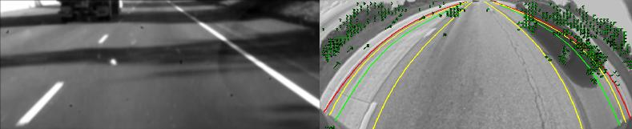
Figure 1: Active Safety includes Lane Departure Warning (left) and Blind Spot Detection (Right)
In addition, it is rumored that in 2014 the government will mandate all new vehicles to possess back-up cameras. Original Equipment Manufacturers (OEM) are striving to meet this requirement and some even to surpass the regulation. Xilinx, a leader in programmable logic products, has already helped some vehicle manufacturers implement active safety features, such as the lane departure warning system, and knows the back-up camera is the next feature which could be improved. Solely providing a live feed from a camera while the vehicle is in reverse is a good start, but it does not reflect the innovative expertise customary of Xilinx. Xilinx, along with the help of Michigan State University’s ECE 480 Team 3, propose to create an algorithm to visually alert the driver of objects seen within the back-up camera using Xilinx’s Xtreme Spartan-3A development board. This feature prevents the driver from overlooking important objects within the camera’s view while the vehicle is in reverse. Xilinx has provided the team with the Xtreme Spartan-3A development board, camera, and the company’s System Generator tools to develop a prototype. The team will bring various algorithms into the design along with other image correction techniques to provide a high quality and accurate system.
Background
Back-up cameras are becoming an increasingly popular feature on vehicles and in the next four years will transition from only a high-end feature into a standard one. Sanyo was the first company to implement the back-up camera into a vehicle’s electronic design and has long used FPGA’s to digitally correct the feeds due to their rapid processing power. Gentex, an automotive supplier, then built onto Sanyo’s success and began implementing their own back-up camera. What stood out about Gentex’s design was their selection of display location to be within the rear view mirror. By placing the back-up camera’s display in a location that the driver should be looking at while backing up before the addition of the camera reinforces good driver safety habits. In April 2010, Fujitsu Ten created a 360 degree overhead camera system by merging the images of four cameras mounted on each side of the car. This innovation will expand vehicle camera technology but is a system still in need of technical development.
Xilinx designs and develops programmable logic products, including FPGAs and CPLDs, for industrial, consumer, data processing, communication, and automotive markets. Being a leader in logic products, Xilinx’s product line includes: EasyPath, Virtex, Spartan, and Xilinx 7 series among various others for a wide array of applications. The FPGA is a cost effective design platform which allows the user to create and implement algorithms and one of Xilinx’s most popular products. Xilinx first introduced their Spartan-3 development board in 2008 for driver assistance applications. They estimate that between 2010 and 2014 that 1-2.5 billion dollars will be invested in camera based driver assistance systems by the automotive market. What makes their system stand out is its FPGA implementation which provides scalable and parallel processing solutions to the large amount of data that has long been a problem of image processing.
Previously, vehicles used ultrasonic components to determine distances to objects but consumers are unhappy with the aesthetics of the sensor located in a vehicle’s bumper and are requesting camera-only detection as shown in Figure 2. Currently, there are no object detection algorithms being used by OEMs within vehicle back-up cameras. The first step in implementing object detection is to begin with edge detection. Once the significant edges in an image are located, further algorithms can help group various edges to determine which belong to a single object. Various design platforms such as Matlab, Simulink, and OpenCV will aid in the creation of an approach in solving this problem.
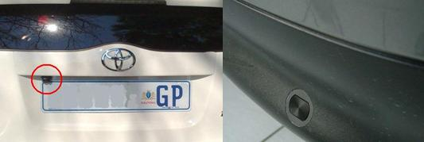
Figure 2: Rear-View Camera (Left) and Ultrasonic Sensor on rear bumper (Right)
There are many algorithms available for development of object detection in the back-up camera. There has been extensive research and many projects completed regarding the issue of edge-detection, which will inevitably be used in the back-up camera project. Edge detection is completed using one of several available functions that involve filtering an image, applying noise reduction to the image to remove portions that may have resembled edges but are not, and finally, revealing the edges in an output image. These functions are very fast and can be implemented in real-time video. Edge detection, however, is only one step in the process of object detection. Further explanation of the process is mentioned later in the conceptual design section.
Xilinx along with the help of Michigan State University’s ECE 480 Team 3, propose to create an algorithm to visually alert the driver of objects seen within the back-up camera using Xilinx’s Xtreme Spartan-3A development board. This algorithm will detect both stationary and in-motion objects in the camera’s view and place a target on the object to alert the driver of its location. This process will be implemented through the use of Matlab and other various platforms for development and then loaded onto the FPGA for application use. It is imperative that the algorithm be cost effective and reliable in order to be mass produced for the automobile industry.
FAST Diagram

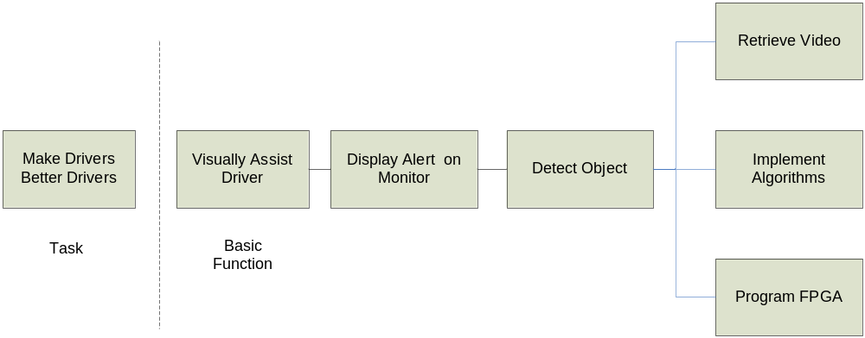
Figure 3: FAST Diagram
Design Specifications
The objective of the project is to develop an algorithm which would visually alert the driver of objects within the back-up camera using Xilinx’s Xtreme Spartan-3A DSP development board. In order to meet the objective effectively, the following specifications must be met in the prototype:
- Functionality
  - Detect objects behind vehicle within back-up camera’s view
  - Provide a visually noticeable indication of all objects in the driver’s back-up camera display
- Cost
  - Must be at minimal cost so that it can be mass produced by an OEM
- Accuracy
  - Required to accurately detect objects of interest in the camera’s view while producing minimal false positives and false negatives
  - Be able to operate properly with noise present, such as rain, snow, etc
- Speed
  - High speed/Real-time detection is imperative
  - Continuous seamless buffer
- User-Friendly
  - Driver must be able to understand what the system is trying to bring to his/her attention
- Low Maintenance
  - The system should be easily accessible for future programmers to encourage further development that encompasses more advanced safety features

Conceptual Design Descriptions
ECE 480’s Team 3 has researched edge detection and object detection methods and the proposed solutions to the problem can be grouped into two sections: OpenCV and Simulink/Matlab.
The OpenCV method: OpenCV is an open-source package that can be downloaded from the internet for free, and used for several different image and video processing functions, including object detection. This method requires hundreds of sample images to be imported which the user then Haar-trains the system to show what is significant and insignificant within the image. Haar-training uses several small rectangles divided into two sections to scan a positive image and add up the intensities of the pixels in each section. If the difference between the two sections is large enough, the trainer detects an edge. The process continues until all edges are found. Using this information, OpenCV then builds a classifier based on what it learned from the training and moving forward will only need to utilize the classifier instead of the database of images. Figure 4 shows a high-level representation of the OpenCV method; the dashed line marked Point A illustrates where the diagram will “break” once the classifier has been built. This classifier is then used to scan input images and find objects similar to those the classifier was developed from. When found, OpenCV is capable of placing a rectangular box around the objects it detects. OpenCV is used in many applications, although there are certainly obstacles in applying it to the back-up camera system such as not training the classifier with a large enough database of images and it would take a long time to create such a large database.
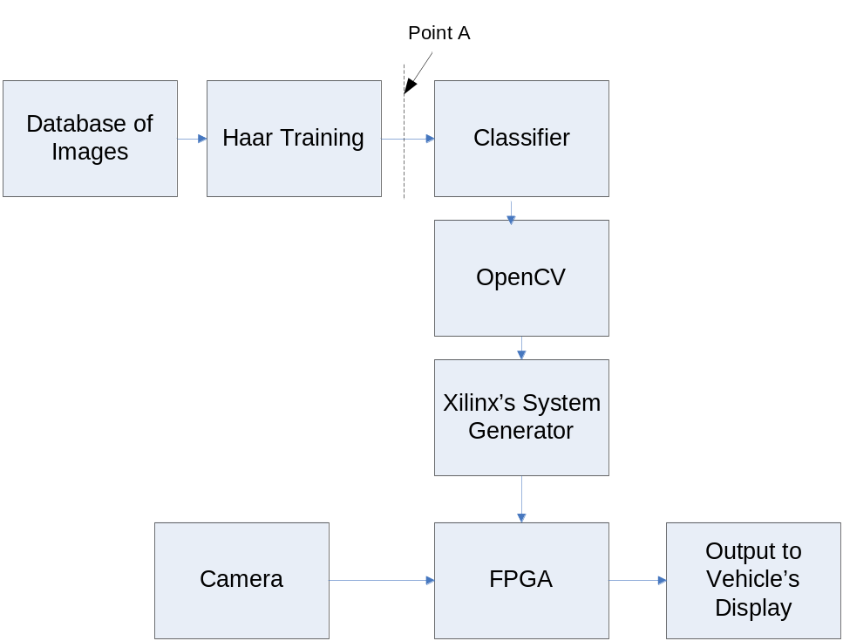
Figure 4: OpenCV Method

OpenCV has already established object detection algorithms that the team could utilize; however, this approach would require a great deal of work. First the team would have to understand how to integrate the OpenCV libraries and functions with Matlab. Then the problem is whether or not these OpenCV functions translate smoothly through Xilinx’s System Generator tools. Second, in order for OpenCV to use the object detection algorithm it possesses, a classifier must be built. The process of developing a classifier begins with providing the OpenCV software with a database of negative images to represent the possible background spaces, and also with a database of positive images as examples of the objects to be detected. OpenCV can then be used to process these images and develop a classifier using the Haar-training application provided in the available package. This classifier is the key to using object detection in OpenCV but may require a large amount of images to train as shown in Figure 5. The main downside to this method is the team’s lack of knowledge surrounding OpenCV which could cause a major hurdle or may cause failure in the project.
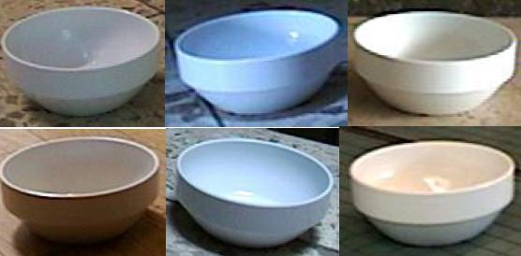
Figure 5: Multiple images of same object for database
The Simulink/Matlab method: Simulink provides an edge detection block algorithm but does not contain an object detection block. Within the edge detection block are various filters that can be chosen and each has its own parameters that can be set according to the system’s needs. There are gradient based filters such as Sobel as shown in Figure 7, and there are extrema filters such as Canny as shown in Figure 8. Canny has the ability to detect more edges but is slower and there are thresholds and a standard deviation that can be adjusted based on the amount of noise in the system. Sobel on the other hand is quick and compact but may not be detailed enough. Testing would be performed to determine which filter is most appropriate for the project. If the Simulink pre-generated filters were not sufficient, there are other algorithms that could be implemented through a user-defined Simulink block using Matlab coding. Once the edge detection algorithms have been implemented, the object detection algorithms will be added. It has proven very difficult to find an already existing algorithm outside of OpenCV that does object detection and the team would most likely be required to develop an algorithm. Designing an algorithm may not have to be from scratch; it may contain bits and pieces of existing coding.
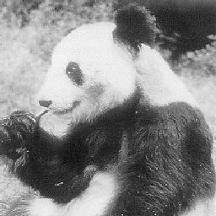
Figure 6: Original Image
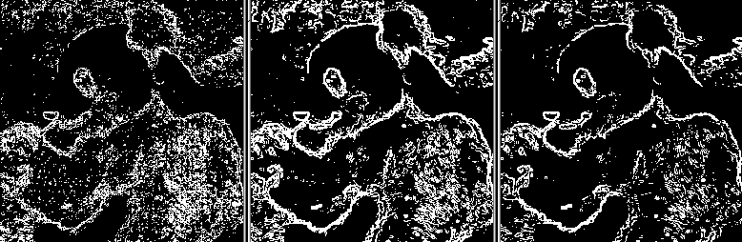
Figure 7: Robert, Sobel and Prewitt Methods (From left to right)
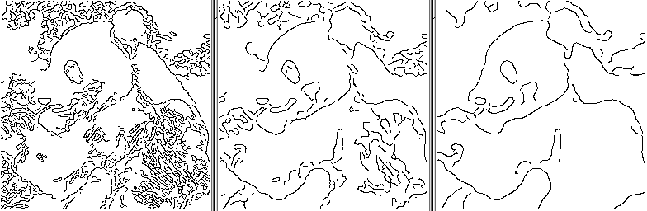
Figure 8: Canny Method (σ = 1, 2, 3 respectively and τ1=0.3, τ2=0.7)
Regardless of which direction the project follows, the team will conduct testing throughout the initial stages of the project to determine the most beneficial path. Both directions will also require the addition of image clarity features such as blurring and noise control features to increase the accuracy of the system. It has also been considered that the system will choose between algorithms to use based upon the environmental conditions, such as noise, but the team will confirm efficiency of the idea through testing.
Along with developing the algorithms to be used for detecting objects in real-time video, the team must also implement the developed system on the Xilinx Xtreme Spartan-3A development board. Whether the OpenCV or the Matlab approach is taken for object detection, Matlab and Simulink will be used to take advantage of Xilinx’s copy written System Generator tools. These tools will compile the program into code that is understood by the development board so that the algorithms will be loaded into the development board, and the system will operate solely using the logic functions provided by the board.

Ranking of Conceptual Designs

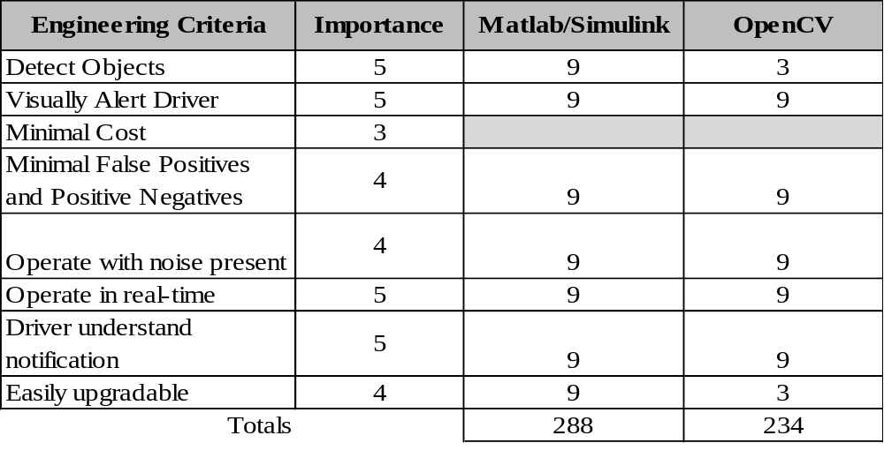
Table 1: Solution Selection Matrix

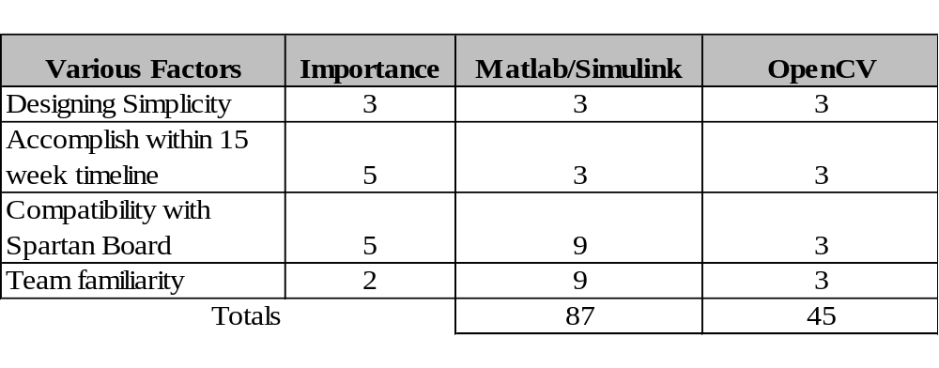
Table 2: Feasibility Matrix with Non-Obvious Ratings
Proposed Design Solution
Design Team 3 proposes that the Simulink/Matlab method would be best for the project; however, further testing of the system will determine specifically which algorithms will be implemented into the design. Regardless of which design is chosen, both software and hardware coding will be necessary for the system’s embedded design. Under the integrated software environment, hardware development is done within Xilinx’s Platform Studio utilizing the Base System Builder (BSB) Wizard which automates a basic hardware configuration. Once hardware development and device configuration is complete, the team will be able to focus on the software development and configuration. Xilinx’s System Generator is a modeling tool which allows for FPGA hardware design which the team can use to implement function blocks similar to those found within Simulink. Using a combination of blocks, edge detection and morphological algorithms can be derived and can be compiled into the FPGA using System Generator. The morphological algorithms are necessary to increase the accuracy of the system and minimize false positives. Object detection can then be designed using either C-code or a combination of System Generator blocks and will be the focus of the project. The team believes that the Simulink/Matlab method in combination with C-coding and System Generator is the best path for the project. OpenCV’s lack of user interface and unfamiliarity with the team may lead to unforeseen problems later. Utilizing a user interface platform such as System Generator reduces the learning curve for the team and allows quicker implementation of the algorithms. Testing will be done to determine which edge detection filters and methods will be used and which morphological algorithms are necessary.

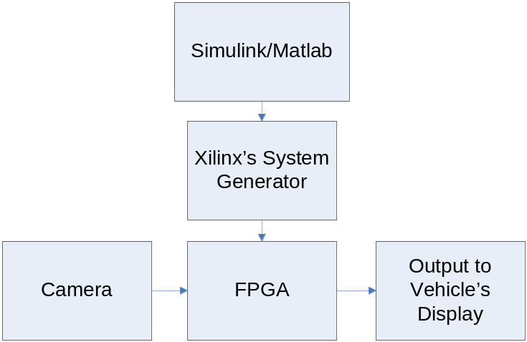
Figure 9: Matlab/Simulink Method

Risk Analysis
There are risks associated with this project both for developing the algorithm and in the developed algorithm itself. The risk in the means of development is that there are two paths in which the team can take to solve the problem. One path involves developing a database of images and creating a Haar-classifier associated with them, understanding the OpenCV source codes, and implementing OpenCV in Matlab. The other path involves developing an object detection algorithm in Matlab/Simulink that is accurate and efficient. Either of these tasks comes with many uncertainties and mild skepticisms about the probability of success. If one path is chosen and the entire team commits to finding a solution down that path, there is little time for failure. The development of the algorithm to be implemented on the FPGA board will consume the majority of the time period given for completion of the project, and the team does not have time for failure and redirection.
The primary risk with the algorithm, itself, will be false positive and false negative object identification. Some objects may be large but far away and could cause the object identification algorithm to classify it as a relatively close object that is of immediate attention. The goal is not to overwhelm the driver with excessive notifications of objects, but rather to indicate closer objects that are of immediate concern. Another large issue is having a moving vehicle identify moving objects. Stability countermeasures will need to be implemented to ensure clean and accurate edge detection. Proper edge detection is a requirement for reliable object identification.
In terms of safety, there will be very minimal safety hazards to our project. The voltage on the board never exceeds 5V. This is to ensure low noise and also low and efficient power consumption.

Project Management Plan
Design team 3’s individual contributions have been divided according to Table 3 below:
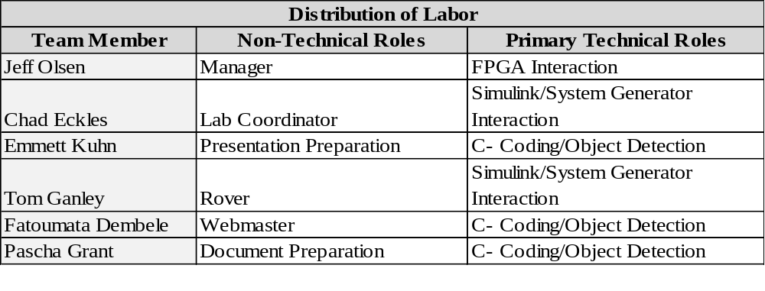
Table 3: Distribution of Labor for Team 3
*Note: Technical roles are for individual’s primary duties. These may change or be altered in time therefore this may not be a complete list of roles.

Budget
The total budget allowed for Senior Capstone projects is $500. The ECE Shop provides several small parts for free. Xilinx supplied the key components to the team via the Spartan 3-A Development Board Starter Kit. This kit included the development board, a camera, numerous cables, software, and documentation. Table 4 illustrates the total costs of this project:
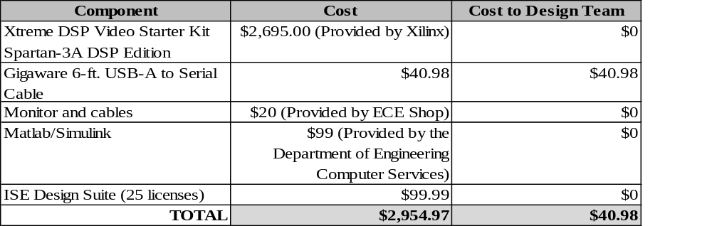
Table 4: Budget

References
“ An Introduction to Edge Detection: The Sobel Edge Detector”. Generation 5. 2002. September 17, 2010. <http://www.generation5.org/content/2002/im01.asphttp:// >.
“Adapting the Sobel Edge Detector and Canny Edge Extractor for iPhone 3GS Architecture”. IWSSIP. 2010. September 17, 2010. <www.ic.uff.bf/iwssip2010/proceedings/nav/papers/paper_161.pdf>.
“Canny Edge Detection”. Ruye Wang. 2004. October 17, 2010. <http://fourier.eng.hmc.edu/e161/lectures/canny/node1.html>.
“Edge Detection”. CNX. 2010. September 17, 2010. <http:// www.cnx.org/content/m24423/latest/>.
“Fujitsu Ten Press Release”. Fujitsu Ten. 2010. September 22, 2010. <http://www.fujitsu-ten.co.jp/english/release/2010/04/20100420_e.html>.
“Gentex Mirror with Rear Camera Display”. Mechanics Warehouse. 2005-2008. September 22, 2010. <http://www.mechanics-warehouse.com/mito-autodim-camera.htm>.
“How to build a cascade of boosted classifiers based on Haar-like features”. KYUtech.Florian Adolf. 2003. October 17, 2010. <http://lab.cntl.kyutech.ac.jp/~kobalab/nishida/opencv/OpenCV_ObjectDetection_HowTo.pdf>.
“Sanyo Automotive Equipment”. Sanyo North America Corporation. 2010. September 22, 2010. <http://us.sanyo.com/Automotive-Equipment>.
“Vehicle Vision Sensing”. John Day’s Automotive Electronics News. 2010. JHDay Communications powered by WordPress. September 17, 2010. <http://johndayautomotivelectronics.com/?p=60>.
“Xilinx Automotive Optical Flow Solution Addresses Image Processing Requirements of Advanced Driver Assistance Systems”. EDACafe. 2010. September 22, 2010. <http://www10.edacafe.com/nbc/articles/view_article.php?articleid=615707&interstitial_displayed=Yes>.

