Lab #2 – Parameter Identification Name:
Short Form Report Date:
Section / Group:
Procedure Steps (from lab manual):
- Follow the Start-Up Procedure in the laboratory manual. Note the safety rules.
- Locate the various springs and masses for the mass-spring-dashpot experimental system.
Part I. Mass, Springs, and Damping (Cart 2). Experiment A
- Disconnect the damper by unhooking the damper rod from the mass.
In the previous lab you were ‘given’ some physical parameters and asked to see how well the theoretical frequencies and decay matched the experimental results. However, most engineers approach problems without values for the system parameters. In this lab you will use an array of experiments to quantify the parameters of the system. These values will be used in the next two lab reports. So work hard to get accurate numbers and be sure to use the same piece of equipment for your next two experiments.
- (5%) Inspect the laboratory equipment. You may do this visually or by moving some of the carts and equipment. Make a list of the parameters that you will need to measure. Be sure to include a set of units for each parameter.

- (5%) For each item in the list above, try to think of an experiment or method for determining the parameter. Choose three experiments and write them in the space below.

- (10%) Use plots “Figure I.A1” and “Figure I.A2” and definitions from the pre-lab to fill in Table 1.
Table 1: Measured Experimental Results.
Variable (units) | Experiment A1 - EmptyCart | Experiment A2 - Loaded Cart
$X_{0}$ (cm)
$X_{1}$ (cm)
$X_{n}$ (cm) n=__________
$t_{0}$ (seconds)
$t_{n}$ (seconds)
Steady state error (cm)
- (5%) Use the log decrement method to approximate the damping ratio in both cases.
$$\frac{ζ}{\sqrt{1-ζ^{2}}}=\frac{1}{2πn}\ln\left(\frac{X_{0}}{X_{n}}\right)≈ζ$$

Method: $\frac{1}{2πn}\ln\left(\frac{X_{0}}{X_{n}}\right)≈ζ$ $\frac{ζ_{*}}{\sqrt{1-{ζ_{*} }^{2}}}=\frac{1}{2πn}\ln\left(\frac{X_{0}}{X_{n}}\right)$

Experiment 1, $ζ_{1}=$________________ $ζ_{1^{*}}=$________________

Experiment 2, $ζ_{2}=$________________ $ζ_{2^{*}}=$________________

- (5%) Why did the value of $ζ$ change between the experiments?

- (5%) Is the difference between $ζ$ and $ζ_{*}$ acceptable? Why or why not?

- (5%) We can now calculate the mass of the cart and spring coefficient. To do this we combine data from experiments 1 and 2. The equation for the natural and damped natural frequency:
$$ω_{n}=\frac{ω_{d}}{\sqrt{1-ζ^{2}}}≈ω_{d}$$
Can be applied to both experiments resulting in two equations and two unknowns.
$$ω_{n1}^{2}=\frac{k}{4m_{w}+m_{c}} \& ω_{n2}^{2}=\frac{k}{m_{c}}$$
Solve these equations to find the spring constant $k$ and mass of the cart $m_{c}$.
$k=$________________ $m_{c}=$________________
- (5%) Repeat this experiment (or devise a new one to experimentally determine the stiffness of the two remaining springs). What is the minimum number of experiments you will need to perform? __________________

$k_{weak}=$___________ $k_{medium}=$_____________ $k_{stiff}=$___________
^{From above}
- (5%) Using your results from above fill in Table I, located on the last page of this report.
Part II. Characterizing the Dashpot. Experiment B
- Re-connect the damper, use all 4 slotted weights, and use the stiffest spring.
- Start with the dashpot in the closed position (do not over tighten). Loosen the screw until one of the 6-sided start points is up.
- Note the initial position of the thumbscrew. How far is the white line from the vertical?
The thumbscrew position is defined by the white line. In Figure 1, the position is $P=n+2/6$ rotations from vertical. If the screw is almost tight then $n=0.$

Figure 1 – Definition of thumbscrew position
- Vary the position of the thumbscrew in 1 whole turn increments after each calculation.
- (10%) Use the log decrement method from lab 1 to fill in Table II of the appendix. Use Table II to plot the function in Figure II.
Compute the log decrement and the damping ratio using $X_{0}$ and$X_{n}$. Be sure to remove any offset (steady state error) present in the data and do not use peaks below 0.25cm. You can check your results by saving the data as “Lab2.C.1.m” and running the Matlab program “Lab2Damping.m”
- (5%) What is the relationship between $ζ$ and $c$? Use this relationship to mark the values of $c$ on the right side of Figure II.

- (5%) Adding springs and the dashpot increase the effective mass of the sled. Is it important to account for the increase in mass? Defend your answer.

- (5%) Discuss a method to experimentally determine the mass added by springs and the dashpot.

Part III. General
- (5%) In a short paragraph, discuss some possible applications of how the material covered in this laboratory could be used in a real application.

Appendix A: Summary of system parameters found in Lab 2.

Table I – System parameter values
 | Parameter | Value | Units
Masses | weight $(m)$
 | cart $(m_{c})$
Spring Constants | $$k_{weak}$$
 | $$k_{medium}$$
 | $$k_{strong}$$
Cart Damping | $c_{c1}$ – cart 1
 | $c_{c2}$ – cart 2

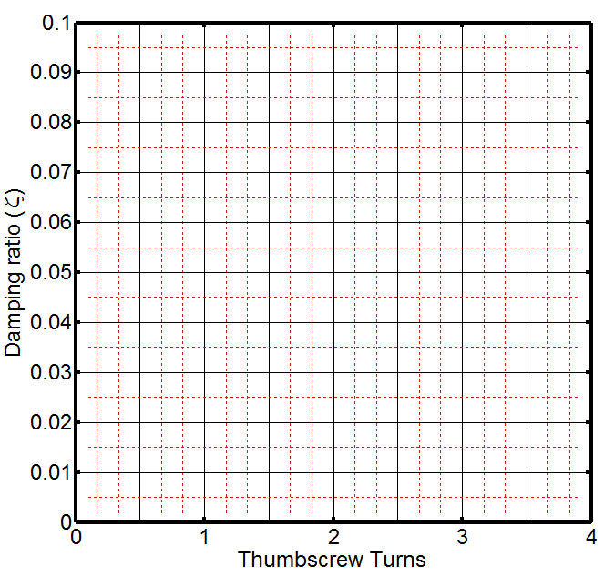
Table II – Damping vs Dashpot position
Damping coefficient (c)
Dashpot Thumbscrew | Damping Ratio
 | -over damped-
Figure II - Damping ratio curve. The damping ratio and damping coefficient as a function of dashpot thumb-screw position. (Up is always a whole number)
Appendix A: Summary of system parameters found in Lab 2.
*Copy from previous page and bring this page to Lab 3.
Table I – System parameter values
 | Parameter | Value | Units
Masses | weight $(m)$
 | cart $(m_{c})$
Spring Constants | $$k_{weak}$$
 | $$k_{medium}$$
 | $$k_{strong}$$
Cart Damping | $c_{c1}$ – cart 1
 | $c_{c2}$ – cart 2

Table II – Damping vs Dashpot position
Damping coefficient (c)
Dashpot Thumbscrew | Damping Ratio
 | -over damped-
Figure II - Damping ratio curve. The damping ratio and damping coefficient as a function of dashpot thumb-screw position. (Up is always a whole number)
Part IV. Differential Error Analysis. Post Lab
Numbers determined by experimental methods are never exact. They contain both systematic and random error. Knowing the accuracy of your measurement is a vital component of parameterizing a system.
NOTE: Please fill out this table from page 2 and answer the following questions. Keep this page and bring it to lab 3.
- (5%) Looking at “Figure I.A1” estimate the accuracy of your measurements.
Table 4: Measured Experimental Results.
Variable (units) | Experiment A1  Empty Cart (Error)
$X_{0}$ (cm)
$X_{1}$ (cm)
$X_{n}$ (cm) n=__________
$t_{0}$ (seconds)
$t_{n}$ (seconds)
Steady state error (cm)
- (10%) Using the information above, use differential error analysis to calculate the error in your damping coefficient from Experiment A1. Show your work below.

- (5%) Would you expect the error to be larger or smaller in experiment 2? Why?

