Project #1

**Surgical Tools for Use in Challenging Conditions**

**Sponsoring Company/ Organization**:

**Contact Information**:

Name: Satish Udpa

**Background Information**:

Conditions for surgery in developing economies present a serious challenge. Surgical operations are often conducted in unhygienic settings, contributing either to higher levels of mortality or significantly longer recovery times. This project is focused on the development of a new class of surgical tools that are continuously suffused with antimicrobials. Initial efforts will involve the development of a surgical tool such as forceps with microchannels to transport and release antimicrobials on the surface. The project will involve construction of the surgical tool, integration of an appropriate pump to the tool, and the development of algorithms for controlling the flow of the antimicrobial.

**Business Case:**

Over 2.7 billion people live on less than $2 a day and opportunities for receiving good health care under hygienic conditions are practically nonexistent (http://www.globalissues.org/article/26/poverty-facts-and-stats). The market for surgical tools that can be employed under these conditions can be large, provided the tools are inexpensive and easy to use. The marketplace is underserved currently, with most medical equipment manufacturers set up to cater to developed economies, since profit margins can be very high. The trick is to recognize the extreme price elasticity of the target markets and employ a business model that maximizes profit based on volume rather than large profit margins. Our challenge is to build a product that serves the specific needs of the market (tools for use in unhygienic conditions) at a cost point that makes it attractive for the market.

**Opportunity Statement:**

Development of a new class of surgical tools that are continuously suffused with antimicrobials. Initial efforts will involve the development of a surgical tool such as forceps with microchannels to transport and release antimicrobials on the surface. The project will involve construction of the surgical tool, integration of an appropriate pump to the tool, and the development of algorithms for controlling the flow of the antimicrobial.

The project can be completed within 13 weeks. Access to a high quality 3D printing facility with good resolution is essential. The window of opportunity exists now and will likely be open for a few years until established companies in the field recognize the potential of the market.

Potential customers include hospitals and surgical facilities in developing countries. The sponsor has contacts (hospitals, surgeons and other medical personnel) in India and other places. These contacts can be leveraged for testing, technology assessment and initiating design improvements.

**Deliverables:**

Working prototype demonstrating the Proof-of-Concept including hardware and software.

**Goals:**

Successful completion of the project goals involves the design, development and performance testing of a working prototype demonstrating the proof-of-concept. The system should be able to continuously suffuse the surgical tool with an antimicrobial for no less than 3 hours. The device should be battery operated and should be able to operate on a single set of batteries for at least 6 hours.

The project goals are attainable and it should be possible to complete the project within 13 weeks.

**Scope:**

Design, development and construction of suffusable surgery tool (forceps?)

Purchase and integration of pump

Design and development and assembly of interface electronics

Design, development and testing of a smartphone (iOS 8 or Android) based control system

System Testing and Verification

The scope is limited to a single surgical tool. The concept can be expanded to include additional tools in later semesters

**Constraints:**

None except imagination

Project #2

3D Model Building using RGB-Depth Cameras

Project Concept, Daniel Morris, January 11, 2015

Recently new sensors that measure dense depth are being commercialized on numerous consumer platforms including laptops, smart phones, game consoles and car interiors. There are many applications from gesture recognition to world modeling. In this project the focus is on the world modeling application. The goal is to acquire depth and color images from a moving RGB-Depth camera and combine these measurements to produce full three dimensional models of objects or of the local scene. Some of the key challenges to be addressed by this project are:

* Estimating position and pose of the sensor as it moves. This could be done by various combinations of matching 3D measurements, visual odometry, and motion sensing hardware.
* Registration between noisy measurements from different viewpoints. The depth values can have significant variance and bias which will need to be modeled for this to be effective.
* Combining range measurements from different views to build a single object surface model that minimizes the range errors from individual measurements.

Some specific project goals to consider include:

* Use a hand-held RGB-Depth sensor, possibly with a gyro or other motion sensor, to produce real time 3D scanner of objects.
* Attach the RGB-Depth sensor to the new iRobot educational mobile platform (the Roomba base) and program it to automatically drive around and map a cluttered room.

Hardware & Software

* Time of flight camera
  + <http://us.creative.com/p/web-cameras/creative-senz3d> (used by our lab)
  + Sensors will soon be integrated on tablets and laptops
* Intel Realsense SDK for Windows 8.1
  + <https://software.intel.com/en-us/intel-realsense-sdk/download>
* iRobot platform
  + <http://www.irobot.com/About-iRobot/STEM/Create-2.aspx>
  + I am checking to see if it is feasible to place a laptop + camera on this.
* Computer
  + Currently available software works in Windows 8.1, so we would need a Windows computer or tablet
  + An exception is the Dell Venue 8 7000 (Android) which has an integrated Intel Realsense camera (I think stereo based) but I have not worked with it.
    - <http://www.dell.com/us/p/dell-venue-8-7840-tablet/pd>

Project #3: Spring 2015 Electrical and Computer Engineering (ECE480) Capstone Design Project

Current Sponsors: Asante Solutions, MSU College of Engineering, MSU Resource Center for Persons with Disabilities (RCPD), Michigan Bureau of Services for Blind Persons, Diabetes Technology Society and the Journal of Diabetes Science and Technology, DiabetesMine.com, MSU Usability/Accessibility Research and Consulting

**Accessible Insulin Pump Design**

**Project Description**

An MSU capstone senior design team in Electrical and Computer Engineering (ECE480) will design and build a virtual insulin pump. That will enable simulated independent use by blind users as well as other users.

This device will look, feel, and operate like a real pump, possibly using the existing housing, display, and touch keys from an Asante pump. The device will have a small speaker and audio jack for joint or discrete use.

This unit can be connected via a cable to external circuitry such as a micro controller, power supply, and programming interfaces.

The user interface and all the operating characteristics will be programmable. One or more example user interfaces will be programmed following the design requests of blind users.

This device will be used to conduct usability reviews by Usability/Accessibility Research and Consulting teams at Michigan State University. Data and discoveries from these tests will be published in the Journal of Diabetes Science and Technology.

**Project impetus**

The need for an accessible insulin pump is becoming a major problem for professionals trying to serve a growing population of users experiencing both blindness and diabetes.

The RCPD will facilitate linkages to blind users of these technologies to help guide needed user-level insights during the design process. MSU medical schools have also participated in these projects when needed to provide further support.

We are very grateful for the support of Mark Estes (VP, marketing), Asante Solutions who will be supplying needed hardware and funding contribution for this project.

We would like to thank Gary Scheiner, 2014 AADE Diabetes Educator of the Year, and the nurses and director at the Michigan Bureau of Services for Blind Persons Training Center for suggesting this project and for recommending Asante Solutions as a sponsor.

Project #4

**Smart Walker Design**

Sponsors: MSU College of Engineering, MSU Resource Center for Persons with Disabilities (RCPD, Marathon Oil

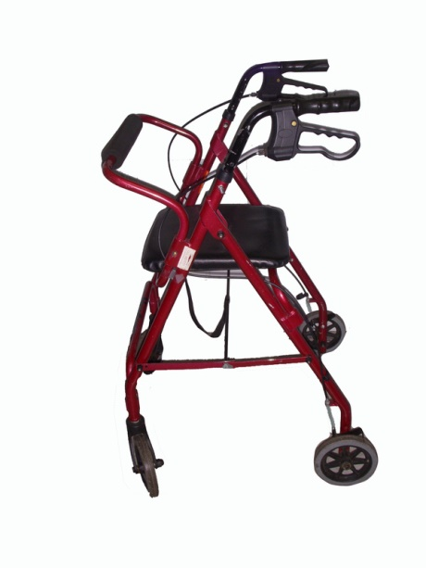

**Project Description**

A MSU capstone senior design team in Electrical and Computer Engineering (ECE480) will design and build an intelligent sensor and feedback device to attach to David’s walker. This device will attempt to alert and stop David from pushing and falling with his walker into dangerous drop offs.

David is a MSU student with a visual and motoric disability who recently fell down a stairs on campus because he was not able to see the drop off as he approached.

The design team will need to work with David to establish the amount of time or distance he needs to stop before falling over a cliff. Different forms of feedback need to be discussed.

David’s request for help is printed at the end of this document.

**Resource materials**

Roomba has 4 IR sensors <http://www.pottsland.com/roomba/Roomba_5xx_Cliff_Sensor.html>

Patent for IR device used in distance measurement <http://www.google.com/patents/US7369951>

Stephen Blosser, patent holder, has all this equipment if it is needed.

Prototype device for the blind that uses video cameras <http://www.yankodesign.com/2010/09/21/visually-impaired-with-fine-hands./>

Ultrasonic echo-location device <http://www.gdp-research.com.au/minig_1.htm>

Laser cane for the blind uses laser diodes and receivers <http://www.photonics.com/Article.aspx?AID=16107>

This is a place where we may wish to publish our project results. <http://www.manorbedandbreakfast.com/wonder-walker-survey.html>

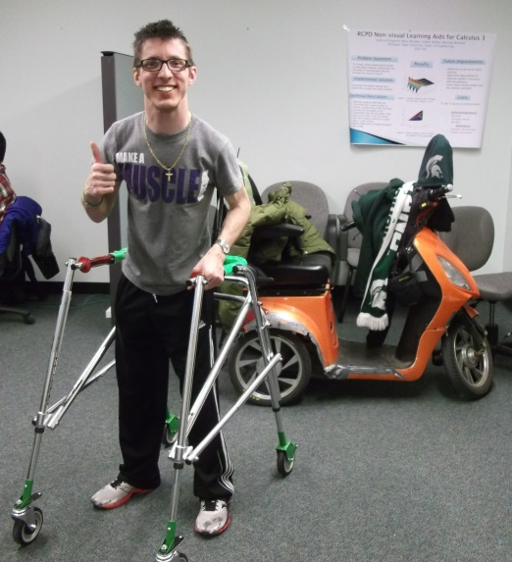Piotr, MSU student shown in this picture, uses a walker that was modified in another MSU engineering project. Piotr’s walker has a brake that stops him from falling backwards. Perhaps this MSU owned brake design could be used by David to stop his walker when approaching a cliff? Electrical actuation would need to be added.

Piotr will be available to demonstrate his walker and to brainstorm with the team.

Piotr used his walker to climb the great wall of China. <https://www.rcpd.msu.edu/blog/post/piotr-pasik-study-abroad>

**David’s Request**

What is the technology you would like to see invented or improved upon?

I am a MSU student associated with the RCPD. I have significant visual and mobility disabilties, plus a moderate hearing loss in the high frequencies. I use a walker on campus, primarily for safety. Last year, I was walking in Brody Hall in a part of the building that I was unfamiliar with. As I was walking forward with my walker, I didn't see a flight of 4 stairs in front of me. As I approached the first stair, the wheels of my walker lurched forward, pulling me down the stairs with it. I was glad this wasn't a full set of stairs, but it was in fact quite a warning sign. Unexpected drop-offs&/or changes in the terrain pose the biggest hindrance to my independence and accessibility throughout campus and the community. My rehab doctor wondered if a simple "Roomba" knows not to go over an edge, why can't my walker? If there was a device that I could attach to my walker to warn me of changes in the terrain, I would have avoided the previously described accident. Anyone with mobility and/visual disabilities could benefit from such an innovation tremendously, increasing confidence, safety and independence.

**Project #5**

**Lightning Strike Detector, Counter, and Time Log**

Capstone Design Project Proposal

By: Instrumented Sensor Technology, Okemos, MI

**Overview:** Lightning strikes are a powerful natural phenomenon. Around the world there are 40 to 50 lightning strikes per second. Lightning is a very high energy phenomenon that if not protected against can cause catastrophic damage to electrical, electronic, and electromechanical devices in the vicinity of the strike, as well as causing thermal meltdowns, fires, and deaths to animals and humans. An average lightning strike has a total duration of from 60 to 200 microseconds carrying an average current of 30 kA, and travels at a speed of approximately 1 x 108 m/sec. A typical strike transfers 15 Coulomb of charge and 500 megajoules of energy. Super bolts can be as large as 120 kA and transfer 350 Coulombs of charge. (ref.: Wikopedia)

Most structures in the developed world are protected, to a degree, from lightning strikes by utilizing specially designed grounding systems. The grounding systems are designed to form a controlled pathway for very large electrical currents from the structure (eg. A cell tower) into the Earth ground. Such grounding systems typically utilize one or more very heavy cable conductors attached at strategic points on the structure, and then connected to an array of conductive grounding rods(ranging from ten to 100 feet long) which are driven into the earth ground. The idea is to enable a safe pathway for the transfer of charge during the lightning strike from the structure to earth ground, bypassing parts of the structure that could be highly succeptible to damage from high currents, voltages, magnetic fields, and heat generated by the lightning, if left undirected in finding earth ground.

For such structures that utilize grounding system(ranging from water towers to RF towers, to refineries, large buildings, and various manufacturing plants, to mention a few), there is a desire to be able to know, and actually keep count of, lightning strikes at a particular facility. Not nearby(miles from) the facility, but at the facility. The use of this knowledge is primarily for maintenance of the grounding system components as well as for inspection of parts of the structure itself(eg. Automated control systems, computers, etc., that still might have suffered damage despite the grounding system).

So this project involves designing and building a device to detect and count lightning strikes, nearby the strike point, or nearby the earth grounding rods of the grounding system. In this context “nearby” is on the order of a few feet (eg., not km or miles).

Desired Operational specifications for the Lightning Detector device are as follows:

1. The device will be relatively small in size and weight(eg. Handheld) and able of surviving the elements- weather
2. The device will have an LCD display that will display a lightning strike count as well as a date/time of each detected lightning strike.
3. The device will have two flashing LEDs. One indicates the device is operational. The second indicates that at least one lightning strike was detected, if flashing. Note- use short duty cycle flashing to minimize power consumption.
4. The clock in the device must be user settable using one or two pushbuttons and a simple procedure.
5. The device must be re-settable using some simple procedure. Obviously the device is re-usable to the extent it does not get destroyed by a direct lightning hit, itself.
6. The device must be battery powered and operational for at least 6 months in the field
7. The device (production) parts cost must be under $25. Assume a production quantity of 5,000 for parts pricing.
8. The device would ideally be Faraday cage shielded as much as possible for lightning protection itself, however keep in mind the sensors being used will likely need to be outside of the device.
9. Operating temperature range of 32 to 130 deg F.

**Design approach considerations:**

From the previous discussion lightning clearly is a very high energy electrostatic event. As such lightning generates very high magnetic, electromagnetic and RF fields in the immediate vicinity of discharge, and even very detectable RF fields several miles or tens of miles away(think AM radio static). There are already devices on the market that detect lightning strikes from such distances which would not be suitable in this project due to the high number of false counts for direct strikes, nearby.

Another challenge in this project is testing and simulation. It is clearly not possible to easily and safely generate a controlled lightning strike. However a highly scaled down version of a lightning strike can be produced with a Van de Graff generator(VDG). The sponsor has one of these available. This machine generates 2-3 kV+ discharges and average discharge currents of around 50 micro-amps. However during a spark, instantaneous currents upwards of hundreds of amps in amplitude can be produced lasting only a micro-second or so. High currents over such short time periods results in little energy and no potential for human injury. However in order to produce sparks with higher energy the VDG can be equipped with high voltage high capacitance capacitors connected in parallel with ground and the sphere. These capacitors will store up much more charge than the sphere of the VDG resulting in a much higher average and peak currents during discharge. These sparks will be much higher energy, much louder(ear protection may be needed, and they will also be DANGEROUS), so experimentation should be done using the utmost caution. The sponsor also has some high voltage, oil filled capacitors.

**Sensors:** A challenging part of this project will also be sensor selection. Ideally the sensors should be passive(ie., not need to be powered) so as to minimize overall power consumption and battery life. Two sensor options that should be considered are (1) an inductor/RF coil. This will detect electromagnetic fields and generate a transient voltage output in response to, eg., high voltage sparks. Inductor coils used in RFID tags might be considered, as well as toroid coils. (2) Magnetic reed switches. Large currents from lightning strikes generate large transient magnetic fields which can be detectable using simple reed switches. These are very inexpensive, however selection of the most sensitive ones available are advisable. Hamilin is a leading manufacturer of these devices and related devices.

**Research and estimation:** It is advisable to do some research on lightning strikes to try and get estimates for the magnetic field strength and transient EM field strength in the near field of a strike. The same should be done with the scaled down VDG lightning simulator system. This will enable you to get a rough scale factor of magnitude of an actual lightning strike from one produced by the beefed up VDG. Knowing this would provide an estimate of how the prototype Lightning Detector might work with real lightning, distance considerations, sensitivities, and design modifications for actual lightning, if needed.

In any case you need your prototype lightning detector to function at a distance of around 12 inches from the actual discharge from the VDG.

Also, for testing approaches using the beefed up VDG, a model test structure should be assembled which approximates a tower(where the discharge will strike), with the tower connected into a simulated earth ground using bare wire(eg. Grounding wires) which run into a metal grounding rod placed into the soil box. Soil in a box may actually be used for the earth ground, so long as the VDG ground is also grounded to the soil in the box with a grounding rod.

Project #6 Crane Collision Avoidance

**Michigan State University**

**College of Engineering; Dept. of Electrical and Computer Eng.**

**ECE 480 Capstone Design Course Project Charter**

**Sponsoring Company/ Organization: ArcelorMittal USA**

**Business Case:**

* Safety is a core value at ArcelorMittal. Electric Overhead Cranes (EOT) are an integral component in the transport of product, parts and materials at all ArcelorMittal facilities. Crane operators are focused primarily on the load and the personnel in the immediate area. The end of the crane rail (End Bumpers), an adjacent crane on the same railway, or derails positioned for maintenance work present hazards that if not immediately recognized by the Crane Operator may result in a catastrophic event (Collision or crane derail).
* Although this does not occur often, there have been instances of cranes hitting an adjacent crane or passing over the derail. The installation of a collision alert system warning operators of the aforementioned hazards is an immediate need, specifically at the Finishing & Coating complex at the Indiana Harbor location.

**Opportunity Statement:**

* What **clearly defined Customer Problem** you hope to solve with this project?
  + The customer for this project is the Maintenance Area of the Finishing & Coating Division at Indiana Harbor, East Chicago, IN. Problem Statement: Electric Overhead Crane (EOT) Operators have, in rare occasions, collided the EOT Crane with an adjacent crane, the end of the rail bumper or passed through a derail on the crane railway used to isolate workers from crane activity. The Operator has nothing that signals the impending collision while focused on the task at hand which is typically not in the direction of the impending hazard. The operator relies on the ability to see the adjacent crane, bumper, or derail flag.

**Deliverables:**

* Describe what is to be delivered at the end of the semester.
  + A design of a collision alert system that will provide an audible and / or visual alarm to the EOT Operator as the EOT crane approaches a hazard at the same elevation as the crane (Specifically approaching a derail, adjacent crane, or end bumper).
  + A story board or similar communication that clearly describes the issue and solution.
  + A small scale (Table Top) working prototype that displays the effective solution.
  + The solution includes an alert when approaching a stationary hazard (Derail / derail flag or the end bumper) or one in motion (An adjacent crane)
  + Design details that a manufacturing facility would utilize to order components and provides the basics required for installation (power supplies, transformers, parts list, etc.).

**Goals:**

* Describe what success will look like at the end of the semester.
* Goals should be SMART
  + Provide a system design that can be applied to the current design of the EOT cranes at Finishing & Coating that will alert the EOT Operator of the potential of a collision with sufficient time to react and avoid the collision. The team will create a working small scale prototype of the design to exhibit how the system design operates.
  + The alarms will vary from cautionary (A distance of 250 feet from the hazard) to urgent (A distance of 100 feet from the hazard) and these alert thresholds will be adjustable by the customer.
  + The project team will accomplish the task within the Spring Semester, 2015.

**Scope:**

* The power supply is limited to what is available on the EOT Cranes. Power will not be supplied to the derail or end bumper. Battery operated devices are not allowed.
* The design will alert the EOT Operator of an impending stationary hazard (Derail or Bumper) or of a hazard in motion – specifically an adjacent crane on the same runway.
* Devices may be mounted to the side of the crane, but it is preferred that any device is mounted such that it does not extend beyond the boundaries of the crane sides. That is, any mounted device on the crane should fit within the dimensions of the crane such that if the device were to become disengaged from the crane it would fall on the crane structure and not onto the area (floor) below. As an alternative, the method used to secure any device to the side of the crane must prove to be secure (E.G., magnetic systems to secure the device to the crane would not be acceptable. welding a housing to secure the device may be acceptable, mounting a device within the confines of the crane is preferable).
* Devices or implements may be securely attached to derail flags / staffs or bumpers.
* The alarming mechanism will be a signal to another device that will alert the EOT operator. The customer will determine the most effective device that will receive this signal, for this project, the team can utilize either visual (light) or audible alarm that will be located inside the EOT crane cab at final installation. The alarming device will be hard wired to the device generating the alarm signal (The alarming device will not be “remote” or wireless to the alert generating device).
* Any logic devices must reboot or reset in the case of power loss without intervention from the EOT Operator. When the logic device powers up or reboots, it must retain the previous settings.
* The design team will be supplied blue prints of the EOT Crane (Multiple views), building layout, EOT electronic schematics; photographs depicting typical bumper arrangements, crane derail devices and warning flags, crane in service; operating parameters (Speed and stopping distances); information on how the crane is operated (Either photographic, descriptive text, or perhaps video).
* The team is welcome to visit the Finishing & Coating, Indiana Harbor, East Chicago, IN facility.

**Constraints:**

* List all constraints on the project team.
  + Any Logic system must reboot or reset upon power up – whether from a power loss or planned shutdown of crane power while retaining the most recent set points.
  + Devices must be securely attached to the crane structure such that if they fail, they do not fall to the ground below (With an understanding that the securing to derail devices may be less secure). Securing a device to a bumper my require discussion between the team and the customer.
  + Power supply is only allowed to the device hosted by the EOT crane and limited to the power supplied within the crane. No new power supply to the EOT crane or battery operated power is allowed.
  + Detection devices must be specifically designed to operate in the bay the crane operates in. That is, adjacent buildings – separated by approximately 3-10 feet of open space – have operating cranes that experience the same hazards.
  + Devices that may interfere with typical radio frequencies (Hand held radios) are discouraged.

Project #7 Gate Security System

**Michigan State University**

**College of Engineering; Dept. of Electrical and Mechanical Eng.**

**Capstone Design Course Project Charter**

**(Note: This will be a combined Electrical & Mechanical project per Gregg Motter)**

**Sponsoring Company/ Organization: ArcelorMittal USA**

**Business Case:**

ArcelorMittal Indiana Harbor Long Carbon (IHLC) Plant located in East Chicago Indiana needs a mechanical and electrical engineering design for its front gate location in an effort to improve security and safety entering the gate through a card reader system, potentially including the following elements at this gate location: lift arm gates, monitoring cameras, raised concrete dividing islands, pavement resurfacing, pavement markings, and signage.

**Opportunity Statement:**

* What **clearly defined Customer Problem** you hope to solve with this project?
* The customer for this project is the ArcelorMittal, Indiana Harbor Long Carbon Plant, East Chicago, IN.
* ArcelorMittal, IHLC needs a mechanical and electrical engineering design for its front gate location in an effort to improve security and safety entering the gate through a card reader system, which may include lift arm gates, monitoring cameras, raised concrete dividing islands, pavement resurfacing, pavement markings, and signage at this gate location.

**Deliverables:**

* Describe what is to be delivered at the end of the semester.
* A design for ArcelorMittal IHLC’s front gate location with an effort to improve security and safety entering the gate through a card reader and video camera system.
* Design new lift arm gates and signage at this gate location.

* Design may include all or part of the following: asphalt pavement and concrete curb removal, full depth asphalt pavement replacement, an asphalt mill and overlay of the southern section of the entrance, concrete curb, new road lanes for the gate, communication and power raceway and conductors, card readers, security cameras gates.

**Goals:**

* Complete all deliverables listed above in a report and PowerPoint presentation format

**Scope:**

* ArcelorMittal Indiana Harbor Long Carbon (IHLC) Plant located in East Chicago, Indiana needs a mechanical and electrical engineering design for its front gate location in an effort to improve security and safety entering the gate through a card reader system, which may include the following at this gate location: lift arm gates, monitoring cameras, raised concrete dividing islands, pavement resurfacing, pavement markings, and signage.
* The main entrance for ArcelorMittal IHLC is located on the southwest side of Dickey Road between the Indiana Harbor Canal and Cline Avenue.
* A building that houses the current gate control employees and gate control infrastructure is immediately adjacent to the entry lane on the southwest side of the entrance.
* The engineering design needed may include all or part of the following: asphalt pavement and concrete curb removal, full depth asphalt pavement replacement, an asphalt mill and overlay of the southern section of the entrance, concrete curb, new road lanes for the gate, communication and power raceway and conductors, card readers, security cameras gates, and a new gate house.
* The design team will be supplied aerial maps of the current ArcelorMittal layout and plant
* The design team will be supplied utility maps in the location.
* The team is welcome to visit the ArcelorMittal IHLC, East Chicago, IN facility and meet with the Environmental, Health, and Safety Manager.

**Constraints:**

* The main entrance is approximately 35-feet wide with two way traffic.
* The entrance is approximately 180 feet in length and there is limited space for turning movements and truck queuing.
* The intersection with Dickey Road (where ArcelorMittal IHLC gate is located is controlled by an existing traffic signal.
* The gate control office building abuts the sidewalk that runs along the northwest side of the entrance. Two drives are cut into the entrance, one on each side that provides access to two parking lots. The drives are not aligned with each other.
* An electric substation that provides power to the plant lies southeast approximately 60 feet from the entrance.
* There is a pipe support column that goes over the gate entrance. The pipe bridge height is sufficient for large vehicles to pass underneath in the existing condition but consideration must be taken to maintain appropriate vertical clearance in the design of the entrance.

Comment from Grotjohn: The ECE part of this is the control system to run the gates, the card reader, the security camera, communication to a central server database with information on valid personnel to enter. I would also like to see a capability for extra security in terms of implementation of a password option to a keypad, or swiping a pattern on a touch screen or a biometric entry (e.g finger print).

Project #8

**Dispenser Cup Contents Detection**

Problem Statement: This project builds on top of the last dispenser cup detection presented in the fall.

The requirement is now to include the cup sensors, may be reused from the previous project or a new

approach, along with the ability to send information from the dispenser cup(s) to the main ACU

(Appliance Control Unit) as well as obtain power to support electronics in the dispenser. The challenge is

to do this by the following method:

1. Power and communications between the dispenser and appliance must occur without any

contact points between them (i.e. no harness or contact pads allowed).

2. Have the ability to support the following in the dispenser:

a. LEDs (at least 6)

b. Microcontroller

c. Dispenser cup content sensors

d. Communications

In addition to sensing contents of each cup, a non-contact system that provides communication and

power would allow the dispenser to be interchangeable with other features that may be integrated into

the dispensing system in the future. It also removes any shock hazard from the user as it is a completely

isolated system.

The final system must be cost effective and robust to high humidity, temperatures (99% humidity with

condensation; up to 65C ambient), and vibration.

Cost is key to the solution. The entire electronic system should not have a manufactured cost more than

$4.00.



## Project #9

High Resolution Ultrasound Technology for Telemedicine

Smart phones have been used as “Point of Care Testing” (POCT) platforms for home health telemedicine. Home monitoring using POCT devices using measurements of blood pressure, blood oxygen, blood sugar, temperature etc. can help in reducing frequent visits to hospital and also enable early detection of specific complications of patient illness. These devices can have other potential telemedicine applications by doctors and specialists for examining patients living in isolated remote regions. Telemedicine and mobile collaborations technology also allow healthcare professionals in multiple locations to share information and discuss patient issues as if they were in the same place. Remote patient monitoring through these technologies can reduce the need for outpatient visits and enable remote prescription verification and drug administration oversight, potentially significantly reducing the overall cost of medical care.

In this project, we aim to develop the technology for remote measurements of musculoskeletal ultrasound (MSKUS) scan and transmit the data wirelessly to physicians or specialists for use in telemedicine .

High resolution MSKUS is used in adult hemophiliacs to assess painful musculoskeletal episodes. The MSKUS data is useful in differentiating between intra-articular bleeding vs. joint inflammation, and intra-muscle bleeds vs. other regional pain syndromes.

Currently, painful joint or musculoskeletal episodes are often misdiagnosed and treated empirically with clotting factor administration or for arthritis. Timely and accurate diagnosis along with appropriate management procedures is critical to ensure best outcomes. Rapid POC imaging would be highly desirable for accurate diagnosis of joint and musculoskeletal pain as due to haemophilic arthropathy or other joint pathology.

The basic idea of this project is to – 1) identify commercial portable UT instruments, 2) connect with the manufacturer to access the B-mode ultrasound data as well as power Doppler ultrasound data, 3) develop Bluetooth or wi-fi interfaces to wirelessly transmit the data to a base station.

Project #10

Screw Machine Condition Monitoring

Sponsor: Great Lakes Controls and Engineering

Overview

The purpose of the project is to provide condition monitoring of a standard automatic lathe machine to provide quality improvement of machined parts.

Faulty parts are produced when the cutting tools begin to dull or spindle bearings wear beyond nominal limits. Condition monitoring would provide a way to identify dull tooling and worn out spindle bearings and proactively replace each specific component prior to production of faulty parts and lengthy down time of machine.

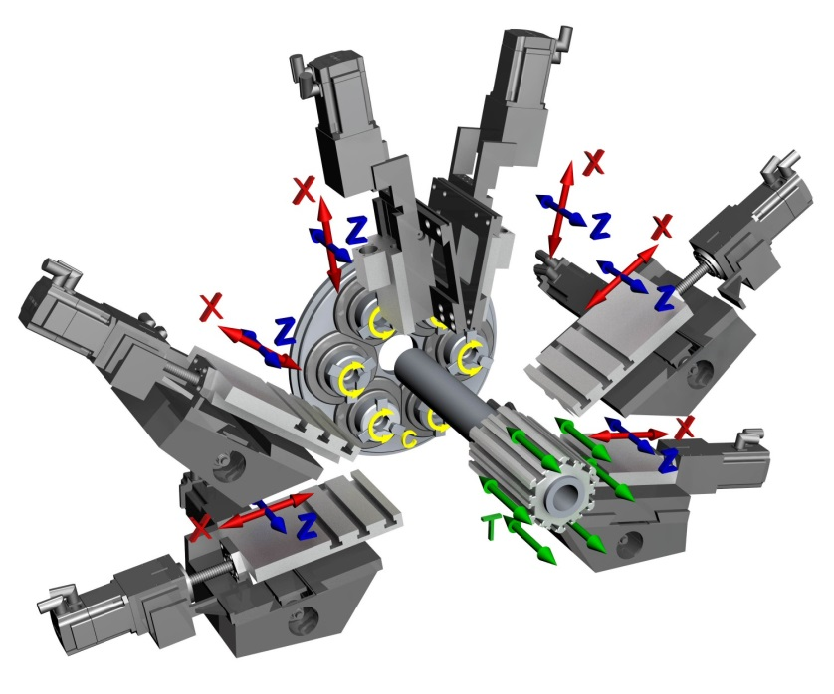

**Figure 1: Automated Lathe Tool Cross Slides**

Tasks

1. Use a sensor(s) to identify sharpness of tool life as operation of the machine is ran.
   1. Sensor must only read one tool operation.
2. Wire cutting operation not in progress, system will have ability to monitor spindle bearings of machine
3. Output a 0 to 10 volt analog signal of the tool life to the Programmable Logic Controller (PLC) of the machine.
   1. Map signal to 0-100% of tool life remaining.
4. Ability to eliminate background noise and focus on one tool inside the automatic screw machine.
5. Run off supplied 24VDC.
   1. 4-pin control cable connector ran from main control panel to device for power and analog signal.
6. Sensing device must be compact to fit inside machine without interrupting process and withstand harsh environment.
   1. Size should be less than 2” x 2” x 2”.
7. $250 budget for multiple units made.

Deliverables

1. A sensing device to place inside the machine.
   1. An auto calibration routine for new tools or location of sensor change.
   2. User-friendly operator interface for set up.
   3. Accurate 0-10 VDC output signal to main PLC for tool life of specific tool.
   4. Device must have ability to auto-reset itself to continuously monitor tool life.
   5. Device must be able to survive in harsh conditions that are inside machine (coolant, metal shavings, etc.)
2. Documentation to place and run the system by operator with high school diploma.

Project #11

Design and Control of 3-D Printer with Two Different Print Heads

Sponsor: MSU Technologies

3-D printers are typically constructed with one print head that deposits “prints” material (e.g. plastic) to form a 3-D part. Some potential applications of 3-D printing would like to combine two different materials in the same printed part, for example a metal inside of a plastic. A printer of this type would require a printer with two print heads (of different type) in the same 3-D printer. The objective of this project is to build a 3-D printer that includes two print heads. A control/software system would need to be developed that allowed two print heads to work together to fabricate one part with two different materials. It is envisioned that the starting point of this project is to buy a 3-D printer kit (components) and then built the printer. Next the software to run the 3-D printer with two print heads will need to be developed. Finally, the demonstration of printing a 3-D part using the two-headed 3-D printer will be done.

Project #12

Sound Emission Measurement of Diamond Polishing

Sponsor: MSU/Fraunhofer Center for Coatings and Diamond Technologies

Diamond polishing is done by putting a diamond powder on a cast iron wheel (scaife) that rotates at a high speed. The diamond being polished is held against the spinning wheel during the polishing operation. Some important parameters for diamond polishing is the rate of material removal, the roughness of the final polished surface and the subsurface damage of the diamond. It is known by talking with people who polish diamond that they can tell if the polishing is working well by the “sound” of the polishing process. The polishing of diamond is very directional with some directions of the spinning wheel touching the diamond being soft directions and some being hard directions. In soft directions the diamond is removed more quickly and the surface is smoother, and in hard directions the polishing rate is slow and the surface is more microcracked. It is also known that sometimes the important sounds when polishing for very smooth finishes may be above the frequency that humans can hear. The objective of this project is to develop a microphone system for listening to the diamond polishing process. It should be directional and have low-to-high frequency capability (up to potentially 100’s kHz). It should then be tested with a diamond polishing system operator. Finally, a prototype system should be developed for use by the operator after the semester ends. The prototype should have a compact, easily understood display that characterizes the diamond polishing process.

Project #13

MSU Solar Car Project

Sponsor: Michigan State University Solar Car Racing Team (MSU Solar Car will have a project. The description below is the project from last semester. This semester’s project will be similar to this one. The final project description has not been received yet.)

The Michigan State University Solar Car Racing Team is a student run organization that designs, builds, and races solar powered vehicles. The team participates in a track race called the Formula Sun Grand Prix (FSGP) every summer, and a road race called the American Solar Challenge (ASC) every other summer. The only source of power for propulsion of the car is the solar array, so efficiency is the most important factor.

A maximum powerpoint tracker (MPPT) is an electronic circuit that is the link between the solar array (power generation) and the battery (power storage). It consists of a DC-DC boost converter to take the lower voltage of the solar array and match the higher voltage of the battery, and a microprocessor controlled tracking algorithm to find the maximum powerpoint by adjusting the voltage slightly. Figure 1 shows a typical IV curve for a solar panel under different illumination levels, and figure 2 shows the basic schematic of a boost converter. As the illumination changes, so does the voltage at which the maximum powerpoint occurs. An MPPT can produce the maximum output power possible regardless of illumination level or temperature.

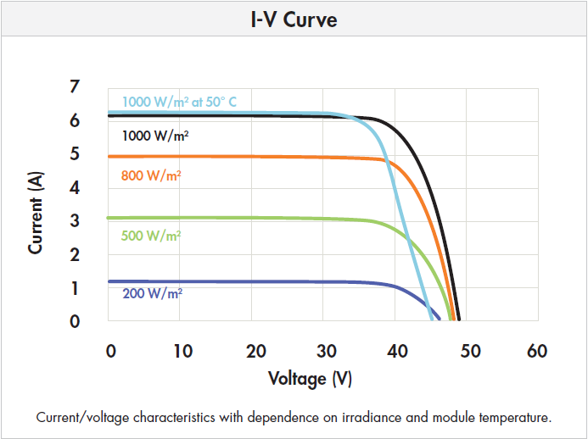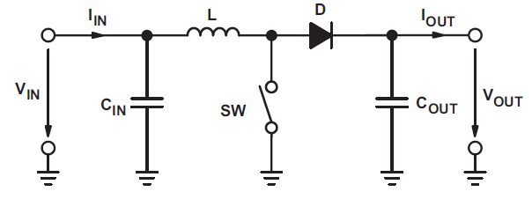

Figure 1: 240W Solar Panel (Source: Sunpower) Figure 2: Boost Converter (Source: TI slva372c)

This project will be divided into three stages:

Stage 1: Prototype a DC-DC boost converter (20-60V, 6A input, ~100V output).

Stage 2: Program a microcontroller (TI MSP430) to track and adjust the powerpoint.

Stage 3: Create a PCB combining these two components that meets the design requirements

Design Requirements:

Efficient (Greater than 95%)

Small (Size of a credit card or less)

Lightweight (less than 100g)

Project #14

A Hand held, Low-Cost Tunable Light Source using LEDs for Solar Cell Efficiency Measurement

Goal of this project is to design and construct a light source which is wavelength tunable over a spectral range of 400 – 1100nm. This source will mimic the spectral content of the sun light. The source will be housed in a compact unit that will allow in the measurement of quantum efficiency of solar cells at local spots. There are table-top commercial systems available that uses broad band light source and optical grating to allow such measurements. Here, instead of using a broad band light source, an array of LEDs are to be used that can actively be controlled using a laptop through a USB port.

For testing of solar cells, illumination of a local spot of 1mm2 area with total power of 0.1W is required. A minimum of 25 peak wavelength points are desirable over a spectral range of 400 – 1100 nm. The output power of the solar cells will be measured using a simple voltmeter.

The prototype unit of this project will be used in future ECE476 labs.

Project #15 Drone Monitoring of Power Lines

**Sponsoring Company/ Organization: Consumers Energy**

**Business Case:**

* Explain why is this an attractive opportunity for your company to pursue now.
  + Consumers Energy has previously sponsored two successful MSU ME Capstone projects. Currently Consumers would like to get involved in EE Capstone projects in an effort to expose students to the utility industry and potentially a future employer.
* Describe the discontinuity creating the competitive opening in the marketplace that makes this project timely. (Competitive action, Legislation, Regulation, etc.)
  + The Federal Aviation Administration (FAA) is on the verge of making unmanned aerial vehicle (UAV) decisions on commercial entities.
* Explain how this product / service will be positioned as a commodity (low cost to serve) or a differentiated (value priced) offering. Why? Through the usage of UAVs Consumers Energy’s infrastructure would benefit vastly in countless ways.
* Outline the competitive barriers to marketplace entry the Design Team needs to take into consideration.
* What is the hypothesized basis of for a sustainable competitive advantage?
  + Patents, Trade Secret, Low cost, privileged relationships?

**Project Intellectual Property Considerations:**

* Will the student Design Team be required to sign a Non-Disclosure Agreement? Yes
* Will the Design Team be able to post their work on the course web site? Yes
* Will the student Design Team be working with technology contained in pending patents not yet granted? Potentially
* Can the electronic design be shown, but the embedded software protected? Yes

**Opportunity Statement:**

* What **clearly defined Customer Problem** you hope to solve with this project?
  + Consumers Energy is looking for students to help us investigate UAV technology utilization within our business. We are looking for the project to investigate various flights and imaging technologies for UAVs to help create readiness to proceed in the near future from a technology standpoint. At this time Consumers Energy has no ideal way to remotely inspect our lines or survey storm damage.
  + Is this problem solvable in a 13 week working semester with students? Yes
  + Does the design challenge need to be run across two back-to-back semesters? No
* Does this problem exist now, or in the future? Now
  + How long will the window of opportunity be open to alternative solutions? 2 years
  + What will drive the window of opportunity closed in the future? FAA Requirements
* Who is the customer?
  + Who makes the buying decision? Students
  + Who will the ECE 480 Design Team deliver their project to at the end of the semester? Consumers Energy Upper Management
  + Describe the benefit to the end Customer for this project.
    - Consumers Energy is interested in Drone technology to use for Low Voltage Distribution (LVD) and High Voltage Distribution (HVD) inspections to help maintain integrity of our lines. Also for remote circuit inspections and damage assessment during storms.

**Deliverables:**

* Describe what is to be delivered at the end of the semester.
  + Proof-of-Concept design? (Bread-boards, wires connecting sub-systems, etc., ugly looking – but functional, development software non-user-friendly interface)
  + Working prototype? (PC boards, cabling between sub-systems, refined software and user friendly interface) Research and purchase a UAV development platform. Determine several types of cameras (infrared, corona) that can fit on platform. Provide image results such as still photos, videos and compare results to Consumers Energy’s current image quality provided.
  + Sub-system ready to fit into the overall system?
  + Final solution ready for end use deployment?

**Goals:**

* Describe what success will look like at the end of the semester. Success will rely on working design of UAV development platform, as well as, research findings related to current/future UAV usages (cameras, image quality etc.) that would ideally benefit Consumers Energy as a whole.
* Goals should be SMART
  + **Specific** – Exactly what is to be delivered?
  + **Measurable** – Describe the measurement system that will determine the degree of success.
  + **Attainable** – Can a student team, with little to no industrial experience complete this project in 13 weeks to your satisfaction?
  + **Relevant** – Limited to this design challenge.
  + **Time Bound** – 13 week working semester (Students loose a week getting organized and a week preparing for Design Week presentations.)

**Scope:**

* Clearly define what is IN and OUT of Scope for the Design Team. What are the clearly defined boundaries to prevent the project form getting too large and complicated?
* Clearly list chipsets, software, equipment, test set-ups, working systems, etc. that will be supplied to the Design Team to facilitate their efforts and keep project cost reasonable. Consumers Energy to supply funding for UAV purchase, test equipment and cameras.